

**Software Engineering**

**Assignment 3**

**Section: E**

**Abdullah Qadri 17K-3922**

**Rahim Samnani 17k-3618**

**Shan Amin 17k-3712**

PROJECT SRS and SDS DOCUMENT

***Project Demo and Source Code***

https://drive.google.com/drive/folders/1oKAWAcicVsRgami1cww8YPL7x5DzKc_q?usp=sharing

***1. Introduction***

***1.1. Purpose of Document***

This document that describes the nature of a project, software or application. In simple words, SRS document is a manual of a project provided it is prepared before you kick-start a project/application.

***1.2. Intended Audience***

The expected audience of this document is the faculty of National University of Computer and Emerging Sciences and course instructor Miss Romasha Khurshid. The rest of document contain description of all the functions and specifications of the First Care Pharmacy Management System.

**1.3 Definition of Terms, Acronyms and Abbreviations**

Not applicable.

***1.4 Document Convention***

Arial 12.

***2. Overall System Description***

***2.1. Project Background***

At present, manual system is being utilized in the pharmacy. It requires the pharmacist to manually monitor each drug that is available in the pharmacy. Pharmacy management has kept paper record in filing cabinets. Managing a very large pharmacy with records on papers will be tedious and difficult to keep track of inventories with regards to the drugs in the store, expiry date, quantity of drugs available based on the categories and their functions. This implies that these services will be manually completed by the pharmacist. This usually leads to mistakes as the workload of the pharmacist increases. This system also ensures that there exists a level of restricted access based on functionality and role. This system also provides optimal drug inventory management by monitoring the drug movement in the pharmacy. The system will not be able to handle drug prescription, drug to drug interaction.

***2.2. Project Scope***

The purpose of this software is to enable users order medicines. It provides a simple interface to the users of the software so they can easily understand it and use it.It also covers all the internal management system of an online pharmacy like management of clients and products.

***2.3. Not in Scope***

* Inventory Reports
* Profit/Loss Calculation
* Expiry Date
* Alerts if any

***2.4. Project Objectives***

Pharmacy management system is a management system that is designed to improve accuracy and to enhance safety and efficiency in the pharmaceutical store. This program can be used in any pharmaceutical shops having a database to maintain. It is a computer based system which helps the Pharmacist to improve inventory management, cost, medical safety and online medicine purchase.

***2.5. Stakeholders***

Customers and Admin

***2.6. Operating Environment***

The whole System will operate on PHP/MySQL for Database and the hardware platform would be system capable of running windows or mac with Xampp preinstalled.

***2.7. System Constraints***

* The software has the ability to run on low specs machine.
* It can be installed in any pharmacy who wants to do online business.
* Not designed for children.
* Easy to operate by naïve users.
* Internet Connection is must.

***2.8. Assumptions & Dependencies***

Not applicable.

***3. External Interface Requirements***

***3.1. Hardware Interfaces***

Not applicable.

***3.2. Software Interfaces***

Tools used:

* HTML
* CSS
* Bootstrap
* PHP
* Javascript

Database Used:

* My/SQL

***3.3. Communications Interfaces***

Web Brower and Internet. Communications standards such as HTTP is used.

***4. Functional Requirements***

***4.1. Functional Hierarchy***

**Customer Portal**

**1.1 Sign in**

**1.2 Create new account**

**1.3 My account**

**1.3.1 Profile setup**

**1.3.2 Address details**

**1.3.3 Order history**

**1.3.4 Payment pending order**

**1.4 Purchase Items**

**1.4.1 Select Category**

**1.4.2 Select Sub Category**

**1.4.3 Add to Wish list**

**1.4.4 View Item Reviews**

**1.4.5 Write Reviews**

**1.4.5.1 Rate items**

**1.4.6 Buy Items**

**1.4.5.1 View Shopping Cart**

**1.4.5.2 Continue Shopping**

**1.4.5.3 Proceed to Checkout**

**1.4.5.3.1 Select Payment Method**

**1.4.6 Track Order**

**1.4.6.1 View Status**

**1.4.7 Search Items**

**1.4.8 Change Password**

**1.4.9 Sign Out**

**Admin Portal**

**1.1 Login**

**1.2 Order Management**

**1.2.1 Today’s Orders**

**1.2.2 Pending Orders**

**1.2.3 Delivered Orders**

**1.2.4 Update Order Status**

**1.3 Manage Users**

**1.3.1 Search Users**

**1.3.2 View Users**

**1.4 Create Product Category**

**1.4.1 Create Sub Category**

**1.4.2 Insert Product**

**1.5 Manage Products**

**1.5.1 Update**

**1.5.2 Delete**

**1.6 User Logs**

**1.7 Change Password**

**1.8 Logout**

***4.2. Use Cases***

***4.2.1. Customer***

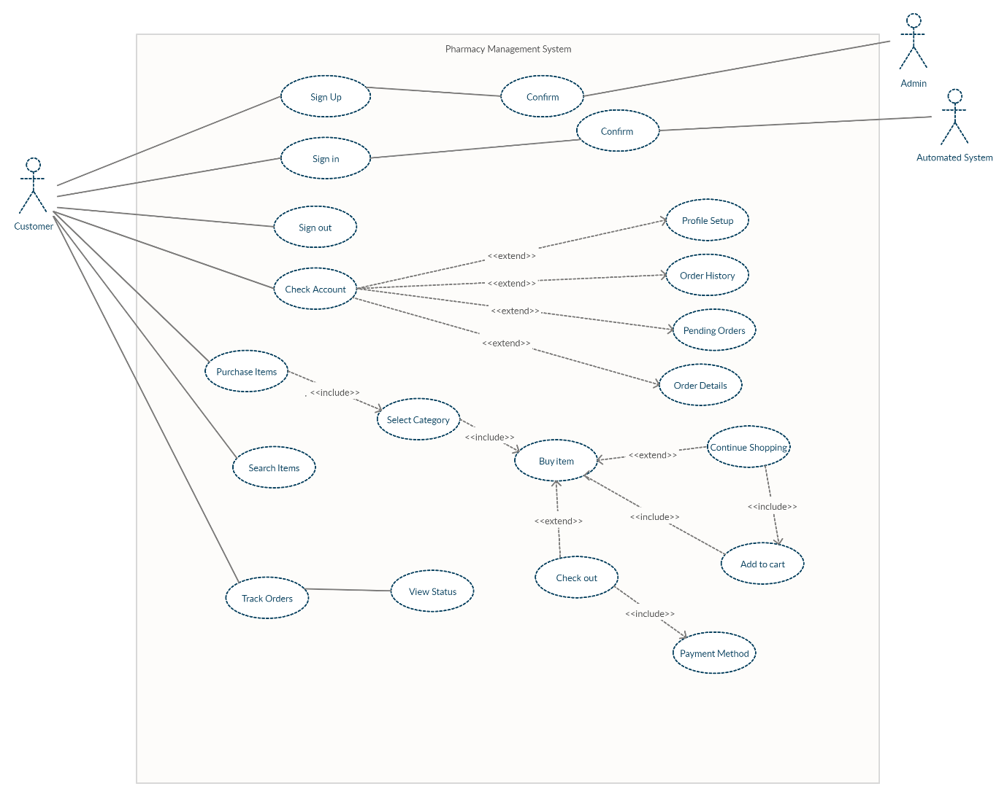

|  |  |
| --- | --- |
| Use Case Description | |
| Use Case Name: | **Sign up** |
| Use Case Description: **Customer Sign up** | |
| Primary Actor: **Customer** | Other Actors: **Admin** |
| Stakeholders: |  |
| Relationship   * Includes: * Extends: | |
| Preconditions: | |
| Flow of Events: **After sign up admin will confirm the sign up** | |
| Alternative and Exceptional Flows: | |
| Post Conditions:   * **Customer Signed in** | |

|  |  |
| --- | --- |
| Use Case Description | |
| Use Case Name: | **Sign in** |
| Use Case Description: **Customer Sign in** | |
| Primary Actor: **Customer** | Other Actors: **Automated System** |
| Stakeholders: |  |
| Relationship   * Includes: * Extends: | |
| Preconditions: | |
| Flow of Events: **After sign in system will automatically confirm credentials of user** | |
| Alternative and Exceptional Flows: | |
| Post Conditions:   * **Customer Signed in** | |

|  |  |
| --- | --- |
| Use Case Description | |
| Use Case Name: | **Sign out** |
| Use Case Description: **Customer Sign out** | |
| Primary Actor: **Customer** | Other Actors: |
| Stakeholders: |  |
| Relationship   * Includes: * Extends: | |
| Preconditions:   * **Customer Signed in** | |
| Flow of Events: | |
| Alternative and Exceptional Flows: | |
| Post Conditions: | |

|  |  |
| --- | --- |
| Use Case Description | |
| Use Case Name: | **Check Account** |
| Use Case Description: **Customer check his/her account** | |
| Primary Actor: **Customer** | Other Actors: |
| Stakeholders: |  |
| Relationship   * Includes: * Extends: **Profile setup, Order History, Pending Order, Order Details** | |
| Preconditions:   * **Customer Signed in** | |
| Flow of Events: **After checking account admin can Profile setup, Order History, Pending Order, Order Details** | |
| Alternative and Exceptional Flows: | |
| Post Conditions: | |

|  |  |
| --- | --- |
| Use Case Description | |
| Use Case Name: | **Purchase items** |
| Use Case Description: **Customer Purchase items** | |
| Primary Actor: **Customer** | Other Actors: |
| Stakeholders: |  |
| Relationship   * Includes: **Select Category include buy item which includes add to cart which include continue shopping will extend buy item** * Extends: | |
| Preconditions:   * **Customer Signed in** | |
| Flow of Events: **After selecting category customer can continue shopping or check out after continue shopping admin will add to card and buy item and after check out admin will go to payment method** | |
| Alternative and Exceptional Flows: | |
| Post Conditions: | |

|  |  |
| --- | --- |
| Use Case Description | |
| Use Case Name: | **Search items** |
| Use Case Description: **Customer Search items** | |
| Primary Actor: **Customer** | Other Actors: |
| Stakeholders: |  |
| Relationship   * Includes: * Extends: | |
| Preconditions:   * **Customer Signed in** | |
| Flow of Events: | |
| Alternative and Exceptional Flows: | |
| Post Conditions: | |

|  |  |
| --- | --- |
| Use Case Description | |
| Use Case Name: | **Track Orders** |
| Use Case Description: **Customer Track orders** | |
| Primary Actor: **Customer** | Other Actors: |
| Stakeholders: |  |
| Relationship   * Includes: * Extends: | |
| Preconditions:   * **Customer Signed in** | |
| Flow of Events: | |
| Alternative and Exceptional Flows: | |
| Post Conditions: | |

***4.2.2. Admin***

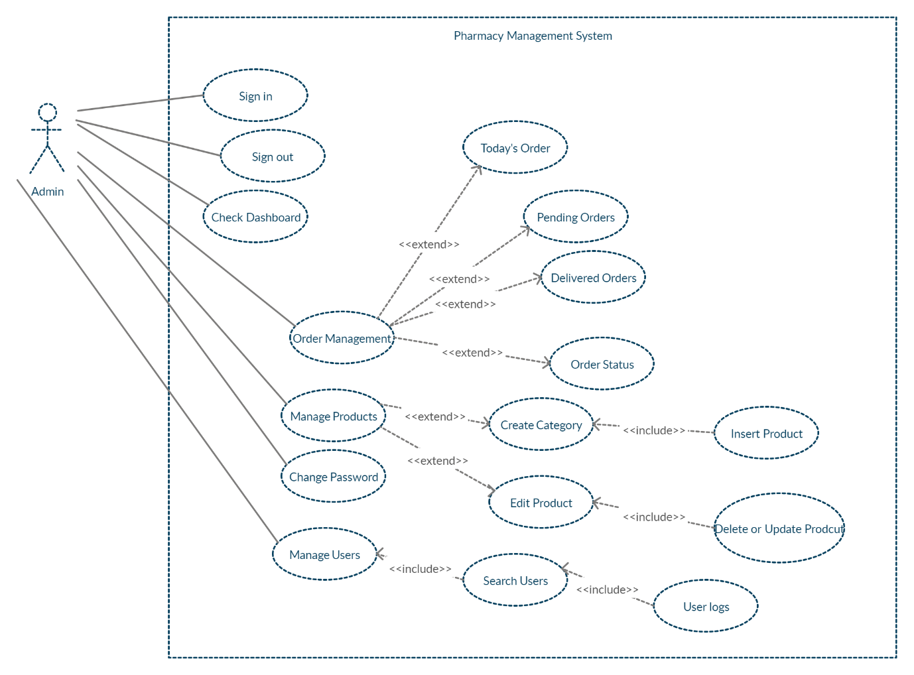

|  |  |
| --- | --- |
| Use Case Description | |
| Use Case Name: | **Sign in** |
| Use Case Description: **Admin Sign in to system** | |
| Primary Actor: **Admin** | Other Actors: |
| Stakeholders: |  |
| Relationship   * Includes: * Extends: | |
| Preconditions: | |
| Flow of Events: **The first event it depends on all the events that are to be triggered afterwards** | |
| Alternative and Exceptional Flows: | |
| Post Conditions: | |

|  |  |
| --- | --- |
| Use Case Description | |
| Use Case Name: | **Sign out** |
| Use Case Description: **Admin Sign out to system** | |
| Primary Actor: **Admin** | Other Actors: |
| Stakeholders: |  |
| Relationship   * Includes: * Extends: | |
| Preconditions:   * **Admin signed in** | |
| Flow of Events: **The last even which ends the system** | |
| Alternative and Exceptional Flows: | |
| Post Conditions: | |

|  |  |
| --- | --- |
| Use Case Description | |
| Use Case Name: | **Check Dashboard** |
| Use Case Description: **Admin check dashboard which was all the other use cases** | |
| Primary Actor: **Admin** | Other Actors: |
| Stakeholders: |  |
| Relationship   * Includes: * Extends: | |
| Preconditions:   * **Admin signed in** | |
| Flow of Events: **After checking dashboard all other use cases will appear** | |
| Alternative and Exceptional Flows: | |
| Post Conditions: | |

|  |  |
| --- | --- |
| Use Case Description | |
| Use Case Name: | **Order Management** |
| Use Case Description: **Admin check and manage orders** | |
| Primary Actor: **Admin** | Other Actors: |
| Stakeholders: |  |
| Relationship   * Includes: * Extends: **Today’s order, pending orders, Delivered Orders, Order Status** | |
| Preconditions:   * **Admin signed in** | |
| Flow of Events: **After Order Management admin has choice of doing Today’s order, pending orders, Delivered Orders, Order Status** | |
| Alternative and Exceptional Flows: | |
| Post Conditions: | |

|  |  |
| --- | --- |
| Use Case Description | |
| Use Case Name: | **Manage Products** |
| Use Case Description: **Admin check and manage Products** | |
| Primary Actor: **Admin** | Other Actors: |
| Stakeholders: |  |
| Relationship   * Includes: * Extends: **Create Category includes Insert Product** | |
| Preconditions:   * **Admin signed in** | |
| Flow of Events: **After** **Manage Products admin can create category or edit product after creating category admin will insert product and after edit product admin will delete or update product** | |
| Alternative and Exceptional Flows: | |
| Post Conditions: | |

|  |  |
| --- | --- |
| Use Case Description | |
| Use Case Name: | **Change Password** |
| Use Case Description: **Admin change password of account** | |
| Primary Actor: **Admin** | Other Actors: |
| Stakeholders: |  |
| Relationship   * Includes: * Extends: | |
| Preconditions:   * **Admin signed in** | |
| Flow of Events: | |
| Alternative and Exceptional Flows: | |
| Post Conditions: | |

|  |  |
| --- | --- |
| Use Case Description | |
| Use Case Name: | **Manage Users** |
| Use Case Description: **Admin will manage user accounts** | |
| Primary Actor: **Admin** | Other Actors: |
| Stakeholders: |  |
| Relationship   * Includes: **Search users includes User logs** * Extends: | |
| Preconditions:   * **Admin signed in** | |
| Flow of Events: **After Manage users admin will search users and after searching user logs will appear** | |
| Alternative and Exceptional Flows: | |
| Post Conditions: | |

***5. Non-functional Requirements RAHIM***

***5.1. Performance Requirements***

The pharmacy management system is easy for use so the user can do pharmacy actions without ambiguities. This refers the pharmacy management system project highly minimize time and resource by which, searching the medicine data you can get the data in quickest time. The main Objectives of the PMS is making the pharmacy organizations computerized by creating neat work through minimizing or eliminating wasting of time as well as removing the resources such as papers for data saving since know a day is paper based, decrease malfunctioned works on the medical usage by giving correct information on each medicine. This system is also helpful to improve the efficiency of the system by ensuring effective monitoring of services and activities.

***5.2. Safety Requirements***

It is required that each management system must be reliable in terms of security aspects as well. There is an Admin Panel in our project in which an admin manages the products, users-logs as well as many other things. Before the user/customer checks out, it is required that he must be a validated user. The user’s billing and shipping records are kept intact and confidential. The user/customer passwords are hashed before inserting them into the database.

***5.3. Security Requirements***

* Login/Logout
* Password encryption.
* Session timeout

***5.4. User Documentation***

Not applicable.

***6. System Architecture***

***6.1. System Level Architecture***

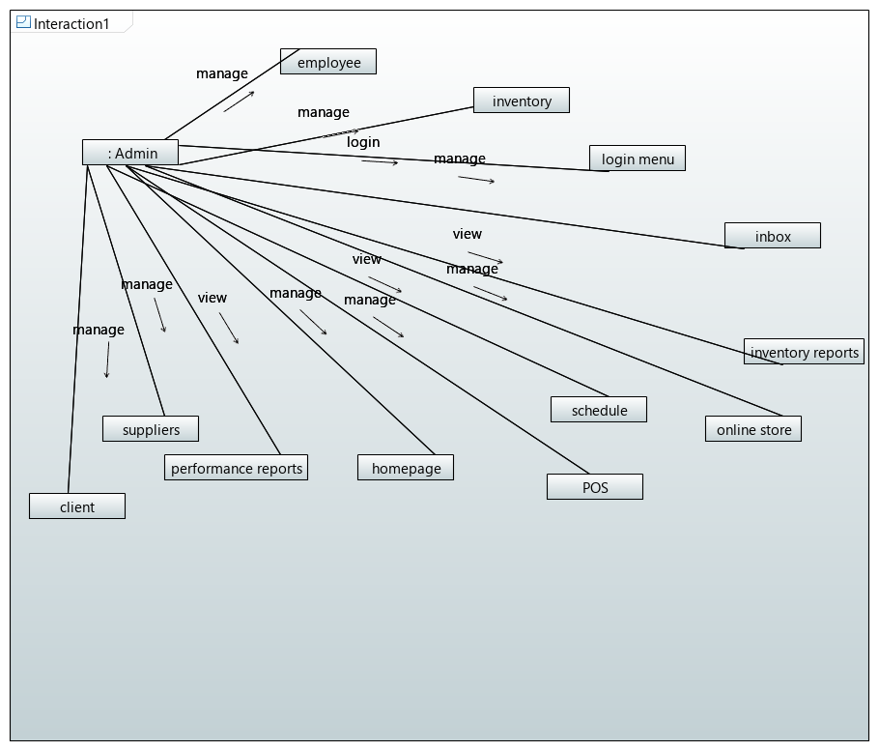

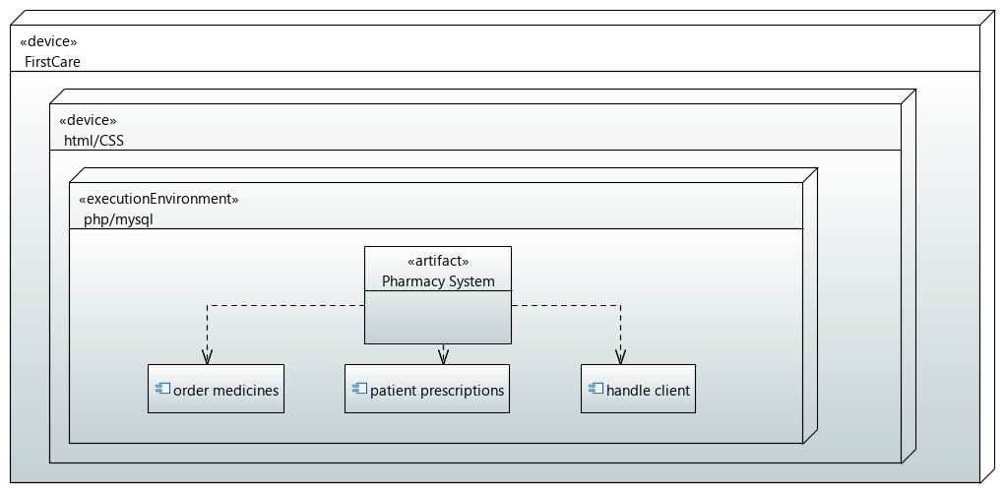

***7. Design Strategy***

**Class Diagram**

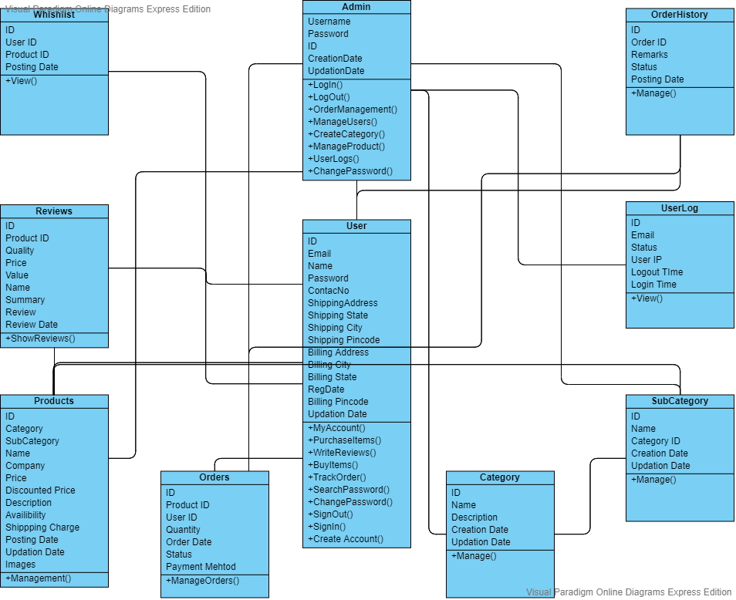

***8. Detailed System Design***

Explained in the video uploaded on drive

<https://drive.google.com/drive/folders/1oKAWAcicVsRgami1cww8YPL7x5DzKc_q?usp=sharing>

C

***8.1. Database Design***

**ERD**

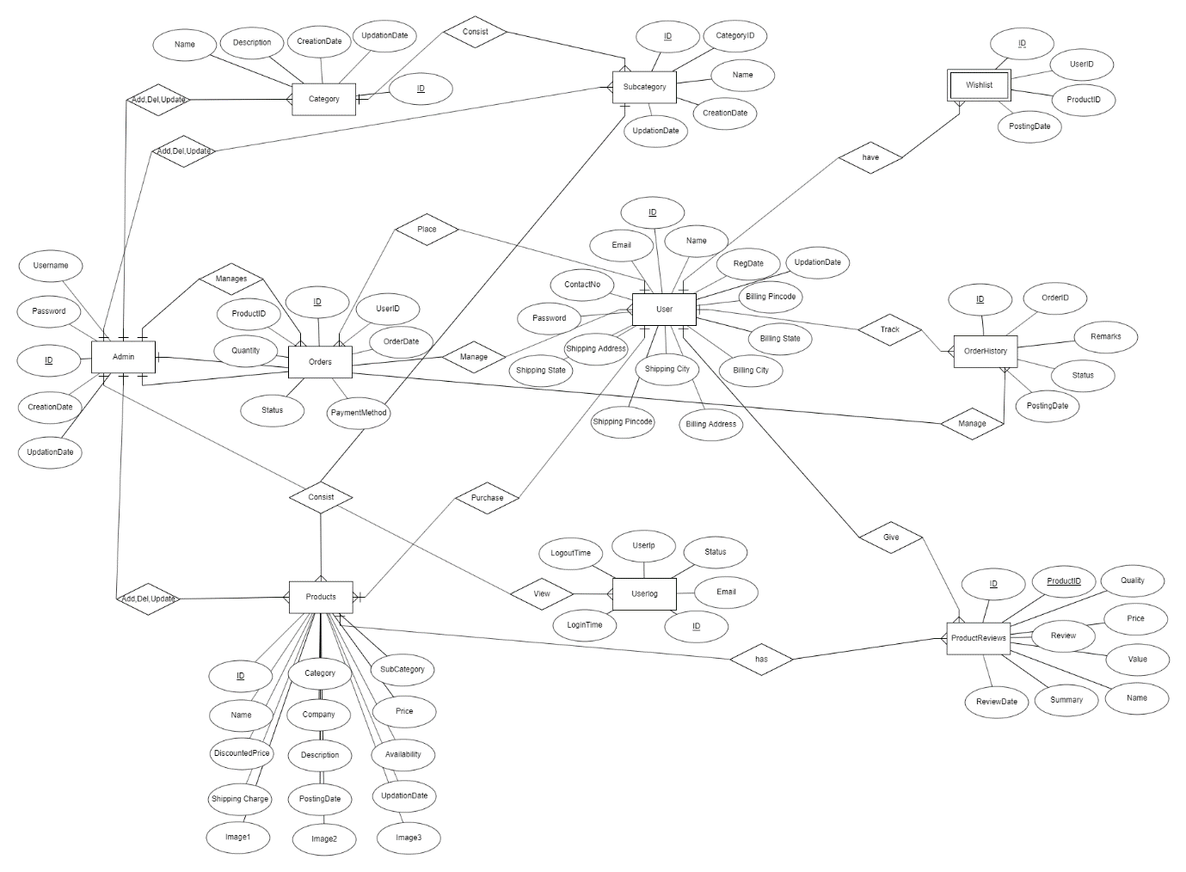

***8.2. Application Design***

***8.2.1 Sequence Diagram***

***8.2.2 State Diagram***

**Admin**

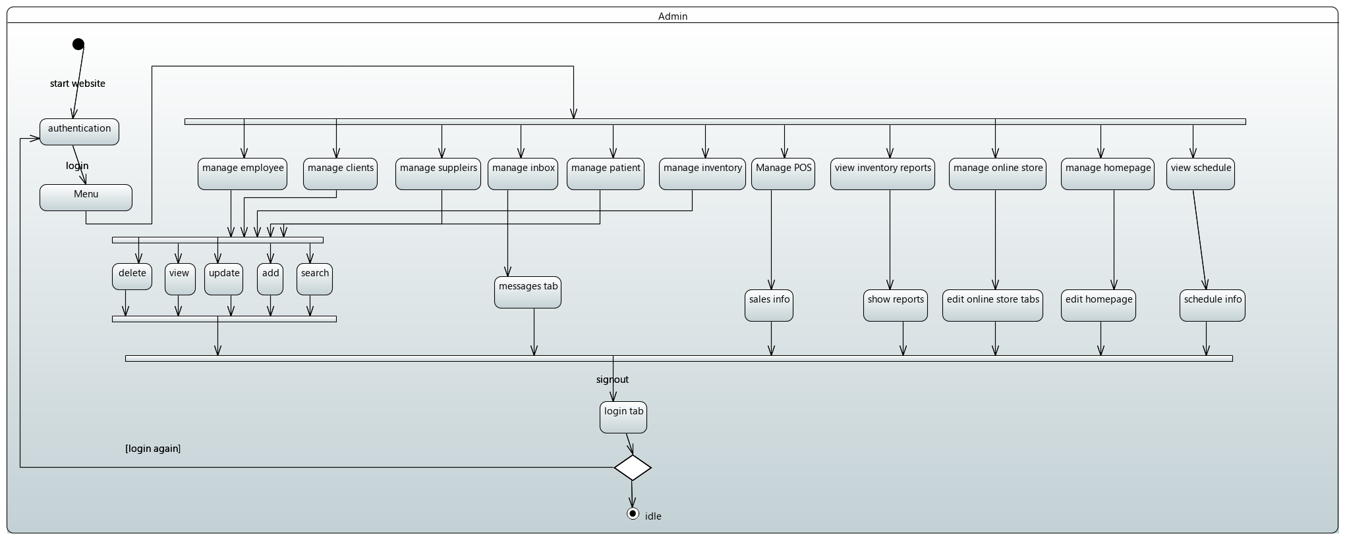

**Customer**

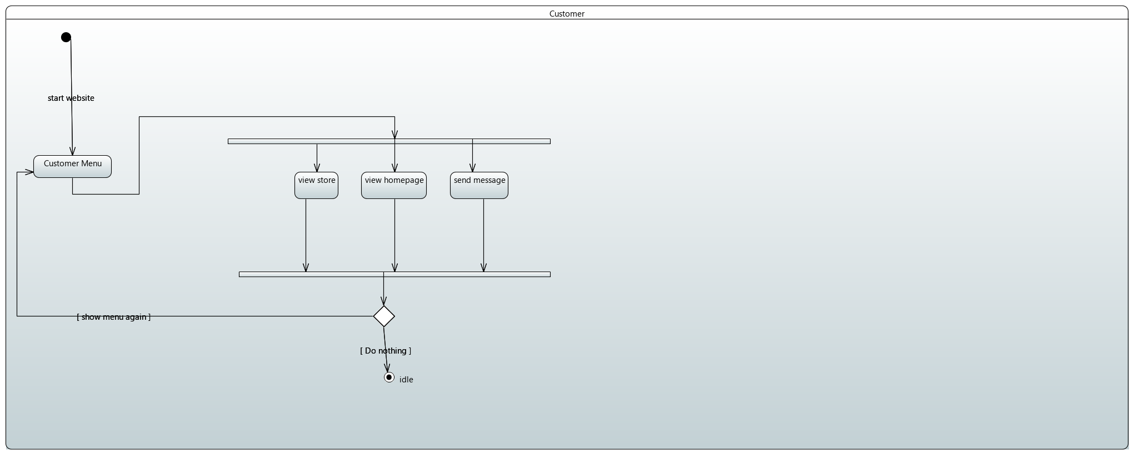

***8.2.3 Activity Diagram***

***9. References***

* [IEEE] The applicable IEEE standards are published in “IEEE Standards Collection,” 2001 edition.
* [Bruade] The principal source of textbook material is “Software Engineering: An Object-Oriented Perspective” by Eric J. Bruade (Wiley 2001).

***10. Appendices***

* <https://dawaai.pk>
* <https://dvago.pk>
* <https://hospitals.aku.edu/pakistan/medical-and-diagnostics/Pages/Pharmacies.aspx>
* <https://www.mckesson.com/Pharmacy-Management/Software/>
* <https://www.bdtask.com/pharmacy-management-system.php>

**\*\*\*\*\*\*\*\*\*\*\*\*\*\*\*\*\*\*\*\*\*\*\*\*\*\*\*\*\*\*\*\*\*\*\*\*\*\*END\*\*\*\***