# Task 1:

## CPs:



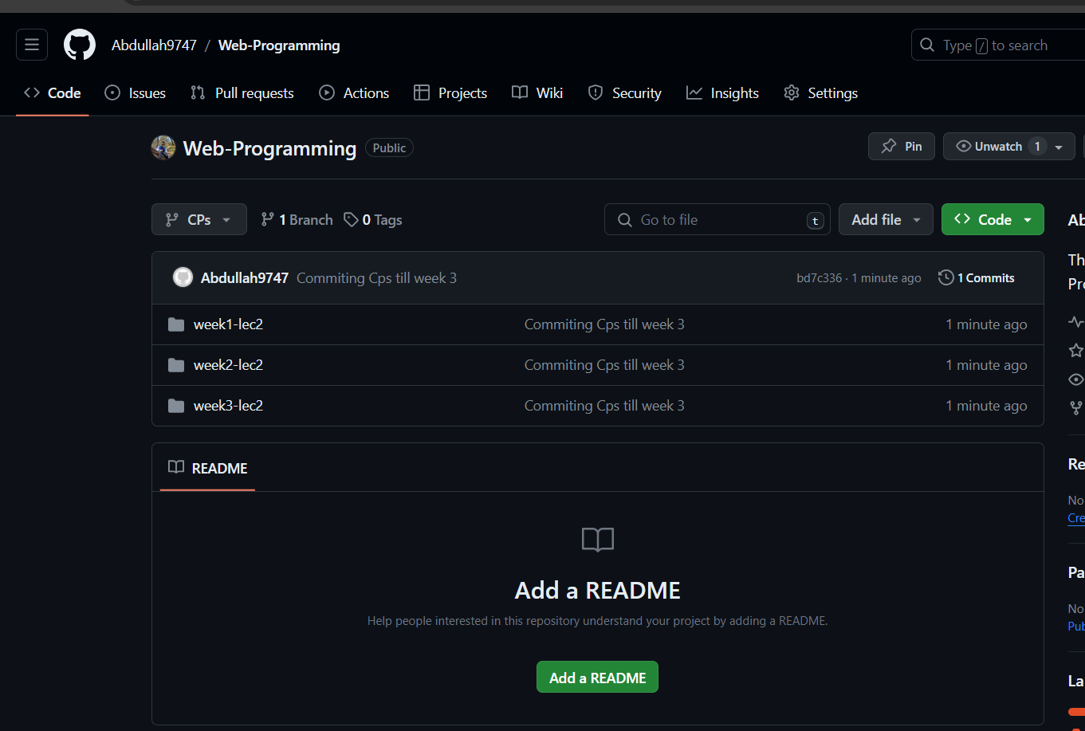

## Assignment 1:





## Assignment 2:

### Task 2:

# Task 2:

## Code:

<!DOCTYPE html>

<html lang="en">

<head>

<meta charset="UTF-8">

<meta name="viewport" content="width=device-width, initial-scale=1.0">

<title>Sign Up</title>

<style>

    body {

        margin: 0;

        padding: 0;

        font-family: Arial, sans-serif;

        display: flex;

        justify-content: center;

        align-items: center;

        height: 100vh;

        background-color: #f0f0f0;

    }

    form {

        background-color: #fff;

        padding: 20px;

        border-radius: 8px;

        box-shadow: 0 0 10px rgba(0, 0, 0, 0.1);

        width: 350px;

        display: flex;

        flex-direction: column;

    }

    form h1 {

        text-align: center;

        margin-bottom: 10px;

    }

    form input[type="text"],

    form input[type="password"],

    form input[type="email"],

    form input[type="tel"],

    form input[type="date"],

    form select {

        margin-bottom: 10px;

        padding: 10px;

        border: 1px solid #ccc;

        border-radius: 5px;

        font-size: 16px;

    }

    form button[type="submit"] {

        background-color: #007bff;

        color: #fff;

        border: none;

        padding: 10px;

        border-radius: 5px;

        cursor: pointer;

        font-size: 16px;

    }

    form button[type="submit"]:hover {

        background-color: #0056b3;

    }

    form label {

        font-weight: bold;

    }

</style>

</head>

<body>

<form id="myform">

    <h1>Sign Up</h1>

    <label for="username">Username</label>

    <input type="text" id="username" name="username" required>

    <label for="password">Password</label>

    <input type="password" id="password" name="password" required>

    <span id="errorMessage" style="color: red;"></span><br>

    <label for="birthdate">Birthdate</label>

    <input type="date" id="birthdate" name="birthdate" required>

    <label for="email">Email</label>

    <input type="text" id="email" name="email" required>

    <span id="emailerror" style="color: red;"></span><br>

    <label for="gender">Gender</label>

    <select id="gender" name="gender" required>

        <option value="male">Male</option>

        <option value="female">Female</option>

        <option value="other">Other</option>

    </select>

    <label for="phonenumber">Phone Number</label>

    <input type="tel" id="phonenumber" name="phonenumber" required>

    <span id="phoneerror" style="color: red;"></span><br>

    <label for="zipcode">Zip Code</label>

    <input type="text" id="zipcode" name="zipcode" required>

    <span id="ziperror" style="color: red;"></span><br>

    <label for="country">Country</label>

    <input type="text" id="country" name="country" required>

    <button type="submit">Submit</button>

</form>

<script>

    document.getElementById('myform').addEventListener('submit',function(event){

        event.preventDefault();

        const passvalue=document.getElementById("password").value;

        const lengthreg=/^.{8,20}$/;

        const patternreg=/^(?=.*[a-z])(?=.*[A-Z])(?=.*\d).+$/;

        if(!lengthreg.test(passvalue)){

            document.getElementById("errorMessage").innerText = "Input must be 8-20 characters long.";

          return;

        }

        if(!patternreg.test(passvalue)){

            document.getElementById("errorMessage").innerText = "Input must contain at least one lowercase letter, one uppercase letter, and one number.";

            return;

        }

        document.getElementById("errorMessage").innerText = "";

        const emailvalue=document.getElementById("email").value;

        const emailreg=/^[^\s@]+@[^\s@]+\.[^\s@]+$/;

        if(!emailreg.test(emailvalue)){

            document.getElementById("emailerror").innerText="Email should be abc@xyz.com"

            return;

        }

        document.getElementById("emailerror").innerText="";

        const phonelen=/^.{11,11}$/;

        const phonereg=/^\d+$/;

        const phonevalue=document.getElementById("phonenumber").value;

        if(!phonelen.test(phonevalue)){

            document.getElementById("phoneerror").innerText="Enter 11 numbers!";

            return;

        }

        document.getElementById("phoneerror").innerText="";

        if(!phonereg.test(phonevalue)){

            document.getElementById("phoneerror").innerText="Enter only numbers!";

            return;

        }

        document.getElementById("phoneerror").innerText="";

        const ziplen=/^.{5,5}$/;

        const zipreg=/^\d+$/;

        const zipvalue=document.getElementById("zipcode").value;

        if(!ziplen.test(zipvalue)){

            document.getElementById("ziperror").innerText="Enter 5 numbers!";

            return;

        }

        document.getElementById("ziperror").innerText="";

        if(!zipreg.test(zipvalue)){

            document.getElementById("ziperror").innerText="Enter only numbers!";

            return;

        }

        document.getElementById("ziperror").innerText="";

    })

</script>

</body>

</html>

## Output:

