# Task 1:

## CPs:

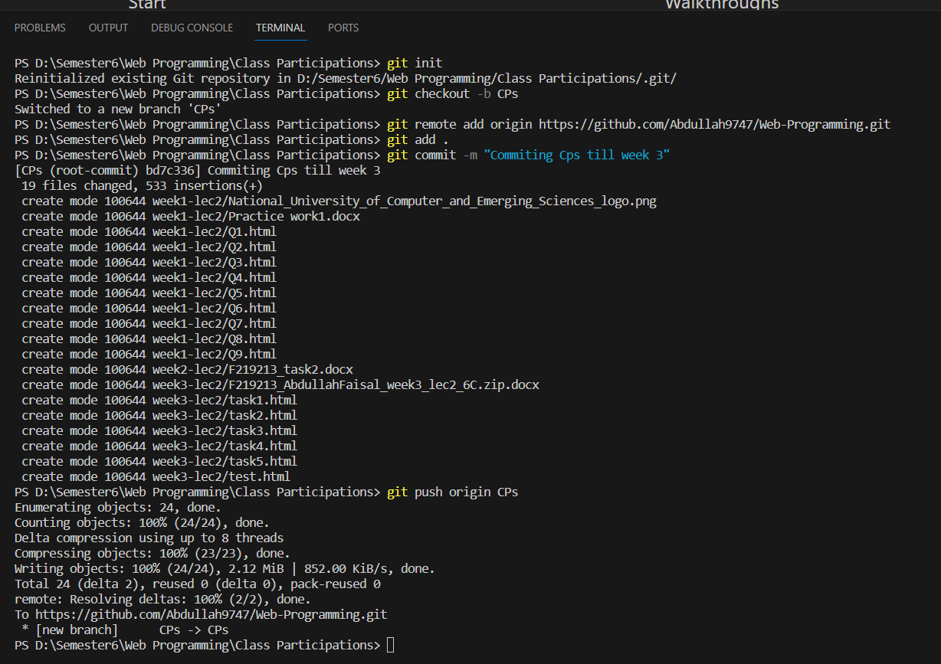

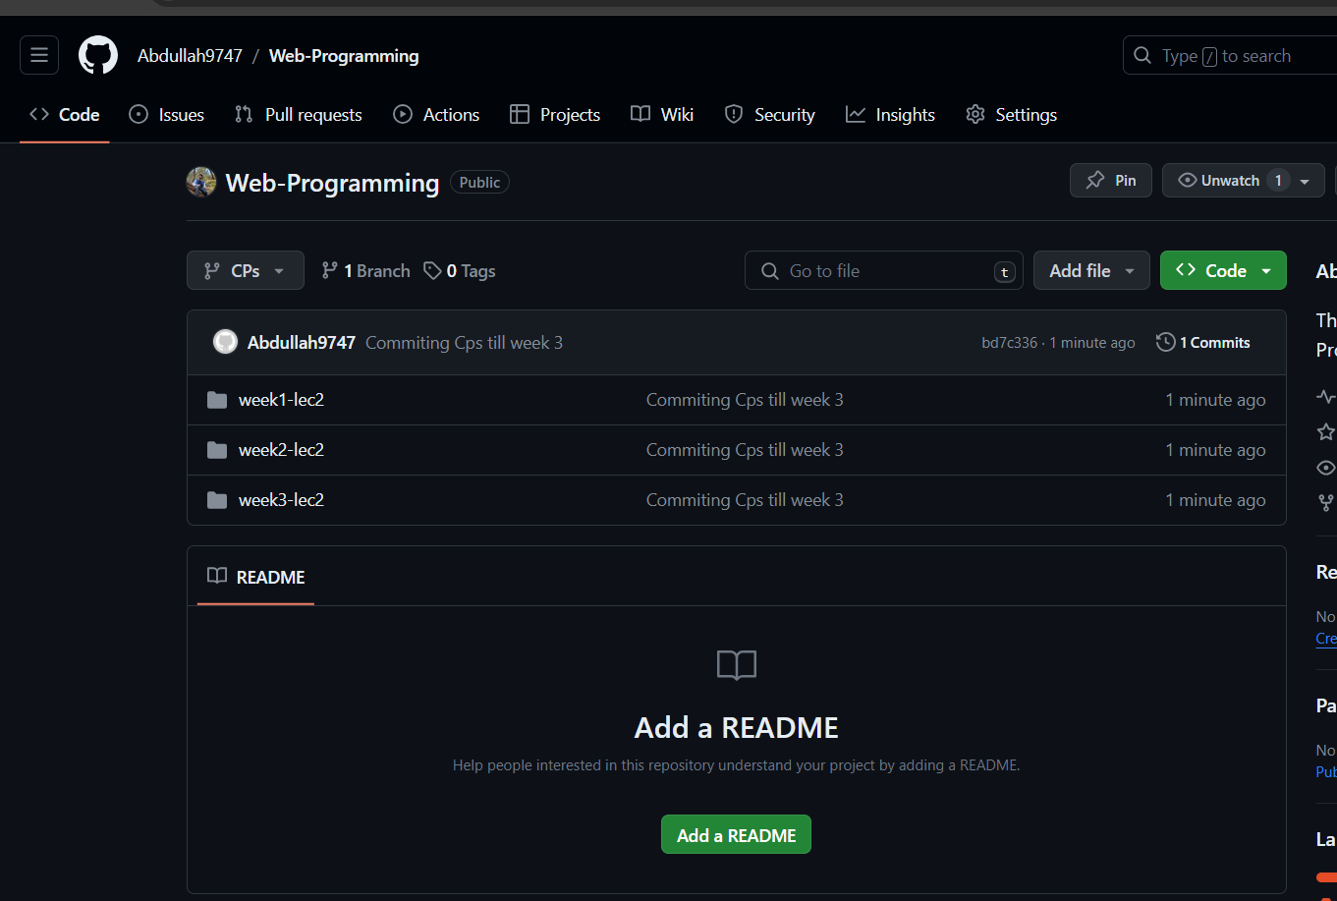

## Assignment 1:

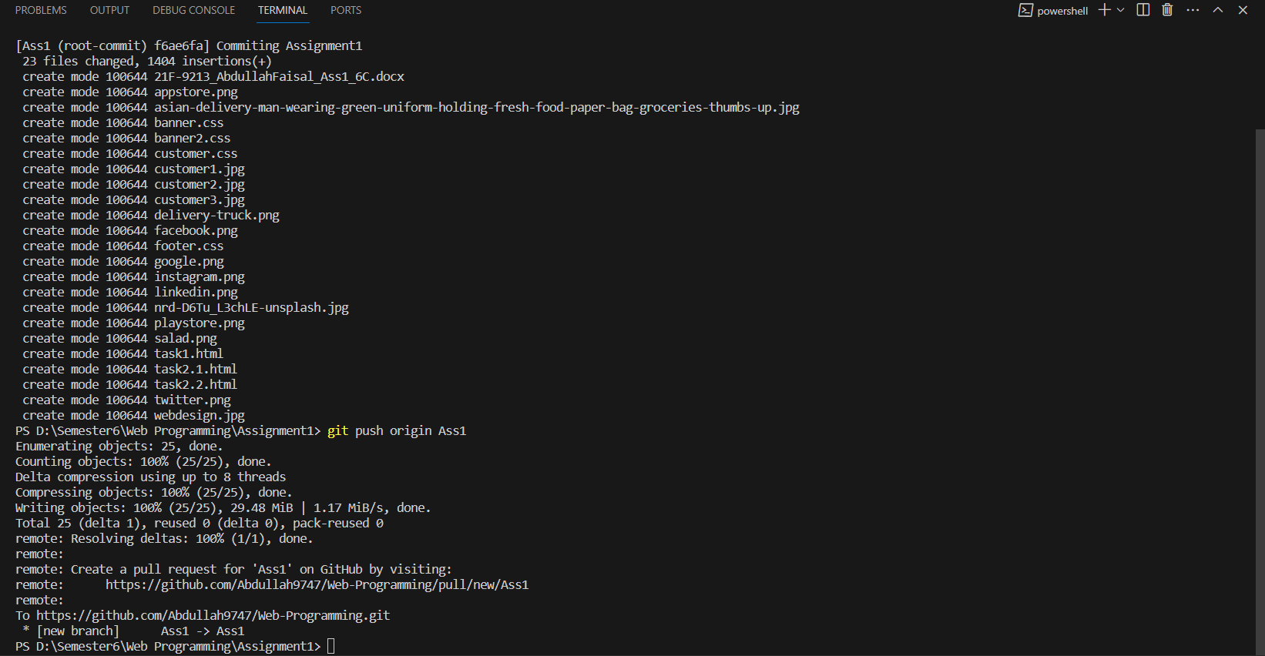

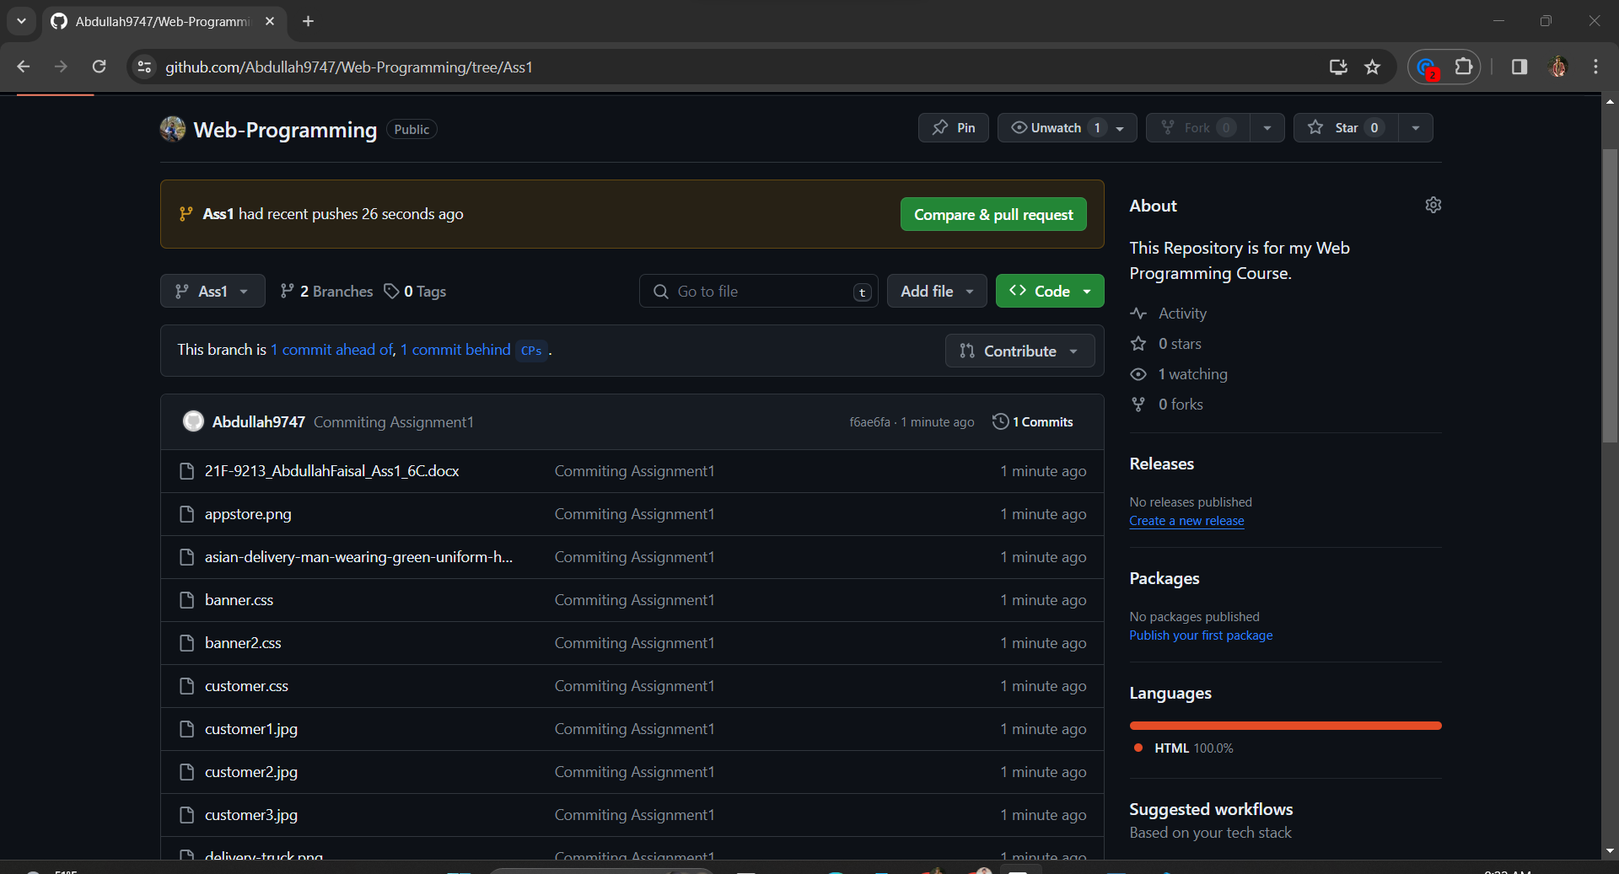

## Assignment 2:

### Task 2:

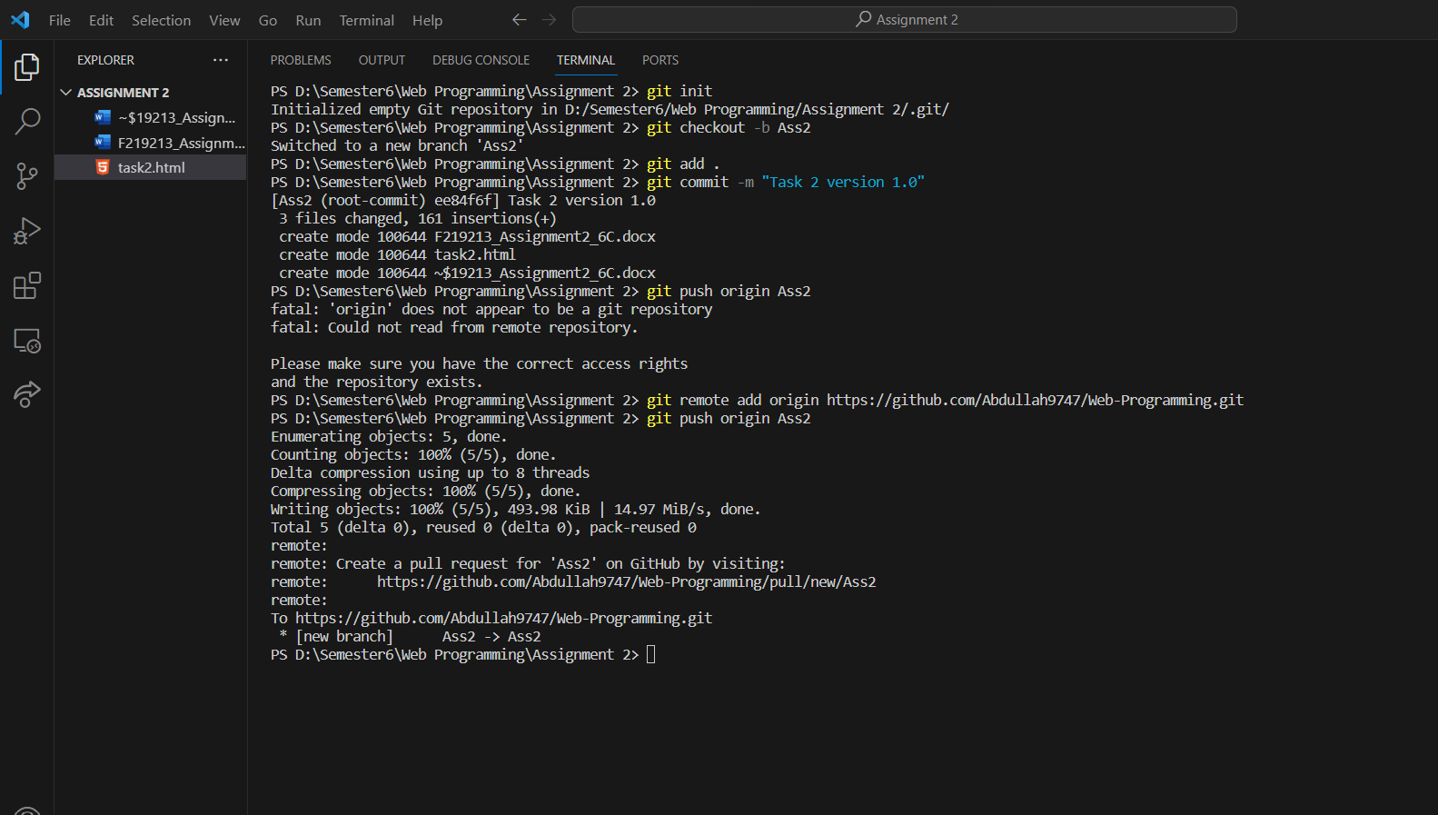

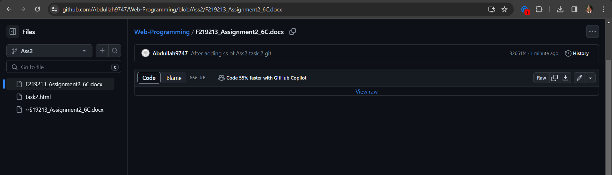

### Task 3:

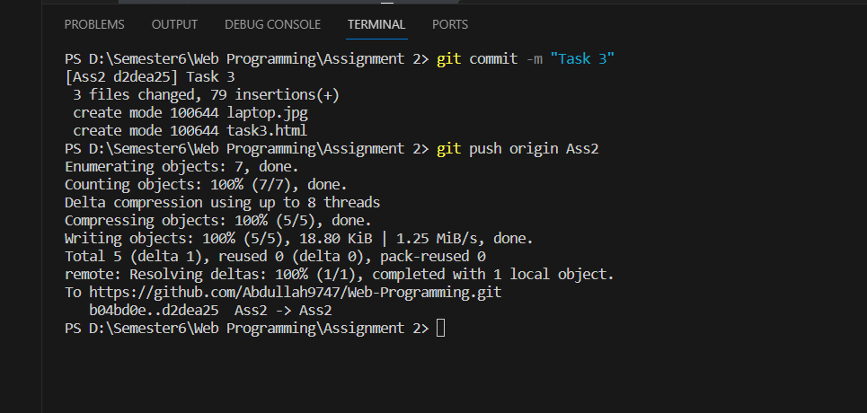

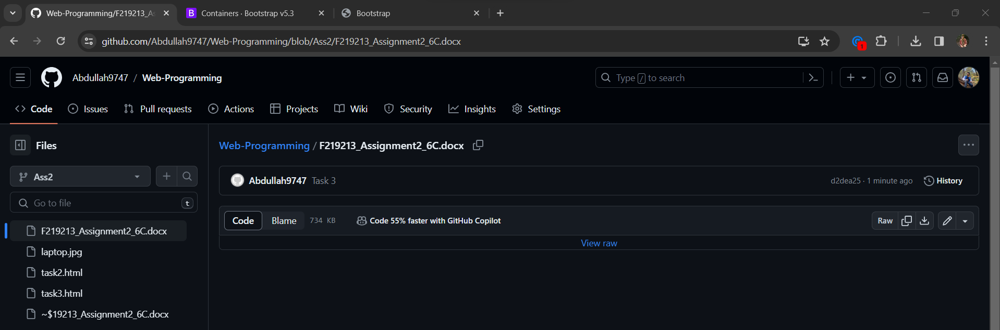

# Task 2:

## Code:

<!DOCTYPE html>

<html lang="en">

<head>

<meta charset="UTF-8">

<meta name="viewport" content="width=device-width, initial-scale=1.0">

<title>Sign Up</title>

<style>

    body {

        margin: 0;

        padding: 0;

        font-family: Arial, sans-serif;

        display: flex;

        justify-content: center;

        align-items: center;

        height: 100vh;

        background-color: #f0f0f0;

    }

    form {

        background-color: #fff;

        padding: 20px;

        border-radius: 8px;

        box-shadow: 0 0 10px rgba(0, 0, 0, 0.1);

        width: 350px;

        display: flex;

        flex-direction: column;

    }

    form h1 {

        text-align: center;

        margin-bottom: 10px;

    }

    form input[type="text"],

    form input[type="password"],

    form input[type="email"],

    form input[type="tel"],

    form input[type="date"],

    form select {

        margin-bottom: 10px;

        padding: 10px;

        border: 1px solid #ccc;

        border-radius: 5px;

        font-size: 16px;

    }

    form button[type="submit"] {

        background-color: #007bff;

        color: #fff;

        border: none;

        padding: 10px;

        border-radius: 5px;

        cursor: pointer;

        font-size: 16px;

    }

    form button[type="submit"]:hover {

        background-color: #0056b3;

    }

    form label {

        font-weight: bold;

    }

</style>

</head>

<body>

<form id="myform">

    <h1>Sign Up</h1>

    <label for="username">Username</label>

    <input type="text" id="username" name="username" required>

    <label for="password">Password</label>

    <input type="password" id="password" name="password" required>

    <span id="errorMessage" style="color: red;"></span><br>

    <label for="birthdate">Birthdate</label>

    <input type="date" id="birthdate" name="birthdate" required>

    <label for="email">Email</label>

    <input type="text" id="email" name="email" required>

    <span id="emailerror" style="color: red;"></span><br>

    <label for="gender">Gender</label>

    <select id="gender" name="gender" required>

        <option value="male">Male</option>

        <option value="female">Female</option>

        <option value="other">Other</option>

    </select>

    <label for="phonenumber">Phone Number</label>

    <input type="tel" id="phonenumber" name="phonenumber" required>

    <span id="phoneerror" style="color: red;"></span><br>

    <label for="zipcode">Zip Code</label>

    <input type="text" id="zipcode" name="zipcode" required>

    <span id="ziperror" style="color: red;"></span><br>

    <label for="country">Country</label>

    <input type="text" id="country" name="country" required>

    <button type="submit">Submit</button>

</form>

<script>

    document.getElementById('myform').addEventListener('submit',function(event){

        event.preventDefault();

        const passvalue=document.getElementById("password").value;

        const lengthreg=/^.{8,20}$/;

        const patternreg=/^(?=.*[a-z])(?=.*[A-Z])(?=.*\d).+$/;

        if(!lengthreg.test(passvalue)){

            document.getElementById("errorMessage").innerText = "Input must be 8-20 characters long.";

          return;

        }

        if(!patternreg.test(passvalue)){

            document.getElementById("errorMessage").innerText = "Input must contain at least one lowercase letter, one uppercase letter, and one number.";

            return;

        }

        document.getElementById("errorMessage").innerText = "";

        const emailvalue=document.getElementById("email").value;

        const emailreg=/^[^\s@]+@[^\s@]+\.[^\s@]+$/;

        if(!emailreg.test(emailvalue)){

            document.getElementById("emailerror").innerText="Email should be abc@xyz.com"

            return;

        }

        document.getElementById("emailerror").innerText="";

        const phonelen=/^.{11,11}$/;

        const phonereg=/^\d+$/;

        const phonevalue=document.getElementById("phonenumber").value;

        if(!phonelen.test(phonevalue)){

            document.getElementById("phoneerror").innerText="Enter 11 numbers!";

            return;

        }

        document.getElementById("phoneerror").innerText="";

        if(!phonereg.test(phonevalue)){

            document.getElementById("phoneerror").innerText="Enter only numbers!";

            return;

        }

        document.getElementById("phoneerror").innerText="";

        const ziplen=/^.{5,5}$/;

        const zipreg=/^\d+$/;

        const zipvalue=document.getElementById("zipcode").value;

        if(!ziplen.test(zipvalue)){

            document.getElementById("ziperror").innerText="Enter 5 numbers!";

            return;

        }

        document.getElementById("ziperror").innerText="";

        if(!zipreg.test(zipvalue)){

            document.getElementById("ziperror").innerText="Enter only numbers!";

            return;

        }

        document.getElementById("ziperror").innerText="";

    })

</script>

</body>

</html>

## Output:

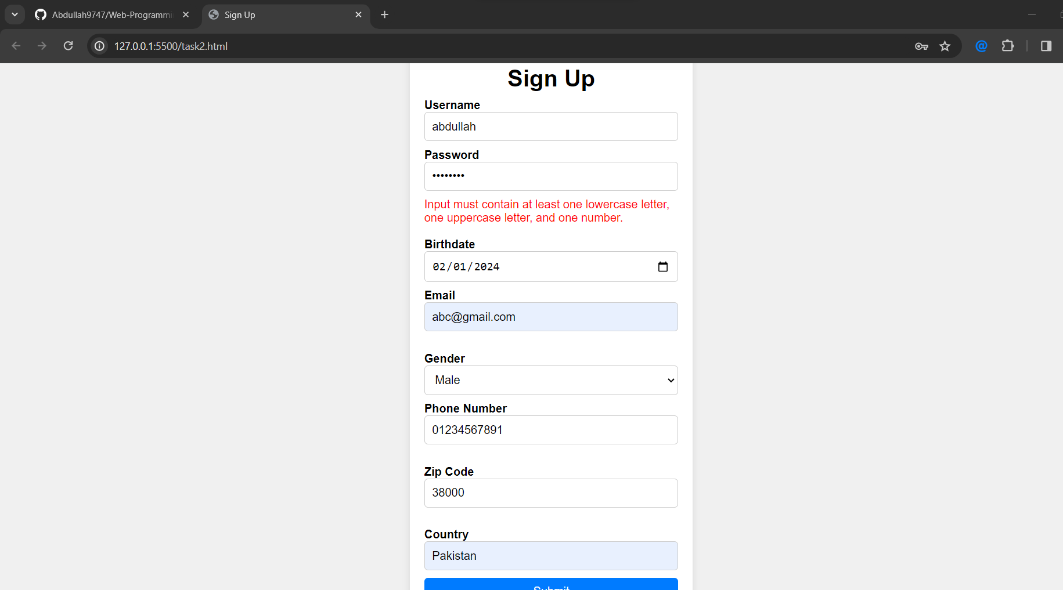

# Task 3:

## Code:

<!DOCTYPE html>

<html lang="en">

<head>

    <meta charset="UTF-8">

    <meta name="viewport" content="width=device-width, initial-scale=1.0">

    <title>Bootstrap</title>

    <link href="https://cdn.jsdelivr.net/npm/bootstrap@5.3.3/dist/css/bootstrap.min.css" rel="stylesheet" integrity="sha384-QWTKZyjpPEjISv5WaRU9OFeRpok6YctnYmDr5pNlyT2bRjXh0JMhjY6hW+ALEwIH" crossorigin="anonymous">

    <style>

        .top {

            background-color: rgb(208, 205, 205);

            border: 1px solid black;

            margin: 10px 10px;

            margin-bottom: 5px;

            padding-top: 2em;

            padding-bottom: 2em;

            display: flex;

            justify-content: center;

            align-items: center;

            flex-direction: column;

            overflow: auto;

        }

        #learnbtn{

            align-self:stretch;

            overflow: auto;

        }

       .container-xxl{

        overflow: auto;

       }

       .foot{

        display: flex;

        justify-content: center;

        align-items: center;

        padding: 5px;

        background-color: rgb(170, 255, 190);

       }

    </style>

</head>

<body>

    <div class="container-xxl">

        <div class="row">

            <div class="col top">

                <h2>Welcome to Our Website!</h2>

                <h3>Look at this button! Wow, let's click on it!</h3>

                <button class="btn btn-primary btn-block" id="learnbtn">Learn More</button>

            </div>

        </div>

    </div>

    <div class="container-xxl">

        <hr class="my-4">

    </div>

    <div class="container-xxl">

        <div class="row">

            <div class="col">

                <h3 style="display: inline-block;">Let's look at some random pictures!</h3> <span style="font-size:large;">from http://lorempixel.com</span>

            </div>

        </div>

        <div class="row">

            <div class="col mid1" style="margin-bottom: 10px;">

                Lorem ipsum dolor sit amet consectetur adipisicing elit. Odio cupiditate earum modi maiores magni, recusandae minima illum iure, omnis labore ipsum quisquam? Delectus officia autem aspernatur sunt animi dolore inventore amet magnam exercitationem eius? Cum maxime sapiente praesentium ad. Ipsum nihil cum veritatis dolorem nulla assumenda quae ipsam, modi incidunt.<br>

                <img src="./laptop.jpg" alt="NOt loaded" height="25%" width="50%">

            </div>

            <div class="col mid2"  style="margin-bottom: 10px;">

                Lorem ipsum dolor sit amet consectetur adipisicing elit. Odio cupiditate earum modi maiores magni, recusandae minima illum iure, omnis labore ipsum quisquam? Delectus officia autem aspernatur sunt animi dolore inventore amet magnam exercitationem eius? Cum maxime sapiente praesentium ad. Ipsum nihil cum veritatis dolorem nulla assumenda quae ipsam, modi incidunt.<br>

                <img src="./laptop.jpg" alt="NOt loaded" height="25%" width="50%">

            </div>

            <div class="col mid3" style="margin-bottom: 10px;">

                Lorem ipsum dolor sit amet consectetur adipisicing elit. Odio cupiditate earum modi maiores magni, recusandae minima illum iure, omnis labore ipsum quisquam? Delectus officia autem aspernatur sunt animi dolore inventore amet magnam exercitationem eius? Cum maxime sapiente praesentium ad. Ipsum nihil cum veritatis dolorem nulla assumenda quae ipsam, modi incidunt.<br>

                <img src="./laptop.jpg" alt="NOt loaded" height="25%" width="50%">

            </div>

        </div>

    </div>

    <div class="container-xxl">

        <hr class="my-3">

    </div>

    <div class="container-xxl foot"><span>Thanks for Visiting!</span></div>

    <script src="https://cdn.jsdelivr.net/npm/bootstrap@5.3.3/dist/js/bootstrap.bundle.min.js" integrity="sha384-YvpcrYf0tY3lHB60NNkmXc5s9fDVZLESaAA55NDzOxhy9GkcIdslK1eN7N6jIeHz" crossorigin="anonymous"></script>

</body>

</html>

## Output:

