# Task 1:

<!DOCTYPE html>

<html lang="en">

<head>

    <meta charset="UTF-8">

    <meta name="viewport" content="width=\, initial-scale=1.0">

    <title>Task 1</title>

    <link href="https://cdn.jsdelivr.net/npm/bootstrap@5.3.2/dist/css/bootstrap.min.css" rel="stylesheet" integrity="sha384-T3c6CoIi6uLrA9TneNEoa7RxnatzjcDSCmG1MXxSR1GAsXEV/Dwwykc2MPK8M2HN" crossorigin="anonymous">

    <style>

        .atag{

            text-decoration: none;

            color: black;

        }

        .box1{

            background-color: rgb(43, 193, 93);

            border-bottom:1px solid black;

        }

        .box2{

            background-color: rgb(137, 216, 226);

            border: 2px;

            border-bottom:1px solid black;

        }

        .box3,.box4{

            background-color: rgb(233, 238, 139);

            border: 2px;

            border-bottom:1px solid black;

        }

        .box5,.box6{

            background-color: rgb(242, 166, 166);

            border: 2px;

            border-bottom:1px solid black;

        }

    </style>

</head>

<body>

     <div class="container-fluid box1" ><a href="https://www.w3schools.com/bootstrap/bootstrap_ver.asp" class="atag">Feel good about bootstrap</a></div>

     <div class="container-fluid box2" ><a href="https://www.w3schools.com/bootstrap/bootstrap_ver.asp" class="atag">Feel good about bootstrap</a></div>

     <div class="container-fluid box3" ><a href="https://www.w3schools.com/bootstrap/bootstrap_ver.asp" class="atag">Feel good about bootstrap</a></div>

     <div class="container-fluid box4" ><a href="https://www.w3schools.com/bootstrap/bootstrap_ver.asp" class="atag">Feel good about bootstrap</a></div>

     <div class="container-fluid box5" ><a href="https://www.w3schools.com/bootstrap/bootstrap_ver.asp" class="atag">Feel good about bootstrap</a></div>

     <div class="container-fluid box6" ><a href="https://www.w3schools.com/bootstrap/bootstrap_ver.asp" class="atag">Feel good about bootstrap</a></div>

    <script src="https://cdn.jsdelivr.net/npm/bootstrap@5.3.2/dist/js/bootstrap.bundle.min.js" integrity="sha384-C6RzsynM9kWDrMNeT87bh95OGNyZPhcTNXj1NW7RuBCsyN/o0jlpcV8Qyq46cDfL" crossorigin="anonymous"></script>

</body>

</html>

## Output:

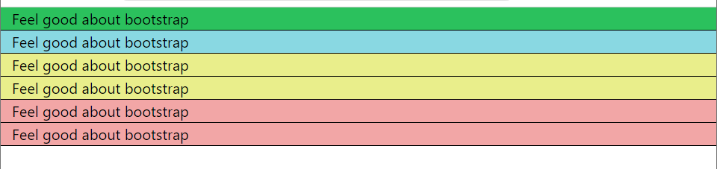

# Task 2:

<!DOCTYPE html>

<html lang="en">

<head>

    <meta charset="UTF-8">

    <meta name="viewport" content="width=device-width, initial-scale=1.0">

    <title>Task 2</title>

    <link href="https://cdn.jsdelivr.net/npm/bootstrap@5.3.2/dist/css/bootstrap.min.css" rel="stylesheet" integrity="sha384-T3c6CoIi6uLrA9TneNEoa7RxnatzjcDSCmG1MXxSR1GAsXEV/Dwwykc2MPK8M2HN" crossorigin="anonymous">

</head>

<body>

    <h1>Button Styles</h1>

     <button type="button" class="btn btn-light" id="basic">Basic</button>

     <button type="button" class="btn btn-secondary" id="default">Default</button>

     <button type="button" class="btn btn-primary" id="primary">Primary</button>

     <button type="button" class="btn btn-success" id="success">Success</button>

     <button type="button" class="btn btn-info" id="info">Info</button>

     <button type="button" class="btn btn-warning" id="warning">Warning</button>

     <button type="button" class="btn btn-danger" id="danger">Danger</button>

     <button type="button" class="btn btn-link" id="link">Link</button>

     <script>

var basicbtn=document.getElementById('basic');

basicbtn.addEventListener('click',function(){

    alert("Basic Button Clicked!")

})

var defaultbtn=document.getElementById('default');

defaultbtn.addEventListener('click',function(){

    alert('Default Button cliked')

})

var primarybtn=document.getElementById('primary');

primarybtn.addEventListener('click',function(){

    alert('primary Button cliked')

})

var success=document.getElementById('success');

success.addEventListener('click',function(){

    alert('Success Button cliked')

})

var info=document.getElementById('info');

info.addEventListener('click',function(){

    alert('info Button cliked')

})

var warning=document.getElementById('warning');

warning.addEventListener('click',function(){

    alert('warning Button cliked')

})

var danger=document.getElementById('danger');

danger.addEventListener('click',function(){

    alert('danger Button cliked')

})

var link=document.getElementById('link');

link.addEventListener('click',function(){

    alert('link Button cliked')

})

     </script>

    <script src="https://cdn.jsdelivr.net/npm/bootstrap@5.3.2/dist/js/bootstrap.bundle.min.js" integrity="sha384-C6RzsynM9kWDrMNeT87bh95OGNyZPhcTNXj1NW7RuBCsyN/o0jlpcV8Qyq46cDfL" crossorigin="anonymous"></script>

</body>

</html>

## Output:

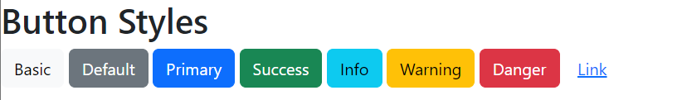

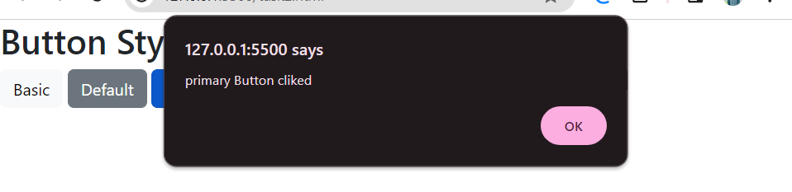

# Task 3:

<!DOCTYPE html>

<html lang="en">

<head>

    <meta charset="UTF-8">

    <meta name="viewport" content="width=device-width, initial-scale=1.0">

    <title>Task 3</title>

    <link href="https://cdn.jsdelivr.net/npm/bootstrap@5.3.2/dist/css/bootstrap.min.css" rel="stylesheet" integrity="sha384-T3c6CoIi6uLrA9TneNEoa7RxnatzjcDSCmG1MXxSR1GAsXEV/Dwwykc2MPK8M2HN" crossorigin="anonymous">

    <style>

        input{

            padding: 2px;

            margin: 2px;

        }

    </style>

</head>

<body>

    <label for="num1">Num1: </label><input type="number" name="num1" id="num1">

    <br>

    <label for="num2">Num2: </label><input type="number" name="num2" id="num2"><br>

    <button type="button" class="btn btn-primary" style="margin-left: 100px; margin-top: 5px;" onclick="calculate()">Calculate</button>

   <div id="sumResult"></div>

   <div id="subResult"></div>

   <div id="mulResult"></div>

   <div id="divResult"></div>

    <script>

       function calculate(){

         var num1=document.getElementById('num1').value;

         var num2=document.getElementById('num2').value;

         var number1=parseInt(num1);

         var number2=parseInt(num2);

         if(isNaN(number1)||isNaN(number2)){

            alert('Enter Valid numbers !');

            return;

         }

         var sum=number1+number2;

         var sub=number1-number2;

         var mul=number1*number2;

         var div=number1/number2;

         var sumResultdiv=document.getElementById('sumResult');

       sumResultdiv.innerText='The Sum is '+sum;

       var subResultdiv=document.getElementById('subResult');

       subResultdiv.innerText='The Difference is '+sub;

       var mulResultdiv=document.getElementById('mulResult');

       mulResultdiv.innerText='The Product is '+mul;

       var divResultdiv=document.getElementById('divResult');

       divResultdiv.innerText='The division is '+div;

       }

    </script>

    <script src="https://cdn.jsdelivr.net/npm/bootstrap@5.3.2/dist/js/bootstrap.bundle.min.js" integrity="sha384-C6RzsynM9kWDrMNeT87bh95OGNyZPhcTNXj1NW7RuBCsyN/o0jlpcV8Qyq46cDfL" crossorigin="anonymous"></script>

</body>

</html>

## Output:

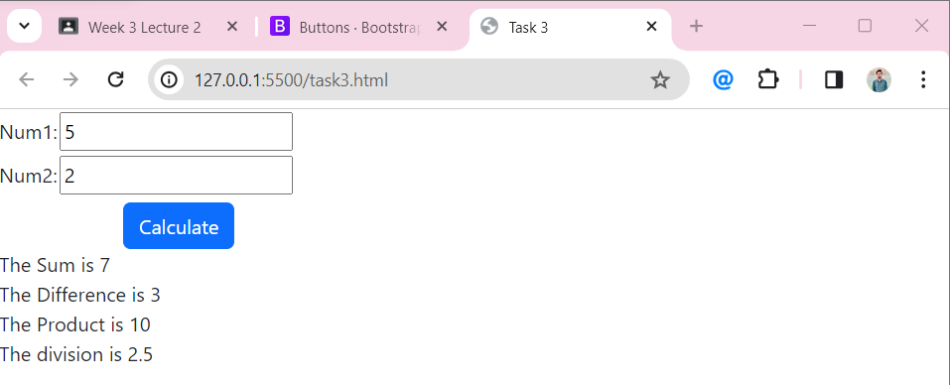

# Task 4:

<!DOCTYPE html>

<html lang="en">

<head>

    <meta charset="UTF-8">

    <meta name="viewport" content="width=device-width, initial-scale=1.0">

    <title>Month Days</title>

    <style>

        #days{

            background-color: red;

        }

    </style>

</head>

<body>

    <label for="monthInput">Enter the name of the month:</label>

    <input type="text" id="monthInput">

    <button onclick="displayMonthDays()">Display Days</button>

    <div id="result"></div>

    <script>

        function displayMonthDays() {

            var monthInput = document.getElementById('monthInput').value;

            var monthName = monthInput.toLowerCase();

            var daysInMonth;

            switch (monthName) {

                case 'jan':

                case 'mar':

                case 'may':

                case 'jul':

                case 'aug':

                case 'oct':

                case 'dec':

                    daysInMonth = 31;

                    break;

                case 'apr':

                case 'jun':

                case 'sept':

                case 'nov':

                    daysInMonth = 30;

                    break;

                case 'feb':

                    daysInMonth = 28;

                    break;

                default:

                    daysInMonth = 'Invalid month';

            }

            var resultDiv = document.getElementById('result');

            resultDiv.innerHTML = `Number of days in ${monthInput}: <span style="color: red">${daysInMonth}</span>`;

        }

    </script>

</body>

</html>

## Output:

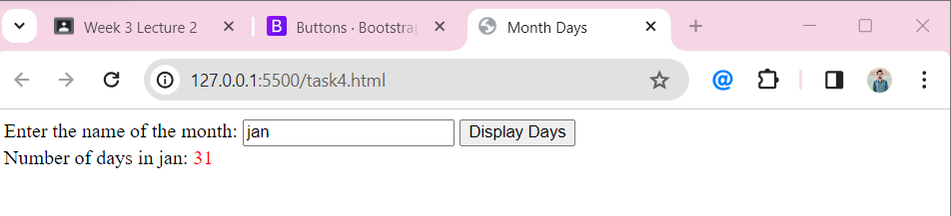

# Task 5:

<!DOCTYPE html>

<html lang="en">

<head>

    <meta charset="UTF-8">

    <meta name="viewport" content="width=device-width, initial-scale=1.0">

    <title>Task 5</title>

    <link href="https://cdn.jsdelivr.net/npm/bootstrap@5.3.2/dist/css/bootstrap.min.css" rel="stylesheet" integrity="sha384-T3c6CoIi6uLrA9TneNEoa7RxnatzjcDSCmG1MXxSR1GAsXEV/Dwwykc2MPK8M2HN" crossorigin="anonymous">

</head>

<body>

    <label for="input" style="margin-right: 5px;">Enter the Number: </label><input type="number" id="number"><br>

    <button type="button" class="btn btn-primary" style="margin-left: 100px; margin-top: 5px;" onclick="calculate()">Calculate</button>

    <div id="result"></div>

    <script>

          function calculate(){

            var num=document.getElementById('number').value;

            var number1=parseInt(num);

            if(isNaN(number1)){

            alert('Enter Valid numbers !');

            return;

         }

         var table=document.getElementById('result');

         table.innerHTML='';

         for(let i=1;i<11;i++){

             table.innerHTML+=`${number1} x ${i} = ${number1*i}<br>`;

         }

          }

    </script>

    <script src="https://cdn.jsdelivr.net/npm/bootstrap@5.3.2/dist/js/bootstrap.bundle.min.js" integrity="sha384-C6RzsynM9kWDrMNeT87bh95OGNyZPhcTNXj1NW7RuBCsyN/o0jlpcV8Qyq46cDfL" crossorigin="anonymous"></script>

</body>

</html>

## Output:

