# Task 1:

<!DOCTYPE html>

<html lang="en">

<head>

    <meta charset="UTF-8">

    <meta name="viewport" content="width=device-width, initial-scale=1.0">

    <title>Document</title>

    <style>

        p{

            /* this is a Css comment */

        }

    </style>

    <script>

        // this is a Javascript comment

    </script>

</head>

<body>

    <!-- this is a Html comment -->

    <p></p>

</body>

</html>

# Task 2:

## Using downloaded file:

<!DOCTYPE html>

<html lang="en">

<head>

    <meta charset="UTF-8">

    <meta name="viewport" content="width=device-width, initial-scale=1.0">

    <title>Document</title>

    <script src="./jquery-3.7.1.js"></script>

</head>

<body>

    <script>

        alert("Welcome to JQUERY");

    </script>

</body>

</html>

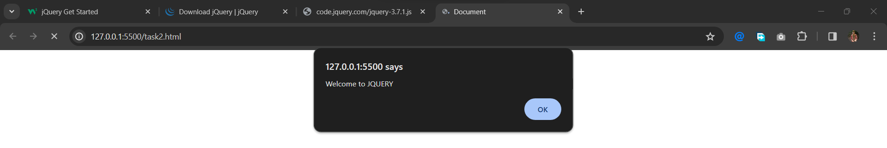

## Using CDN:

<!DOCTYPE html>

<html lang="en">

<head>

    <meta charset="UTF-8">

    <meta name="viewport" content="width=device-width, initial-scale=1.0">

    <title>Document</title>

    <script src="https://code.jquery.com/jquery-3.7.1.js" integrity="sha256-eKhayi8LEQwp4NKxN+CfCh+3qOVUtJn3QNZ0TciWLP4=" crossorigin="anonymous"></script>

</head>

<body>

    <script>

        alert("Welcome to Jquery");

    </script>

</body>

</html>

## 

# Task 3:

<!DOCTYPE html>

<html lang="en">

<head>

    <meta charset="UTF-8">

    <meta name="viewport" content="width=device-width, initial-scale=1.0">

    <title>Task 3</title>

    <script src="https://code.jquery.com/jquery-3.7.1.js" integrity="sha256-eKhayi8LEQwp4NKxN+CfCh+3qOVUtJn3QNZ0TciWLP4=" crossorigin="anonymous"></script>

</head>

<body>

    <img src="./laptop.jpg" alt="Image not loaded" id="img1">

    <button id="btn1">Hide</button>

    <script>

        $(document).ready(function(){

            $("#btn1").click(function(){

                $("#img1").toggle(2000);

                $(this).text(function(i,text){

                    return text==="Hide"?"Show":"Hide";

                })

            })

        })

    </script>

</body>

</html>

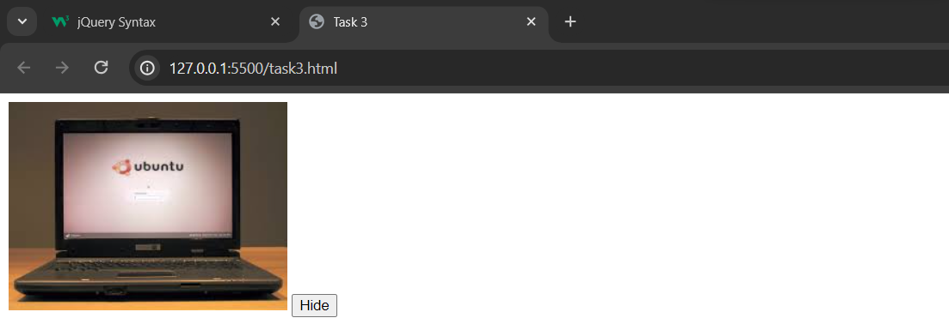

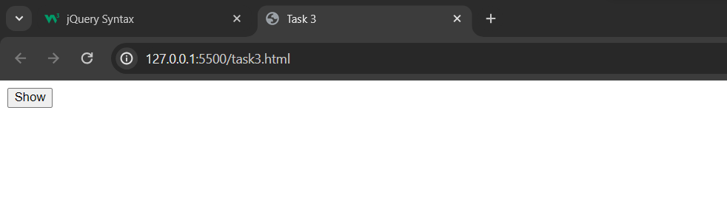

# Task 4:

<!DOCTYPE html>

<html lang="en">

<head>

    <meta charset="UTF-8">

    <meta name="viewport" content="width=device-width, initial-scale=1.0">

    <title>Task 4</title>

    <script src="https://code.jquery.com/jquery-3.7.1.js" integrity="sha256-eKhayi8LEQwp4NKxN+CfCh+3qOVUtJn3QNZ0TciWLP4=" crossorigin="anonymous"></script>

    <style>

        table{

            border-collapse: collapse;

            border: 2px solid black;

        }

        td, th {

        border: 1px solid black;

        padding: 8px;

        text-align: center;

    }

    </style>

</head>

<body>

    <table>

        <tr><td>hello</td></tr>

        <tr><td>world</td></tr>

        <tr id="r3"><td>click this row  to remove</td>

            <td id="r3">hello world </td>

        </tr>

    </table>

    <script>

          $(document).ready(function(){

            $("#r3").click(function(){

                $("#r3").remove();

            });

        });

    </script>

</body>

</html>

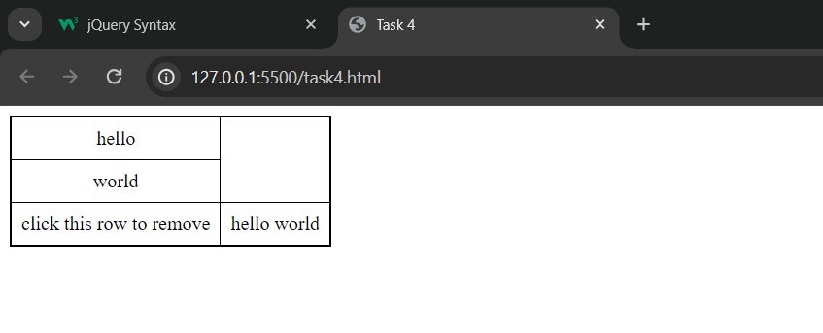

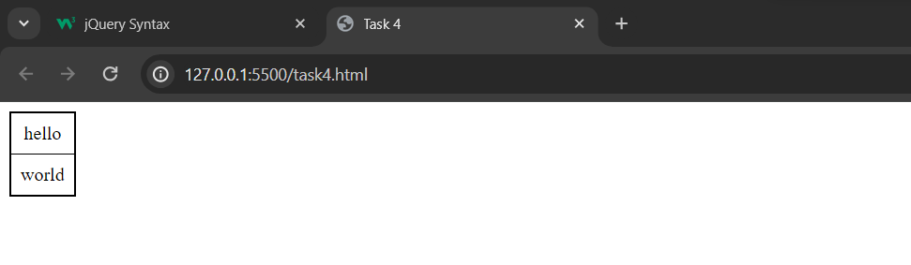

# Task 5:

<!DOCTYPE html>

<html lang="en">

<head>

    <meta charset="UTF-8">

    <meta name="viewport" content="width=device-width, initial-scale=1.0">

    <title>Document</title>

    <script src="https://code.jquery.com/jquery-3.7.1.js" integrity="sha256-eKhayi8LEQwp4NKxN+CfCh+3qOVUtJn3QNZ0TciWLP4=" crossorigin="anonymous"></script>

</head>

<body>

    <div class="container" id="id1">Lorem ipsum dolor sit amet consectetur adipisicing elit. Laboriosam rerum eos repellendus et totam cupiditate ullam, temporibus, repellat animi at esse omnis consequuntur fugiat enim.</div>

    <script>

        $(document).ready(function(){

            $("*").click(function(event){

                event.stopPropagation();

               let id= $(this).attr("id");

               let classname=$(this).attr("class");

               alert("Class : " + classname + "\n" + "ID : " + id);

            })

        })

    </script>

</body>

</html>

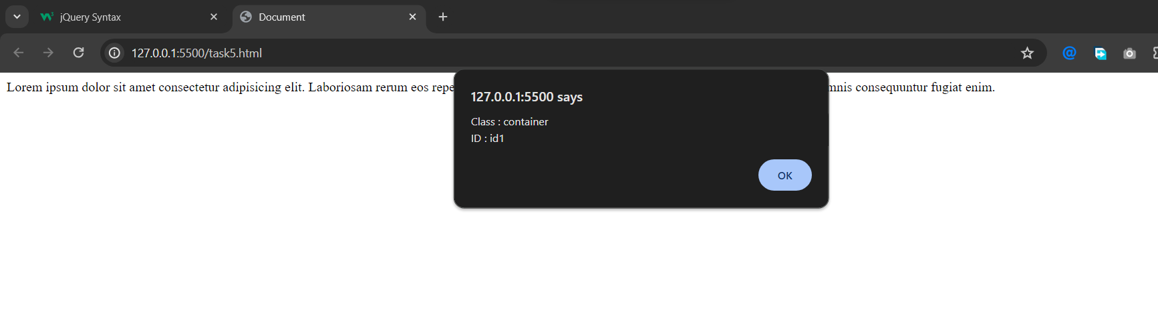

# Task 6:

<!DOCTYPE html>

<html>

<head>

<script src="https://code.jquery.com/jquery-git.js"></script>

<meta charset="utf-8">

<meta name="viewport" content="width=device-width">

<title>Find total width of an element (including width, padding and

border) in jQuery.</title>

<script src="https://code.jquery.com/jquery-3.7.1.js" integrity="sha256-eKhayi8LEQwp4NKxN+CfCh+3qOVUtJn3QNZ0TciWLP4=" crossorigin="anonymous"></script>

<style>

    p {

 padding-top: 50px;

 padding-right: 30px;

 padding-bottom: 50px;

 padding-left: 80px;

}

</style>

</head>

<body>

<p id="myText">jQuery Exercises, Practice, Solution</p>

<script>

    $(document).ready(function(){

        let wid=$("#myText").outerWidth();

        alert("The total width till border is : " + wid);

    })

</script>

</body>

</html>

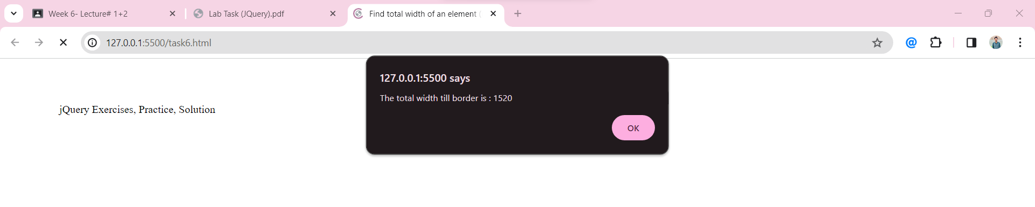

# Task 7:

<!DOCTYPE html>

<html>

<head>

<meta charset="utf-8">

<meta name="viewport" content="width=device-width">

<title>Count child elements using jQuery. </title>

<script src="https://code.jquery.com/jquery-3.7.1.js" integrity="sha256-eKhayi8LEQwp4NKxN+CfCh+3qOVUtJn3QNZ0TciWLP4=" crossorigin="anonymous"></script>

</head>

<body>

<div id="selected">

<p>Red</p>

<p>White</p>

<p>Green</p>

<p>Black</p>

<p>Blue</p>

<p>Orange</p>

</div>

<script>

    $(document).ready(function(){

        let pt=$("p").length;

        alert("No of p tags are : "+pt);

    })

</script>

</body>

</html>

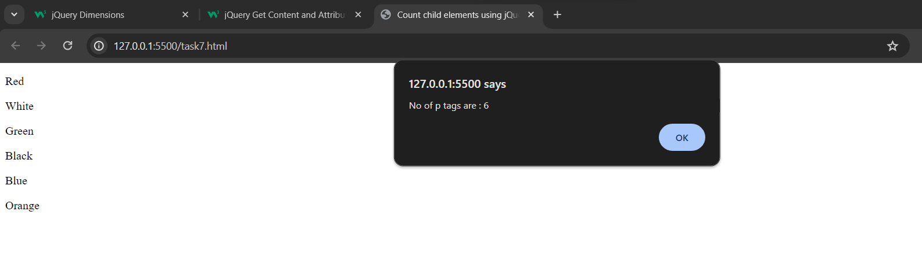

# Task 8:

<!DOCTYPE html>

<html lang="en">

<head>

    <meta charset="UTF-8">

    <meta name="viewport" content="width=device-width, initial-scale=1.0">

    <title>Task 8</title>

    <script src="https://code.jquery.com/jquery-3.7.1.js" integrity="sha256-eKhayi8LEQwp4NKxN+CfCh+3qOVUtJn3QNZ0TciWLP4=" crossorigin="anonymous"></script>

   <style>

    .container{

        height: 250px;

        width: 250px;

        background-color: blue;

        color: white;

        text-align: center;

        line-height: 250px;

        cursor: pointer;

        position: relative;

    }

   </style>

</head>

<body>

    <div class="container">

        click to perform animation

    </div>

    <script>

        $(document).ready(function(){

            $(".container").click(function(){

                $(".container").animate({left:"85%"},8000);

            })

        })

    </script>

</body>

</html>

