

Mini Compiler — Workflow Documentation

Course: Compiler Construction (COMP338)

Group Members:

Abdul Haseeb
2023f-mulbscs-079
Roohan Ahmed
2023f-mulbscs-097
Muhammad Hamza
2023f-mulbscs-075
Zain Ali
2023f-mulbscs-084
Abdullah Ahmed
2023f-mulbscs-166
Shuaib Fakhar
2023f-mulbscs-064

1. Introduction
A Mini Compiler is a simplified version of a compiler that translates source code written in a high-level language into a lower-level language such as assembly, bytecode, or machine code. It implements the core phases of compilation and serves as an educational tool for understanding compiler design and language processing concepts.

2. Abstract:
This project presents the design and implementation of a Mini Compiler that demonstrates the fundamental stages of the compilation process. The compiler processes source code through lexical analysis, syntax analysis, semantic analysis, intermediate code generation, code optimization, and target code generation. Error handling is incorporated throughout each phase to identify and report issues effectively. The project provides a practical understanding of compiler construction and the transformation of source code into executable output.

3. Compiler Flow Chart
The mini compiler processes source code through the following chart:
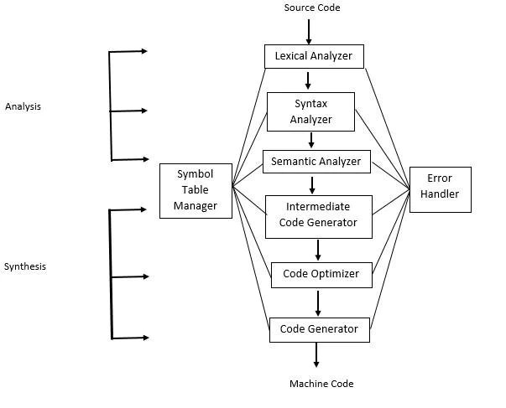

4. Detailed Phase Descriptions

Phase 1 — Lexical Analysis (Lexer)
Input | Raw source code characters
Task | Scans the input character by character and groups them into meaningful tokens
Output | Token stream: INT, ID(x), EQ, NUM(5), PLUS, NUM(3), SEMI
Tools | Regular expressions, finite automata (DFA/NFA)
Errors | Illegal character error — e.g. using @ or # in an unsupported context
Example | int x = 5 + 3; → [INT][ID:x][=][5][+][3][;]

Phase 2 — Syntax Analysis (Parser)
Input | Token stream from the lexer
Task | Checks that the token sequence conforms to the grammar rules of the language
Output | Abstract Syntax Tree (AST) representing the program structure
Tools | Context-Free Grammar (CFG), BNF/EBNF, recursive descent or LR parsing
Errors | Syntax error — e.g. missing semicolon, unmatched parentheses
Example | AST: Assignment → Identifier(x), BinaryOp(+, 5, 3)

Phase 3 — Semantic Analysis
Input | Abstract Syntax Tree (AST)
Task | Verifies the meaning of the program: type checking, scope resolution, declarations
Output | Annotated AST with type information; symbol table populated
Tools | Symbol table (maps identifiers to type/scope), type inference rules
Errors | Type mismatch, undeclared variable, re-declaration in same scope
Symbol Table | x → type: int, scope: local, value: uninitialized

Phase 4 — Intermediate Representation (IR) Generation
Input | Annotated AST
Task | Flattens the AST into a simple, linear sequence of instructions
Output | Three-Address Code (TAC) — each instruction has at most 3 operands
Format | t1 = 5 + 3 | x = t1
Purpose | Platform-independent; makes optimization and code generation easier
Example | t1 = 5 + 3 → stored in temp register t1; then assigned to x

Phase 5 — Optimization (Optional)
Input | IR (three-address code)
Task | Improves efficiency of the IR without changing program behavior
Technique 1 | Constant folding: evaluate constant expressions at compile time (5+3 → 8)
Technique 2 | Dead code elimination: remove unreachable code
Technique 3 | Common subexpression elimination: avoid recomputing the same value
Output | Optimized IR: x = 8 (constant folded)

Phase 6 — Code Generation
Input | Optimized IR (or plain IR if no optimization phase)
Task | Translates IR instructions into target machine instructions or assembly
Output | Assembly code, bytecode, or machine code
Register Alloc. | Maps IR temporaries (t1, t2...) to real CPU registers
Example | MOV eax, 8 | MOV [x], eax
Target | Can target x86, MIPS, or a custom virtual machine / stack machine

5. Error Handling Summary
Each phase of the compiler is responsible for detecting and reporting a specific class of errors. The compiler should report as many errors as possible before stopping.

Phase | Error Type | Example
Lexer | Lexical error | Unrecognized character: @ # $
Parser | Syntax error | Missing semicolon or mismatched brackets
Semantic | Semantic error | Type mismatch: int x = "hello"
Code Gen | Runtime error | Division by zero (if checked)

6. Mini Compiler Workflow:
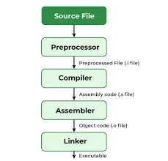

7. Data Flow Diagram:

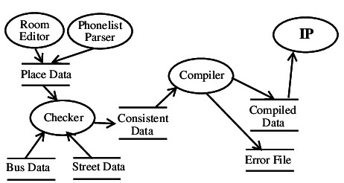

8. Conclusion
A mini compiler is an excellent project for understanding the full lifecycle of program translation. By implementing all six phases — from lexical analysis to code generation — students gain hands-on experience with formal languages, grammars, data structures (AST, symbol tables), and low-level code generation principles.

Each phase is a well-defined module with a clear input, transformation, and output, making a mini compiler both modular and testable. The techniques used in each phase — regular expressions, CFGs, type systems, three-address code — form the foundation of all modern programming language tools.

