

COMPUTER GRAPHICS – PROJECT DOCUMENTATION

|  |  |
| --- | --- |
| **Course Name** | **Computer Graphics** |
| **Section** | **F** |
| **Course Tutor** | **ANEEM AL AHSAN RUPAI** |

**Group Members Information:**

|  |  |
| --- | --- |
| Name | ID |
| **Abdullah Al Amin** | **19-39502-1** |
| **Rezaul Karim** | **19-39521-1** |
| **Dip Roy** | **19-39544-1** |
|  |  |

**Table of Content:**

|  |  |
| --- | --- |
| Content List | Page No |
| Introduction | 03 |
| Proposal | 03-05 |
| Schematic Diagram | 06 |
| List of Objects | 07-08 |
| Functions to Represent the Objects | 09 - 16 |
| Interactive Functions | 17-19 |
| Task Assignment and Codes of Functions | 20-22 |
| Output | 23-25 |
| Conclusion | 26 |

**Introduction**

The project will demonstrate scenario of a “Sea-Mountain View of Winter” and “City View” scene. We implemented a scenario of mountain and sea in winter view when snowfall will happen. In the next scenario, we implemented a city life where day and night view will be shown. There will be rain feature in day and night view by pressing a keyboard button in the city view. There will be also snow feature in sea mountain scene. All together it would render an eye pleasing sea-mountain sights and city view scenario. Our program provides fast and accurate rendering of the objects as well as a landscape to simulate a sea mountain and city view.

**Proposal**

The project is about scenario type. There will be two scenes in our project, first will be a “Sea-Mountain view of Winter”. There will be mountains, cargo ships, boats, bridges, lampposts, train, car, sun, plane, clouds, trees and many more. In this view, snowfall will be started after pressing a button and some components will be covered by snow.

The second scene will be a “City View” scene. In city view, there will be a three-way road in a city area beside lakeside with multiple buildings, trees, cars, lake, boats, plane, trump, cloud, helicopter, lamppost, traffic light, post box, bench, park and other small components. It will have summer and rainy seasons with day, night and rainy view. There will have multiple animation in this project.

**Component**

* Sky
* Sun
* Moon
* Star
* Cloud
* Mountain
* Glacier
* Field
* Road
* Footpath
* Sea
* Lake
* Bridge
* Plane
* Helicopter
* Trump
* Car
* RV
* Truck
* Dock
* Boat
* Ship
* Tree
* Bush
* Park
* Post box
* Lamppost
* Bench
* Traffic lights
* Dustbin
* Building
* Mall
* Shop
* Station
* Car shop

**Animation**

* Cloud
* Sun
* Moon
* Wave
* Plane
* Helicopter
* Clock
* Trump
* Car
* Truck
* RV
* Boat
* Ship
* Day-night
* Rain
* Snow
* Snow effect

**Schematic Diagram** 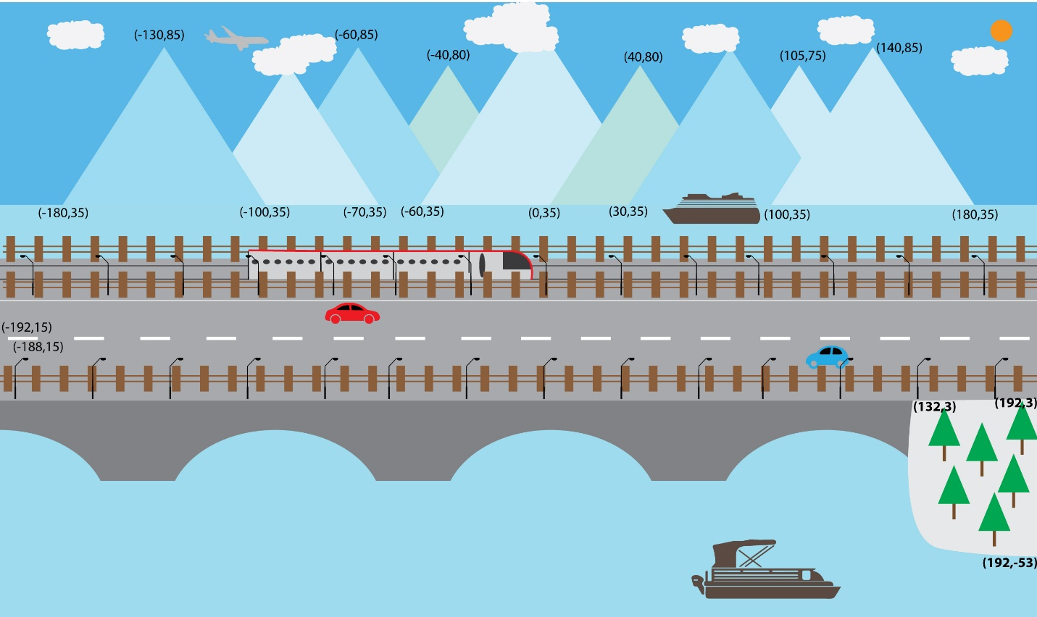

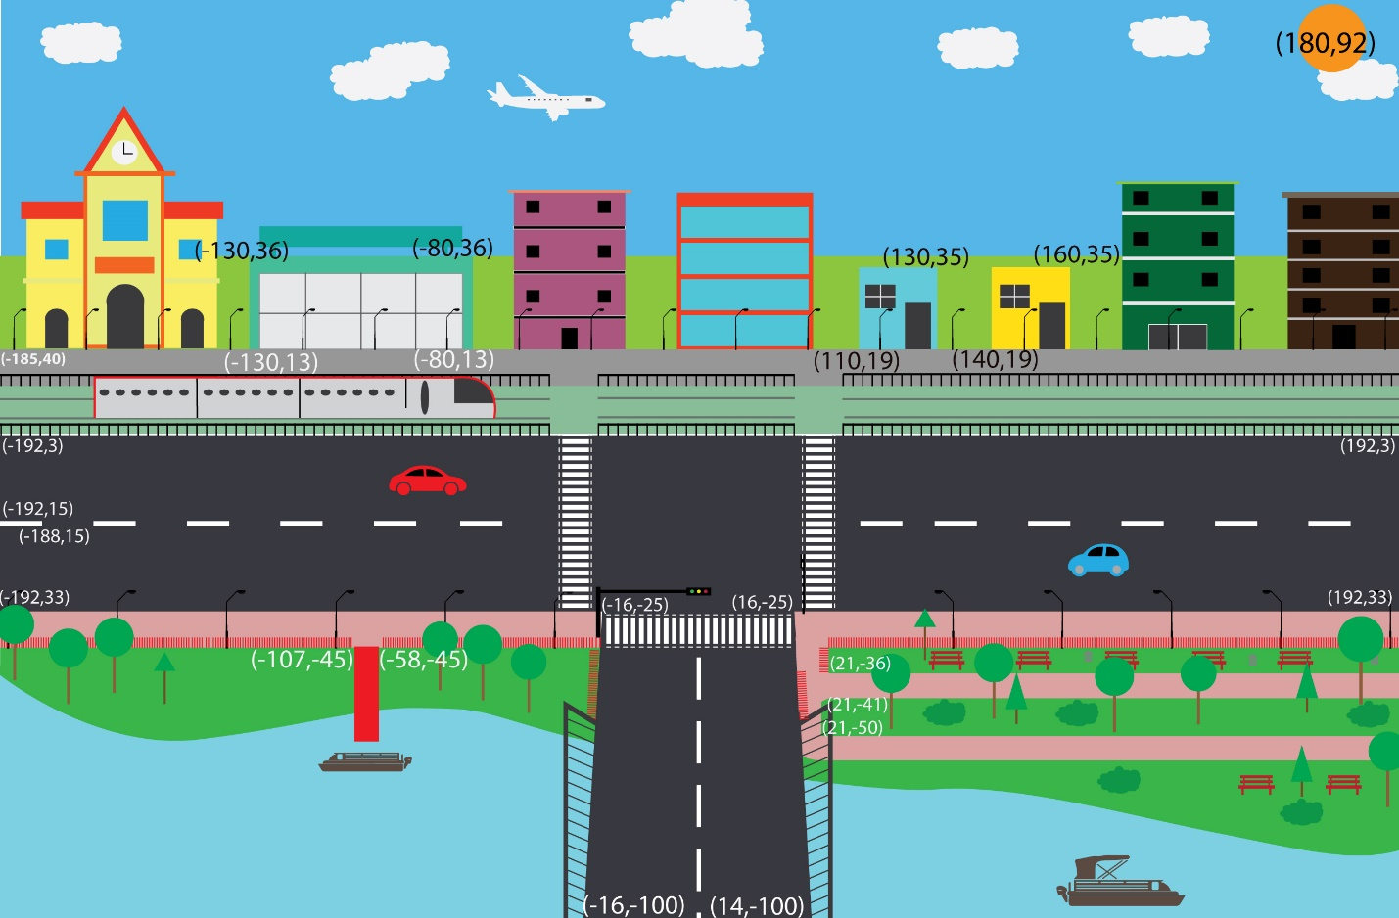

**List of Objects**

1. Sky
2. Star
3. Sun
4. Moon
5. Cloud
6. Snow
7. Rain
8. Plane
9. Helicopter
10. Mountain
11. Glacier
12. Lake
13. Ship1
14. Ship2
15. Boat1
16. Boat2
17. Grass
18. Bridge1
19. Bridge2
20. Road
21. Trainline
22. Trump
23. Road Sign
24. Traffic Signal
25. Truck
26. RV
27. Car1
28. Car2
29. Railing
30. Fence
31. Lamp-post
32. Tree
33. Bush
34. Dustbin
35. Postbox
36. Footpath
37. Park road
38. Bench
39. Dock
40. Building1
41. Building2
42. Building3
43. Building4
44. Mall
45. Shop
46. Car Shop
47. Mini Shop
48. Station
49. Clock
50. Rain_cloud
51. Snow_cloud

**Functions to Represent the Objects**

**\*ID: 2-Components, 2-Serial, 2-Extra Part, 1-Update**

|  |  |  |
| --- | --- | --- |
| **Object**  **List of Objects** | **Function** | **ID** |
|  | void star() | 0101 |
| **Star** | void star1() | 010101 |
|  | void star3() | 010102 |
|  | void star2() | 010103 |
| **Sky** | void sky() | 0201 |
| **Mountain** | void mountain() | 0301 |
| **Glacier** | void glacier() | 0401 |
| **Grass** | void grass() | 0501 |
|  | void bridge() | 0601 |
| **Bridge** | void bridge_1() | 0602 |
| **Road** | void road() | 0701 |
| **Road-sign** | void roadsign() | 0801 |
| **Traffic** | void traffic() | 0901 |
|  | void traffic1() | 0902 |
| **Railing** | void ralling1() | 1001 |
|  | void ralling2() | 1002 |
|  | void ralling3() | 1003 |
|  | void fence() | 1101 |
| **Fence** | void fence_train_top() | 1102 |
|  | void fence_train_buttom() | 1103 |
|  | void lampost_top_1() | 1201 |
| **Lamppost** | void lampost_buttom_1() | 1202 |
|  | void lampost() | 1203 |
|  | void tree_1() | 1301 |
|  | void tree_2() | 1302 |
|  | void tree_3() | 1303 |
|  | void tree_4() | 1304 |
|  | void tree_5() | 1305 |
| **Tree** | void tree_6() | 1306 |
|  | void tree_7() | 1307 |
|  | void tree_8() | 1308 |
|  | void tree_9() | 1309 |
|  | void field_tree() | 1310 |
|  | void field_tree1() | 1311 |
|  | void field_tree2() | 1312 |
|  | void field_tree3() | 1313 |
|  | void field_tree4() | 1314 |
|  | void park_tree() | 1315 |
| **Mini Shop Side** | void mini_shop_side() | 1401 |
|  | void bush() | 1501 |
|  | void bush_1() | 1502 |
| **Bush** | void bush_2() | 1503 |
|  | void bush_3() | 1504 |
|  | void bush_4() | 1505 |
|  | void bush_5() | 1506 |
|  | void bush_6() | 1507 |
| **Dustbin** | void dustbin() | 1601 |
| **Post Box** | void post_box_park() | 1701 |
|  | void post_box_trump() | 1702 |
| **Footpath** | void footpath() | 1801 |
| **Park road** | void park_road() | 1901 |
| **Park Bench** | void park_bench() | 2001 |
| **Dock** | void dock() | 2101 |
| **Building** | void building1() | 2201 |
|  | void building2() | 2202 |
|  | void building3() | 2203 |
|  | void building4() | 2204 |
| **Mall** | void mall() | 2205 |
| **Shop** | void shop() | 2206 |
| **Car Shop** | void car_shop() | 2207 |
| **Mini Shop** | void mini_shop_1() | 2208 |
|  | void mini_shop_2() | 2209 |
| **Station** | void station() | 2210 |
| **Sun** | void sun() | 2301 |
| **Moon** | void moon() | 2401 |
| **Lake** | void lake() | 2501 |
|  | void cloud() | 2601 |
|  | void cloud_1() | 2602 |
|  | void cloud_2() | 2603 |
| **Cloud** | void cloud_3() | 2604 |
|  | void cloud_4() | 2605 |
|  | void cloud_5() | 2606 |
|  | void cloud_6() | 2607 |
|  | void cloud_7() | 2608 |
|  | void cloud_8() | 2609 |
|  | void cloud_9() | 2610 |
|  | void cloud_10() | 2611 |
|  | void cloud_11() | 2612 |
|  | void cloud_12() | 2613 |
|  | void cloud_13() | 2614 |
|  | void cloud_14() | 2615 |
|  | void cloud_15() | 2616 |
|  | void cloud_16() | 2617 |
| **Snow** | void snow1() | 2701 |
|  | void snow2() | 2702 |
|  | void snow3() | 2703 |
|  | void snow4() | 2704 |
|  | void snow5() | 2705 |
|  | void snow() | 2706 |
|  | void snowfall_1() | 2707 |
|  | void snowfall_2() | 2708 |
|  | void snow_shade_tree_0() | 2709 |
|  | void snow_shade_tree() | 2710 |
| **Snow Cloud** | void snow_cloud() | 2801 |
|  | void snow_cloud1() | 2802 |
| **Rain Cloud** | void rain_cloud() | 2901 |
|  | void rain_cloud1() | 2902 |
| **Rain** | void rain() | 3001 |
| **Plane** | void plane() | 3201 |
| **Plane-2** | void plane_1() | 3202 |
| **Helicopter** | void heli_blade1() | 330101 |
|  | void heli_blade2() | 330102 |
|  | void heli_body() | 330103 |
|  | void helicopter() | 3301 |
| **Ship** | void ship_body() | 340101 |
|  | void ship_pillar() | 340102 |
|  | void ship_container() | 340103 |
|  | void ship_container_1() | 340104 |
|  | void ship_container_2() | 340105 |
|  | void ship_container_3() | 340106 |
|  | void ship_container_4() | 340107 |
|  | void ship_container_5() | 340108 |
|  | void ship_container_6() | 340109 |
|  | void ship_container_7() | 340110 |
|  | void ship_container_8() | 340111 |
|  | void ship_container_9() | 340112 |
|  | void ship_container_10() | 340113 |
|  | void ship_container_11() | 340114 |
|  | void ship_container_12() | 340115 |
|  | void ship() | 3401 |
| **Ship-2** | void ship_2() | 3402 |
| **Boat** | void boat_1() | 3403 |
| **Boat-2** | void boat_11() | 3405 |
| **Boat-3** | void boat_2() | 3404 |
| **Boat-4** | void boat_21() | 3406 |
| **Trump** | void t_body() | 350101 |
|  | void t_body2() | 350102 |
|  | void t_body3() | 350103 |
|  | void t_body4() | 350104 |
|  | void trump() | 3501 |
| **Trump-2** | void trump_1() | 3502 |
| **Truck** | void truck_tire1() | 360101 |
|  | void truck_tire2() | 360102 |
|  | void truck_tire3() | 360102 |
|  | void truck () | 3601 |
| **Truck-2** | void truck _1() | 3602 |
| **RV** | void rv_tire1() | 370101 |
|  | void rv_tire2() | 370102 |
|  | void rv_tire3() | 370103 |
|  | void rv() | 3701 |
| **RV-2** | void rv_1() | 3702 |
| **Car-1** | void c1_body() | 380101 |
|  | void c1_tire1() | 380102 |
|  | void c1_tire2() | 380103 |
|  | void car1() | 3801 |
| **Car-2** | void car1_1() | 3802 |
| **Car-3** | void c2_body() | 380301 |
|  | void c2_tire1() | 380302 |
|  | void c2_tire2() | 380303 |
|  | void car2() | 3803 |
| **Car-4** | void car2_1() | 3804 |

**Interactive Functions**

|  |  |  |
| --- | --- | --- |
| **Interactive Functions** | **Interaction** | **ID** |
| void update_station_clock(int value) | station_clock_minute_move, station_clock_hour_move | 2210001 |
| void update_sun(int value) | sun_move | 2301001 |
| void update_moon(int value) | moon_move | 2401001 |
| void update_wave(int value) | lake_move | 2501001 |
| void update_cloud(int value) | cloud_1_move_right - cloud_8_move_right | 2601001 |
| void snow_update(int value) | snow_move_x, snow_move_y,snow_speed | 2701001 |
| void snow_update1(int value) | snow_move_x1, snow_move_y1 | 2701002 |
| void snow_cloud_update(int value) | snow_move_cloud, snow_move_cloud2 | 2801001 |
| void snow_cloud_stop(int value) | snow_move_cloud, snow_move_cloud2 | 2801002 |
| void rain_cloud_update(int value) | rain_move_cloud, rain_move_cloud2 | 2901001 |
| void rain_cloud_stop(int value) | rain_move_cloud, rain_move_cloud2 | 2901002 |
| void rain_update(int value) | rain_move_x, rain_move_y | 3001001 |
| void update_plane(int value) | plane_move | 3201001 |
| void helicopter_angle(int value) | heli_angle | 3301001 |
| void helicopter_movex(int value) | heli_movex, heli_movey | 3301002 |
| void helicopter_movey(int value) | heli_movey | 3301003 |
| void update_ship_1(int value) | ship_1_move_right | 3401001 |
| void update_ship_2(int value) | ship_2_move_left | 3402001 |
| void update_boat_1(int value) | boat_1_move_right | 3403001 |
| void update_boat_2(int value) | boat_2_move_left | 3404001 |
| void update_boat_21(int value) | boat_21_move_right | 3406001 |
| void trump_update(int value) | trump_move,trump_speed | 3501001 |
| void trump_1_update(int value) | trump_1_move | 3502001 |
| void update_tuck_tire(int value) | truck_tire_rotate_left | 3601001 |
| void update_tuck(int value) | truck_move | 3601002 |
| void update_tuck_1(int value) | truck_move_1 | 3602001 |
| void update_rv_tire(int value) | van1_tire_rotate_right | 3701001 |
| void update_rv(int value) | Van1_move | 3701002 |
| void car2_angle(int value) | _angle1 | 3801001 |
| void car2move(int value) | _move1 | 3801002 |
| void car1move(int value) | car1_move | 3801003 |
| void car1angle(int value) | car1_angle | 3801004 |

**Task Assignment and Codes of Functions**

**Contribution Table:**

|  |  |  |  |
| --- | --- | --- | --- |
| **Member-1** | **Member-2** | **Member-3** | **TOTAL** |
| 33.33% | 33.33% | 33.33% | 100% |

|  |  |
| --- | --- |
| **Name**  **ID** | **Contribution in Project** |
| **Abdullah Al Amin**  **19-39502-1** | **Object**   1. sky 2. Sun 3. Moon 4. Grass 5. Plane 6. Truck 7. RV 8. Building1 9. Building2 10. Mall 11. Shop 12. Car Shop 13. Mini Shop-1 14. Mini Shop-2 15. Railing 16. lamppost 17. Fence 18. Postbox   **Animation**   1. Sun 2. Moon 3. Plane 4. Truck 5. RV 6. Clock 7. Night 8. Snow Effect |
| **Karim, Rezaul**  **19-39521-1** | 1. Star 2. Snow 3. Helicopter 4. Glacier 5. Lake 6. Grass 7. Bridge-1 8. Bridge-2 9. Road 10. Train-line 11. Trump 12. Road-sign 13. Traffic-signal 14. Car-1 15. Car-2 16. Tree 17. Dock 18. Building3 19. Building4   **Animation**   1. Car-1 2. Car-2 3. Trump 4. Helicopter 5. Snow 6. Snow Cloud 7. Wave |
| **Dip Roy**  **19-394544-1** | 1. Bench 2. Park road 3. Dustbin 4. Tree 5. Bush 6. Cloud 7. Station 8. Clock 9. Rain 10. Boat-1 11. Boat-2 12. Ship-1 13. Ship-2 14. Mountain 15. Lamppost 16. Rain-cloud 17. Footpath   **Animation**   1. Boat-1 2. Boat-2 3. Ship-1 4. Ship-2 5. Cloud 6. Rain 7. Rain Cloud |

**OUTPUT**

|  |  |
| --- | --- |
| **Day View1** |  |
| **Snow**  **View** |  |
| **Day View2** |  |
| **Night**  **view** |  |
| **Rain**  **view** |  |

**Conclusion**

Our program starts with a sea-mountain view in winter. In this scene, we implemented snow mode. By pressing ‘r’ key, Snow cloud covers the full sky. After a moment, full sky covers with snow cloud and snowfall starts. During the snowfall, snow effects on road, bridge, tree & sea starts continuously. A train passes in the scenario. When the train passes left to right fully from there city scene starts. We have implemented an automatic view of city scenario where day and night are automatically time lapsing of the clock. Sun and moon automatically rise in the sky with the time of day and night. There is also a manual keyboard interaction of day and night feature. In the city scenario, we also implemented rain feature. Using ‘r’ keyboard button rain can be called. Before starting rain fall all the sky will be cover with rain cloud. Then the rainfall starts and creates a water overflow in the lake. The rainfall can stop any time by using keyboard button ‘s’. The program runs everything with some automated feature. Even those features can be control manually. The program runs much smoothy that one scene to another scene can be called anytime and both scene runs in real time. So, switching one display to another, both displays feature will run smoothly.