

American International University-Bangladesh (AIUB)  
 **Department of Computer Science**

**Faculty of Science &Technology (FST)**

**Section:A  
 Group No: 02**

**Smart Irrigation System**

A software Engineering project submitted

By

|  |  |  |
| --- | --- | --- |
| SN | Student Name | Student ID |
| 4 | ESHA, ABDULLAH | 18-37577-1 |
| 5 | ISLAM, AMENA | 18-37596-1 |
| 6 | JOBAYER, MD.ABDULLAH AL | 18-37647-1 |
| 7 | PRIA, TASMIA TAMANNA | 18-37746-1 |

The project will be Evaluated for the following Course Outcomes

|  |  |
| --- | --- |
| CO3: Choose appropriate software engineering model in a software development   environment | Total Marks |
|  |
| Project Background Analysis (needs, goal, benefits, etc.) [5Marks] |  |
| Appropriate Process Model Selection and Argumentation with Evidence [5Marks] |  |
| Completeness, Spelling, Grammar and Organization of the Answer [5Marks] |  |
|  | |
| CO4: Explain the roles and their responsibilities in the software project   management activities | Total Marks |
|  |
| Content Knowledge (e.g., System Functionalities, Related Product/Services) [5Marks] |  |
| Project Role identification and Responsibilities descriptions [5Marks] |  |
| Presentation Delivery and Defense [5Marks] |  |

**Table of Contents**

1. **Problem Domain**
   1. Background of the problem
   2. Existing solutions
   3. System features
2. **Selection of process model**
   1. Process model
   2. Project roles identification and responsibilities
3. **System Requirements**
   1. Functional requirements
   2. Non-Functional requirements
   3. Project requirements
4. **Design Specification**
   1. Use case diagram
   2. Class diagram
   3. Activity diagram
   4. ER Diagram
   5. TimeLine Chart
5. **UI/UX Design**
6. **Project Test Planning**

# PROBLEM DOMAIN

## Background to the Problem

Agriculture in villages plays an essential role in developing the country. Basically, agriculture depends on the monsoons which have not enough water source. To overcome this problem, the irrigation system is employed in the field of agriculture. In this system, based on the soil type, the water will be provided to the agricultural field. In agriculture, there are two things, namely, the moisture content of the soil as well as the fertility of the soil. Farmers and others involved in crop harvesting may use smart irrigation tools to maximize their water usage during the crop lifecycle. These platforms provide detailed, real-time information on consumption levels in specific areas and across the entire landscape, as well as the ability to remotely activate or disable irrigation systems. Scheduling features may provide users facility to map out water cycles, as well as options to automatically increase or decrease sprinkler output based on weather and other environmental factors. Businesses will make informed irrigation decisions based on the data obtained by this program in order to improve water conservation and quality.

## Solution to the Problem

At this time, there are a variety of irrigation strategies available to minimize the need for rain. Mainly we will focus on the techniques which are regulated by an electrical power on/off schedule and sensor devices. With the aid of the internet and electronic sensors, the ‘IOT' links different devices and modes of transportation, allowing us to solve the issue.

## System Features

The proposed system features are given below,

* **Online registration**: The farmers can easily apply for (Project name) through the following procedure specified below.
* First, the farmers have to visit the official site of (Project name). Now, farmers can log in with the reference number on the homepage of the portal. After you have logged in to the portal, farmers can fill out the online application form to take the (project name). Now farmers need to enter all the requested details in the application form. Enter the details such as farmers' names, mobile numbers, e-mail address, NID and other information. After completing all the details, the farmer must click on the submit button to complete the registration process. On submitting the application form, the farmer will receive the message stating “Successfully Registered”.
* **SMS/ Notification**: The purpose of this study was to develop a decision support system for the management of irrigation water, fertilizer via SMS to provide information and irrigation advice to the farmer on mobile phone. Simulations were performed to do. Establish support systems to observe greater water storage, less water, fertilizer quantity from the beginning to the end of the season. The proposed software was able to reduce water waste in agriculture and send easy and quality irrigation advice to remote areas via SMS using already integrated technology in rural areas.
* **Irrigation control:** As soon as the farmer gets the notification or SMS from the system regarding his land condition he can use the app remotely if his land in need of quick irrigation. He has to just call or chat with help center to provide irrigation to him land.
* **Forecasting information and smart decision:** There will be a sensor in every registered farmer’s land. The soil moisture sensor is used to measure the volumetric water content of soil. It is used to monitor soil moisture content to control irrigation in greenhouses. A moisture sensor is used to sense the level of moisture content present in irrigation field. It has a level detection module. Collected data by sensor will provide to software. Then the software will analyze the data and make smart decision that will fix for seasonal basis.
* **Payment:** Users have to payment on monthly basis .they can payment online or offline. If they want to payment on online then they have to give money through Bkash or Nagad or Rocket .For this they can payment by themselves by opening personal account of Bkash or Nagad or Rocket. Beside they can do this from agent account of Bkash or Nagad or Rocket. But if they want to payment on offline then they have to come to the help center.
* **Help center:** For any kind of query or suggestion registered farmers can contact with help center .They can contact through online or offline. For online communication they have to call or chat through the app of the software. But for offline contact the have to go to the help center.

# SOFTWARE DEVELOPMENT LIFE CYCLE

## Process Model

We will develop an agro based software call “**Agro Solution**”. After considering all the facts and requirements, we are going to use the “**AGILE Software Development Model”**.

**Waterfall model**, we can’t use this model here because it’s static. Using this we won’t be able to test our output throughout the development process is running. We might add or update any feature in future but waterfall model doesn’t give us the luxury. So, that’s why we can’t use waterfall model or any extensions either.

On the other hand **AGILE** is flexible, less complicated, less risky, better feedback, higher productivity and success rate. Our software will be dynamic and medium in size and we can have some extra benefits using AGILE.

Finally, we can say that AGILE Software Development Model will be the best option over all other software development models.

Within each phase, AGILE software development model relies on several activities and techniques based on these principles-

* Customer satisfaction by early and continuous delivery of valuable software.
* Welcome changing requirements, even in late development.
* Delivery working software frequently (weeks rather than months).
* Close daily cooperation between business people and developers.
* Projects are built around motivated individuals, who should trusted.
* Face-to-face conversation is the form of communication (co-location).
* Working software is the primary measure of progress.
* Sustainable development, able to maintain a constant pace.
* Continuous attention to technical excellence and good design.
* Simplicity- the art of maximizing the amount of work not done- is essential.
* Best architecture, requirements, and designs emerge from self-organizing teams.
* Regularly, the team reflects on how to become more effective, and adjust accordingly.

## Project Role Identification and Responsibilities

**Project Manager:**

A product manager is the person who identifies the customer need and business objective that a product or feature will fulfill, evident what success looks like for a product. And product manager mainly liable for organizing, managing, planning, designing, controlling and most importantly communicating. He who had leadership ability, innovativeness and ability to think strategically. He is responsible for the advance issues that unsolvable and tries to solve them in short time.

**Project Analyst:**

Project analyst is to utilize data analysis software to research markets trend. They make recommendation and provide launch strategies based on their analysis to increase firm profitability. They are also responsible for project documentation and monitoring the whole process of project. They think of possibilities for profit and scales, monitor the performance of product on the market to come up with better product.

**Project Owner:**

Product owner is a strategic role responsible for representing the interests of the customer for the development team. They act as the main point of contact for all concerning decisions for project and as such, need to be empowered to perform their responsibilities without the need to seek to much prior authorization from the project sponsors. He knows everything individually of project and he’s the one who provide the requirement and feature for software product to developer team. He also responsible for ensuring that the software product vision statement is adhered to making the final decision on all scope that related.

**Functional Manager:**

A functional manger assigns specific individuals to the team and negotiate with the project manager regarding resources. He participates in the initial planning until activities are assigned and manage activities within their functional areas. He recommends s change to the project and corrects actions if any wrong is done.

**Tracker:**

There is a role called tracker whose main responsibility is to track the progress of the project so that there will be no overshooting money and time

**Developers:**

The developers are responsible for the actual building of the project. They basically do the program and build the entire software

**Tester:**

The tester ensure that the project meets the requirements and it is free of errors and defects which is very helpful for owner to not facing any loss in business for having error in software. He helps the developer by testing after a certain time and broadcast results.

# SYSTEM REQUIRMENT

## Functional Requirement

1. **User Registration:** For using this software or mobile app user must register to confirm his identical information. After registration he can access next few step like login, user payment, user SMS notification, user guideline, notification for forecasting.

After going to the registration option, a new interface will be shown that will ask user name, phone number*, NID*, location or address, password/code.

Then after registration, the user will receive a notification to phone number stating that the registration is successful and he will get a pincode or password to access the login system.

**Priority- High**

**Precondition-** User must have a valid phone number and NID (national identity).

1. **User Login:** The system will allow user to login into the system by using their NID and given pincode or password. After login successfully he will see the main home page.

But if user mistakenly ordered insert wrong nid number or pincode he will get warning for invalid login. He will get three chances to make a valid login otherwise he will have to register newly.

If he wants to change the password, he can change that by using pincode which was given from the system and he can renew his password. And system will verify the user by his NID whether it is he or not.

**Priority- High**

**Precondition-** User must have a valid NID and accurate pin or password to access to login.

1. **User payment in online:** After getting service or facility from the system he can pay by using some online payment system such as Bkash, Nagad, Rocket etc.

After user choose the option for payment, he will get a notification and verification code for that procedure.

After payment or getting services, those data will store in system repository or database.

**Priority- High**

**Precondition-** User must have pay his bill otherwise it will on his lend list and have to pay before getting the next services.

1. **User payment in offline:** There will an office in every village/location for giving services or help the user in physically. User can go to that office and pay the bill.

User payment can also be stored in database and other information.

**Priority-** Low

**Precondition-** An office should be there to give services.

1. **SMS/Notification:** As we talked about a sensor machine that will provide user to know his land condition, type of his land soil, what is the fertility of the soil, what crops can be produced next etc.

By using that sensor in user land, he will get his necessary information easily and will able to take necessary steps further.

**Priority-High**

**Precondition-** User must setup a sensor in his field.

1. **Forecasting information:** After every 4-month user get information about what crop he should cultivate in his land as he using sensor in his field.

User also with get to know the list of crop priority which crop he should plant after first cultivation. He also get notification about weather which will good for crop, how much rain can be per week, fertility and moisture rate after one cultivation.

**Priority-** High

**Precondition-** Need at least 1 year data/information of that land.

1. **User Guideline:** The system will provide user necessary guideline how to register for this system, what’s advantage of using this system, what facilities he will get after using this system.

User will also get idea about using sensor, the service office location, how to pay bill, how to get more knowledge about fertility and product and services he will get.

User can also be able to modify this feature according to their comfort like language, font etc.

**Priority-**Medium

**Precondition-** User must have this system on his mobile app to see the guideline.

## Nonfunctional Requirement

1. **Performance:** The performance of software should be quick as possible as single person will have app individually in their mobile, like less than 10 second software will response to user command.

**Priority-** High

**Precondition-** N/A

1. **Efficiency:** After running this app the capacity of processor will have enough space/storage (25-30%) to hold data and execute them. Thus, will increase performance as well.

**Priority-** High

**Precondition-**N/A

1. **Maintainability:** This software should improve its usefulness. And if we want any modification or add any feature, that should be take less time and done by experienced developer to change or modify any policy.

**Priority-** Medium

**Precondition-**N/A

1. **Integrity:** The payment processing gateway of the system will be based on SSLCOMMERZ session API. Any malware or virus, as well as any unauthorized access, cannot access or damage any data.

**Priority-** High

**Precondition-** N/A

1. **Interoperability:** As the system use NID from user for login/registration and the system have no database for NID, it should interconnect with NID server which is connected with election committee.

**Priority-** High

**Precondition-**N/A

1. **Reliability:** The system should be reliable after running the app. It should have less failure chances for increasing reliability.

**Priority-** High

**Precondition-** N/A

## Project Requirement:

To develop this project some following project requirements are necessary as a manager’s perspective. They are here to support developing the project but not a part of the software-

* Budget
* Time
* Tools (testing tool, design tool, project management tool etc.)
* Human resources
* Environment resources
* Hardware resources
* Software chooses
* Network resources (such as network connection like router, cloud computing etc.)
* Requirement description
* Acceptance criteria
* Other materials etc.

# Design Specification:

## Use Case Diagram:

If farmer isn’t registered then he has to register or he can see following guidelines. If he registered then he can login with his NID and Password. After login he will be able to get notifications regularly and see his land conditions and also gets forecasting information in between every 4 months. From those information he will get idea, if he needs irrigation in his land or not after that he go to irrigation control in the app and command for irrigation. If there is no need of irritate then it is ok with that. If he irrigates his land, he has to pay through the payment method. After getting all kind of help from our software he has to pay on monthly basis. He can payment online or offline both way. If he wants to pay online then he can do this through Bkash, Nagad or Roket mobile banking. Otherwise for offline payment he has to pay Cash or Pay-order. After completing payment, he will get a SMS that is payment completed.

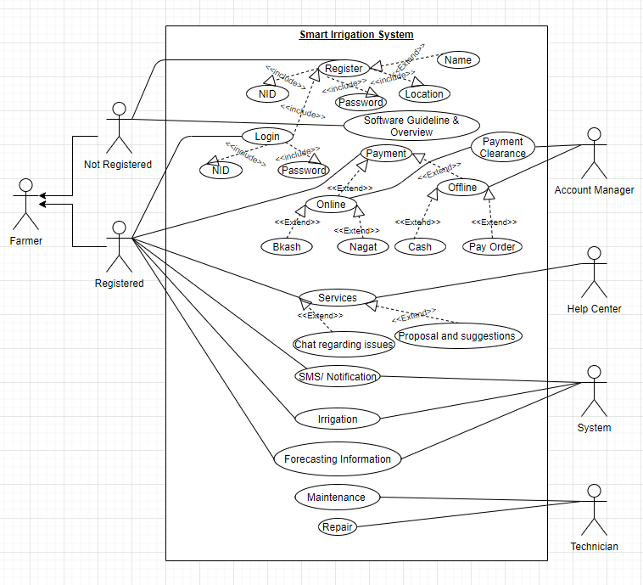

## Class Diagram:

At first, we can see a farmer class that’s has farmer details such as Name, NID, Password, Location. A farmer can register and login by using register & login methods. A farmer must be have one land or many lands. Land class has also land’s details such as Farmer NID, Land ID, Location, Land Breadth &Land Length. We can know about land details by using getLandDetail method. If farmer want to irrigation, here is irrigation class. Farmer control his irrigation system by using this class. In irrigation class has Farmer NID, Land ID, Quantity &Time. Farmer can do irrigate and get SMS by irrigate & getSMS method. When farmer irrigates his land, he has to pay. For this, here is a Payment class. That’s has Transaction ID, Farmer NID, Amount & Time. Farmer can payment online or offline both ways. If he pays his payment on offline, he must needs Account Manager ID. If he payment online, him must has a MBSP (Mobile Banking Service Provider) like Bikash, Nagad, Roket etc. When farmer login the system he will be able to get notification regularly via Forecast class where has Farmer NID, Land ID &Time. Farmer can see his land conditions and also gets forecasting information in between every 4 months by using getForeCastInfo() & get SMS methods.

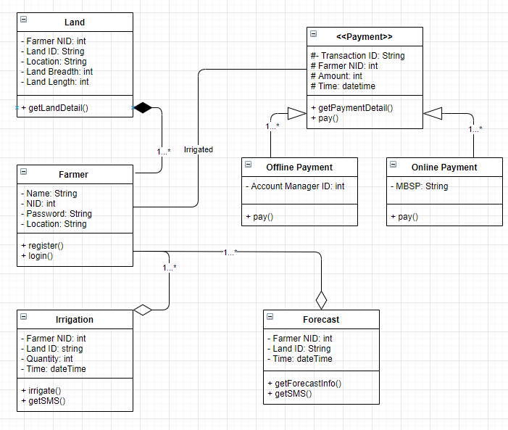

## Activity Diagram:

At first a farmer will login. If he is not registered then he has to register following show guidelines. If he registered then he can login. After login he will be able to get notifications regularly and see his land conditions and also gets forecasting information. From the information if he needs irrigation then he calls or chat with help center to provide irrigation. Otherwise, there is no need to irritate then don’t ask for help. If he irrigates his land, he has to pay or not irrigate he may return to home page. After getting all kind of help from our software he has to payment on monthly basis. He can payment online or offline both way. If he wants to pay online then he can do this through Bkash, Nagad or Roket mobile banking. Otherwise for offline payment he has to pay Cash or Pay-order. After completing payment, he will get a SMS that is payment completed.

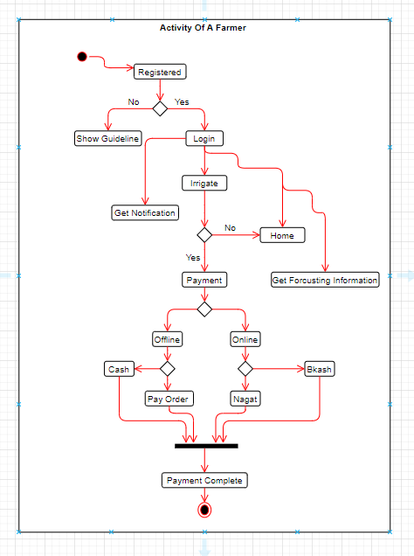

## ER Diagram Scenario:

We have design an application name Smart Irrigation System. It is agriculturally based application. By using this software farmer can get facilities for their land and cultivation. Farmer can pay his bill or service payment in online also offline. First of all, he has to register into application. Then he can get password by SMS, the he can login into app to access the features. He can get forecasting notification about weather, his land condition. He can get information about moisture, fertility rate etc. necessary about land. He will also get guideline how to use this app and get information what facilities he will get after using this app. Thus, will help him to cultivate properly and get good harvest and next time what crop will be better for him to plant on that land.

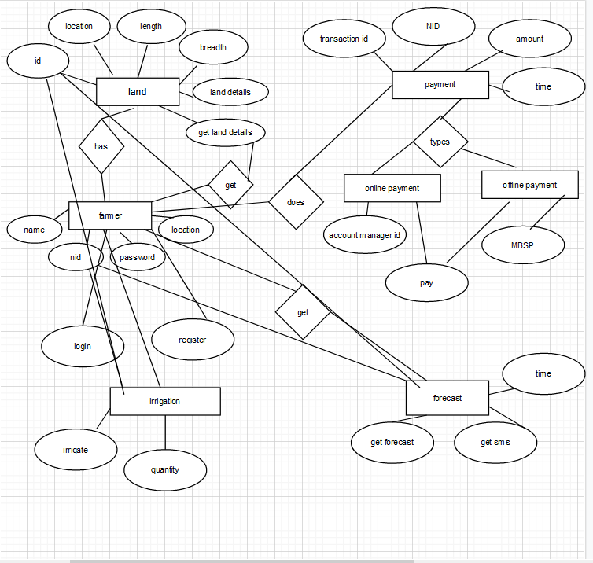

## TimeLine Charts:

Task 1: Collecting Requirements Task 10: Unit Testing

Task 2: Design and Analysis Task 11: System testing

Task 3: Module 1

Task 4: Module 2

Task 5: Module 3

Task 6: Code Module 1

Task 7: Code Module 3

Task 8: Code Module 2

Task 9: Integration Testing

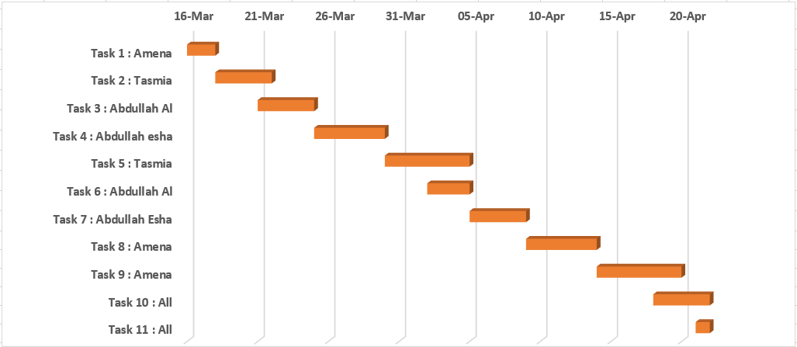

# UI/UX Design:

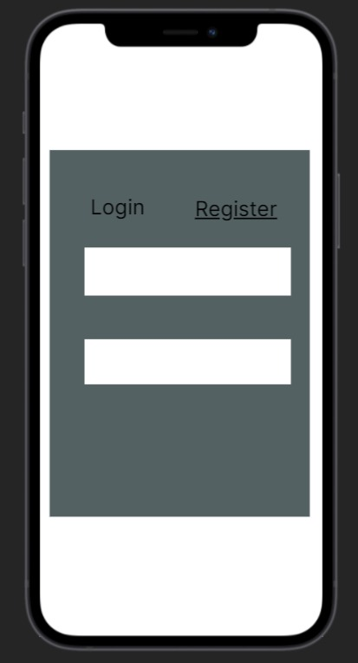 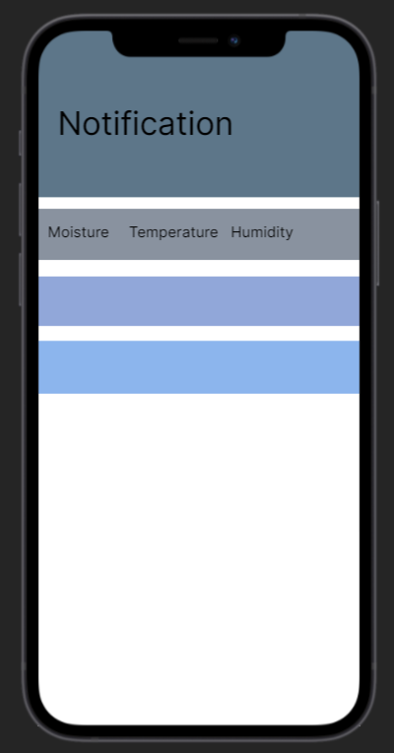

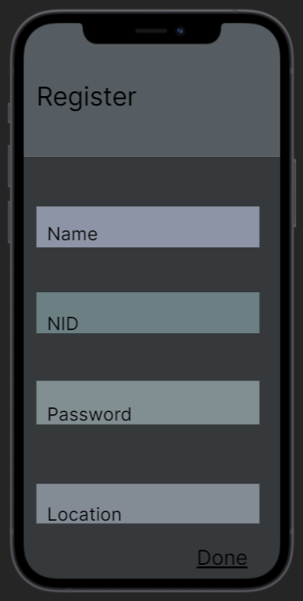 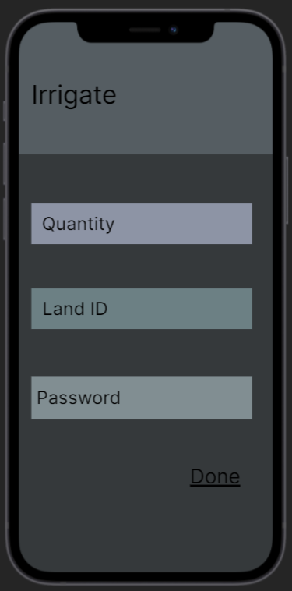

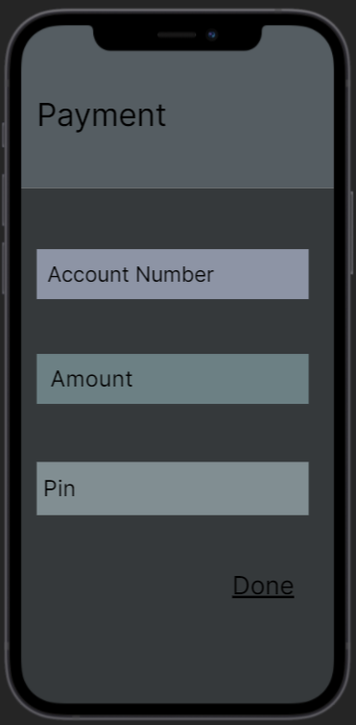

# Project Test Planning:

|  |  |  |  |  |  |
| --- | --- | --- | --- | --- | --- |
| Project Name: Smart Irrigation System | | | Test Designed by: Amena Islam | | |
| Test Case ID: FR_1 | | | Test Designed date: 18th April, 2021 | | |
| Test Priority (Low, Medium, High): High | | | Test Executed by: | | |
| Module Name: User Registration | | | Test Execution date: | | |
| Test Title: Verify registration with NID and pincode/password | | | | | |
| Description: Test registration page whether the user is successfully registered into the application | | | | | |
| Precondition (If any): User must have a valid mobile number and NID | | | | | |
| Test Steps | Test Data | Expected Results | | Actual Results | Status (Pass/Fail) |
| 1. Go to the app 2. Enter name 3. Enter mobile number 4. Enter NID 5. Enter location 6. Click register | Name: Md. Karim  Mobile: +8801938746234  NID: 6549760986  Location: | User should register into the application | |  |  |
| Post Condition: User is validated with database and successfully registered into the application. The account session details are logged in the database. | | | | | |

|  |  |  |  |  |  |
| --- | --- | --- | --- | --- | --- |
| Project Name: Smart Irrigation System | | | Test Designed by: Amena Islam | | |
| Test Case ID: FR_2 | | | Test Designed date: 18th April,2021 | | |
| Test Priority (Low, Medium, High): High | | | Test Executed by: | | |
| Module Name: Login Session | | | Test Execution date: | | |
| Test Title: Verify login with valid NID and pincode/password | | | | | |
| Description: Test login page whether the user is successfully logged in into the application | | | | | |
| Precondition (If any): User must have valid NID and pincode/password | | | | | |
| Test Steps | Test Data | Expected Results | | Actual Results | Status (Pass/Fail) |
| 1. Go to the app 2. Enter NID 3. Enter password/pincode 4. Click login | NID: 6549760986  Password: bd568 | User should login into the application | |  |  |
| Post Condition: User is validated with database and successfully login to account. The account session details are logged in the database. | | | | | |
| Project Name: Helping Hand | | | Test Designed by: Amena Islam | | |
| Test Case ID: FR_2 | | | Test Designed date: 18th April,2021 | | |
| Test Priority (Low, Medium, High): High | | | Test Executed by: | | |
| Module Name: Login Session | | | Test Execution date: | | |
| Test Title: Verify resetting pincode/password | | | | | |
| Description: Test login page whether user gets warning while they input wrong password and gets reset password option when they click reset pin. | | | | | |
| Precondition (If any): User must have an account | | | | | |
| Test Steps | Test Data | Expected Results | | Actual Results | Status (Pass/Fail) |
| 1. Go to the app 2. Type NID 3. Click Reset pin 4. Click Confirm | NID: 6549760986  Reset Pin: 12345 | User should get warning  User should get reset pin | |  |  |
| Post Condition: N/A | | | | | |

|  |  |  |  |  |  |
| --- | --- | --- | --- | --- | --- |
| Project Name: Smart Irrigation System | | | Test Designed by: Amena Islam | | |
| Test Case ID: FR_3 | | | Test Designed date: 18th April,2021 | | |
| Test Priority (Low, Medium, High): High | | | Test Executed by: | | |
| Module Name: User Payment in online | | | Test Execution date: | | |
| Test Title: Verify having account in online payment app (bkash, rocket) | | | | | |
| Description: Test app payment page | | | | | |
| Precondition (If any): user must choose payment option. | | | | | |
| Test Steps | Test Data | Expected Results | | Actual Results | Status (Pass/Fail) |
| 1. Go to the app 2. Go to Payment option 3. Check which app for payment 4. Then pay the bill | Previous Payment: 0  Update payment: 1300 | A verification code should be sent to user or card info should be asked from user. | |  |  |
| Post Condition: User will have notification that he have pay his bill. | | | | | |

|  |  |  |  |  |  |
| --- | --- | --- | --- | --- | --- |
| Project Name: Smart Irrigation System | | | Test Designed by: Amena Islam | | |
| Test Case ID: FR_5 | | | Test Designed date: 19th April,2021 | | |
| Test Priority (Low, Medium, High): High | | | Test Executed by: | | |
| Module Name: SMS/Notification | | | Test Execution date: | | |
| Test Title: Verify sending SMS about land condition and necessary step while using sensor. | | | | | |
| Description: Test Notification page | | | | | |
| Precondition (If any): User must have account in this application | | | | | |
| Test Steps | Test Data | Expected Results | | Actual Results | Status (Pass/Fail) |
| 1. Go to the app 2. Go to Notification bar. 3. Click to get the information | Notification:  Moisture level:40%  Fertility rate:75%  temperature: 35C  Irrigation requires: Yes | User will get this SMS/notification if he has sensor in his field and he can cultivate his land. | |  |  |
| Post Condition: N/A | | | | | |

|  |  |  |  |  |  |
| --- | --- | --- | --- | --- | --- |
| Project Name: Smart Irrigation System | | | Test Designed by: Amena Islam | | |
| Test Case ID: FR_6 | | | Test Designed date: 19th April,2021 | | |
| Test Priority (Low, Medium, High): High | | | Test Executed by: | | |
| Module Name: Forecasting | | | Test Execution date: | | |
| Test Title: Verify if user getting right information of forecasting | | | | | |
| Description: Test app forecasting option page | | | | | |
| Precondition (If any): User must have account in the application | | | | | |
| Test Steps | Test Data | Expected Results | | Actual Results | Status (Pass/Fail) |
| 1. Go to the app 2. Go to forecasting option 3. Click button to see the information | Average land moisture: 85%  Average fertility rate: 50%  Average temp.: 38C  weather: sunny  Suggestions:   1. Sugarcane 2. Wheat 3. Potato | Notification will show after every 4 month, will show the condition of weather, and land condition. | |  |  |
| Post Condition: N/A | | | | | |

|  |  |  |  |  |  |
| --- | --- | --- | --- | --- | --- |
| Project Name: Smart Irrigation System | | | Test Designed by: Amena Islam | | |
| Test Case ID: NFR_1 | | | Test Designed date: 20th April,2021 | | |
| Test Priority (Low, Medium, High): High | | | Test Executed by: | | |
| Module Name: Performance | | | Test Execution date: | | |
| Test Title: Verify Performance of system | | | | | |
| Description: Test how fast the interfaces work | | | | | |
| Precondition (If any): N/A | | | | | |
| Test Steps | Test Data | Expected Results | | Actual Results | Status (Pass/Fail) |
| 1. Go to the app 2. Click registration/login 3. Click forecasting | Read info  Check how fast login done  Check forecasting | The interfaces should not take more than 10 second to execute command | |  |  |
| Post Condition: N/A | | | | | |

|  |  |  |  |  |  |
| --- | --- | --- | --- | --- | --- |
| Project Name: Smart Irrigation System | | | Test Designed by: Amena Islam | | |
| Test Case ID: NFR_4 | | | Test Designed date: 20th April,2021 | | |
| Test Priority (Low, Medium, High): | | | Test Executed by: | | |
| Module Name: Integrity | | | Test Execution date: | | |
| Test Title: Verify Integrity | | | | | |
| Description: test if any unauthorized access or not . | | | | | |
| Precondition (If any): N/A | | | | | |
| Test Steps | Test Data | Expected Results | | Actual Results | Status (Pass/Fail) |
| 1. Go to the app | User NID number  User pin code | No unauthorized access of data and account. | |  |  |
| Post Condition: N/A | | | | | |

|  |  |  |  |  |  |
| --- | --- | --- | --- | --- | --- |
| Project Name: Smart Irrigation System | | | Test Designed by: Amena Islam | | |
| Test Case ID: NFR_5 | | | Test Designed date: 20th April,2021 | | |
| Test Priority (Low, Medium, High): High | | | Test Executed by: Mr. Rahim | | |
| Module Name: Interoperability | | | Test Execution date: 25th April,2021 | | |
| Test Title: Verify Interoperability | | | | | |
| Description: Test the interconnection with NID server to get database access for NID list. | | | | | |
| Precondition (If any): N/A | | | | | |
| Test Steps | Test Data | Expected Results | | Actual Results | Status (Pass/Fail) |
| 1. Go to the app | Connect with NID server | Get the NID list | |  |  |
| Post Condition: N/A | | | | | |

|  |  |  |  |  |  |
| --- | --- | --- | --- | --- | --- |
| Project Name: Smart Irrigation System | | | Test Designed by: Amena Islam | | |
| Test Case ID: NFR_2 | | | Test Designed date: 20th April,2021 | | |
| Test Priority (Low, Medium, High): High | | | Test Executed by: | | |
| Module Name: Efficiency | | | Test Execution date: | | |
| Test Title: Verify how much unused space remains | | | | | |
| Description: Test how much resource it consumes | | | | | |
| Precondition (If any): N/A | | | | | |
| Test Steps | Test Data | Expected Results | | Actual Results | Status (Pass/Fail) |
| 1. Go to the app | Use any function | There should be at least 25-30% space free in ram and processor. | |  |  |
| Post Condition: N/A | | | | | |

|  |  |  |  |  |  |
| --- | --- | --- | --- | --- | --- |
| Project Name: Smart Irrigation System | | | Test Designed by: Amena Islam | | |
| Test Case ID: NFR_6 | | | Test Designed date: 20th April,2021 | | |
| Test Priority (Low, Medium, High): High | | | Test Executed by: | | |
| Module Name: Reliability | | | Test Execution date: | | |
| Test Title: Verify Reliability of the software | | | | | |
| Description: Test how many times the software fails | | | | | |
| Precondition (If any): N/A | | | | | |
| Test Steps | Test Data | Expected Results | | Actual Results | Status (Pass/Fail) |
| 1. Go to the app | Run the app 500 times | The system should not fail more than 3-4 times. | |  |  |
| Post Condition: N/A | | | | | |