BanglaPlate: Automated Vehicle Number Plate Detection and Recognition using YOLOv8

Abdullah Al Noman  
*Department of Computer Science and Engineering*  
*Daffodil International University*  
noman15-5387@diu.edu.bd

Ayon Mazumder  
*Department of Information Technology*  
*Towson University*Towson, USA  
amazumd2@students.towson.edu

Nushrat Jahan Mila  
*Department of Computer Science and Engineering*  
*Daffodil International University*  
mila15-5758@diu.edu.bd

Nusrat Khan  
*Department of Computer Science and Engineering*  
*Daffodil International University*Dhaka-1216, Bangladesh  
nusratkhan.cse@diu.edu.bd

Abrar Hameem Bornil  
*Department of Computer Science and Engineering*  
*Daffodil International University*  
bornil15-5331@diu.edu.bd

Md. Hasan Imam Bijoy  
*Department of Computer Science and Engineering*  
*Daffodil International University*Dhaka-1216, Bangladesh  
hasan15-11743@diu.edu.bd

*Abstract*—License plate detection and recognition are critical components of intelligent transportation systems, supporting applications such as automated toll collection, parking management, and traffic monitoring. This study introduces a robust system specifically designed for detecting and recognizing Bangla vehicle license plates. Leveraging YOLOv8, a state-of-the-art object detection model, and EasyOCR for optical character recognition, the system effectively addresses the complexities of Bangla scripts. A custom dataset was created, consisting of 276 training, 79 validation, and 38 testing images. These images were meticulously annotated using Roboflow to ensure high-quality training data. The system demonstrated impressive performance, achieving detection accuracy between 93% and 96%, a Character Error Rate (CER) of 1.52%, and a Word Error Rate (WER) of 5.53%. These results underscore its capability to handle challenges such as skewed plates, partial occlusions, and varying lighting conditions. The training process was validated through performance curves showing steady improvements in loss and accuracy, while visualizations of the detection pipeline further highlighted the system's ability to accurately localize and process license plates in diverse environments. Despite its success, the system faces challenges with noisy inputs, low-resolution images, and non-standardized fonts. Future work will focus on addressing these limitations to enhance scalability and robustness. This study provides a reliable, scalable solution for Bangla license plate detection and recognition, advancing intelligent transportation in Bangladesh.

Keywords—Bangla Number Plate, Vehical Detection, Plate Detection, YOLOv8, Bangladesh.

# Introduction

Effective management of transportation networks is becoming more difficult as a result of the sharp increase in vehicle traffic brought on by the fast urbanization of cities around the world, especially in Bangladesh. Bangladesh’s capital, Dhaka, suffers from ongoing traffic jams and ineffective law enforcement, which compromise urban safety and mobility [1]. By facilitating automated toll collection, parking management, traffic monitoring, and law enforcement, automated vehicle number plate recognition systems have become a viable way to address these problems. However, reliable license plate identification and recognition is a difficult challenge because to the intricacy of multilingual Bangla-English license plates and a variety of environmental factors, including skewed angles, fluctuating lighting, and loud inputs [2]. The literature has found gaps in reaching high accuracy for multilingual number plate identification, despite notable progress in deep learning-based systems. The necessity for a reliable and scalable solution is highlighted by the limits of current systems in managing non-standard fonts, low-resolution photos, and ambient noise [3] – [5]. In order to overcome these obstacles, this paper presents a sophisticated system that makes use of EasyOCR, a powerful multilingual OCR framework, and YOLOv8, a cutting-edge object identification model. Real-time detection and recognition of car license plates with Bangla and English scripts is the goal of the suggested system. This study intends to close the gap found in current systems, namely in handling the complexities of multilingual scripts and non-standardized license plates, by employing a custom dataset annotated via Roboflow and enhanced to include a variety of environmental requirements. This study is driven by the growing demand for intelligent transportation solutions in cities, where efficient traffic control and law enforcement can greatly improve commuter experiences and public safety.

This study offers both practical and technical contributions. Technically speaking, the combination of EasyOCR for multilingual character recognition and YOLOv8 for high-precision detection has shown remarkable performance metrics, such as detection accuracy between 93% and 96% and character recognition rates with a Word Error Rate (WER) of 5.53% and Character Error Rate (CER) of 1.52% [6]. These outcomes demonstrate how well the system handles intricate multilingual scripts in a variety of environmental settings. From a practical perspective, this system offers a dependable and expandable solution for applications including toll collecting, automated parking, and traffic monitoring. The superiority of the suggested system is demonstrated by the comparison evaluation against baseline models, such as YOLOv4 + Tesseract, which shows notable gains in detection and recognition accuracy.

Therefore, this research covers the missing parts of existing systems and provides a new, scalable, and effective technique for detecting and recognizing license plates; it creates a new boundary for the research on multilingual number plate recognition and overcomes all the flaws mentioned in the literature, like poor performances on noisy or low light environment data and complicated scripts, such as English and Bangla. These results provide useful answers to real-world problems in traffic control and urban mobility, thereby developing computer vision and intelligent transportation systems.

# Literature Review

Jawale et al. [1] stated various frameworks to propose for license plate detection and recognition. Methods include CNN, MobileNet, Inception V3, ResNet 50 for recognition. Techniques address issues like low illumination, complicated backgrounds. Frameworks designed for robust recognition in different conditions. Onim et al. [2] said YOLOv2 model for vehicle and VLP detection with high accuracy. The main challenges to VLP detection: shadows, sunlight, and false positives. The authors used the YOLOv4 model for VLP detection and character recognition in Bangladesh. Tripathi et al. [3] said that ANPR systems are applied in law enforcement and electronic toll collection. The ANPR system includes cameras, image processing software, and computers. The existing works on ANPR systems are related to number plate recognition only and lack tracking. ANPR can help in tracking stolen vehicles and also aids law enforcement. Tech M et al. [4] said ResNet Convolution Neural Network model for license plate recognition. Focus on character recognition complexity and un-tapped potential in data analytics.

Barreto et al. [5] said The research paper focuses on developing an Android app for car details. The app uses computer vision, image preprocessing, and YOLO technique. The system consists of an OCR service and a database of car information. He. J. Wang [6] said Delineates on intelligent traffic monitoring using CNN for number plate recognition. Compares system accuracy with existing methods for image processing. Discusses the importance of vehicle number plate recognition for smart cities. Presents the challenges in Bangla number plate detection and recognition. Explains the segmentation process for character recognition in number plates. Alam et al. [7] said Existing works focus on UK plates, not suitable for Indian plates. Various methods like morphological opera-tions and neural networks have been explored. Research area in smart cities and IoT, focusing on image processing methods. Adaptive thresholding, Gaussian smoothing, and contour filtering are key techniques.

Ganta et al. [8] said ANPR systems address traffic control, vehicle identification, and urban traffic monitoring. Vehicle number-plate recognition systems are based on image processing technology. ANPR is used for mass surveillance and optical character recognition. Chandra et al. [9] said the ANPR sys-tems use deep learning for vehicle tracking and number plate recognition. Previous studies include deep learning models for number plate recognition. Gnanaprakash et al. [10] said ANPR detects vehicle images and confirms license plate numbers. ANPR is used for stolen vehicles and crime suspects. ANPR can detect stolen vehicles on highways, parking lots, and signals. Kumar et al. [11] Various systems used Python, OpenCV for plate number recognition. ALPR systems detected traffic violators using cameras and OCR. LIDAR technology checks the speed of moving vehicles for overseeding detec-tion. Systems focused on capturing plate numbers of fast-moving vehicles.

Islam et al. [12] said Various frameworks have been proposed for license plate detection and recognition. Methods include CNN, MobileNet, Inception V3, ResNet 50 for recognition. Techniques address issues like low illumination, complicated backgrounds. Frameworks designed for robust recognition in different conditions. Mhatre et al. [13] said Novel techniques for LP identification to decrease false positives. Use of CNN for character recognition in noisy and blurred images. Various LP detection and segmentation methods analyzed for accuracy improvement. Rema et al. [14] said Survey on LP detection, character segmentation, and recognition methods. Existing works include CNN-oriented techniques, deep learning methods, and DL approaches. Garg et al. [15] has made, automated license plate recognition sys-tem using image processing techniques. The methodology includes modules for preprocessing, extraction, segmentation, and character recognition. They obtained a recognition accuracy of 94.17% using MATLAB software. Neupane et al. [16] They research various license plate recognition studies using deep learning models. CNN models used were AlexNet and MobileNetV2 for recognition. Neupane et al. [17] Plate identification algorithms developed included edge-based, colorbased, and texture-based meth-ods. Techniques used in number plate segmentation enhance recognition precision and speed.

Ba. Ya. and Sun et al. [18] said Numerous techniques for vehicle detection have been developed recently. Detection and classification are the two primary phases in vehicle recognition. Various methodologies include frame differencing and background subtraction techniques. Convolutional Neural Networks (CNNs) enhance vehicle detection precision significantly. MobileNet architectures balance efficiency and accuracy for mobile applications. ANPR systems face challenges like diverse license plate formats and lighting. The Stanford Cars Dataset is a standard for MMR algorithms. and their methodology Deep learning techniques for vehicle identification and ANPR. MobileNet-V2 for vehicle make and model detection. YOLOv4-tiny for license plate detection. Paddle OCR for character recognition on license plates. Gradient-weighted Class Activation Mapping (Grad-CAM) for model insights. their result The system achieved a 97.5% accuracy rate. It correctly identified 975 out of 1,000 images. Robust performance in adverse weather conditions was demonstrated. The system integrates vehicle make/model detection and ANPR.

Mustafa et al. [19] said Various frameworks exist for license plate detection and recognition. Techniques include kernel density function and binary processing methods. Image processing methods address noisy environments and low light conditions. Hybrid models combine feature extraction with neural network classifiers. Two-dimensional wavelet transform aids in vertical edge extraction. Capsule networks improve processing time and robustness in recognition. Histogram of oriented gradient is used for feature extraction. Techniques handle uneven illumination and tilted images effectively. .and their methodology License Plate Extraction for region acquisition. Image Pre-Processing for detail enhancement. Character Segmentation for character extraction. Character Recognition using CNN, MobileNet, Inception V3, and ResNet276.Their result The proposed ALPDR system has four main phases. Character recognition accuracy with CNN is 98.5%. CNN model shows minimum loss of 4.25. Performance compared using Precision, Accuracy, Recall, F1-Score, and Loss. System performs well under low illumination and hazy conditions. And their limitations Illumination variations affect recognition accuracy. Presence of noise and blur complicates detection. Distortion from tilt impacts image capturing. Diverse font shapes and sizes create challenges. Variations in colors complicate character recognition.

# Proposed Methodology

In the method section, we detail the implementation of a YOLOv8 model for detecting and recognizing Bangladeshi vehicle number plates. The process involves dataset preparation, model training, and fine-tuning to optimize detection accuracy in real-world conditions. The methodology also incorporates preprocessing techniques and custom scripts for character segmentation and recognition to ensure precise results. The working procedure diagram is presents in Fig. 1.

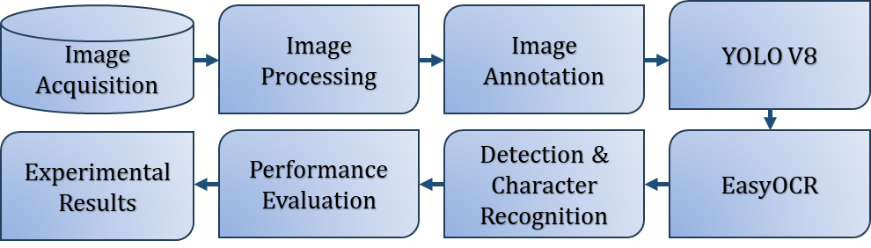

1. Working procedure diagram.

## Image Acquisition

The dataset for this study consists of images of vehicle number plates collected from various locations across Dhaka city, with a particular focus on the transport pool of Daffodil International University. A total of approximately 400 images were gathered, ensuring a diverse representation of vehicle types and plate designs. These images capture the unique characteristics of Bangladeshi number plates, including variations in fonts, sizes, colors, and lighting conditions, to enhance the robustness and generalizability of the system. This carefully curated dataset serves as the foundation for developing and testing the proposed detection and recognition system. The sample image is presents in Fig. 2.

|  |  |
| --- | --- |
|  |  |

1. Sample images of number plate.

## Image Processing and Annotation

The collected images underwent essential preprocessing steps, including resizing, cropping, and noise removal, to improve their quality and suitability for analysis. Annotation was then conducted using the Roboflow platform to ensure accurate and high-quality labeling for training and testing [20]. A total of 393 images were processed, with 276 allocated for training, 79 for validation, and 38 for testing (as shown in Table I). Each image was meticulously annotated within Roboflow to identify and mark the exact regions of the vehicle license plates. To further enhance the model’s resilience in diverse scenarios, the annotated dataset was augmented with techniques such as flipping, rotation, and contrast adjustments [21]. This comprehensive pipeline of image preprocessing and annotation forms a robust foundation, enabling the system to generalize effectively across various conditions for both detection and recognition tasks.

1. Data Distributions.

|  |  |
| --- | --- |
| Dataset | Number of images |
| Train | 279 |
| Test | 38 |
| Validation | 79 |
| Total | 393 |

## YOLOV8 Model Implementation

YOLOv8 [22] is a state-of-the-art object detection framework designed for accuracy and efficiency. Its architecture features a backbone based on CSPNet (Cross Stage Partial Network) for extracting multi-scale spatial and semantic features, ensuring efficient gradient flow and reduced redundancy. The neck, comprising a Feature Pyramid Network (FPN) and Path Aggregation Network (PAN), refines these features to detect objects of varying sizes. The anchor-free detection head predicts bounding boxes, objectness scores, and class probabilities in a streamlined manner. YOLOv8 employs advanced loss functions like CIoU (Complete Intersection over Union) for bounding box regression and binary cross-entropy for classification, ensuring precise localization and accurate predictions. This robust architecture, coupled with real-time processing capabilities, makes YOLOv8 ideal for detecting vehicle number plates under diverse and challenging conditions.

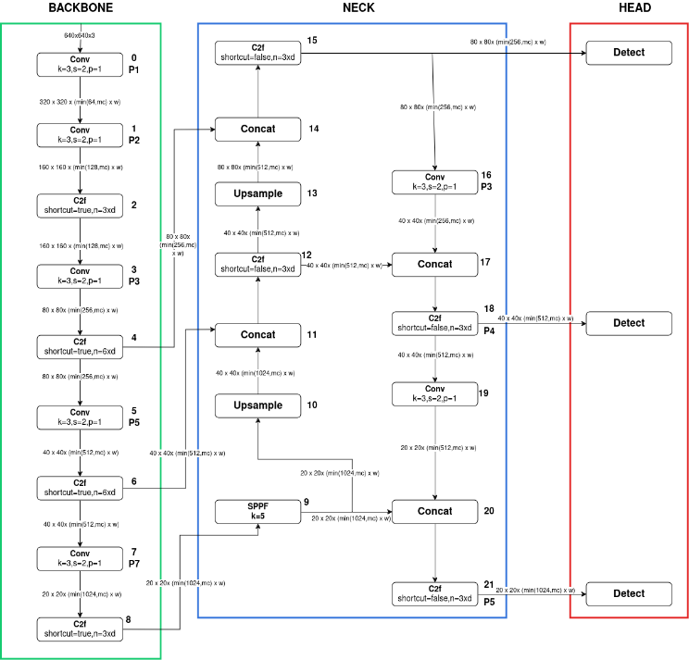

1. YoloV8 architecture.

The detection task was performed using YOLOv8, a state-of-the-art object detection framework recognized for its exceptional accuracy and speed. This model was specifically trained to identify both English and Bangla characters on vehicle license plates, making it well-suited for the multilingual nature of Bangladeshi plates. As illustrated in Fig. 3, YOLOv8 processes input images resized to 640×640 pixels and utilizes a training pipeline with a learning rate of 0.01 and a batch size of 16. The model underwent 200 epochs of training, during which bounding box predictions were continuously refined to ensure precise license plate localization.

## EasyOCR framework

For character recognition, the EasyOCR framework was employed due to its robust multilingual capabilities, particularly in recognizing English and Bangla scripts [23]. After YOLOv8 successfully identified and localized the license plates by cropping the respective sections from the input images, EasyOCR was utilized to extract textual information from these regions.

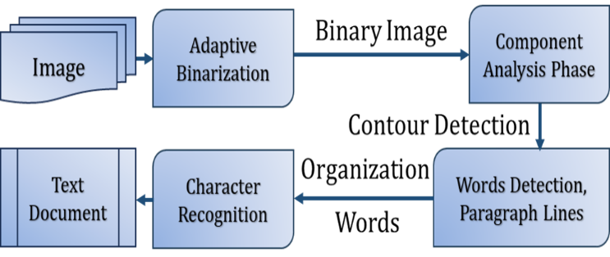

1. EASY-OCR working technique.

From Fig. 4, the recognition process followed a structured sequence, starting with the original image, which underwent adaptive binarization to enhance contrast and remove noise. Component analysis was then applied to identify and group connected components, aiding in the detection of word regions within the image. The detected words were processed through a two-step recognition process, converting them into an editable document format.

In parallel, the license plate region identified by YOLOv8 was segmented to isolate individual characters or clusters of characters. This segmentation step minimized overlap and ensured accurate input for the OCR phase. EasyOCR was then utilized to process these segmented characters, accurately decoding alphanumeric information while addressing challenges such as varying fonts, irregular spacing, and partial occlusions. The integration of YOLOv8 for detection and EasyOCR for recognition provided a seamless and robust pipeline for number plate recognition. This methodology effectively tackled the multilingual and complex nature of Bangladeshi license plates, delivering reliable results across diverse and challenging scenarios.

# Results and Discussions

After the successful development of the model and completion of character segmentation, various performance evaluation metrics were calculated to assess the overall effectiveness of the system and analyze the research outcomes. These metrics include Mean Average Precision (mAP), precision, recall, Character Error Rate (CER), and Word Error Rate (WER) [24]. The results obtained from these evaluations provide a comprehensive understanding of the system's accuracy in detecting and recognizing license plate characters, highlighting its strengths and areas for improvement. The mathematical formulations of these metrics are provided below for a clear and precise interpretation of the performance.

(1)

(2)

(2)

(3)

(4)

## Experiemtns Results

The results of our proposed system demonstrate its effectiveness in detecting Bangla vehicle number plates and recognizing multilingual characters, showcasing its robustness and adaptability in diverse scenarios. By utilizing YOLOv8 for number plate detection, the system achieved impressive performance metrics: a precision of 94.78%, recall of 93.05%, and a mean average precision (mAP@0.5) of 96.80% (see Table II). These results highlight the model’s ability to accurately localize license plates under challenging conditions, such as skewed plates, varying lighting, and partial occlusions.

1. Detection and Recognition Metrics For YOLOv8.

| Detection Matrix | | | Recognition Matrix | |
| --- | --- | --- | --- | --- |
| Precision | Recall | mAp@0.5 | Character Error Rate (CER) | Word Error Rate (WER) |
| 94.78% | 93.05% | 96.80% | 1.52% | 5.53% |

From Table III, to further evaluate the proposed system, we compared its performance with a baseline model using YOLOv4 for detection and Tesseract for character recognition. The YOLOv4 + Tesseract system achieved a detection accuracy of 88.5%, with a higher CER of 5.10% and WER of 12.50%. In contrast, our system, which leverages YOLOv8 for detection and EasyOCR for character recognition, achieved a significantly higher detection accuracy of 96.0%, with a much lower CER of 1.52% and WER of 5.33%. This comparison clearly demonstrates the superior performance of our system, particularly in handling the complexity of multilingual scripts. The enhanced detection capabilities of YOLOv8 and the robust multilingual support of EasyOCR are key factors contributing to the system's improved performance, making it a more reliable and scalable solution for real-world applications.

1. Performance Comparision with Two Models.

| Model version | Detection Accuracy | Character Error Rate (CER) | Word Error Rate (WER) |
| --- | --- | --- | --- |
| TOLOv4+ tesseract | 88.5% | 5.10% | 12.50% |
| YOLOv8+ EasyOCR | 96.0% | 1.52% | 5.33% |

Fig. 5 presents the model’s performance curves, including train box loss and class loss graphs, which offer a deeper insight into the training dynamics and overall efficiency of the system. These curves reflect the model’s convergence during training, with the loss steadily decreasing and the accuracy improving across epochs. This progression underscores the model’s ability to learn from the dataset and optimize for better generalization in real-world scenarios. Additionally, Fig. 6 visualizes the entire detection pipeline, starting from the original image to the localized license plate with bounding boxes, demonstrating YOLOv8’s effectiveness in real-world applications. The bounding boxes, which mark the detected vehicle license plates, clearly indicate the system’s ability to accurately identify and isolate the number plate region in varying conditions. This process is essential for applications like toll collection, parking management, and traffic monitoring, where real-time vehicle identification is crucial. The visual representation in Fig. 5 not only showcases the system’s capability to handle complex detection tasks but also validates the robustness of YOLOv8 in processing images with skewed, occluded, or partially blurred plates.

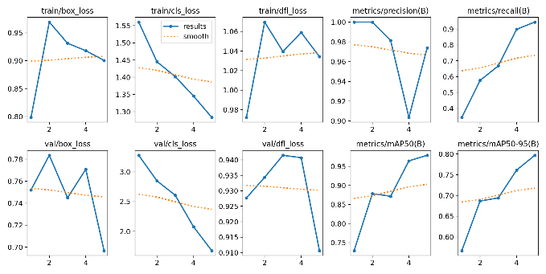

1. The perofrmance curve for the proposed model.

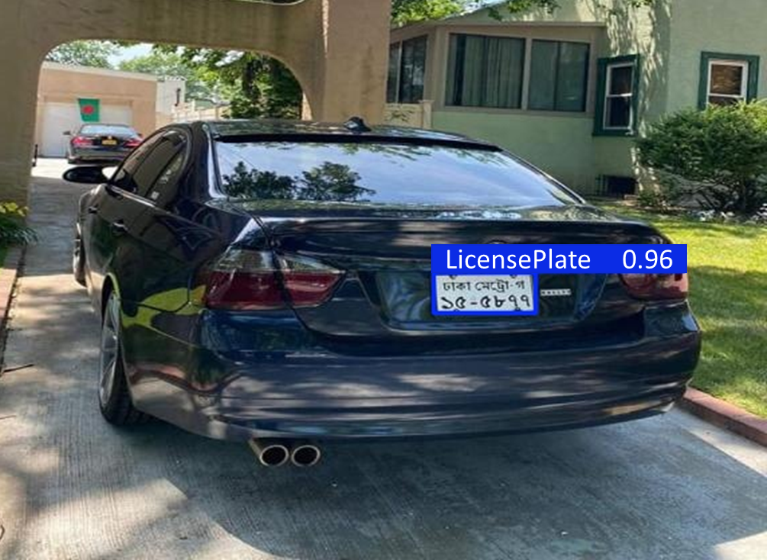

1. EASY-OCR working technique.
2. Character Recognition from the Detected Number Plate.

| Character Recognition |
| --- |
| Detected Text: ঢাকা মেট্রো-গ  Detected Text: ১৫-৫৮৭৭ |

Table IV shows the output of character recognition from the detected number plate. In real-time applications, such as automated toll booths or smart traffic management systems, accurate number plate detection and character identification are vital for ensuring the smooth operation of transportation infrastructure. The combination of YOLOv8’s high-precision detection and EasyOCR’s accurate character recognition, as visualized in the performance curves, makes the system a reliable and scalable solution for real-time vehicle monitoring and identification. With continuous improvement in detection accuracy and robustness, this system can be expanded to handle diverse environmental conditions, including adverse weather, poor lighting, and various license plate formats.

## Discussions

This study presents an advanced system that integrates EasyOCR for accurate character recognition and YOLOv8 for high-precision vehicle number plate detection. The system demonstrated remarkable performance, achieving a Character Error Rate (CER) of 1.52%, a Word Error Rate (WER) of 5.53%, and detection accuracy ranging from 93% to 96%. These results highlight the system’s ability to handle the complexities of multilingual license plates, including both Bangla and English scripts, under various challenging conditions such as skewed plates, occlusions, and varying lighting. The combination of EasyOCR’s Bangla recognition capabilities and YOLOv8’s detection strength makes the system highly adaptable for practical applications like automated toll collection, parking management, and traffic monitoring.

However, the system does face certain limitations. The recognition of Bangla-English plates is hindered by the intricacies of Bangla script, such as diacritical marks and varying sizes, resulting in occasional misclassifications, as reflected by the CER and WER values. Additionally, challenges such as font diversity, low-resolution images, noise, motion blur, and poor lighting conditions can degrade performance, especially in real-world environments like CCTV footage. These limitations indicate that further refinement is needed to enhance the system's robustness and accuracy under a wider range of real-world conditions.

# Conclusion

In conclusion, the proposed system for Bangla vehicle number plate detection and recognition, utilizing YOLOv8 for detection and EasyOCR for character recognition, demonstrates exceptional performance across various metrics. The system achieved a Character Error Rate (CER) of 1.52%, a Word Error Rate (WER) of 5.53%, and a detection accuracy between 93% and 96%, highlighting its robustness in accurately detecting and recognizing Bangla and English scripts. These results validate the system's capability to effectively handle complex and challenging scenarios such as skewed plates, varying illumination, partial occlusions, and multilingual scripts, making it a viable solution for intelligent transportation applications, including automated toll collection, parking management, and traffic monitoring. The combination of state-of-the-art deep learning techniques and a carefully curated dataset enhances the system’s adaptability and resilience in real-world environments, particularly in regions like South Asia, where multilingual number plates are common. However, the system does face certain limitations, such as difficulties with the intricacies of Bangla scripts, font diversity, and performance degradation under low-resolution or noisy inputs. These challenges can result in occasional misclassifications, as indicated by the CER and WER. Despite these challenges, the proposed system holds significant promise for widespread practical application. Future work should focus on addressing the existing limitations, including improving recognition accuracy under challenging conditions and enhancing the generalization capabilities of the model. By refining these aspects, the system’s scalability and effectiveness in real-world deployments can be further strengthened, making it a more robust solution for intelligent transportation and smart city initiatives.

##### References

1. Jawale, M.A., William, P., Pawar, A.B. and Marriwala, N., 2023. Implementation of a number plate detection system for vehicle registration using IOT and recognition using CNN. Measurement: Sensors, 27, p.100761.
2. Onim, M.S.H., Akash, M.I., Haque, M. and Hafiz, R.I., 2024, December. Traffic surveillance using vehicle license plate detection and recognition in bangladesh. In 2020 11th International conference on electrical and computer engineering (ICECE) (pp. 121-124). IEEE.
3. Tripathi, S., Jain, S., Shetty, S. and Sharma, V., 2023. Automatic Number Plate Recognition System (ANPR): The Implementation. International journal of Innovative technology and exploring engineering, 10(8S), pp.580-585.
4. Tech M. and Kumari, L.R., 2023. Automatic Traffic E Challan Generation using Deep learning. MATERIAL SCIENCE, 22(09).
5. Barreto, F., Almeida, N.D., Nadar, P., Kaur, R. and Khairnar, S., 2024. Object Detection and e-Challan Generation Systems for Traffic Violation: A Review. International Journal of Research in Engineering, Science and Management, 4(5), pp.54-57.
6. He, J., Wang, K., Bibicu, D., Moldovanu, S., Moraru, L., Teodor, V.G., Baroiu, N. and Berbinschi, S., 2023, November. IOP conference series: materials science and engineering. In Proceedings of the International Conference on Functional Materials and Chemical Engineering, Dubai, United Arab Emirates (pp. 24-26).
7. Alam, N.A., Ahsan, M., Based, M.A. and Haider, J., 2023. Intelligent system for vehicles number plate detection and recognition using convolutional neural networks. Technologies, 9(1), p.9.
8. Ganta, S. and Svsrk, P., 2024. A novel method for Indian vehicle registration number plate detection and recognition using image processing techniques. Procedia Computer Science, 167, pp.2623- 2633.
9. Chandra, B.M., Sonia, D., Roopa Devi, A., Yamini Saraswathi, C., Mighty Rathan, K. and Bharghavi, K., 2023. Recognition of vehicle number plate using Matlab. J. Univ. Shanghai Sci. Technol, 23(2), pp.363-370.
10. Gnanaprakash, V., Kanthimathi, N. and Saranya, N., 2024, March. Automatic number plate recognition using deep learning. In IOP Conference series: materials science and engineering (Vol. 1084, No. 1, p. 012027). IOP Publishing.
11. Kumar, J.R., Sujatha, B. and Leelavathi, N., 2024, February. Automatic vehicle number plate recognition system using machine learning. In IOP Conference Series: Materials Science and Engineering (Vol. 1074, No. 1, p. 012012). IOP Publishing.
12. Islam, D., Mahmud, T. and Chowdhury, T., 2023. An efficient automated vehicle license plate recognition system under image processing. Indonesian Journal of Electrical Engineering and Computer Science, 29(2), pp.1055-1062.
13. Mhatre, A. and Sharma, P., 2023. Deep Learning Approach for Vehicle Number Plate Recognition System with Image Enhancement Technique. International Journal of Intelligent Systems and Applications in Engineering, 11(1s), pp.251-262.
14. rema, M.D.R., Balaji, S.S., Srikanth, P. and Kumar, S.A., LICENSE PLATE DETECTION USING IMAGE PROCESSING.
15. Garg, P., Toshniwal, P. and Panjwani, R., REAL TIME MOVING VEHICLE REGISTRATION PLATE DETECTION.
16. Alsudani, M.Q., Waheed, S.R., Kadhim, K.A., Adnan, M.M. and Al- khaykan, A., 2023. Automatic Car Number Plate Detection using Morphological Image Processing. Malaysian Journal of Fundamental and Applied Sciences, 19(3), pp.379-388.
17. Neupane, D., Bhattarai, A., Aryal, S., Bouadjenek, M.R., Seok, U. and Seok, J., 2024. Shine: A deep learning-based accessible parking management system. Expert Systems with Applications, 238, p.122205.
18. Ba, Y. and Sun, J., 2024, February. Athlete Number Plate Application Based on Deep Learning Image Recognition. In 2023 International Conference on Data Science, Advanced Algorithm and Intelligent Computing (DAI 2023) (pp. 343-353). Atlantis Press
19. Mustafa, Twana, and Murat Karabatak. "Real time car model and plate detection system by using deep learning architectures." IEEE Access (2024).
20. Mhatre, Amruta, and Prashant Sharma. "Deep Learning Approach for Vehicle Number Plate Recognition System with Image Enhancement Technique." International Journal of Intelligent Systems and Applications in Engineering 11, no. 1s (2023): 251-262.
21. Kothai, G., E. Povammal, S. Amutha, and V. Deepa. "An Efficient Deep Learning Approach for Automatic License Plate Detection with Novel Feature Extraction." Procedia Computer Science 235 (2024): 2822-2832.
22. Gui, Zili, and Jianping Geng. "YOLO-ADS: An Improved YOLOv8 Algorithm for Metal Surface Defect Detection." *Electronics* 13, no. 16 (2024): 3129.
23. Maruf, Abdullah Al, Aditi Golder, Maryam Sabah Naser, Ahmad Jainul Abidin, Ananna Alom Chowdhury Giti, and Zeyar Aung. "Development of Automatic Number Plate Recognition System of Bangladeshi Vehicle Using Object Detection and OCR." In *International Conference on Advances in Data-driven Computing and Intelligent Systems*, pp. 331-342. Singapore: Springer Nature Singapore, 2023.
24. Rajabhushanam, C., P. Kiran Kumar, P. Shanmukha Sai, P. Ajay, and P. Suvarna Jayaprada. "Helmet Detection and Number Plate Recognition Using Deep Learning." (2024).