Haider Alkhalifah – 202157510 | Abdullah AL-Abbas – 202156190

Project Report

King Fahd University of Petroleum and Minerals

ICS-108 : Object-Oriented Programming

Mr. Rashad Othman

Ghost class – Haider:

This code helps the game to create and show different ghosts with their own scores and pictures. It has two instance variables: score, which represent the score associated with the ghost, and image, which represent the image file associated with the ghost.

Player class – Haider:

This class creates unique players. Each player has their own score, which is important for creating a leaderboard that shows the top 5 players after the game ends.

Leaderboard class – Haider:

When a player finishes the game, we use the "addPlayer" method to add them to the leaderboard. This method also takes care of arranging the players in order of their scores, from the highest to the lowest. That way, the best players will be at the top of the list.

and if there are more than 5 players on the list, we remove the player who is ranked 6th, which makes sure we only keep the best 5 players.

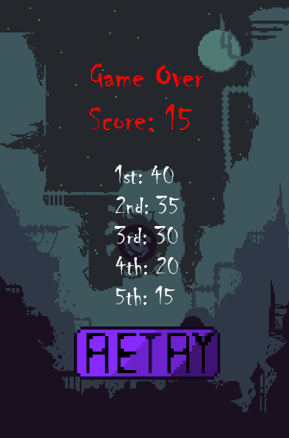

Ghostbuster class

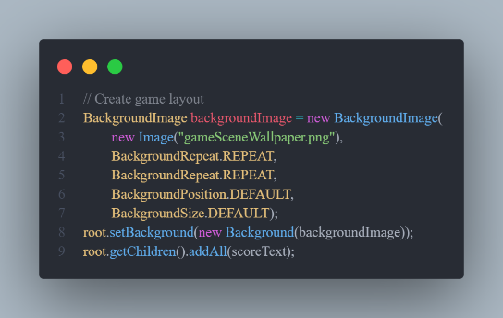-Creating the game layout – Abdullah

This code sets the background image for

the game scene and adds the score text

node to the root node.

-Creating Score and gameOver text – Abdullah

This code configures the font, color, and position of the

scoreText and gameOverText nodes, and adds the

gameOverText node to the root node.

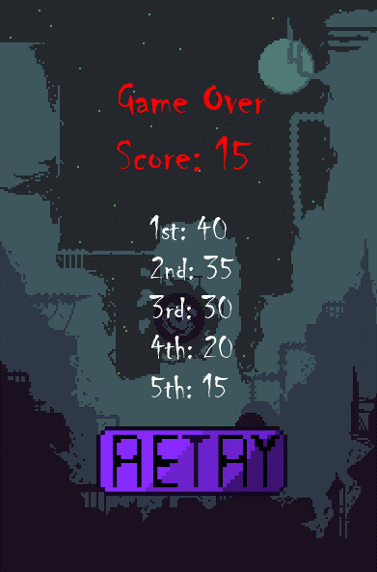

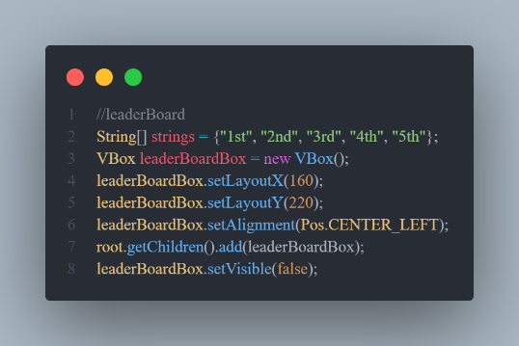-Creating leaderBoard – Haider

This code creates a VBox container and configures

its layout properties and alignment. The

leaderBoardBox is then added to the root node,

making it part of the game layout.

-Handling mouse clicks on different objects – Abdullah

Each object, object1, object2, and object3, has an

setOnMouseClicked event handler assigned to it

that when the user clicks on any of these objects,

the object is removed and the score is increased and .

the scoreText object is updated with the new score and

the objectSpeed variable is incremented .

-Creating startButton – Haider

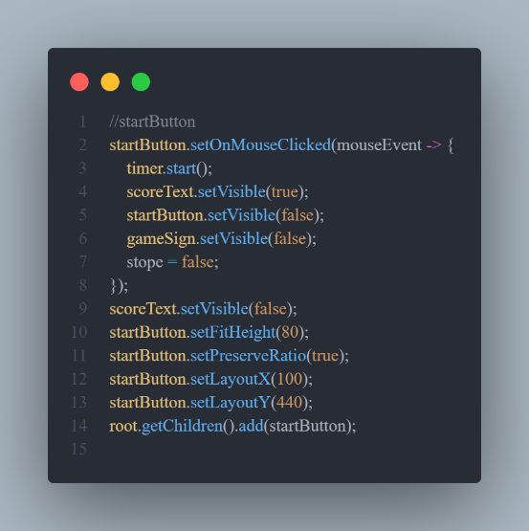This code sets up the start button functionality,

including starting the game and when the user press on it ,

it will display the score and hide the start button.



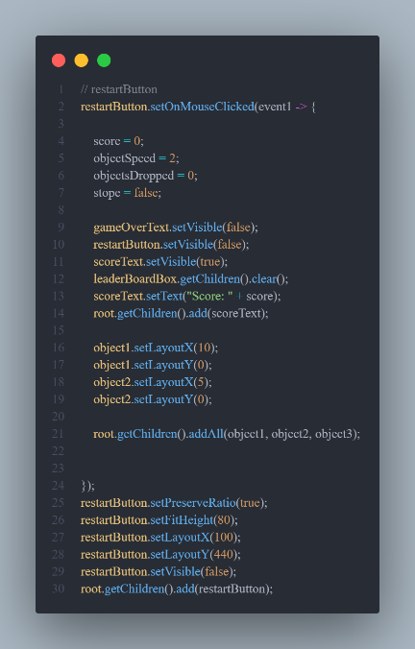

-Creating restartButton – Haider

This code sets up an event handler for a restart button.

When the button is clicked, the code inside the event

handler is executed, which performs several actions to reset

the game state and prepare for a new game.



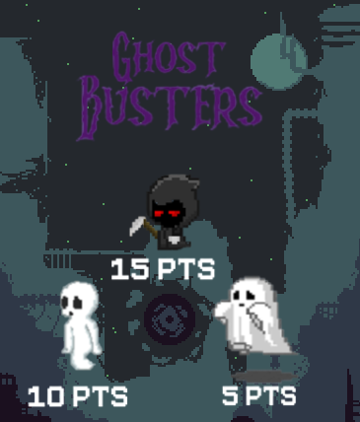-Creating gameSign – Abdullah

This code display the gameSign image on the

screen and the point on the ghosts.

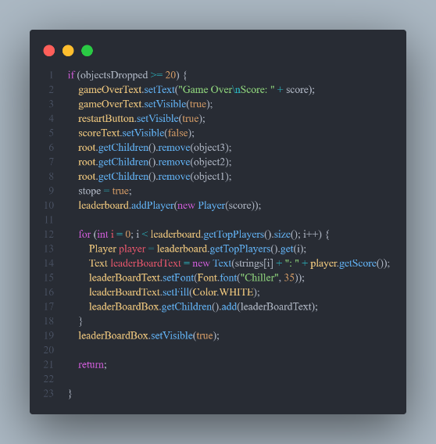

-Ending the game – Haider

This code ends the game after a certain amount of ghosts

Appear on the screen then display the leaderBoard.

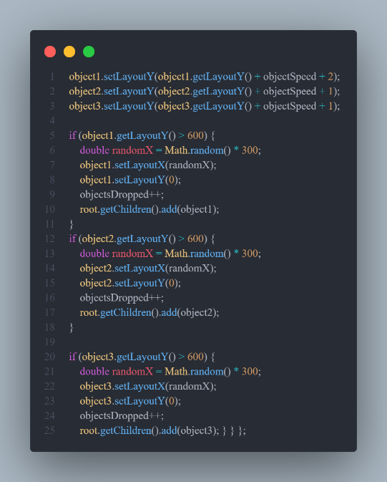-Objects position – Haider and Abdullah

This code make sure that the ghost fall on a specific

boundaries and in a random position.

Links:-

[our working process.](https://github.com/AbdullahAlabbas/ICS-108/tree/editable/Ghostbusters)

[project demo.](https://youtu.be/wzCCGzdYKkw)