Constellation Worksheet

Repl.it: <https://repl.it/join/dfttzygq-abdullahalazza1>

Screenshot of Screen 1:

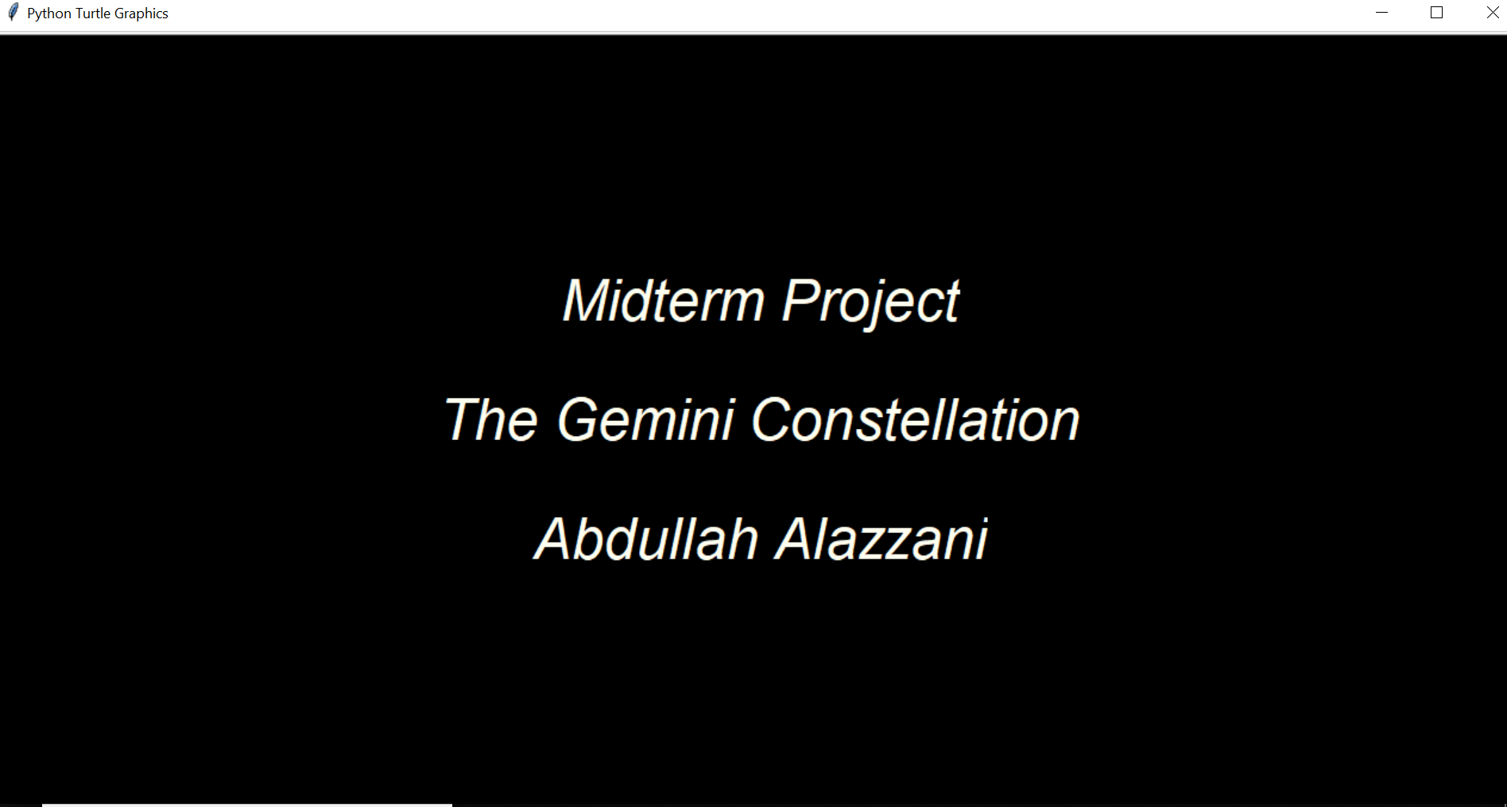

Screenshot of Screen 2:

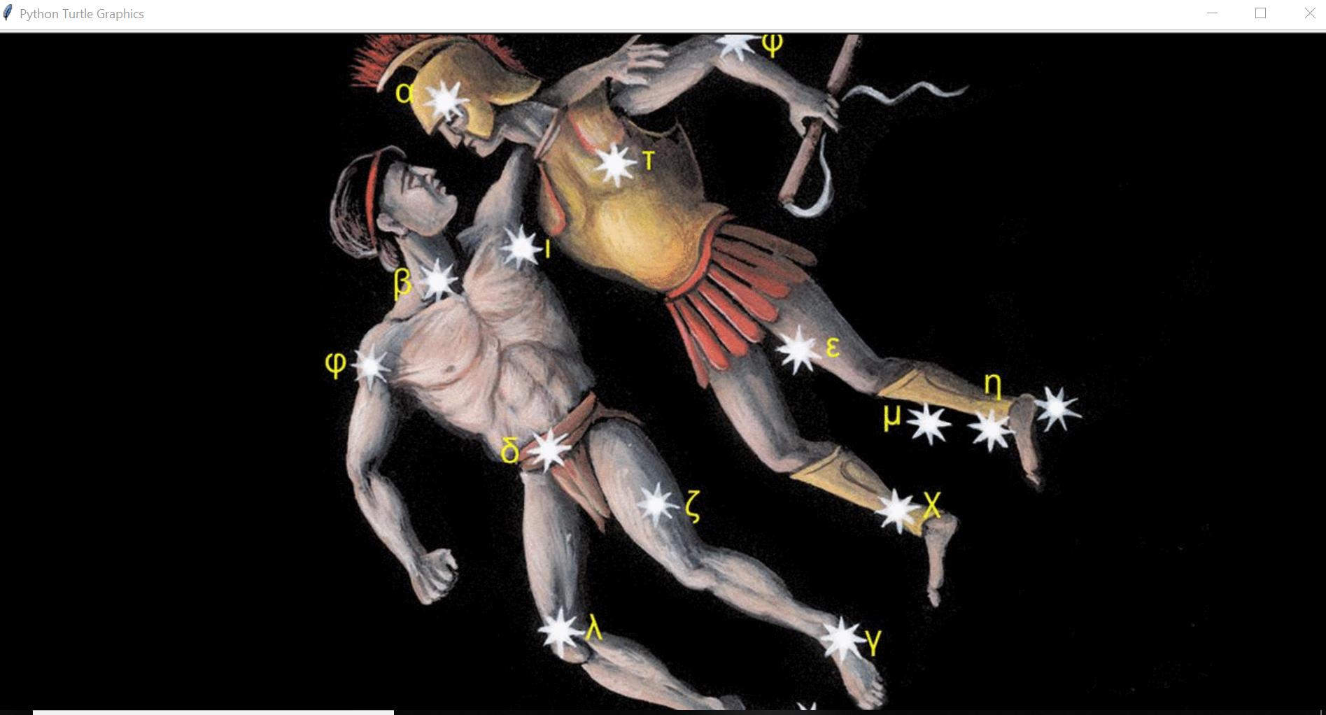

Screenshot of Screen 3:

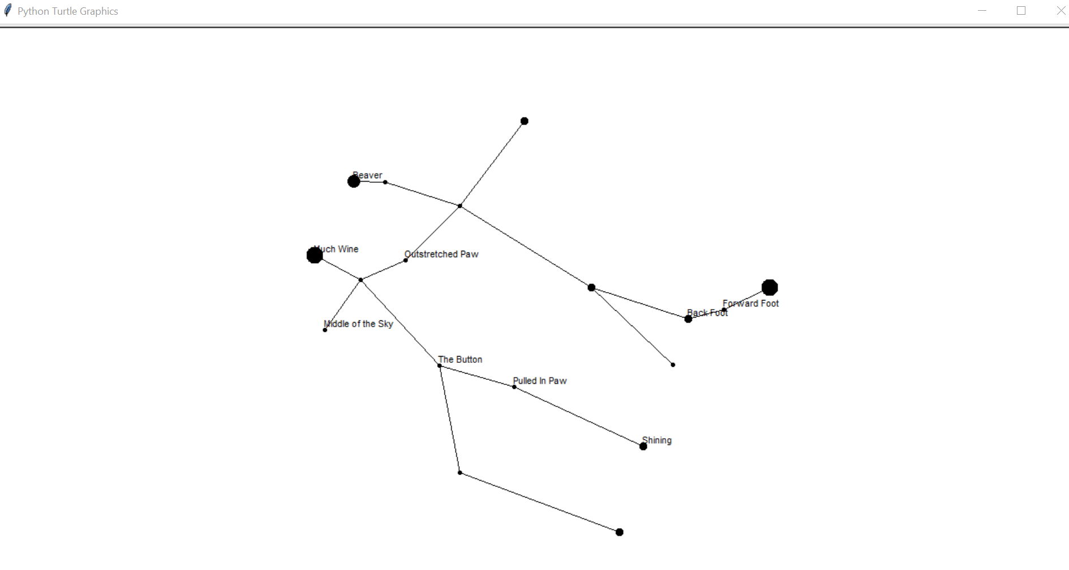

Screenshot of Screen 4:

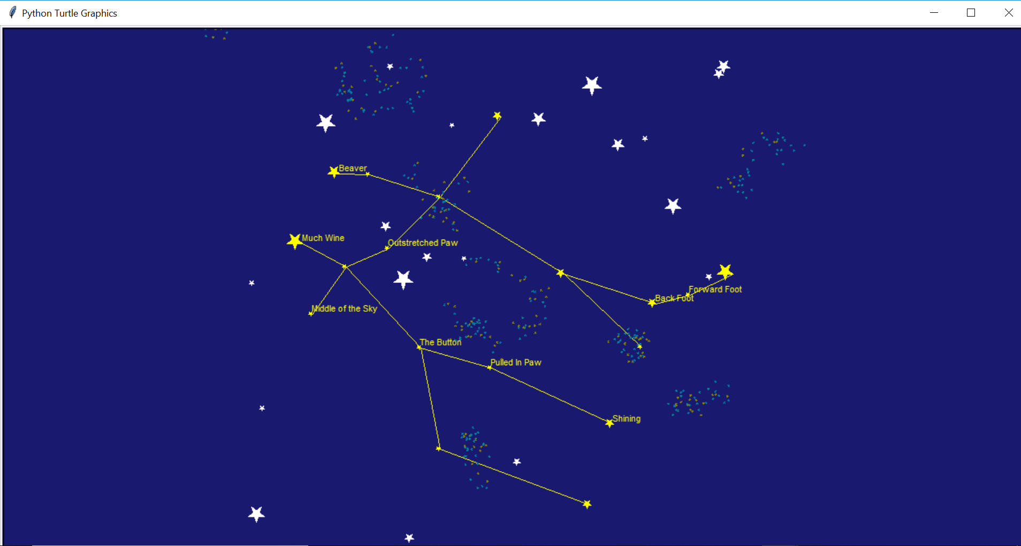

Screenshot of Code:

I uploaded the source file.

Repl.it: <https://repl.it/join/dfttzygq-abdullahalazza1>