

**MedVision AI**

**Tuwaiq Academy final project**

**Team members:**

* Abdullah Albuqmi
* Khalid Khubrani
* Khalid Alshuraim
* Razan Albishri
* Reem Alsaif

**Instructors:**

* Eng. Hany ELshafey
* Eng. Yazeed Alzahrani

**Table of Content**

| No. | Section Title | Page |
| --- | --- | --- |
| 1 | Abstract | 3 |
| 2 | Problem Statement | 4 |
| 3 | Objective Statement | 5 |
| 4 | Existing Solutions | 6 |
| 5 | Our Proposed Solution | 7 |
| 6 | Engineering Requirements | 10 |
| 7 | Engineering Specifications | 11 |
| 8 | The design | 12 |
| 9 | Conclusion | 16 |
| 10 | References | 17 |
|  |

**Abstract**

MedVision AI is a comprehensive clinical platform integrating computer vision diagnostics with multilingual AI assistance. The system features specialized deep learning models for medical imaging analysis including chest X-ray brain MRI, kidney CT, skin diseases, and eye diseases classification. The platform combines bilingual drug interaction tools with clinical chatbots using DeepSeek and fine-tuned TinyLLaMa, enhanced with safety guardrails. Delivered through an interactive website interface, it provides Arabic/English clinical decision support, transforming complex medical data into actionable insights for improved diagnostic accuracy and patient care.

**الملخص**

تمثل منصة MedVision AI نظاماً متكاملاً للدعم السريري تجمع بين تشخيصات الرؤية الحاسوبية والمساعدة الذكية متعددة اللغات. تتضمن المنصة نماذج متخصصة للتعلم العميق لتحليل الصور الطبية تشمل أشعة الصدر، والرنين المغناطيسي للدماغ، والأشعة المقطعية للكلى، بالإضافة إلى تصنيف أمراض الجلد والعيون. تجمع المنصة بين أدوات التفاعلات الدوائية ثنائية اللغة ومساعدين سريريين ذكيين باستخدام DeepSeek وTinyLLama المحسن، مع تطبيق إجراءات السلامة. تُقدم المنصة عبر واجهة ويب تفاعلية دعماً سريرياً باللغتين العربية والإنجليزية، محولةً البيانات الطبية المعقدة إلى رؤى قابلة للتطبيق لتحسين دقة التشخيص والرعاية المرضية.

**Problem Statement**

The Saudi healthcare system faces significant challenges in diagnostic accuracy and clinical knowledge across multiple medical specialties, potentially compromising patient safety and treatment outcomes. Current evidence reveals substantial knowledge gaps among healthcare professionals, including:

1. **Inadequate Radiological Interpretation**: Approximately 29% of physicians demonstrate only fair knowledge in interpreting pediatric emergency chest X-rays, with recognition rates for critical findings ranging from 28-65%, indicating potential delays in emergency pediatric care.
2. **High Diagnostic Error Rates**: Ophthalmology referrals show only 33% accuracy in initial diagnoses, while central nervous system tumors experience approximately 30% diagnostic errors, despite a 330% increase in incidence rates from 1990-2019.
3. **Knowledge Deficiencies in Primary Care**: Primary care physicians exhibit variable dermatological knowledge, with literature reporting up to 68.5% insufficient knowledge in some settings, potentially affecting early detection of serious skin conditions.
4. **Technical Performance Gaps**: MRI radiographers demonstrate limited proficiency in identifying (20% success rate) and correcting image-quality errors, potentially leading to suboptimal imaging and repeated scans.
5. **Medication Safety Concerns**: Geriatric outpatients show alarming rates of potential drug-drug interactions (90.64%), with 16.45% being category-X (most severe), compounded by community pharmacists' knowledge gaps (approximately 38.2% mean knowledge score).

These systemic challenges highlight the urgent need for comprehensive assessment and targeted interventions to enhance diagnostic accuracy, clinical knowledge, and patient safety across the Saudi healthcare landscape.

**Objective Statement**

This research aims to develop and implement an integrated AI-powered clinical decision support platform to address critical diagnostic and knowledge gaps in Saudi healthcare through the following specific objectives:

1. **Develop Advanced Computer Vision Systems: Build and deploy deep learning models for automated analysis and quality rating of medical imaging, specifically targeting:**
   * Chest X-ray interpretation with performance scoring
   * MRI image quality assessment and error detection
   * Radiological finding classification and prioritization
2. **Create Intelligent Drug Interaction Platform: Implement a comprehensive medication safety system featuring:**
   * Real-time drug-drug interaction detection and severity classification
   * Bilingual drug information and therapeutic guidelines
3. **Build Bilingual Clinical AI Assistant: Develop an LLM-powered clinical chatbot specifically designed for healthcare professionals with:**
   * Natural Arabic and English language processing capabilities
   * Context-aware clinical decision support
   * Evidence-based medical knowledge retrieval
   * Differential diagnosis assistance
4. **Design Integrated User Experience: Create an intuitive, unified web interface that provides:**
   * Streamlined workflow integration for busy clinical environments
   * Interactive diagnostic tools and visualization dashboards
   * Simple navigation between imaging analysis, drug safety, and clinical consultation modules
   * Responsive design optimized for hospital and clinic use cases
   * Regulatory compliance and data security standards

By achieving these objectives, this platform will serve as a comprehensive AI clinical assistant, enhancing diagnostic precision, medication safety, and clinical decision-making while supporting Saudi Arabia's healthcare digital transformation goals under Vision 2030.

**Existing Solutions**

Several medical platforms currently provide drug information and interaction checking, including:

* **DrugBank** – offers structured pharmaceutical data but mainly in a static database format with limited user interaction.
* **Medscape** and **Drugs.com** – allow users to search and check conflicts but provide long textual outputs without context-aware reasoning.
* **FDA Drug Interaction Checker** – reliable but minimalistic, lacking deep explanations or user-friendly visual tools.
* **AI-based health assistants** like WebMD bots or general-purpose models like ChatGPT and Bard can provide medical answers, but they lack domain specialization, cannot visualize relationships, and do not guarantee medical-grade accuracy without curated datasets.

Despite their usefulness, these solutions share major shortcomings:

* **No intelligent explanation or summarization** — Users must manually interpret dense medical jargon.
* **No real-time visualization** — Conflict relationships between drugs are not shown graphically.
* **Weak or no Arabic support** — Most systems are English-only or offer poor translations.
* **Lack of personalized interaction** — No AI-driven chatbot that adapts responses based on user queries or symptoms.
* **No side-by-side comparison** — Users cannot easily contrast two drugs to see conflict severity or compatibility.

**Our Proposed Solution**

To address the limitations of existing drug information platforms, we propose an integrated AI-powered medical assistant that combines multilingual reasoning, visual analytics, and biometric monitoring within a unified interface.

Unlike traditional systems that only provide static text-based results, our solution is designed as a modular and scalable platform, where each component can evolve independently and new healthcare features can be added over time.

**Core Technological Innovations:**

* **Dual AI Clinical Chatbot System**
* DeepSeek 3.2v-685B: Native Arabic and English understanding for complex clinical reasoning and detailed medical explanations
* Fine-tuned TinyLLaMa-1B: Optimized for rapid response generation in English, with Deep-Translator library for Arabic support
* Unified Safety Framework: Guardrails Instructions implemented on both models to ensure medically appropriate responses and prevent hallucinations
* Context-Aware Dialog: Maintains conversation context for follow-up questions and clinical scenario development across both chatbots
* **Advanced Medical Imaging Analysis - Multi-Modal Approach**

**Chest X-ray Pathology Detection:**

* Model Architecture: Traditional Computer Vision pipeline using HOG (Histogram of Oriented Gradients) feature extraction with SVM (Support Vector Machine) classification
* Technical Stack: OpenCV (cv2) for image processing and feature extraction
* Training Data: Chest X-ray Dataset (comprehensive pulmonary imaging collection)
* Performance: 96.29% Accuracy in detecting pulmonary abnormalities and pathologies
* Clinical Application: Rapid screening for pneumonia, tuberculosis, and other thoracic conditions

**Brain Tumor MRI Detection:**

* Model Architecture: DenseNet121 with Transfer Learning and Fine-Tuning
* Training Data: Brain Tumor MRI Dataset (≈7,000 images)
* Training Data source: Kaggle
* Network Depth: ≈126 layers optimized for neurological imaging
* Clinical Application: Automated brain tumor classification
* Performance:Test Accuracy: 93.36%

**Kidney Stone CT Detection:**

* Model Architecture: DenseNet121 with Fine-Tuning on renal imaging
* Training Data: Kidney Stone CT Dataset (≈4200 images)
* Data source: Kaggle
* Network Depth: ≈125 layers specialized for urinary system analysis
* Clinical Application: Kidney Stone Detection
* Performance: Test Accuracy: 98.36%

**Skin Disease Classification**

* Model Architecture**:** Specialized neural networks
* Training Data: Skin computer vision dataset (≈750 images)
* Data source: roboflow
* Clinical Application**:** Diagnose skin diseases from images

**Eye Disease Classification**

* ModelArchitecture**:** Advanced computer vision models
* Training Data: Eye-disease-classification dataset (≈1200 images)
* Data source: roboflow
* Clinical Application**:** Analyze eye images for disease diagnosis

**Advanced Drug Conflict Detection & Visualization**

* Intelligent Interaction Engine: Retrieves and analyzes data from Drugbank
* Data source: Drugbank
* Comparative Analysis Tools: Side-by-side drug compatibility matrices

**Comprehensive Drug Documentation System**

* Structured Information Access: Instant retrieval of medication details including indications, contraindications, side effects, and classifications
* Quick Reference Design: Optimized for busy clinical environments requiring rapid information access
* Data source: Drugbank

This approach transforms complex medical data into interactive, understandable, and bilingual insights, Merged under one website, positioning the system as a reliable and extensible digital health companion for real-world healthcare applications.

**Engineering Requirements**

The system was designed with both **functional** and **non-functional** engineering requirements:

**Functional Requirements**

* Ability to input drug names or IDs and retrieve corresponding data.
* Multi-modal Medical Analysis to Process and classify medical images including X-rays, MRIs, CT scans, skin lesions, and eye diseases
* Automatic translation for multilingual inputs and outputs.
* Intelligent analysis of potential drug conflicts.
* Interactive visualizations in the website.
* Real-time chatbot responses based on AI reasoning.
* Drug-to-drug comparison capability.

**Non-Functional Requirements**

* High reliability and uptime for continuous data access.
* Data privacy and security for medical datasets.
* Fast response time (<3 seconds per query).
* Scalable architecture for adding more drugs or models.
* Support for mobile and desktop web browsers.

**Engineering Specifications**

| **Component** | **Description** |
| --- | --- |
| **AI Model** | TinyLLaMa-1B, DeepSeek 3.2v 685B |
| **Translation Engine** | Deep Translator – handles multilingual input/output |
| **Frontend** | Website – builds an interactive and lightweight dashboard |
| **Backend** | PostgreSQL, Render, FastAPI, Ngrok, Flask, Huggingface Providers |
| **Visualization Tools** | Matplotlib, Plotly, Seaborn for graphs and visual insights |
| **Database / Dataset** | Multiple different sources, including: drugbank, Kaggle and roboflow |
| **Chatbot Framework** | LLM dialogue system using both: TinyLLaMa-1B, DeepSeek 3.2v 685B, with prompt-engineering and Guardrails instructions |
| **Hosting Environment** | Google Colab / Localhost / render / Huggingface / lovable servers |
| **Security** | Encrypted PostgreSQL database |
| **Performance Metrics** | Models: 92% to 98%, Latency: < 3seconds |

**The Design**

* **Concept Summary**

The Smart Medical System is an integrated AI-driven healthcare platform that combines computer vision, natural language processing, and clinical decision support into one unified digital environment.  
It enables doctors and medical staff to analyze medical images, interact with intelligent assistants, and review safe drug interactions — all through a single, web-based interface.

The system is designed for clinical efficiency, data security, and multilingual accessibility, with special focus on supporting the Arabic medical community.

* **Core Concept**

The system functions as a modular AI ecosystem, where each medical model or service operates independently but connects through a central orchestrator (FastAPI-based backend).  
This ensures scalability, easy model upgrades, and parallel service operation.

All services are connected through secure APIs, ensuring smooth data flow between:

* the frontend (Lovable),
* the AI inference services (on Render),
* and external AI endpoints (Hugging Face, Google Colab).
* **System architecture**

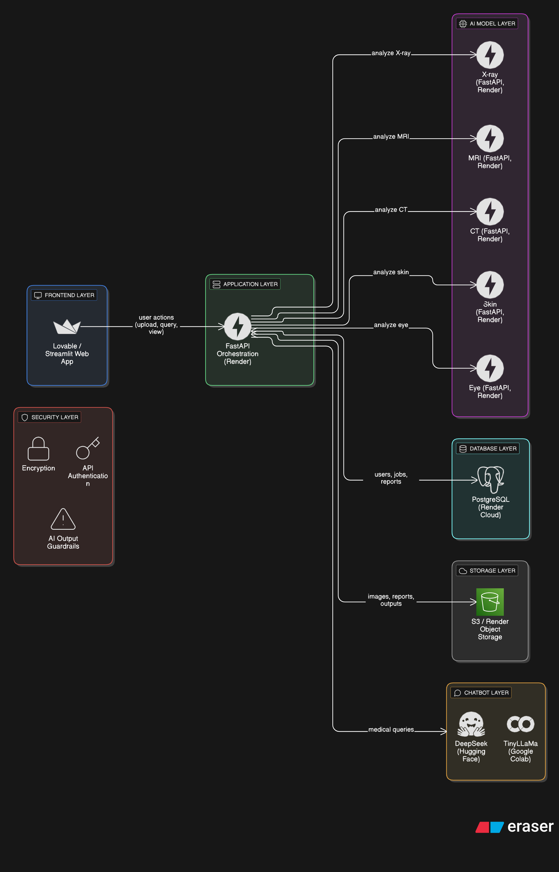

* **Use cases**

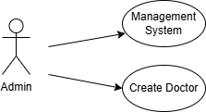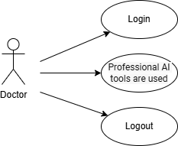

* **Functional Modules**

1. Computer Vision
   * Detects diseases from medical images (X-ray, MRI, CT, etc.)
2. Smart Pharmaceutical System
   * Checks drug interactions, dosage, and safety warnings
3. Smart Medical Assistant (Chatbots)
   * Provides multilingual medical explanations and translation
4. Clinical Dashboard
   * Visualizes diagnostic results and models analytics
5. Security & Privacy
   * Implements guardrails, data encryption, and user access control

* **Hosting & Integration Concept**

| **Platform** | **Purpose** |
| --- | --- |
| Render | Hosts all FastAPI services |
| Hugging Face | Hosts the DeepSeek chatbot model |
| Google Colab | Hosts TinyLLaMa (lightweight translation/QA model) |
| Lovable | Unified web interface for all system features and database |

**Key Conceptual Advantages**

* Unified Interface: One platform for imaging, drugs, and chat assistance
* Scalable Design: Each AI model runs independently (microservice architecture)
* Bilingual AI: Arabic & English chatbot integration
* Explainable AI: Visual model interpretation for transparency

**Conclusion**

The Smart Medical System integrates AI-driven imaging, drug analysis, and multilingual chat support into a single, secure platform. Its modular design ensures scalability, reliability, and continuous improvement.

Doctors can quickly analyze medical images, review drug interactions, and interact with intelligent assistants in Arabic and English, all while maintaining data privacy and compliance.

This platform demonstrates how AI can enhance clinical decision-making, improve efficiency, and provide accessible, explainable medical support in real-world healthcare settings.

**References**

**1. Inadequate Radiological Interpretation**

* Soudack, M., et al. "Who should be reading chest radiographs in the pediatric emergency department?" *Pediatric Emergency Care*, vol. 28, no. 6, 2012, pp. 539-542. DOI: 10.1097/PEC.0b013e31825a8c0a.

**2. High Diagnostic Error Rates**

* Liu, Y., et al. "Referral for ophthalmology evaluation and visual sequelae in children with brain tumors." *Journal of Pediatric Ophthalmology and Strabismus*, vol. 56, no. 6, 2019, pp. 368-373. DOI: 10.3928/01913913-20191111-01.

**3. Knowledge Deficiencies in Primary Care**

* Alotaibi, H. M., et al. "Assessment of primary care physicians' expertise in dermatology." *Journal of Family Medicine and Community Health*, vol. 10, no. 2, 2023, pp. 1-6. DOI: 10.15406/jfmch.2023.10.00372.

**4. Technical Performance Gaps**

* Kjelle, E., et al. "The assessment of image quality and diagnostic value in X-ray imaging." *Insights into Imaging*, vol. 13, no. 1, 2022, pp. 1-9. DOI: 10.1186/s13244-022-01169-9.

**5. Medication Safety Concerns**

* Aljadani, R., et al. "Prevalence of drug–drug interactions in geriatric patients at a tertiary care hospital." *BMC Research Notes*, vol. 11, no. 1, 2018, pp. 1-5. DOI: 10.1186/s13104-018-3342-5.