**Kairiz CYber Technologies**

***Submitted By: Abdullah Amjad***

***Cell No: 03309772003***

***Gmail****:* ***abdullahamjad17301@gmail.com***

***Instructor: Sir Afaq and Mam Noor***

***CEO: Kainat Rizwan***

***Date: 21 July 2024.***

**Task:4**

1. **Platform on which I am start my working:**

First, I will give you a short introduction means what I am trying to do in this task. In this task I am creating a chatbot for testing whether it works properly or not and fulfills the assignment need or not.

Basically, I am using the Dialogflow because Dialogflow is a Google-owned platform that is used for the building the conversational interfaces and the main advantage of this platform is free license.

DialogFlow supports both text and voice-based interactions.

1. **Create an Account:**

First step is to create an account and for creating account first I will sign up on DialogFlow’s official website then login into the website.  
Then first step is Go to the **console** and create a **new Agent.**

1. **Agent:**

Basically, agent plays an important role in the creation of chatbot like we will take it as an imaginary human, and we are creating and then tell it how you will work.

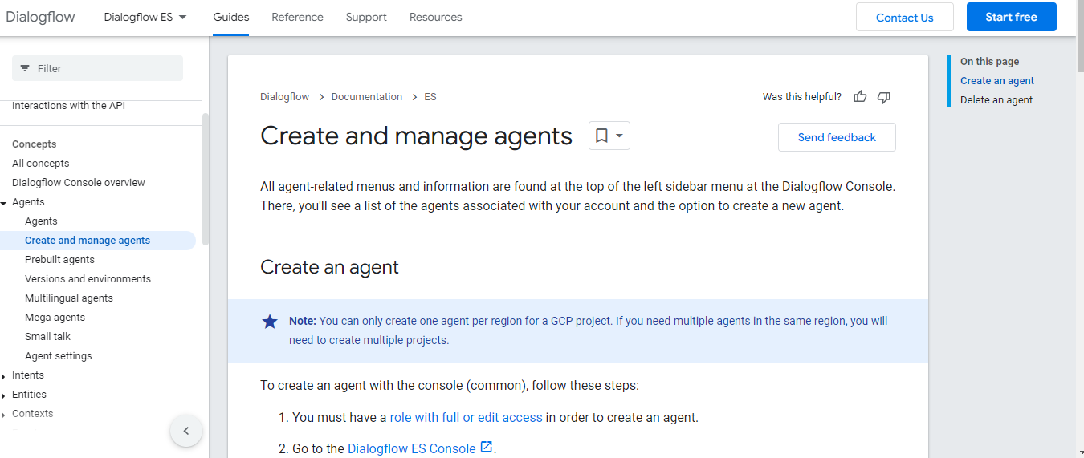

1. **Intents:**

Intents are very important thing because on the intents chatbot can perform different tasks means its working depends on the intents. In this task we are creating different intents like I am trying to train my agent on the following contents.

* Greetings.
* Booking.
* Canceling.
* FAQs.
* Feedback.

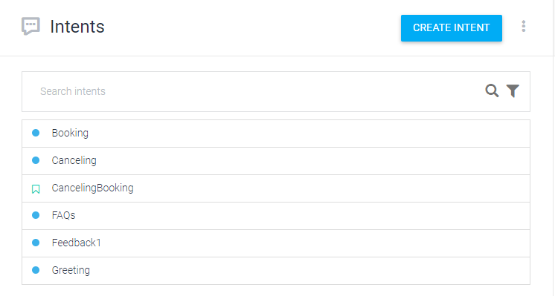

Basically, these are starting requirements are this task. Every part is dependent on the other like if we have an agent then we will work on it further then we will define the roadmap on which it will works then what are the inner things that our chatbot or agent is responding. Means we will tell it how to deal with user. This is the main purpose of the intents. In intents basically I will guide my agent that how you will talk with your user. In which tone you will talk and how you will fulfill the user requirements.

1. **Create Entities:**

The main purpose of the entities is to make the conversation user friendly. The user feels easy to use it and our agent provides the full guidelines that the user wants. Means we will elaborate our conversation, or we will clear the conversation that is easy to understand.

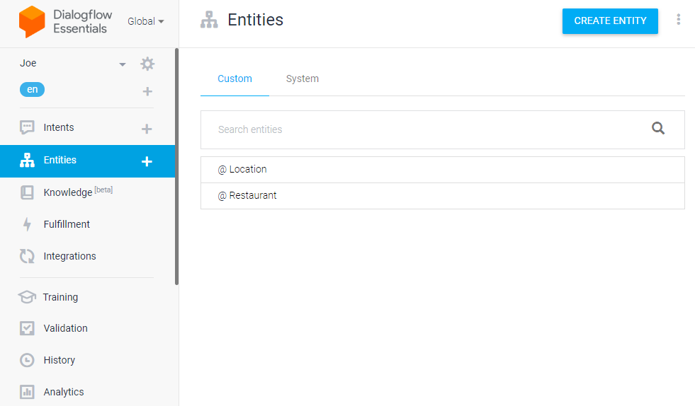

1. **Set Up Training Phrases:**

Basically, our chatbot is two directional means in this task we are creating user for questioning as well as we are creating the chatbot also for answering. Basically, the purpose of training phrases and the entities is to improve accuracy.

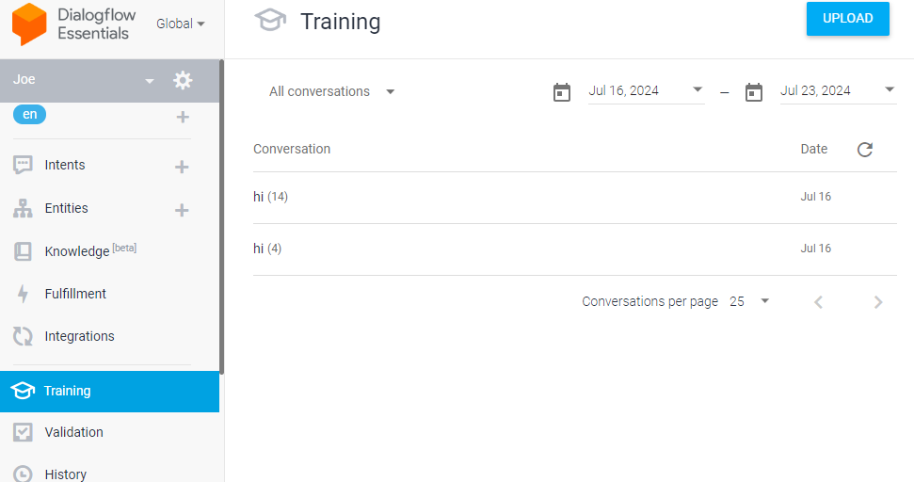

1. **Integrate with Messaging Platform:**

Now after creating the agent and defining all intents, it’s time to integrate it with any platform. Means now I am using DialogFlow’s integrations to connect with another platforms like Slack. Slack integrates well with various tools and services that I am trying to use in our chatbot.

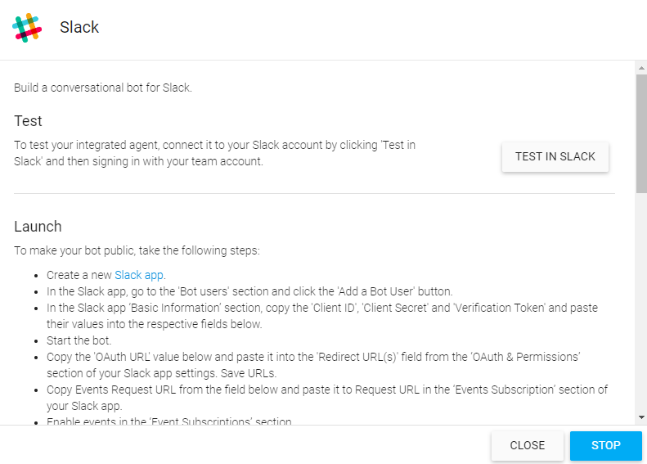

1. **Improve NLU:**

After creating the chatbot now, I am working on performance now I am integrating my chatbot with fine-tuned BERT model. BERT stands for Bidirectional Encoder Representations from Transformers.

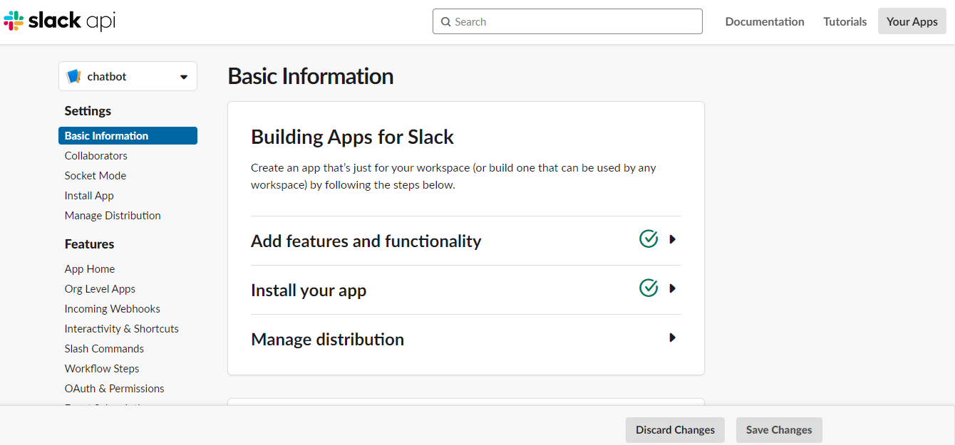

1. **Test Functionality:**

This is my last step in which I am testing the functionalities by making the different scenarios and I will see how my chatbot responds after fixing all issues in understanding or responding.

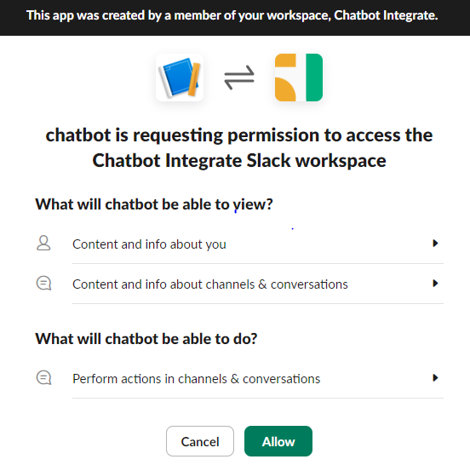

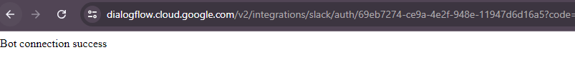

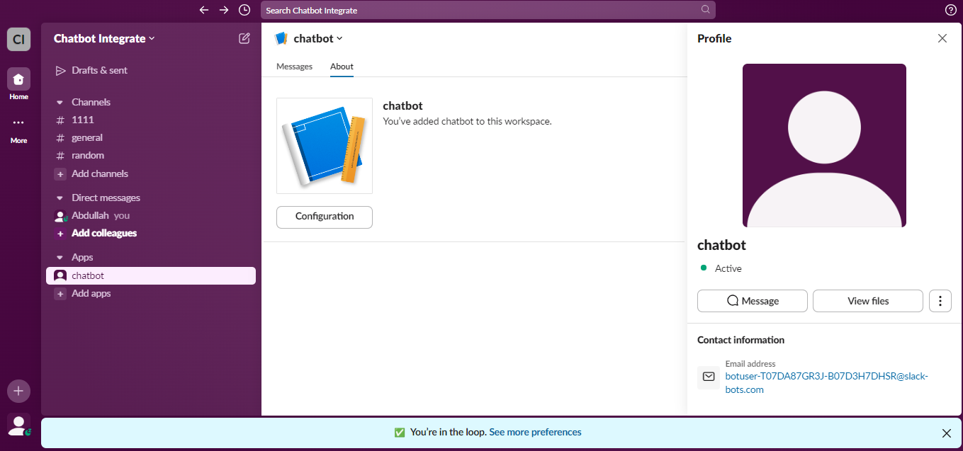

Helping Material:

<https://www.youtube.com/live/JzPgeRJfNo4?si=Vu08UXxomfqoKphw>

<https://youtu.be/nZCk2JkTpUw?si=ufC1R3edBlYHGTDJ>

<https://www.youtube.com/live/-9BQ6tCEjTw?si=w2iCzdqGMZ16CeyQ>

<https://youtu.be/ckAiJtRXNpk?si=OiIecm-cGVAUE4-R>

<https://youtu.be/TYDbmXCS1HI?si=P2FuLukW2CN12ZTv>

<https://youtu.be/pBEOM81TAfc?si=dOpZkSxrcYXlHHC4>

<https://youtu.be/DPViDXor4Fc?si=vB_1tfpiMTTuUQDX>

<https://youtu.be/ckAiJtRXNpk?si=7K4cZFMR58QakMMc>

Thanks.