**Kairiz CYber Technologies**

***Submitted By: Abdullah Amjad***

***Cell No: 03309772003***

***Gmail****:* ***abdullahamjad17301@gmail.com***

***Instructor: Sir Afaq and Mam Noor***

***CEO: Kainat Rizwan***

***Date: 24 July 2024.***

**Task:5**

1. **Load Dataset:**

First, I will download the dataset from Kaggle then we will start working on it. When I downloaded that dataset then I will load the dataset from a CSV file and then display the first few rows to take some hint from dataset.

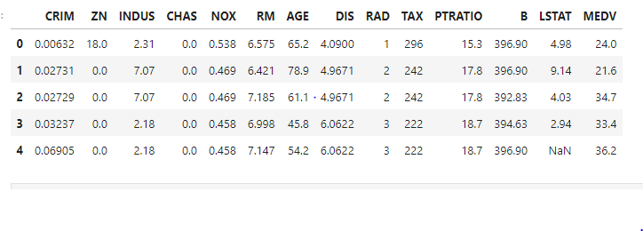

1. **Data Cleaning, Feature Engineering and Splitting:**

In this step first I will check the missing values and for missing values I will use the **isnull()** function and to find any missing vales in the dataset I will use the **sum()** function to get the total missing values in each column.  
The library behind these functions are **pandas** because pandas library provides these functions.

1. **Standardizing Features:**

I will use **StandardScaler** from **sklearn.preprocesing** to scale some features basically **sklearn** is the library that I am using in for the standard features.

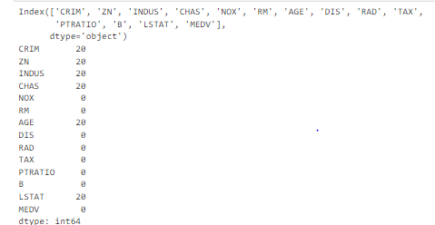

1. **Splitting The Dataset:**

Basically, first I will load my dataset then I will check the missing values then I will standardize the features then I will split the dataset into two parts.

* Training sets.
* Tasting sets.

The reason to do this because the training set is used to train the model while on the other side the testing set is used to evaluate its performance.

1. **Train the Model:**

In this step I will train my model before first I will initialize the model. In initialization I will create an instance of **RandonForestRegressor** with parameters **n_estimators**(number of trees) and **random_state** ( for reproducibility).

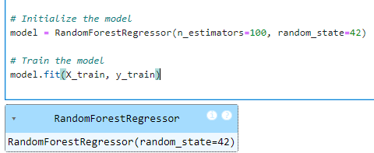

Basically, I will use the fit() method to train my model on the following features.

* X_train.
* Y_train.

The library that I will use for training the Random Forest Model is from **sklearn.ensemble import** **RandomForestRegressor.**

1. **Evaluate the Model:**

Now I will some mathematical function to evaluate the performance of my model means I will calculate the

* RMSE (Root Mean Squared Error)
* MAE (Mean Absolute Error)
* R^2 (R-squared )

RMSE is used to measure the average magnitude of errors with more emphasis on larger errors. MAE is used to measure the average magnitude of errors with equal weight of all errors. R^2 indicates “How well the model explains the variability of the target variable”.

So, by doing these mathematical operation I will evaluate my model performance.

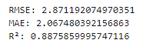

1. **Save the Model.**

Now I will save my model in .pkl format because after that I will make some files that’s help me in creating the Api with flash then these files are used to create a localhost environment and, on that localhost, I will deploy my model using the Postman software.

1. **Deploying:**

Now I will use the pythonanywhere website to deploy mu model because this website gives us a free license to use the limited resources but that limited resources will fulfill my needs. So I will use that.

**Pythonanywhere Dashboard:**

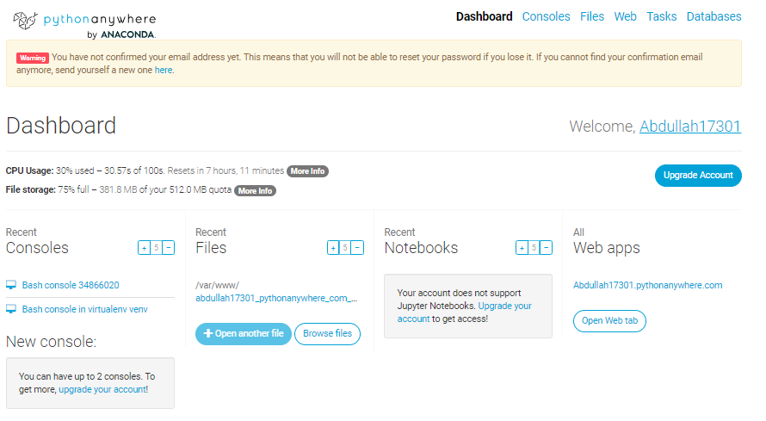

After creating its account first, I will upload my files like my model that I have save in .pkl format then I will make a one more file that will start our localhost means that is the bridge between model and the postman. Basically, Postman is the website to show the real time data of model. So, I am using that. Postman have too many features, but I don’t use that too much postman.

**Postman Working:**

1. **Implement Monitoring:**

So, in the last step I will implement some monitoring to check the performance of my model in the real time means I had ready my model and then I had connect that with the pythonanywhere then after that I had connect with the postman then I had send the **URL** to the postman and on that **URL** I had seen the real time model features and performance.

This is my local host URL: http://127.0.0.1:5000

**Helping Material:**

<https://youtu.be/uDr67HBIPz8?si=qdbJhtzZNvQXFRID>  
<https://youtu.be/Bx_jHawKn5A?si=wF9hwmlCSPhGkQXl>  
<https://youtu.be/qSuMP3jifbk?si=z1p8WvwDH7um76o8>

<https://youtu.be/QDymcZ5xYow?si=ef7Km942obel1X7T>

<https://youtu.be/vaoSQhZnLE0?si=WLaiKjM603t_Mu4t>

<https://youtu.be/pUGmhtqVJRk?si=iNru_rHsPpOascxP>

<https://youtu.be/CLG0ha_a0q8?si=WxxMe4CUXdaluUCw>  
<https://youtu.be/VywxIQ2ZXw4?si=H0ghlFeeFhTGtZNu>

<https://youtu.be/pUGmhtqVJRk?si=gYt1pFI0YbJ9zFXB>

Thanks.