Final Project Report

Online Discussion Forums



Project Supervisor
Usman Waheed

Submitted By

F230228787

Abdullah Ansari BC220212964

Software Projects & Research Section,
Department of Computer Sciences,
Virtual University of Pakistan


CERTIFICATE

This is to certify that Abdullah Ansari (Bc220212964) has worked on and completed their Software Project at Software & Research Projects Section, Department of Computer Sciences, Virtual University of Pakistan in partial fulfillment of the requirement for the degree of BS in Computer Sciences under my guidance and supervision.

In our opinion, it is satisfactory and up to the mark and therefore fulfills the requirements of BS in Computer Sciences.

Supervisor / Internal Examiner

Usman Waheed
Supervisor,
Software Projects & Research Section,
Department of Computer Sciences
Virtual University of Pakistan

___________________
(Signature)

External Examiner/Subject Specialist
<<External Supervisor Name>>

___________________
(Signature)

Accepted By:

_____________
(For office use)

EXORDIUM

In the name of Allah, the Compassionate, the Merciful.

Praise be to Allah, Lord of Creation,
The Compassionate, the Merciful,
King of Judgment-day!

You alone we worship, and to You alone we pray for help,
Guide us to the straight path

The path of those who You have favored,

Not of those who have incurred Your wrath,
Nor of those who have gone astray.

DEDICATION

Dedicated to the unsung heroes of academia, those whose support and encouragement propel dreams into reality. To my mentors, guides, and silent supporters, thank you for being the driving force behind this academic journey.

ACKNOWLEDGEMENT

In the completion of this project, my heart swells with gratitude for the unwavering support of my loved ones. To those who stood by me, offered encouragement, and lent a helping hand, your belief in me fueled this endeavor. This achievement is a reflection of our collective strength and unity.
PREFACE

In the digital landscape we navigate, this project endeavors to construct a secure and dynamic online forum system. With a meticulous focus on user roles—Admin, Moderator, and Normal User—our aim is to foster a secure space for meaningful exchanges.
The Admin, a guardian of the forum's integrity, holds the reins to user access, content curation, and keyword management. Clear boundaries separate administrative functions from user engagement.
Normal Users traverse a path of approval, gaining access to create topics and post comments, each subject to an automated content filter. Meanwhile, Moderators wield the authority to delete topics and impose temporary bans, ensuring order in the digital realm.
This project, at its core, seeks to balance security, accessibility, and individual expression, offering a streamlined online forum experience for all.

TABLE OF CONTENTS

CHAPTER NO. 1
Software requirements specification (SRS Document)

1.1 scope
1.2 Functional & non-fucntional)
1.3 Use Case Diagram
1.4 Work Plan (Use MS Project to create Schedule/Work Plan)

CHAPTER NO. 2
designing the project (Design Document)
2.1 Introduction of Design Document
2.2 Data Flow Diagram (DFD)
2.3 Entity Relationship Diagram (ERD)
2.4 Database Design
2.5 Interface Design

<<Dear Students, before starting each chapter the following would be the title page for each chapter on a separate page>>

CHAPTER 1
SOFTWARE REQUIREMENTS SPECIFICATION (SRS DOCUMENT)

1.1 Scope of Project:

The project aims to develop a secure online discussion forum that caters to general-purpose/public categories such as Sports, Movies, and News. Users can post new topics and engage in discussions through comments. The system will implement keyword filtering to remove inappropriate words defined by forum moderators and admin.

1.2 Functional and non Functional Requirements:

Functional Requirements:
The system shall implement a role-based access control system with three user types: Admin, Moderator, and Normal User.
1. Admin Responsibilities:
- Ability to add, update, and delete Moderators.
- Approval of Normal User account requests.
- Management of inappropriate keywords, with the ability to add, update, and delete them.
- Restriction from using the forum as a Normal User or Moderator.
2. Normal User Functionality:
- Account creation, subject to Admin approval.
- Posting new topics and comments.
- Automatic filtering of inappropriate words from posted content.
3. Moderator Abilities:
- Deletion of topics, leading to the automatic removal of associated comments.
- Temporary banning of users for a specified period.

4. Basic Profile Management:
- All three user types can update their profiles, including name, email, and password.
The system ensures a secure and controlled environment, where Admin oversees user roles, content appropriateness, and account approvals. Moderators have specific content management duties, while Normal Users can actively engage in the forum, with their content automatically filtered for inappropriate language.
Non-Functional Requirements:
- Security:
  - Implement secure access controls for user types.
  - Ensure data privacy and protection.
- Performance:
  - Efficient filtering of keywords to maintain system responsiveness.
- Reliability:
  - System reliability in handling user requests and filtering content.

1.3 Use Case Diagram

1.4 Work Plan (Use MS Project to create Schedule/Work Plan)

CHAPTER 2
Designing the Project
(Design Document)

  - Introduction of Design Document
Purpose:
The purpose of this Design Document is to outline the architectural and design aspects of the proposed online discussion forum system. This document provides a comprehensive understanding of the system's structure, data flow, and database design, laying the foundation for the development phase.

Benefits:

Clarity in System Design:
A detailed design document ensures a clear and shared understanding of the system architecture among developers, testers, and stakeholders.

Guidance for Development:
Serves as a roadmap for the development team, aiding in the systematic implementation of features and functionalities.

Basis for Evaluation:
Facilitates an organized approach to system evaluation, allowing stakeholders to assess whether the developed system aligns with the specified requirements.

Future Reference:
Acts as a reference document for future maintenance, updates, or enhancements to the system.

Phase Overview:
The design phase focuses on translating the requirements specified in the Software Requirements Specification (SRS) into a well-structured system architecture. The following sections will delve into the Data Flow Diagram (DFD), Entity Relationship Diagram (ERD), and Database Design of the online discussion forum.

  - Data Flow Diagram (DFD) (To be developed using Microsoft Visio or any other drawing software of your choice)
  - Entity Relationship Diagram (ERD) (To be developed using Microsoft Visio or any other drawing software of your choice)
  - Database Design

  - Interface Design (Optional)
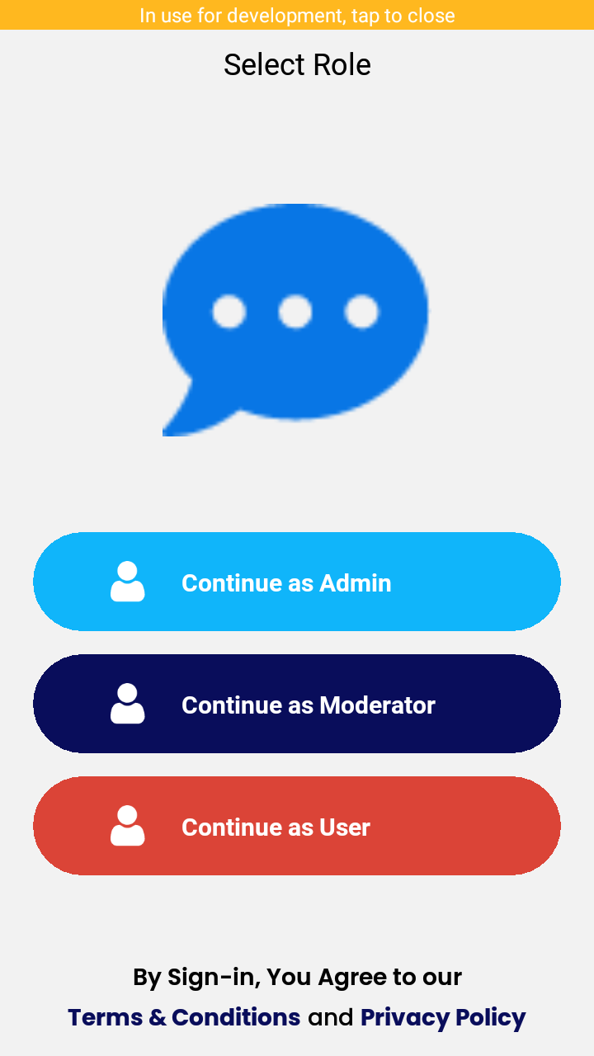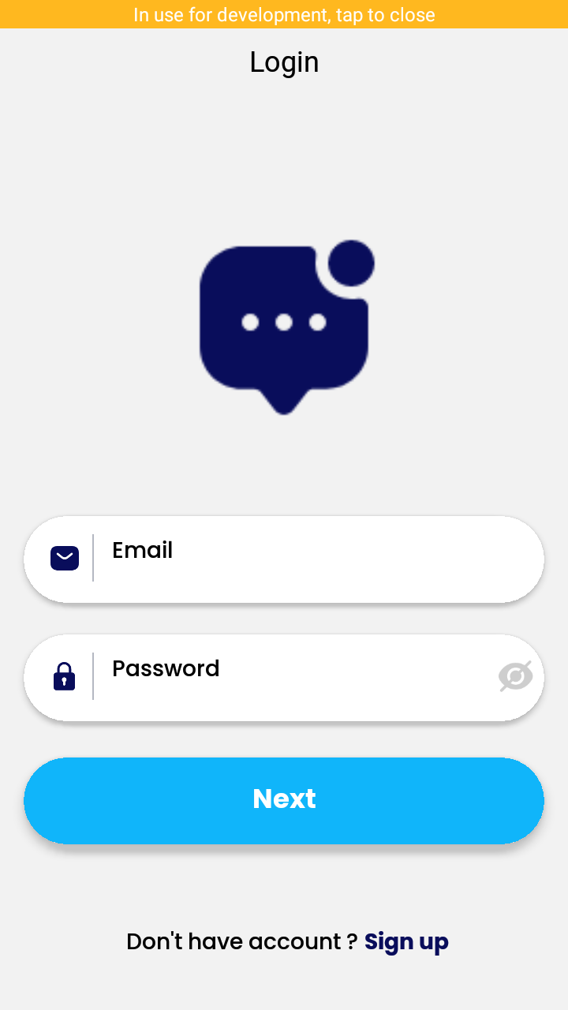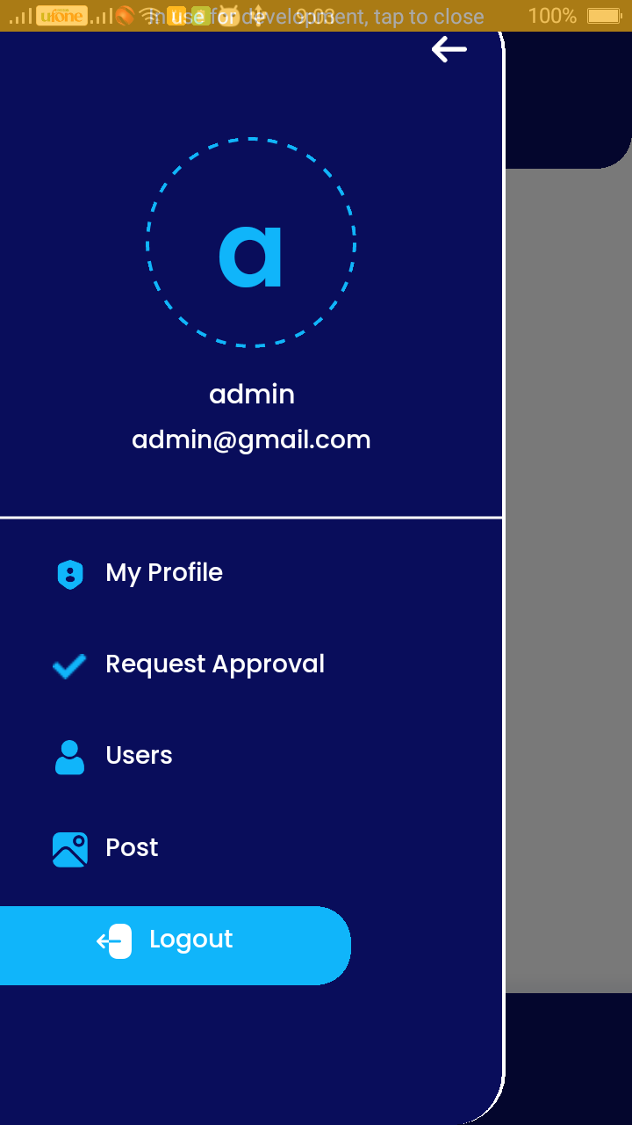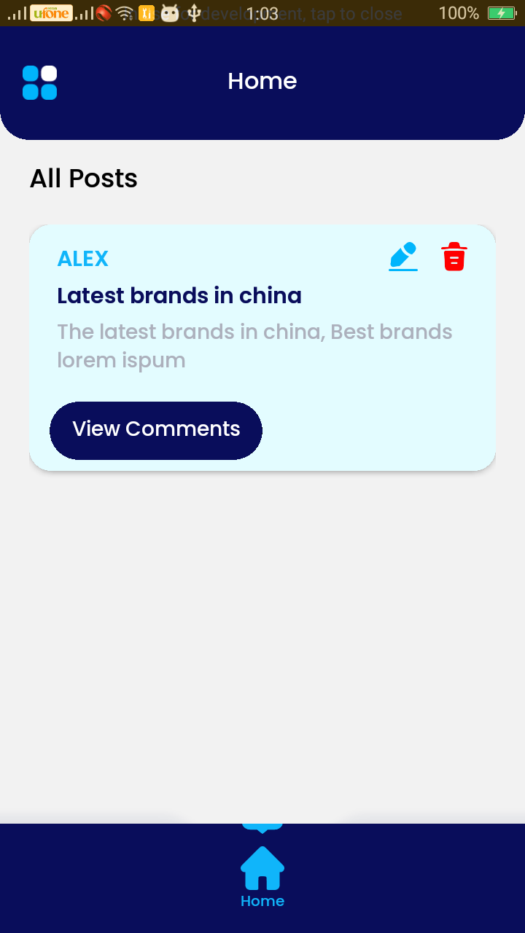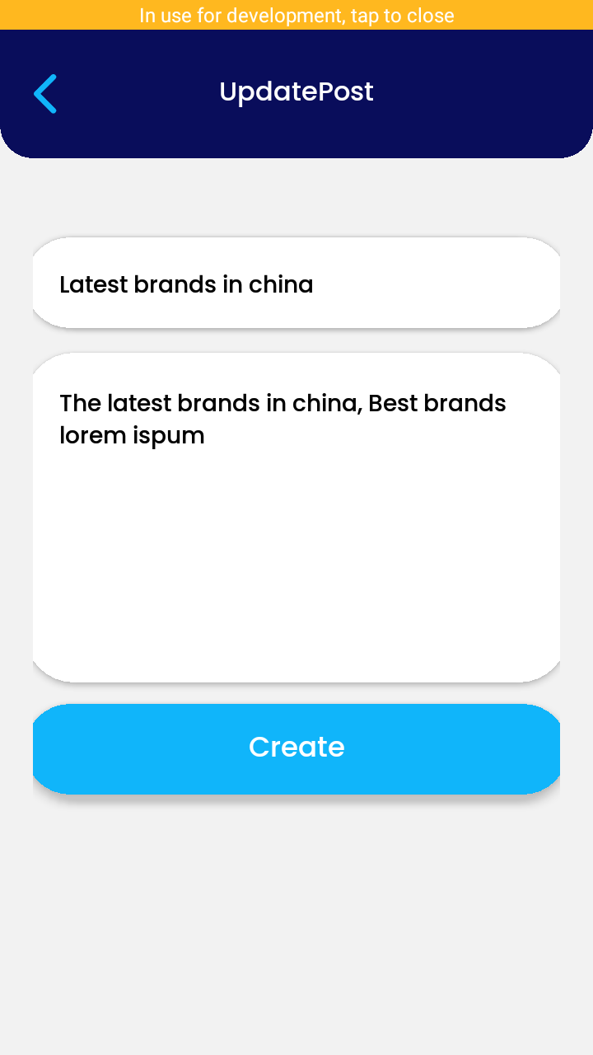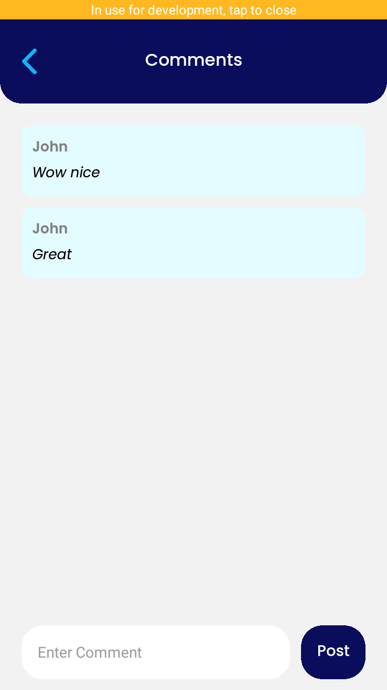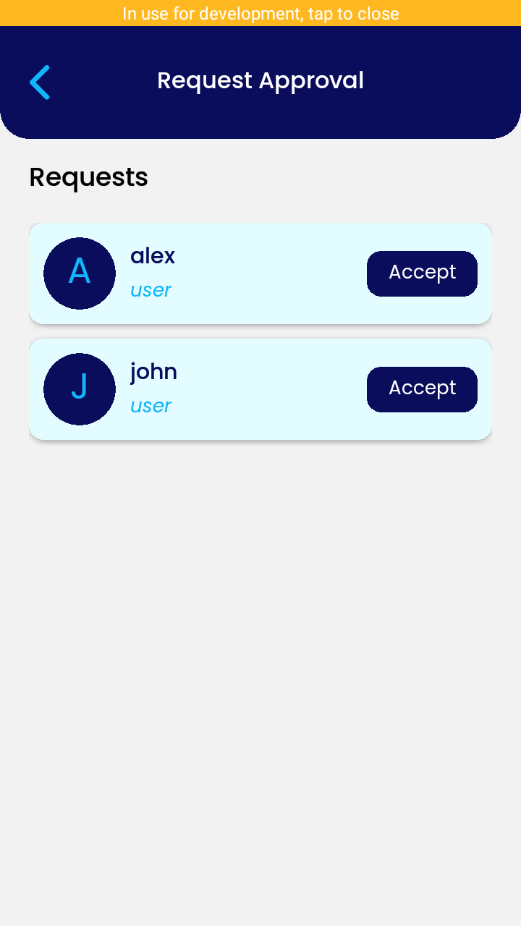

REFERENCES

APPENDIX

Supplementary Material

