Base URL: http://tmds1.fortiddns.com:7331
Base URI: mst/enc

4.5 EMS Checkin Room - Energy Management Function POST
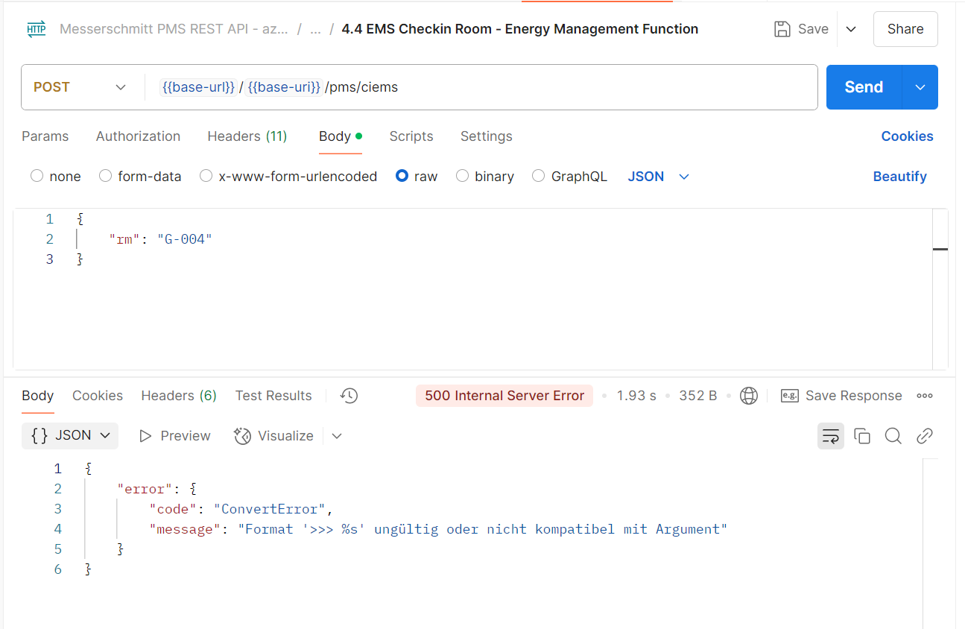
few days ago, while testing, I encountered this error, but API was still working (as confirmed by Paradeep). Today, API is not working, and I'm facing the same error.

4.8 Checkout Room – Delete Key Function POST
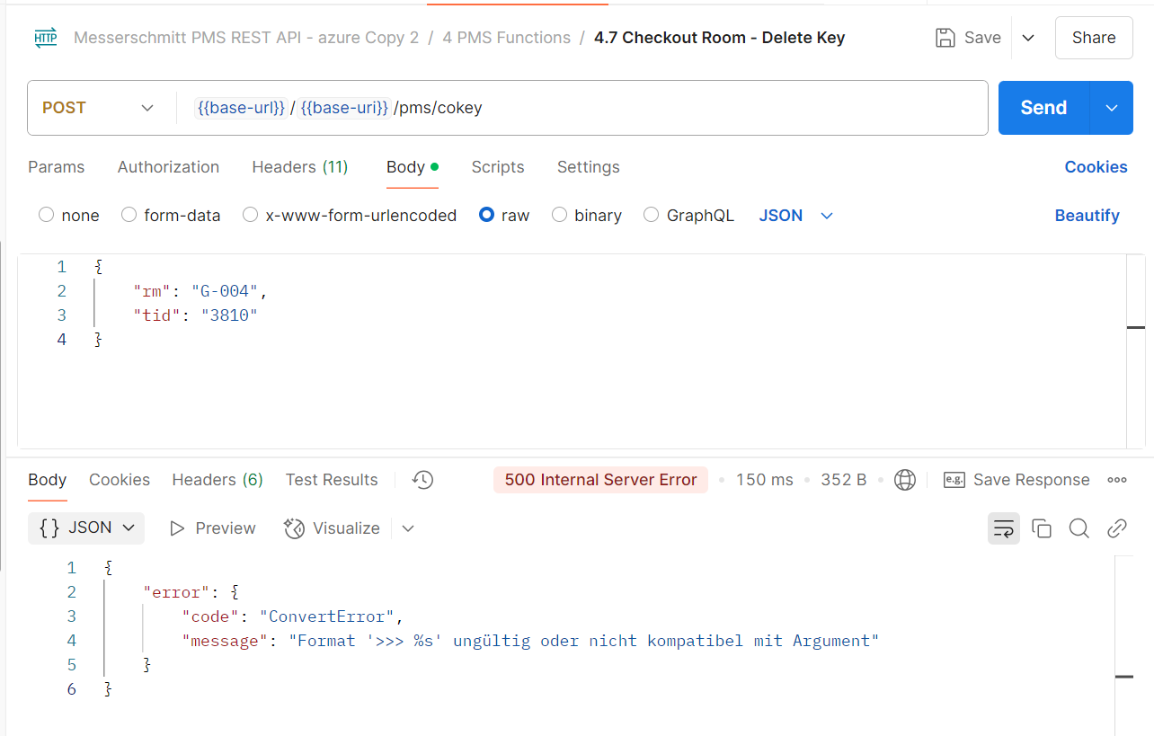Facing this error, but the functionality is working fine and card becomes invalid when I perform this API request.

