Software Requirements and Design Document
for
Bookify
Afrah Syed (22i1008), Abdullah Aslam (22i0784), Abdur Raheem (22i0777)

Table of Contents
Table of Contents ii
1. Introduction 3
1.1 Purpose 3
1.2 Product Scope 3
1.3 Title 3
1.4 Objectives 3
1.5 Problem Statement 3
2. Overall Description 4
2.1 Product Perspective 4
2.2 Product Functions 4
2.3 List of Use Cases 4
2.4 Extended Use Cases 4
2.5 Use Case Diagram 29
3. Other Nonfunctional Requirements 29
3.1 Performance Requirements 29
3.2 Safety Requirements 29
3.3 Security Requirements 30
3.4 Software Quality Attributes 30
3.5 Business Rules 30
3.6 Operating Environment 30
3.7 User Interfaces 30
4. Domain Model 31
5. System Sequence Diagram 32
6. Sequence Diagram 33
7. Class Diagram 2
8. Component Diagram 2
9. Package Diagram 4
10. Deployment Diagram 5

Introduction

Purpose

The purpose of this document is to outline the functional and non-functional requirements for "Bookify," a comprehensive booking management system. The focus is on facilitating seamless bookings across various services like hotels and restaurants, while enhancing user experience and integrating diverse features for both end-users and service providers.

Product Scope
Bookify is a unified booking platform, providing a one-stop solution for users to book various services, consolidating multiple apps into one. This platform aims to simplify the booking process by providing features such as notifications, cancellation management, and targeted offers, alongside tools for service providers to manage services and analytics.

Title
Bookify: A Unified Platform for Seamless Service Bookings

Objectives
• Simplify the process of booking diverse services through one platform.
• Improve user experience with intuitive and efficient navigation.
• Provide service providers tools for managing bookings, offering promotions, and viewing analytics.
• Minimize user frustration by integrating service options into a single interface.

Problem Statement
Existing booking platforms are limited to specific services and often require users to juggle multiple apps. Bookify addresses this by offering a unified system, allowing users to manage all bookings efficiently. This solution reduces errors, saves time, and provides value-added features for convenience.

Overall Description

Product Perspective
Bookify is a standalone platform that bridges the gap between multiple service categories, providing an all-in-one booking system. It integrates with existing service providers to streamline bookings and user interactions, with a responsive design for mobile and desktop compatibility.

Product Functions
• User registration and login.
• Service browsing and booking.
• Payment processing with multiple gateways.
• Notifications for service availability and reminders.
• Analytics for service providers.
• Customer support and targeted offers.

List of Use Cases
• View Booking
• Make Payment
• Customer Support
• Targeted Offers
• Service Availability Notifications
• View Service Analytics
• Manage Service Approvals
• Register User
• Browse Services
• Book a Service
• Modify Booking

Extended Use Cases

Use Case 1: View Booking (Abdullah Aslam)

Element | Details
Scope | Booking Management System
Level | Customer goal
Primary Actor | Customer, Service Owner (Hotel/Restaurant Owner)
Stakeholders and Interests | Customer: Wants to view and manage their bookings. Service Owner: Wants to view customer reservations. System Admin: Ensures system is running smoothly.
Preconditions | - The Customer must be logged into the system.  - The service owner must have an approved account and services listed.
Success Guarantee (Postconditions) | The Customer can view their bookings, and the service owner can view current bookings for their hotel, restaurant.
Main Success Scenario:

Actor Action | System Responsibility
1. Customer/Owner logs into the system. | 2. System authenticates the Customer or owner and grants access to the dashboard.
3. Customer/Owner navigates to the "My Bookings" or "View Reservations" section. | 4. System retrieves a list of bookings or reservations from the database.
5. Customer views their past or upcoming bookings. | 6. System displays booking details such as date, time, location, service name, and payment status.
5. Service owner views the list of all bookings for their service. | 6. System displays the list of reservations, including customer details, booking time, and any special requests.
7. Customer/Owner can filter or sort the bookings. | 8. System processes the filters (e.g., by date, service type) and displays the updated list of bookings.
9. Customer/Owner can select a specific booking to view details. | 10. System shows detailed information about the booking (e.g., service, payment status, customer/guest details).

Extensions (Alternate Scenarios):

Actor Action | System Responsibility
4a. No bookings exist for the Customer or owner. | System displays a message indicating no current or past bookings are available.
6a. Customer/Owner tries to access booking details, but the booking has been canceled. | System notifies the Customer that the booking has been canceled and displays the cancellation details.
8a. Customer/Owner filters by a date range with no bookings. | System displays a message indicating no bookings available for the selected date range.
Special Requirements:
- The system should handle a large number of bookings efficiently, ensuring minimal loading time.
- Customers and owners should have secure access to their data.
- The UI should be responsive across devices (e.g., mobile, tablet, desktop).

Technology and Data Variations List:
- Customers may access the system via different Operating Systems (Linux, Windows).
- Booking information may be stored in different date formats depending on Customer or service owner location (e.g., DD/MM/YYYY or MM/DD/YYYY).

Use Case 2: Make Payment(Abdullah Aslam)

Element | Details
Scope | Booking Management System
Level | User goal
Primary Actor | Customer (End-User)
Stakeholders and Interests | Customer: Wants to successfully make a secure payment for their booking.  Service Owner: Receives confirmation of a paid booking.  System Admin: Ensures smooth and secure processing of payments.
Preconditions | - The customer must have selected a service and filled out booking details.  - The customer must be logged into the system.
Success Guarantee (Postconditions) | The customer successfully completes the payment, and the booking is confirmed. The system records the payment and updates the booking status to "Paid".
Main Success Scenario:

Actor Action | System Responsibility
1. Customer proceeds to the payment page after confirming a booking. | 2. System displays available payment options (e.g., credit card, PayPal, etc.).
3. Customer selects a preferred payment method. | 4. System validates the selected payment method and prompts the customer for required details (e.g., card number, CVV, etc.).
5. Customer enters payment information. | 6. System securely processes the payment by interacting with the payment gateway.
7. Customer confirms the payment and submits the form. | 8. System processes the payment and provides confirmation.
9. Customer receives a payment confirmation message. | 10. System updates the booking status to "Paid" and sends a confirmation email/SMS to the customer with booking details.

Actor Action | System Responsibility
11. Customer can view their updated booking in the "My Bookings" section. | 12. System reflects the updated payment status in the customer's booking history.

Extensions (Alternate Scenarios):

Actor Action | System Responsibility
4a. Customer selects an unsupported payment method. | System shows an error message indicating the payment method is not supported.
6a. Payment gateway is down or unavailable. | System notifies the customer of a payment processing error and provides options to retry or use another payment method.
8a. Payment is declined (e.g., insufficient funds, invalid card). | System displays a message informing the customer of the payment failure and prompts them to re-enter payment details or choose another method.
10a. Payment is successful, but the booking confirmation email/SMS is delayed. | System displays a success message on-screen, even if the email/SMS is delayed, assuring the customer that their payment was processed.
Special Requirements:
- The system must securely handle all payment information, adhering to PCI-DSS standards.
- Payment processing should be done through a reliable payment gateway with minimal downtime.
- The system must support a variety of payment options (e.g., credit card, debit card, PayPal, etc.).

Technology and Data Variations List:
- Customers may use different Technologies (Online Transfer, Card, Cash) to make payments.
- Payment data, such as currencies and transaction amounts, may vary based on the customer's location.

Use Case 3: Customer Support(Abdullah Aslam)

Element | Details
Scope | Booking Management System
Level | User goal
Primary Actor | Customer (End-User)
Stakeholders and Interests | Customer: Wants prompt and accurate assistance regarding issues or inquiries.  Service Owner: Ensures customers can resolve service-related issues smoothly.  System Admin: Ensures the platform has a functional support system, monitoring and addressing issues escalated beyond the owner.
Preconditions | - The customer is logged into their account.  - The customer has an issue or inquiry they need help with (e.g., booking, payment, cancellation).
Success Guarantee (Postconditions) | The customer successfully interacts with customer support and gets their issue resolved or inquiry answered.
Main Success Scenario:

Actor Action | System Responsibility
1. Customer navigates to the "Customer Support" section. | 2. System displays support options (e.g., live chat, email, phone number).
3. Customer selects a preferred method of support (e.g., chat, email). | 4. System initiates the support method (opens live chat, email form, or displays phone details).
5. Customer describes their issue or inquiry. | 6. System receives the issue and routes it to the appropriate support agent or department.
7. Customer interacts with the support agent (or system bot for automated responses). | 8. Support agent/system bot provides an answer, solution, or escalates the issue if necessary.
9. Customer receives a resolution or confirmation that the issue will be handled (e.g., via follow-up). | 10. System records the interaction, and if necessary, generates a support ticket for further action or follow-up.

Actor Action | System Responsibility
11. Customer receives confirmation or a follow-up email/SMS for unresolved cases. | 12. System updates the status of the issue and notifies the customer once resolved.

Extensions (Alternate Scenarios):

Actor Action | System Responsibility
4a. Customer selects live chat, but no agent is available. | System displays a message about unavailability, offering to leave a message or use another support method (email or phone).
6a. Support agent is unable to resolve the issue. | System escalates the issue to a higher-level support team or admin for resolution and notifies the customer of the escalation.
8a. The issue requires follow-up (e.g., technical problem, billing dispute). | System generates a support ticket, assigns it to a relevant team, and sends a confirmation email/SMS with the case number to the customer.
10a. Customer tries to reach support during offline hours (for live chat or phone). | System provides a notification of the working hours and allows the customer to leave a message, which will be responded to later.
Special Requirements:
- Support services should be available 24/7 via automated systems or during working hours for live agents.
- The system must ensure that sensitive information shared by the customer (e.g., booking details, payment disputes) is handled securely.
- The platform should have automated FAǪs to ensure customers can self-resolve simple issues.

Technology and Data Variations List:
- Support interactions may occur over different Operating Systems (Windows, Linux).
- The system may route different types of inquiries (e.g., booking issues, payment disputes) to different departments.

Use Case 4: Targeted Offers(Abdullah Aslam)

Element | Details
Scope | Booking Management System
Level | User goal
Primary Actor | Service Owner (Hotel/Restaurant Owner)
Stakeholders and Interests | Service Owner: Wants to promote their services and attract more customers by offering targeted promotions.  Customer: Wants relevant offers and discounts that suit their preferences.  System Admin: Ensures offers meet platform standards and prevents any misuse.
Preconditions | - The service owner has a registered account and their service is approved by the System Admin.  - The customer is registered and has booking history or preferences in the system.
Success Guarantee (Postconditions) | Targeted offers are successfully created and delivered to the customer, leading to increased bookings.
Main Success Scenario:

Actor Action | System Responsibility
1. Service owner navigates to the "Create Offer" section. | 2. System displays a form to input offer details (discounts, service type, validity, etc.).
3. Service owner inputs offer details (e.g., 20% off for a hotel booking, valid for 1 month). | 4. System validates the offer details and checks if all fields are complete and valid.
5. Service owner selects the target audience based on customer attributes (e.g., location, booking history, or preferences). | 6. System retrieves customer data to match the selected criteria (e.g., customers who booked similar services before).
7. Service owner submits the offer. | 8. System stores the offer and schedules notifications to be sent to targeted customers.
9. Customers receive notifications or see the offers when logged in (via email/SMS or dashboard). | 10. System presents the offer to eligible customers on the homepage, in the "Offers" section, or through direct notifications.

Extensions (Alternate Scenarios):

Actor Action | System Responsibility
4a. Service owner enters incomplete or invalid offer details (e.g., missing expiry date). | System highlights the missing or incorrect fields and prompts the service owner to correct them before submitting.
6a. No customers match the targeting criteria. | System notifies the service owner that no customers meet the criteria and suggests broadening the target audience.
9a. Customer ignores or does not respond to the offer. | System may send a follow-up reminder, depending on settings (optional). If the offer expires, the system removes it from the dashboard.
Special Requirements:
- Offers should be personalized and relevant to customers, based on their booking history, location, or preferences.
- The system must ensure that multiple offers do not spam the customer or result in overwhelming notifications.
- The platform should support the use of various media (e.g., images, videos) in offers to attract more attention.

Technology and Data Variations List:
- Offers will be displayed within the desktop application interface, such as the dashboard and the "Offers" section.

Use Case 5: Service Availability Notifications (Abdur-Raheem Shaikh)

Element | Details
Scope | Booking Management System
Level | User goal
Primary Actor | Customer
Stakeholders and Interests | Customer: Wants to be informed when a desired service becomes available.  Service Owner: Wants to fill vacancies and maximize bookings.
Preconditions | - The customer is registered and has opted to be notified for specific services.  - The desired service was previously unavailable.
Success Guarantee (Postconditions) | The customer is notified when the service becomes available, and the service owner can potentially gain additional bookings.
Main Success Scenario:

Actor Action | System Responsibility
1. Customer navigates to a fully booked service and opts to be notified when it becomes available. | 2. System stores the customer's request and monitors the availability of the service.
3. A service (e.g., a hotel room, restaurant table) becomes available. | 4. System automatically sends a notification (via email or desktop notification) to the customer informing them of the availability.
5. Customer receives the notification and can proceed to make the booking. | 6. System allows the customer to quickly access the booking process for the newly available service.

Extensions (Alternate Scenarios):

Actor Action | System Responsibility
1a. Customer doesn’t opt for notification  when the service is unavailable. | 2a. System does not store any notification request for the customer.

Actor Action | System Responsibility
3a. The service is no longer available when the customer attempts to book after receiving the notification. | 4a. System notifies the customer that the service is no longer available and suggests similar services.
3b. Customer is not reachable by email/notification service. | 4b. System logs the failed notification attempt and retries at the next available opportunity or allows the customer to check manually.

Special Requirements:
- Response Time: The system must send notifications within seconds of a service becoming available to ensure fairness.
- Scalability: The notification system must handle high traffic and simultaneous notifications for popular services.
- Notification Channels: System should support multiple notification methods (e.g., email, desktop notifications, SMS, etc.).

Technology and Data Variations:
- Notification Channels: Desktop notification or email.
- Service Availability: The system continuously checks for service availability updates in real-time or scheduled intervals.

Use Case 6: View Service Analytics (Abdur-Raheem Shaikh)

Element | Details
Scope | Booking Management System
Level | User Goal
Primary Actor | Service Provider (Hotel/Restaurant Owner)
Stakeholders and Interests | Service Provider: Wants to view performance data, understand strengths, and identify areas for improvement to attract more customers.  System Admin: Wants to ensure that analytics are accurate and accessible.  Customer: Indirect interest in improved services based on insights obtained from analytics.
Preconditions | - The service provider is registered and authenticated within the system.  - The service provider has been approved by the System Admin.  - Performance data is available for the service provider (e.g., bookings, revenue, customer ratings).
Success Guarantee (Postcondition) | The service provider successfully views a detailed analytics report, including customer ratings, number of bookings, revenue, and feedback.
Main Success Scenario:

Actor Action | System Responsibility
1. Service provider navigates to the “Analytics” section from the dashboard. | 2. The system displays available performance metrics and analytics options (e.g., bookings, revenue, ratings, trends).
3. Service provider selects relevant analytics (e.g., bookings for the last month). | 4. The system fetches and displays the requested performance data, including total bookings, revenue generated, average customer ratings, etc.
5. Service provider views graphs or reports showing key performance metrics. | 6. The system visualizes the data in a user-friendly format, such as bar charts, pie charts, or tables.

Actor Action | System Responsibility
7. Service provider analyzes the data to see where they performed best (e.g., highest bookings). | 8. The system highlights any trends or key insights (e.g., best-selling periods, services with highest customer satisfaction).
9. Service provider logs out or navigates away from the analytics section. | 10. The system securely logs out the session or returns the user to the dashboard.

Extensions (Alternate Scenarios):

Actor Action | System Responsibility
1a. The service provider has no performance data available. | The system informs the service provider that no data is available and suggests tips on how to improve bookings.
2a. The system fails to load analytics data due to server issues. | The system notifies the service provider of the error and prompts them to try again later.
3a. The service provider wants to download the analytics report. | The system generates a downloadable file (e.g., PDF, CSV) containing the performance report.
Special Requirements:
- Data visualizations should be responsive and optimized for both mobile and desktop views.
- The system must ensure data accuracy and real-time synchronization with bookings and reviews.

Technology and Data Variations List:
- Analytics can be viewed on-screen in graphical format (bar charts, pie charts, line graphs).
- Reports can be downloaded in multiple formats (PDF, CSV).
- Desktop application access for service providers.
- The system should support different display resolutions for desktops.

Use Case 7: Manage Service Approvals and Modifications (Abdur-Raheem Shaikh)

Element | Details
Scope | Booking Management System
Level | User Goal
Primary Actor | System Admin
Stakeholders and Interests | System Admin: Ensures only valid service providers are approved and manages modifications or deletions efficiently.  Service Providers (Hotel/Restaurant Owners): Want prompt approval and efficient handling of service modifications or deletions.  Customers: Indirectly affected by the availability of valid and up-to- date service listings.
Preconditions | - The system admin is authenticated within the system.  - Service provider registration requests or modification requests are pending.  - The system admin has access to service data, registration requests, and modification logs.
Success Guarantee (Postcondition) | The system admin successfully approves, modifies, or deletes services, ensuring the system is updated with valid and accurate listings.
Main Success Scenario:

Actor Action | System Responsibility
1. Registration Approval Process
1. System admin navigates to the “Pending Registrations” section. | 2. The system displays a list of service provider registration requests, including business details.
3. System admin reviews the details (e.g., business name, location, type of service). | 4. The system allows the admin to approve or reject the registration.
5. System admin approves or rejects the registration. | 6. The system updates the service provider's status and notifies them of the approval or rejection.
2. Service Modification Process
7. System admin navigates to the “Modify Services” section. | 8. The system displays modification requests or  allows the admin to view service details needing updates.

Actor Action | System Responsibility
9. System admin reviews modification details (e.g., new pricing, service description, availability). | 10. The system updates the service listing based on  the admin’s confirmation of the modifications.
3. Service Deletion Process
11. System admin navigates to the “Delete Services” section. | 12. The system displays a list of services marked for deletion by service providers or flagged for removal by the system.
13. System admin selects a service to delete. | 14. The system prompts for confirmation and deletes the service upon admin approval, updating customer availability.

Extensions (Alternate Scenarios):

Actor Action | System Responsibility
1a. The system admin rejects a registration request. | The system notifies the service provider of the rejection and may provide optional feedback.
2a. The system admin tries to modify or delete a service but encounters an error. | The system shows an error message and logs the error, allowing the admin to retry later.
3a. The service provider updates service details while admin is reviewing. | The system notifies the admin of the recent changes and requests confirmation before proceeding.
Special Requirements:
- The system must ensure secure handling of all registration and service modification data, with logs maintained for auditing.
- The admin interface must offer intuitive navigation, especially for handling high volumes of registration and modification requests.

Technology and Data Variations List:
- Notifications sent via email or system messages to service providers post-approval or rejection.
- Desktop-based interface for admin actions.
- Responsive design for ease of access on different screen sizes.

Use Case 8: Purchase Membership and Avail Exclusive Offers (Abdur-Raheem Shaikh)

Element | Details
Scope | Booking Management System
Level | User Goal
Primary Actor | Customer (System Member)
Stakeholders and Interests | Customer (System Member): Wants to pay a one-time membership fee and enjoy exclusive offers and discounts on hotel, restaurant bookings.  Service Providers (Hotel/Restaurant Owners): Interested in offering special deals to attract members and expand their customer base.  System Admin: Wants to ensure that membership payments are processed securely, and customers receive the appropriate benefits.
Preconditions | - The customer is registered and authenticated in the system.  - The membership program is available with clearly defined benefits (discounts, offers).  - The payment gateway is functional for processing membership fees.
Success Guarantee (Postcondition) | The customer successfully pays a one-time membership fee and gains access to exclusive discounts and offers for future bookings within the system.
Main Success Scenario:

Actor Action | System Responsibility
1. Customer navigates to the "Membership" section in their profile. | 2. The system displays the available membership plan, including benefits and the one-time membership fee.
3. Customer selects the membership plan and clicks "Join Now." | 4. The system redirects the customer to the payment page, displaying the fee details.
5. Customer provides payment details and confirms the transaction. | 6. The system processes the payment securely through the payment gateway.
7. Customer receives a payment confirmation. | 8. The system updates the customer's status to "Member" and sends a confirmation email/SMS with membership details.
9. Customer starts making bookings (e.g., hotel, restaurant). | 10. The system automatically applies the membership discounts or offers to eligible bookings during checkout.

Actor Action | System Responsibility
11. Customer enjoys discounts on selected services during checkout. | 12. The system ensures that the discounts are reflected in the total price and provides a breakdown of savings.

Extensions (Alternate Scenarios):

Actor Action | System Responsibility
1a. Payment fails due to network issues or incorrect details. | The system notifies the customer of the payment failure and prompts them to retry after correcting the issues.
2a. Customer cancels the membership payment before completion. | The system cancels the transaction and notifies the customer that their membership has not been activated.
3a. Customer’s membership status  is expired or invalid. | The system alerts the customer that their membership is no longer valid and offers an option to renew the membership.
Special Requirements:
- The system must securely process membership payments using encrypted payment gateways and follow industry standards for data protection.
- Membership benefits should automatically apply to eligible bookings, ensuring a seamless user experience.
- The system should send reminder emails to customers with expiring or expired memberships, encouraging renewal.

Technology and Data Variations List:
- Membership confirmation and renewal notices are sent via email or SMS.
- Membership status and benefits are displayed on the user’s profile/dashboard.

Use Case 9: Register User (Afrah Syed)

Element | Details
Scope | Booking Management System
Level | User Goal
Primary Actor | Customer: A person looking to book services (e.g., hotels, restaurants).  Service Owner: A business owner registering their service for listing on the platform.
Stakeholders and Interests | Customer: Wants to create an account to access and book services. Service Owner: Wants to register their business so customers can book their services.  System Admin: Ensures the registration process is valid, secure, and approves service owner and customer accounts.
Preconditions | - The customer or service owner is on the registration page.  - The system has access to email/SMS verification services.  - The System Admin is available to approve service owner accounts.
Success Guarantee (Postcondition) | The user or service owner account is created, verified, and approved by the System Admin. The user or service owner can log in and access the platform.
Main Success Scenario:

Actor Action | System Responsibility
1. User navigates to the registration page. | 2. The system displays the registration page with role selection options (Customer or Service Owner).
3. User selects the appropriate role (Customer or Service Owner). | 4. The system displays the respective registration form (Customer: personal details, Service Owner: business details).
5. User fills in the required information and submits the form. | 6. The system validates the input data for completeness and correctness.
 | 7. The system sends a confirmation email or SMS for verification.

Actor Action | System Responsibility
8. User receives the verification link and confirms their account. | 9. The system notifies the user of successful approval, allowing them to log in and use the platform.
10. User logs in to access their dashboard (Customer: book services; Service Owner: manage services).

Extensions (Alternate Scenarios):

Actor Action | System Responsibility
6a. User enters invalid or incomplete data. | The system displays an error message and prompts the user to correct the input.
6b. Service owner’s registration is rejected  by the System Admin. | The system notifies the service owner of the rejection and provides reasons.
8a. User does not receive the confirmation email/SMS. | The system allows the user to request a new confirmation email/SMS.
8b. User or service owner fails to verify their account. | The system prevents login and sends a reminder email/SMS for verification.
10a. Service owner enters incorrect login credentials. | The system displays an error message and prompts the service owner to try again.
Special Requirements:
- The system must enforce security protocols (e.g., strong password policies, encryption of sensitive data).
- For service owners, additional verification processes (such as uploading business documents) may be required for approval.

Technology and Data Variations List:
- The system may support multiple forms of verification (email, SMS).
- The system may require service owners to upload additional documents for verification before approval.

Use Case 10: Browse Services (Afrah Syed)

Element | Details
Scope | Booking Management System
Level | User Goal Level
Primary Actor | Customer
Preconditions | - The customer has already registered and logged into the system.  - The system contains data about services (e.g., hotels, restaurants).
Postconditions (Success Guarantee) | The customer is able to view the details of the services that match their preferences.

Stakeholders and Interests:

Stakeholder | Interests
Customer | Wants a simple, efficient way to find the most suitable services.
Service Owner | Wants their services to be displayed correctly and filtered appropriately.
System Admin | Ensures the system functions properly, providing accurate results and a smooth experience for users.

Main Success Scenario:

Actor Action | System Responsibility
1. Customer navigates to the Browse Services page. | 2. The system displays service categories such as hotels, restaurants.
3. Customer selects a category (e.g., hotels). | 4. The system lists available services under the selected category.
5. Customer applies filters (e.g., price, rating, location, availability, time, date). | 6. The system updates the service list based on the applied filters.

Actor Action | System Responsibility
7. Customer selects a service to view more details. | 8. The system displays detailed information about the selected service, including images, pricing, availability, and reviews.

Extensions (Alternate Scenarios):

Actor Action | System Responsibility
4a. No service is currently registered under the selected category. | The system informs the customer that no services are registered in this category and suggests trying another category.
5a. Customer applies filters that result in no matches. | The system informs the customer that no services match the applied filters and suggests removing or adjusting some of the filters.

Special Requirements:
- The system must ensure real-time updates to service availability and pricing.
- The filtering system must be user-friendly, responsive, and optimized for both mobile and desktop interfaces.

Technology and Data Variations List:
- The system may offer various methods for filtering services (e.g., dropdown menus, sliders for price range, checkboxes for amenities).
- Services can be displayed with a combination of images, text (e.g., service descriptions), and pricing, along with real-time availability status.

Use Case 11: Book a Service (Afrah Syed)

Element | Details
Scope | Booking Management System
Level | User Goal Level
Primary Actor | Customer
Preconditions | - The customer has browsed services and selected a specific one.  - The customer is logged into the system.  - The system has updated availability data for the services.
Postconditions (Success Guarantee) | The customer successfully books the desired service.
Stakeholders and Interests:

Stakeholder | Interests
Customer | Wants to easily and securely book a desired service (e.g., hotel room, restaurant table).
Service Owner | Wants to receive and manage bookings efficiently.
System Admin | Ensures that bookings are processed smoothly and that all data is accurate and up to date.

Main Success Scenario:

Actor Action | System Responsibility
1. The customer selects a service to book (e.g., hotel room, restaurant table). | 2. The system retrieves the details of the selected service and checks its availability.
3. The customer provides booking details (e.g., date, time, number of guests). | 4. The system validates the booking details and checks availability for the provided date and time.
5. The customer confirms the booking. | 6. The system holds the booking and proceeds to the payment step.

Actor Action | System Responsibility
7. The customer selects a payment method and pays (e.g., credit card, PayPal). | 8. The system processes the payment securely and confirms the booking, sending a confirmation email or notification.

Extensions (Alternate Scenarios):

Actor Action | System Responsibility
3a. The customer provides invalid booking details (e.g., wrong date or number of guests). | The system prompts the customer to correct the booking details.
7a. The payment method is declined. | The system notifies the customer of the declined payment and requests another payment method.
7b. The customer tries to book a service without being logged in. | The system prompts the customer to log in or register before proceeding with the booking.

Special Requirements:
- The system must handle multiple payment gateways to provide flexibility for customers.
- Payments must be processed securely using encrypted communication through Payment Gateway services.
- Availability checks should be conducted in real time to avoid double bookings.

Technology and Data Variations List:
- Various options such as credit card, PayPal, and bank transfers should be available.
- Date and time formats might vary based on the user's location or preferences, so the system should adapt accordingly.

Use Case 12: Modify Booking (Afrah Syed)

Element | Details
Scope | Booking Management System
Level | User Goal Level
Primary Actor | Customer
Preconditions | - The customer is logged into the system.  - The customer has an active booking in the system.
Postconditions (Success Guarantee) | - The booking is either cancelled or modified as requested by the customer.  - The customer is notified of the modification.  - Refunds, if applicable, are processed.
Stakeholders and Interests:

Stakeholder | Interests
Customer | Needs the ability to easily modify or cancel bookings.
Service Owner | Requires timely updates on booking changes and needs to enforce cancellation and modification policies.
System Admin | Monitors and enforces booking policies, ensuring system performance is smooth and customers are properly informed of policies.

Main Success Scenario:

Actor Action | System Responsibility
1. Customer selects a booking to modify or cancel. | 2. The system retrieves the booking details and displays them to the customer.
3. Customer chooses to either modify or cancel the booking. | 4. The system checks if the modification or cancellation is possible based on booking policies.
5. Customer confirms the modification or cancellation. | 6. The system updates the booking status or modifies the booking details accordingly.

Actor Action | System Responsibility
 | 7. The system notifies the customer of the successful modification or cancellation and any refund details if applicable.

Extensions (Alternate Scenarios):

Actor Action | System Responsibility
4a. The booking cannot be modified or cancelled due to policy restrictions (e.g., too close to the booking date). | The system informs the customer that the booking cannot be modified or cancelled, stating the specific restriction.
4b. A refund is applicable for a cancelled booking. | The system informs the customer about the refund process and initiates the refund.
6a. The system encounters an error while modifying or cancelling the booking. | The system notifies the customer of the error and suggests retrying or contacting support.
6b. The customer attempts to modify a non- existent or already cancelled booking. | The system displays an error message and informs the customer that the booking is no longer valid.

Special Requirements:
- The system must clearly display any cancellation fees, refund amounts, or refund policies before confirming a modification or cancellation.
- Only bookings that meet policy conditions (e.g., within a certain timeframe or availability) can be modified or cancelled.

Technology and Data Variations List:
- The system should have an intuitive interface that allows users to easily view and modify their bookings.
- The system must display the current booking status, cancellation policy, and any applicable fees or refunds in real time.
- The system must send confirmation notifications for successful modifications or cancellations via email or SMS, including details about refunds if applicable.

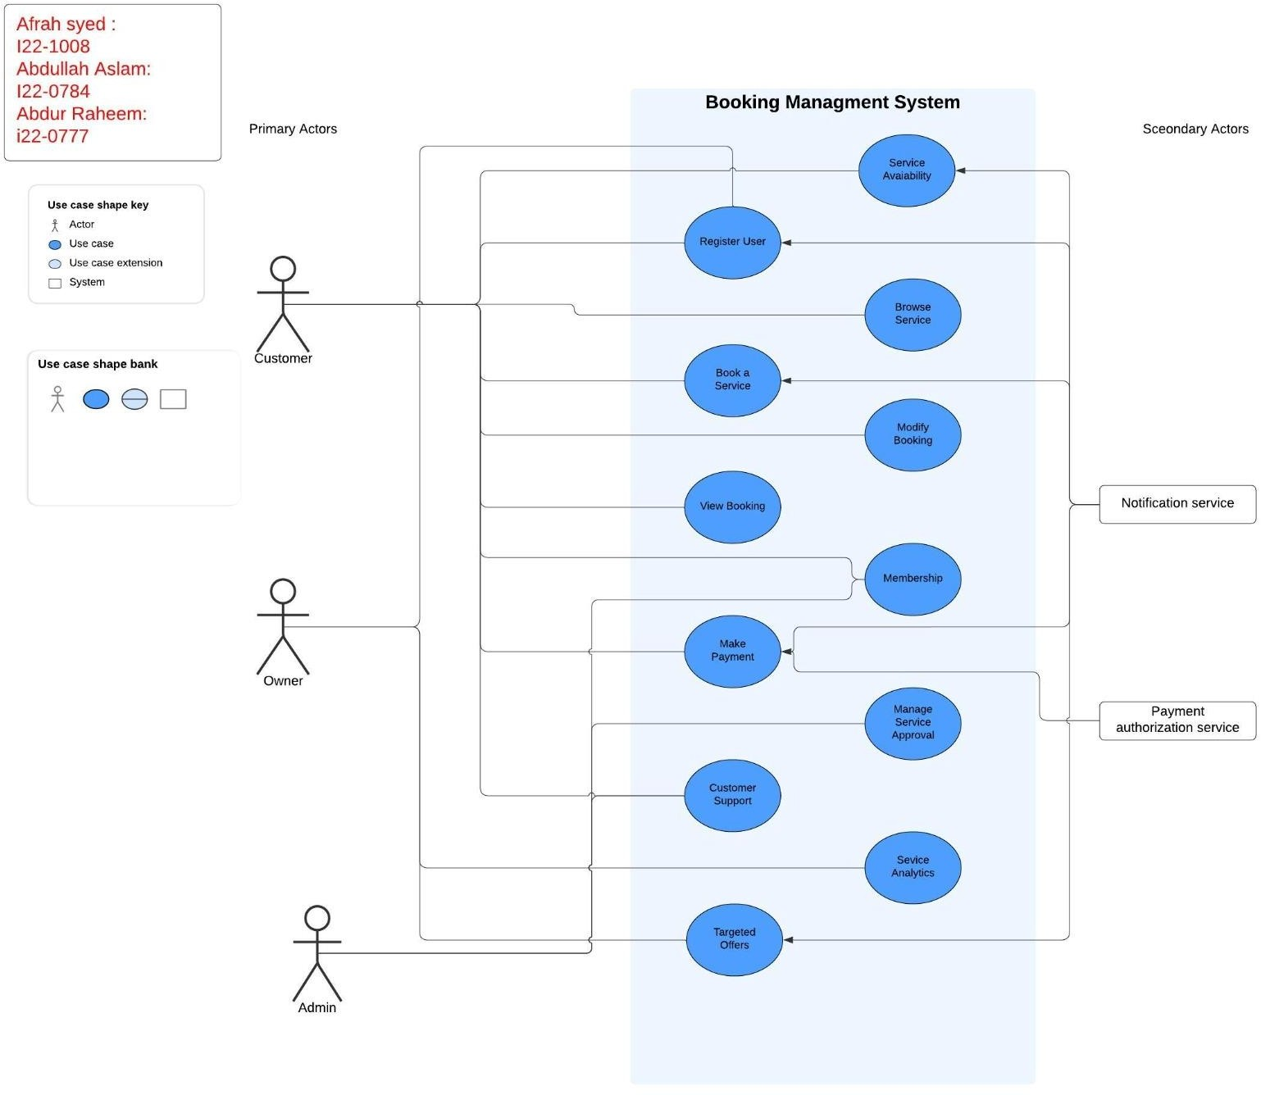

Use Case Diagram

Other Nonfunctional Requirements

Performance Requirements
• The system should handle multiple users simultaneously without performance issues.
• Booking confirmations must be processed and displayed quickly.
• Notifications should be delivered promptly after an event occurs.
• Data retrieval, such as fetching bookings or service details, should be efficient and fast.
• The system should maintain optimal performance as the database grows in size.
• Login and authentication processes should ensure a seamless user experience.

Safety Requirements
• Safeguard data to prevent accidental loss or corruption, with daily backups and recovery mechanisms in place.
• Prevent double-booking by implementing real-time availability checks before confirming a booking.
• User actions that involve irreversible changes, such as cancellation, must prompt for confirmation.

Security Requirements
- Role-based access control to ensure users only access functionalities appropriate to their role (customer, provider, or admin).
- Limit database access to authorized backend services.
- Use a trusted payment gateway for processing transactions safely.

Software Quality Attributes
• Maintainability: Modular and scalable design for easy updates.
• Usability: Responsive UI optimized for all devices.
• Reliability: 99.9% uptime for critical booking operations.

Business Rules
• Customers must register before booking.
• Service providers must be approved by the admin to list services.

Operating Environment
• Compatible with standard desktops and laptops with at least 4GB RAM, 2 GHz dual-core processor, and 500MB free disk space.
• Runs on Windows 10 or later and macOS 10.15 or later.
• Uses JavaFX for the user interface and Java for backend processing.
• Stores and manages data with MySQL 8.0.
• Extendable to other databases through a factory pattern.
• Requires Java Runtime Environment (JRE) and MySQL Client for smooth operation.

User Interfaces
- Clear menu with options for home, services, bookings, and support.
- Easy-to-use forms for login, registration, and booking.

The interface includes a dashboard for customers and service providers, with clearly labeled sections for browsing, bookings, and analytics.
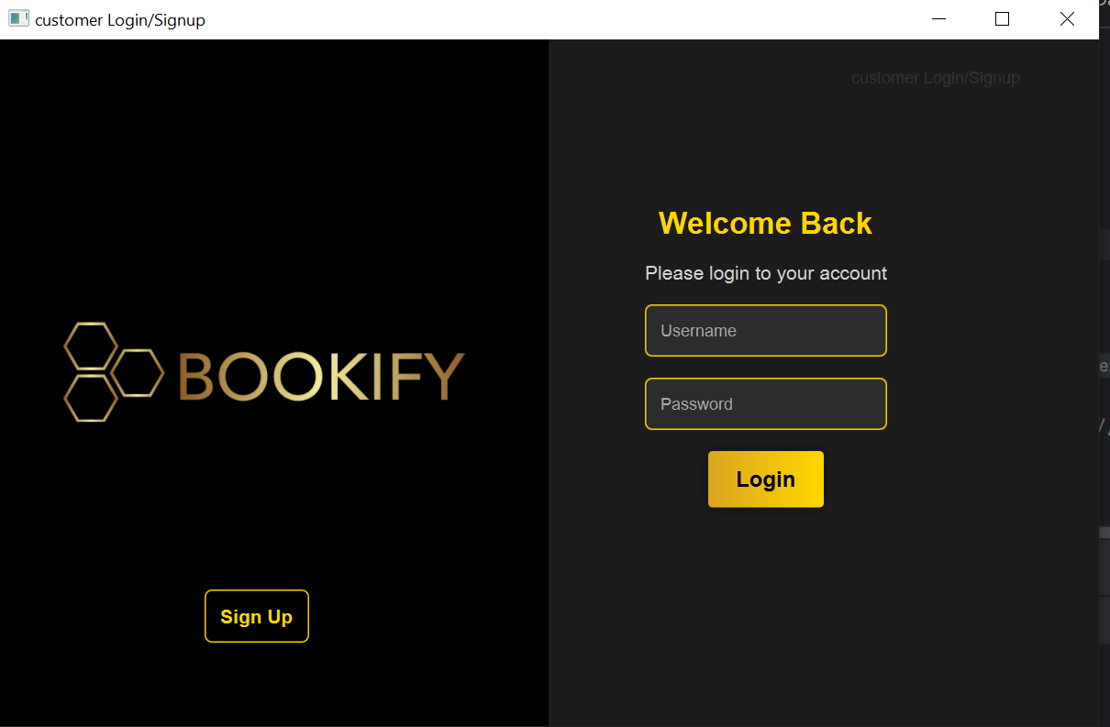

Domain Model
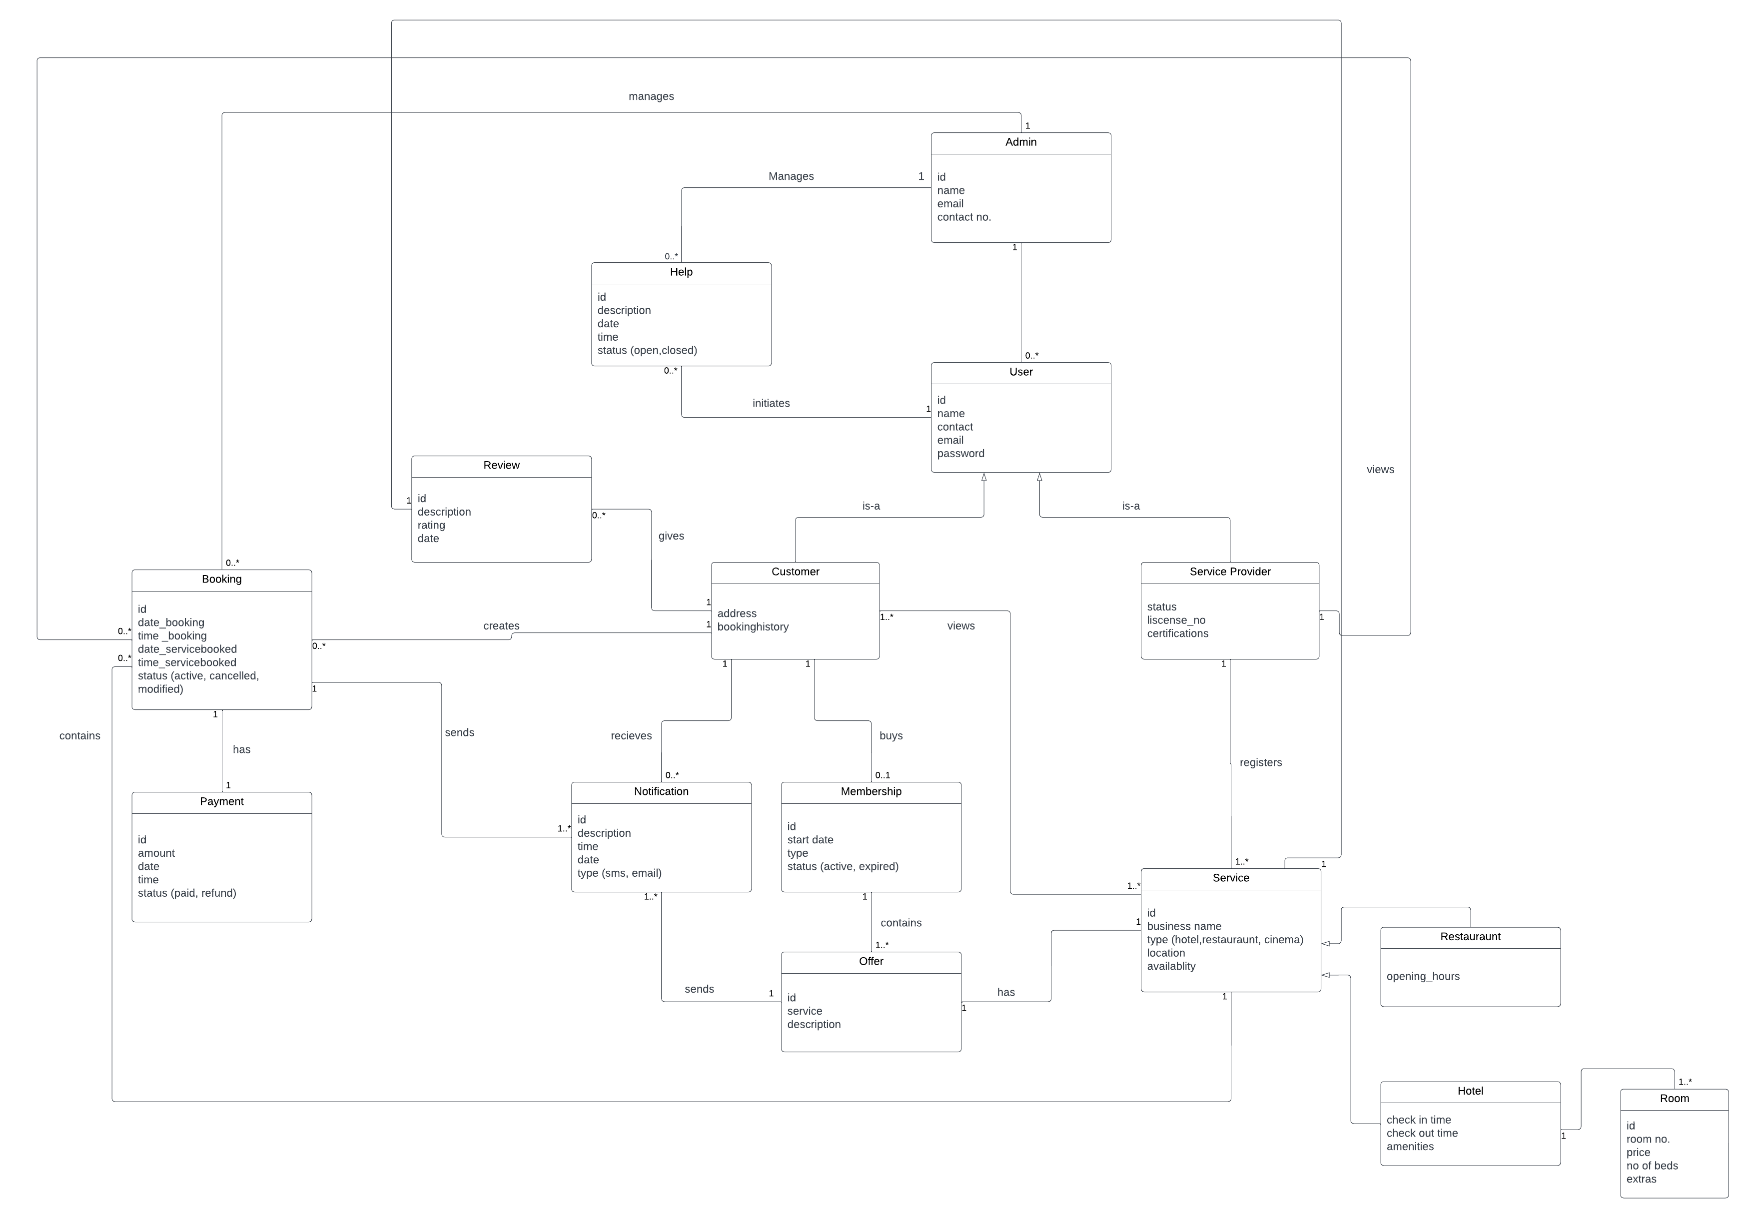

System Sequence Diagram

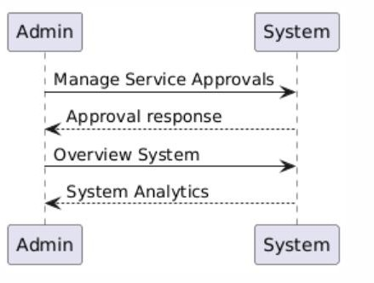
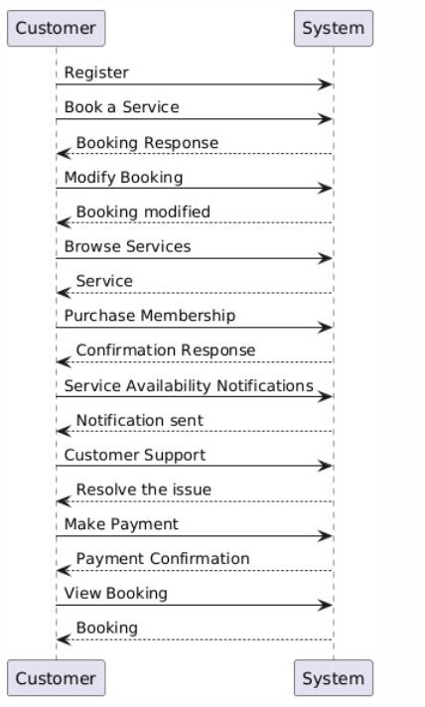

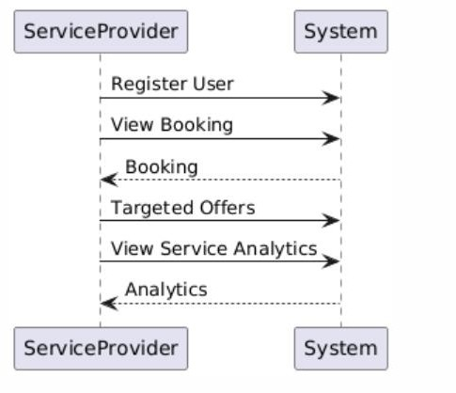

Sequence Diagram
- BOOK A SERVICE
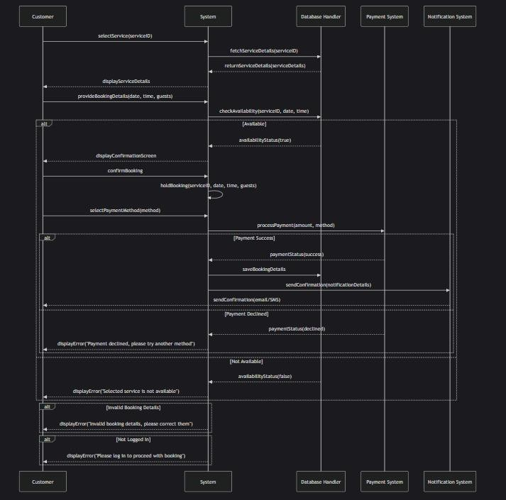
- CUSTOMER SUPPORT
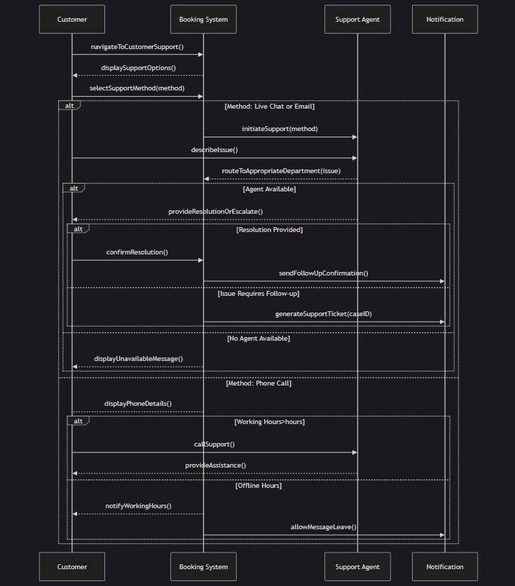
- MEMBERSHIP
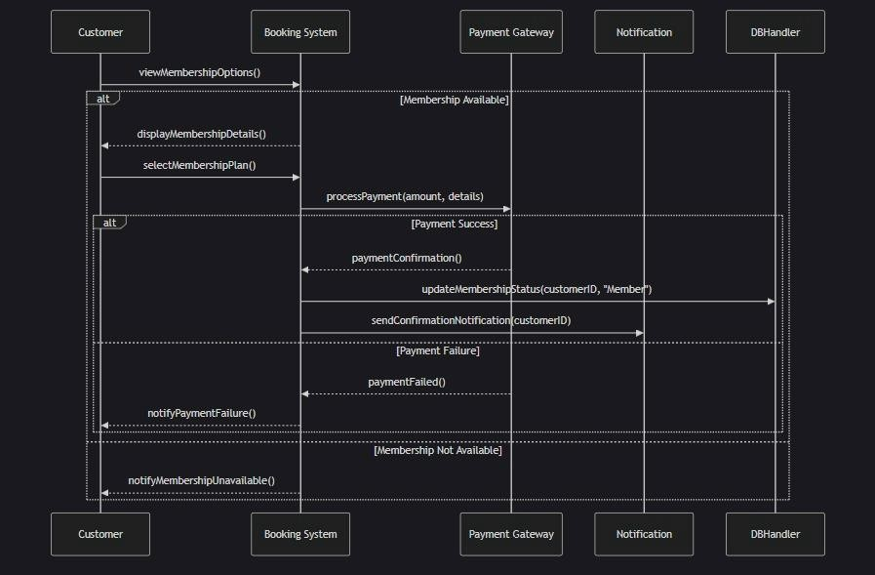
- MODIFY BOOKING
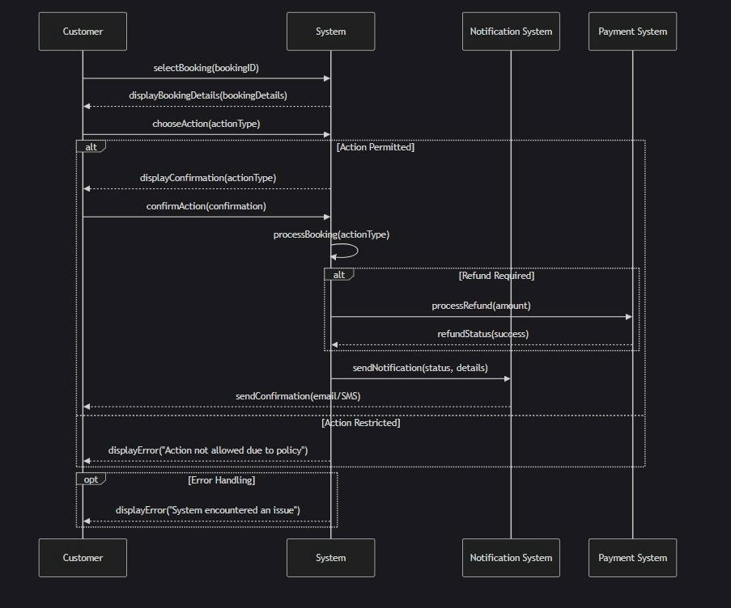
- MAKE PAYMENT
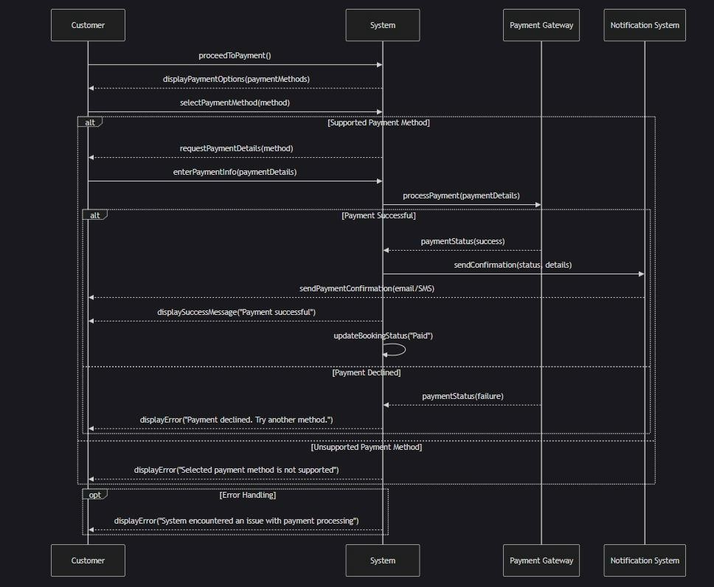

Class Diagram

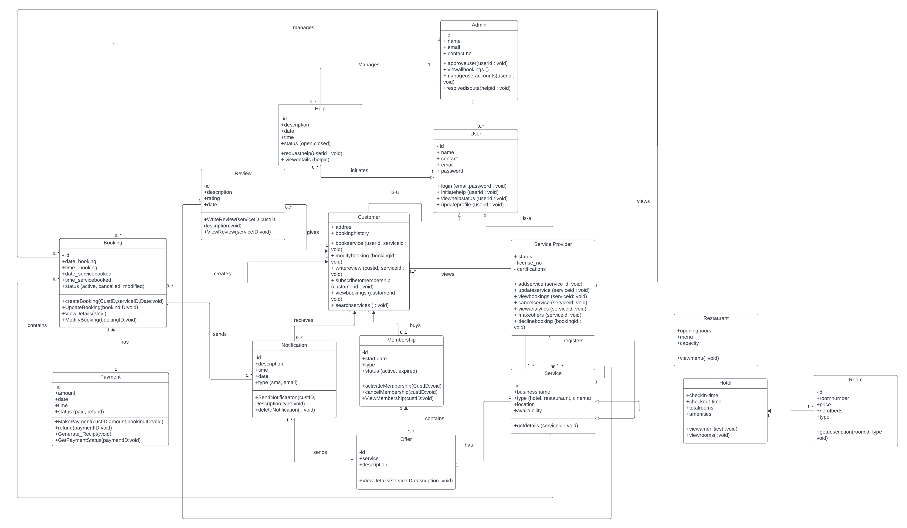

Component Diagram

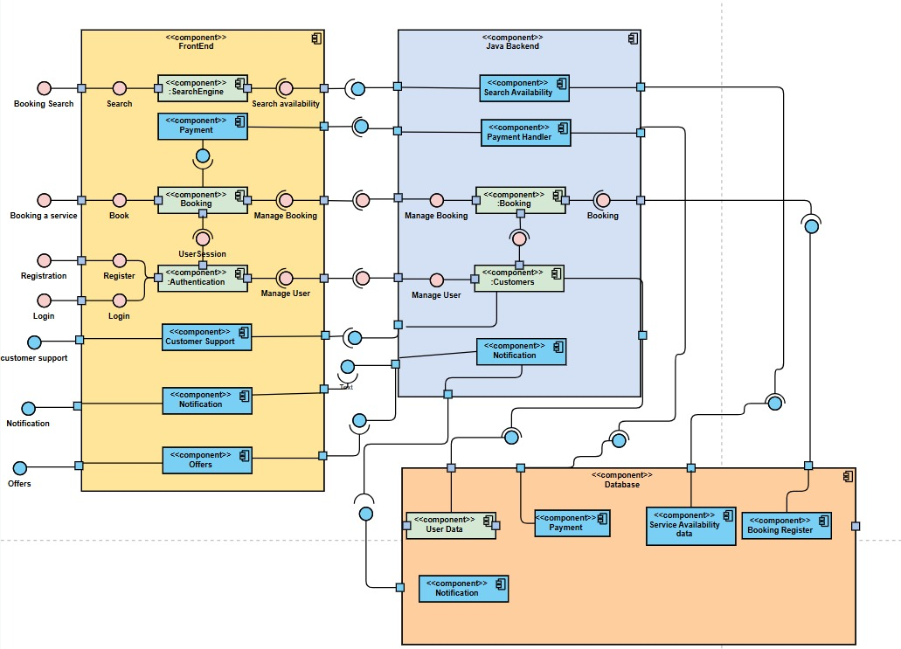

Package Diagram

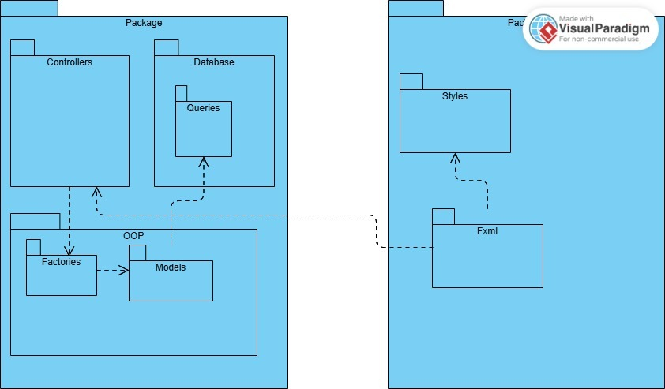

Deployment Diagram

