Software Requirements Specification (SRS)
Project Title: AI-Powered HR Recruitment System using Multi-Agent LLM Framework
1. Introduction
1.1 Purpose
This SRS outlines the functional and non-functional requirements of an AI-powered HR recruitment system using a multi-agent architecture based on fine-tuned large language models (LLMs). The system will automate the HR process including resume screening, interview simulation, candidate scoring, and feedback delivery.
1.2 Scope
The system simulates a team of intelligent agents:
- Recruiter Agent for job-role matching
- Quiz Generator Agent for generating adaptive quizzes based on job role and resume content
- Scoring Agent for rating candidates
- Feedback Agent for generating tailored feedback
- UI/UX Interface for candidate and HR interaction
- Backend and Database for managing interactions, storing resumes, logs, and feedback
- Additionally, the system integrates Retrieval-Augmented Generation (RAG) techniques into relevant agents, particularly the Resume Parsing Agent and Feedback Agent.
1.3 Intended Audience
- Project Supervisors
- Developers
- HR Professionals
- AI Researchers
1.4 Definitions, Acronyms, and Abbreviations
- LLM: Large Language Model
- LoRA: Low-Rank Adaptation
- NER: Named Entity Recognition
- UI: User Interface
- DB: Database
- API: Application Programming Interface

2. System Architecture Overview
2.1 High-Level Architecture
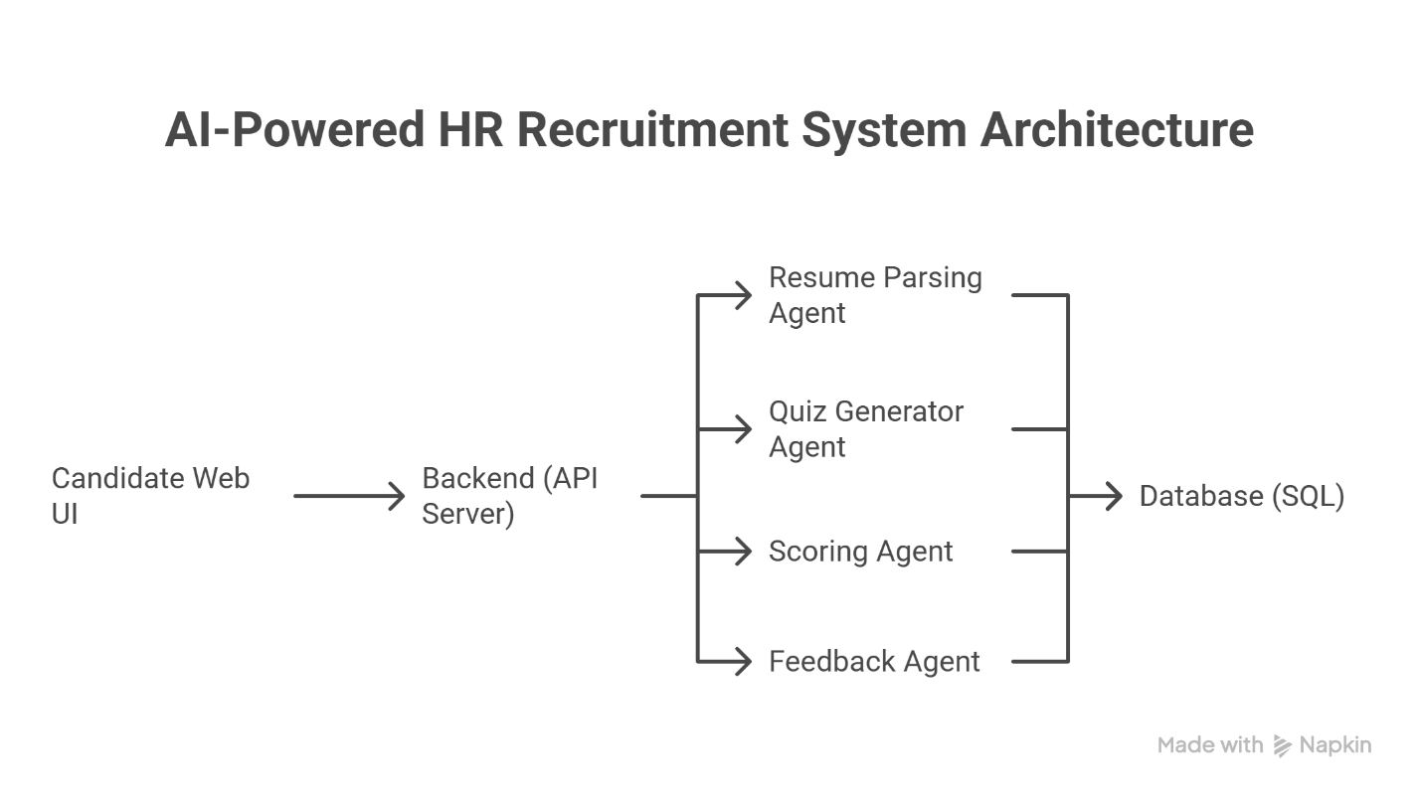

3. Functional Requirements
3.1 User Registration and Login
- Candidates and HR personnel should register and log in using email/password.
- Role-based access control for admin and user.
3.2 Resume Upload and Parsing
- Candidate uploads PDF/DOC resume.
- Recruiter Agent parses and extracts skills using NLP and NER.
3.4 Adaptive Quiz Generation and Scoring
- Quiz Generator Agent creates a multiple-choice or short-answer quiz based on the job role and resume content.
- Candidate completes the quiz through the UI.
- Scoring Agent evaluates the answers automatically using predefined keys or LLM-based logic.
- Score is stored in the database.
3.5 Candidate Scoring
- Scoring Agent rates candidates based on parsed resume and interview results.
- Scores stored in the database.
3.6 Feedback Generation
- Feedback Agent sends custom improvement suggestions based on interview.
3.7 Admin Dashboard
- View all candidates, interviews, feedback, and performance analytics.

4. Non-Functional Requirements
4.1 Performance
- Response time for resume parsing and agent interaction should be <3 seconds.
4.2 Scalability
- Should handle 100 concurrent candidates.
4.3 Security
- JWT-based authentication
- Password hashing (bcrypt)
4.4 Reliability
- Database backup and failover support
4.5 Maintainability
- Modular codebase using microservices (optional)

5. Technology Stack
- Frontend: ReactJS / Next.js
- Backend: FastAPI / Flask (Python)
- LLMs: open ai + LoRA Fine-Tuning
- Multi-Agent Framework: CrewAI
- Database: PostgreSQL
- Resume Parsing: spaCy + Transformers
- Deployment: Docker

6. Database Design (Simplified)
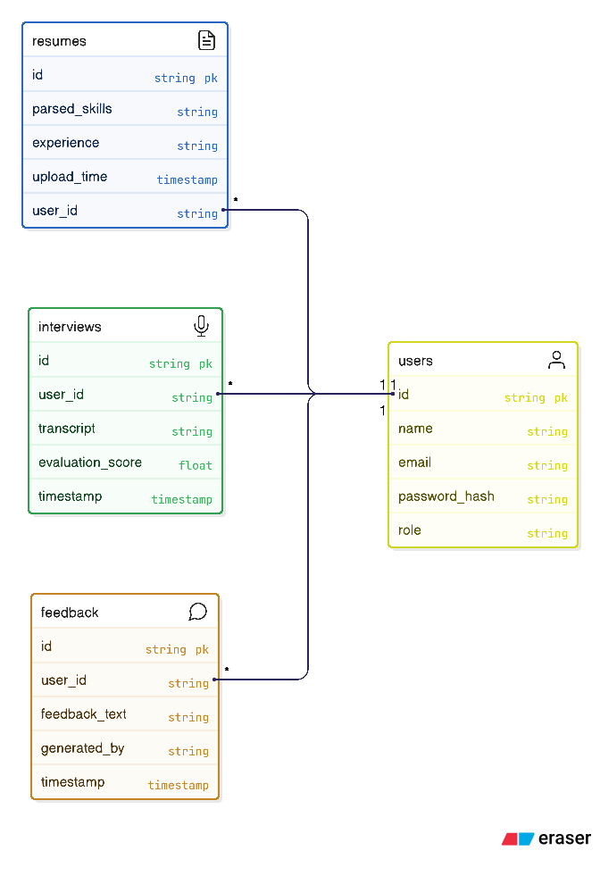

7. Future Enhancements
- Multilingual support
- Interview Agent for real-time voice or chat-based assessment
- Voice-based interview agent
- Integration with LinkedIn or job portals

8. Appendix
- Sample prompts used by each agent
- Evaluation rubrics for scoring agent
- LoRA fine-tuning strategy summary

This SRS serves as the baseline document for system design, development, and validation of the AI-based multi-agent recruitment system.

Based on the current HR recruitment system, here are some valuable features I can add to enhance the platform:

1. Interview Management System
- Schedule interviews with candidates
- Video call integration (Zoom/Teams links)
- Interview feedback forms and scoring
- Interview status tracking (scheduled, completed, cancelled)
- Calendar integration for HR and interviewers
2. Advanced Candidate Communication
- Email templates for different stages (application received, interview invite, rejection, offer)
- Bulk email functionality for multiple candidates
- Email history tracking
- Automated email workflows based on application status
3. Resume Parsing & Skill Enhancement
- Better resume text extraction and parsing
- Automatic skill detection from resume text
- Experience level detection
- Education background extraction
- Contact information parsing
4. Advanced Search & Filtering
- Skill-based candidate search
- Boolean search capabilities
- Saved search filters
- Advanced job matching algorithms
- Candidate tagging system
5. Reporting & Advanced Analytics
- Time-to-hire metrics
- Source tracking (where candidates come from)
- Conversion funnel analysis
- Department-wise hiring statistics
- Export reports to PDF/Excel
6. Candidate Pipeline Management
- Kanban-style board for moving candidates through stages
- Custom hiring stages for different job types
- Bulk actions on candidates
- Pipeline analytics and bottleneck identification
- . Job Board & Public Career Page
- Public job listings page for candidates
- Application form for external candidates
- Company branding customization
- SEO optimization for job listings
8. Collaboration Features
- Comments and notes on candidate profiles
- Team member assignments
- Internal ratings and feedback
- Hiring team collaboration tools
9. Integration Capabilities
- LinkedIn profile import
- Google Calendar integration
- Slack/Teams notifications
- ATS system integrations
10. Mobile Responsiveness & PWA
- Mobile-optimized interface
- Progressive Web App features
- Offline capabilities
- Push notifications

