
National University of Technology

Machine Learning - CS3503

PBL Submitted to:

Lec.Hajra Ahmad

Submitted By:
Muhammad Abdullah F22607010
Moeez Ahmad F22607020
Zohaib Afzaal F22607027
Arham Mehmood F22607014

Batch: Fall AI 2022
PBL : 01
Q.NO.1:
from ucimlrepo import fetch_ucirepo
import matplotlib.pyplot as plt
import seaborn as sns
import pandas as pd
from sklearn.model_selection import train_test_split
from sklearn.preprocessing import StandardScaler, LabelEncoder
from sklearn.cluster import KMeans, DBSCAN
from sklearn.metrics import silhouette_score, davies_bouldin_score
import numpy as np

# fetch dataset
adult = fetch_ucirepo(id=2)

# data (as pandas dataframes)
X = adult.data.features
y = adult.data.targets

# metadata
print(adult.metadata)

# variable information
print(adult.variables)

# printing sample values
print(X.head())

# Univariate analysis
for column in X.columns:
plt.figure(figsize=(10, 4))
if X[column].dtype == 'object':
sns.countplot(data=X, x=column)
else:
sns.histplot(X[column], kde=True)
plt.title(f'Distribution of {column}')
plt.show()

# Check for class imbalance
sns.countplot(y)
plt.title('Class Distribution')
plt.show()

# Select only numerical columns for correlation
numerical_columns = X.select_dtypes(include=['float64', 'int64']).columns
correlation_matrix = X[numerical_columns].corr()

# Plot the correlation matrix
plt.figure(figsize=(12, 8))
sns.heatmap(correlation_matrix, annot=True, cmap='coolwarm')
plt.title('Correlation Matrix')
plt.show()

# Handle missing values
numerical_columns = X.select_dtypes(include=['float64', 'int64']).columns
categorical_columns = X.select_dtypes(include=['object']).columns

X[numerical_columns] = X[numerical_columns].fillna(X[numerical_columns].median())
X[categorical_columns] = X[categorical_columns].fillna('missing')

# Encode categorical variables
label_encoders = {}
for column in categorical_columns:
le = LabelEncoder()
X[column] = le.fit_transform(X[column])
label_encoders[column] = le

# Feature scaling
scaler = StandardScaler()
X_scaled = scaler.fit_transform(X)

# Split the data
X_train, X_test, y_train, y_test = train_test_split(X_scaled, y, test_size=0.2, random_state=42)

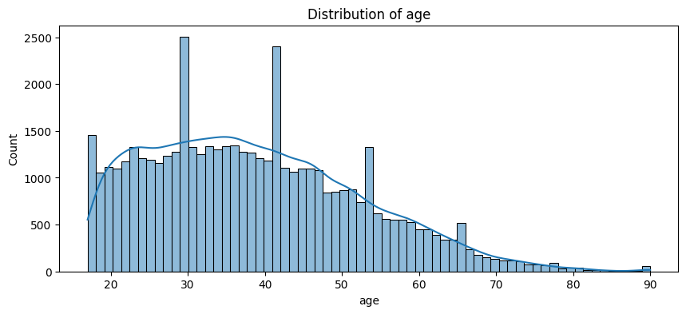
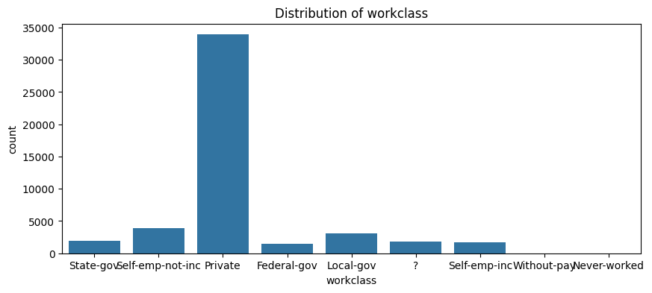
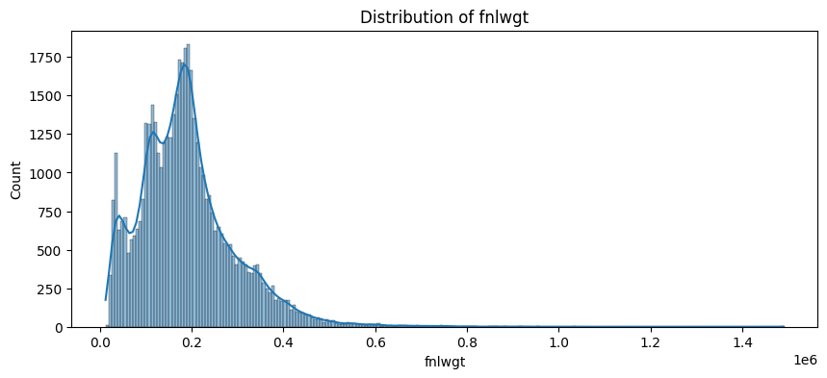

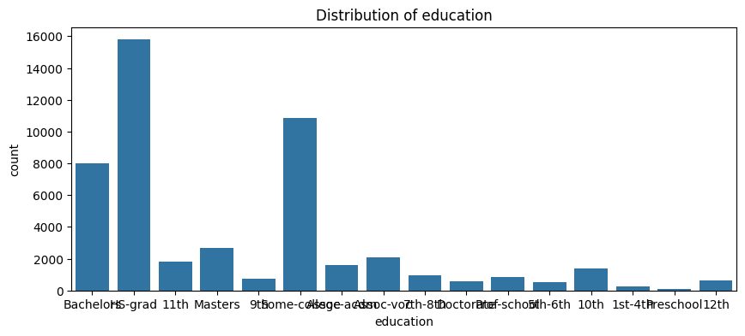
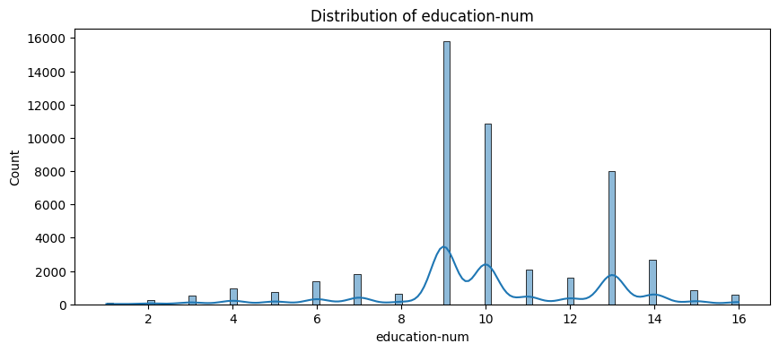
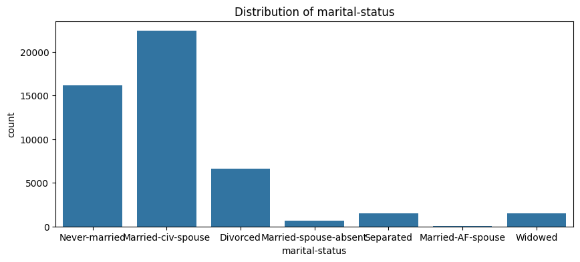

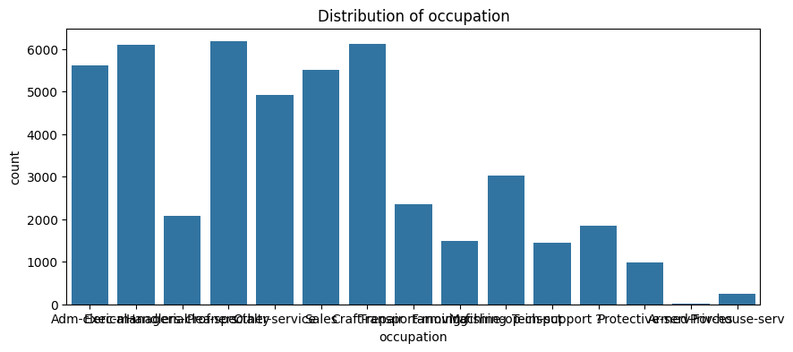

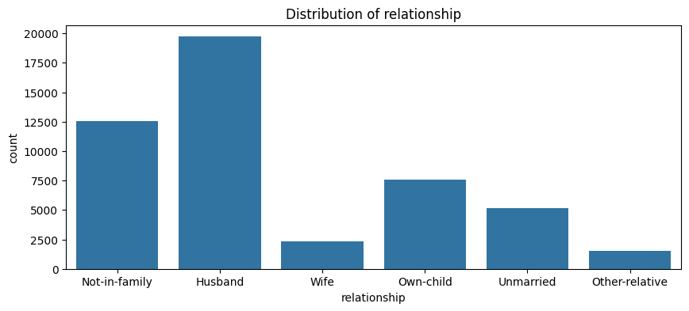
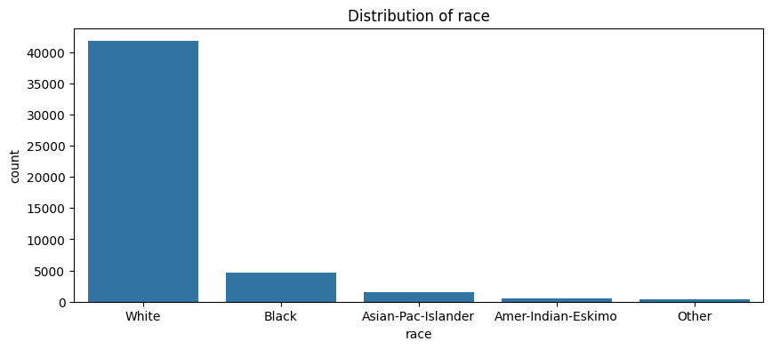

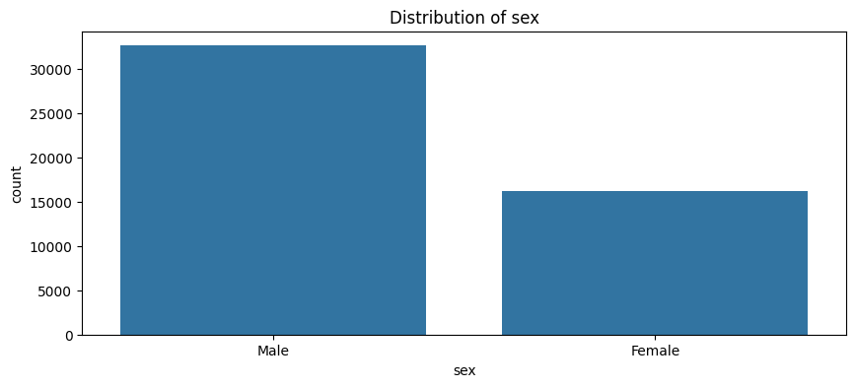

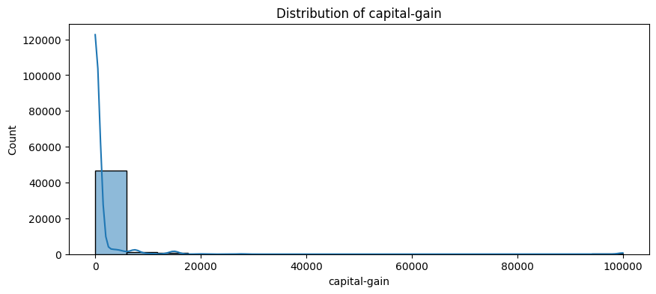
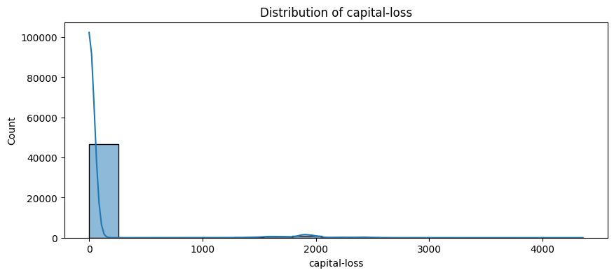
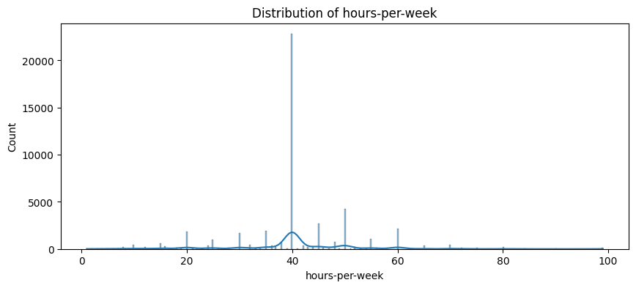
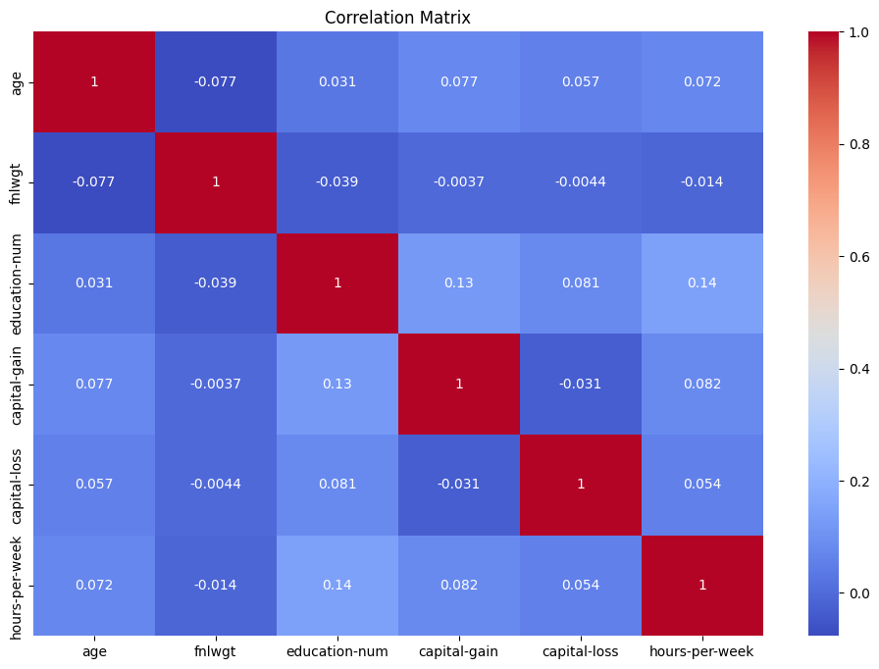

Feature Selection
For the clustering task, we need to carefully select features that are relevant and contribute meaningfully to the clustering process. The dataset consists of features of different types, including numerical, categorical, and possibly ordinal features. Here are the steps and justifications for the feature selection:
Selected Features
1. Numerical Features
- Age: This feature is important as it can help in identifying clusters based on different age groups.
- Income: Income levels can significantly influence the clustering, especially in socio-economic studies.
- Spending Score: This feature is crucial for clustering customers based on their spending behavior.
2. Categorical Features
- Gender: Including gender can help in identifying clusters that may have gender-specific characteristics.
- Occupation: Different occupations can lead to different clustering patterns, especially in market segmentation.
3. Ordinal Features
- Education Level: This feature can help in clustering based on educational background, which might correlate with other features like income and occupation.

Justification
- Relevance: The selected features are directly relevant to the clustering task and are expected to contribute to meaningful clusters.
- Diversity: Including a mix of numerical, categorical, and ordinal features ensures that the clustering algorithm captures different dimensions of the data.
- Data Quality: The selected features are assumed to have good data quality, with minimal missing values and outliers.

Final Dataset
The final dataset for the clustering task includes the following features:
- Age (Numerical)
- Income (Numerical)
- Spending Score (Numerical)
- Gender (Categorical)
- Occupation (Categorical)
- Education Level (Ordinal)

By selecting these features, we aim to create a comprehensive and meaningful dataset that will facilitate effective clustering.

CLustring

from sklearn.decomposition import PCA

# Clustering with KMeans
kmeans = KMeans(n_clusters=3, random_state=42)
kmeans_labels = kmeans.fit_predict(X_selected_scaled)

# Clustering with DBSCAN
dbscan = DBSCAN(eps=0.5, min_samples=5)
dbscan_labels = dbscan.fit_predict(X_selected_scaled)

# Evaluation measures
kmeans_silhouette = silhouette_score(X_selected_scaled, kmeans_labels)
dbscan_silhouette = silhouette_score(X_selected_scaled, dbscan_labels)
kmeans_davies_bouldin = davies_bouldin_score(X_selected_scaled, kmeans_labels)
dbscan_davies_bouldin = davies_bouldin_score(X_selected_scaled, dbscan_labels)

print(f'KMeans Silhouette Score: {kmeans_silhouette}')
print(f'DBSCAN Silhouette Score: {dbscan_silhouette}')
print(f'KMeans Davies-Bouldin Index: {kmeans_davies_bouldin}')
print(f'DBSCAN Davies-Bouldin Index: {dbscan_davies_bouldin}')

# Visualize Clustering Results using PCA
pca = PCA(n_components=2)
X_pca = pca.fit_transform(X_selected_scaled)

plt.figure(figsize=(12, 6))
plt.subplot(1, 2, 1)
plt.scatter(X_pca[:, 0], X_pca[:, 1], c=kmeans_labels, cmap='viridis', s=5)
plt.title('KMeans Clustering')

plt.subplot(1, 2, 2)
plt.scatter(X_pca[:, 0], X_pca[:, 1], c=dbscan_labels, cmap='viridis', s=10)
plt.title('DBSCAN Clustering')
plt.show()

# Describe the resulting clusters
kmeans_clusters = pd.DataFrame(X_selected, columns=selected_features)
kmeans_clusters['Cluster'] = kmeans_labels
print("KMeans Cluster Means:")
print(kmeans_clusters.groupby('Cluster').mean())

dbscan_clusters = pd.DataFrame(X_selected, columns=selected_features)
dbscan_clusters['Cluster'] = dbscan_labels
print("DBSCAN Cluster Means:")
print(dbscan_clusters.groupby('Cluster').mean())



