
National University of Technology

Machine Learning Lab- CS3504

LAB Submitted to:

Lec.Hajra Ahmad

Submitted By:
Muhammad Abdullah

Reg. No: F22607010
Batch: Fall AI 2022
Lab : 01
Q.NO.1:
def primeNumber(n):
if n==1:
return False
for i in range(2,n):
if n%i==0:
return False
return True
num = int(input("Enter a number: "))
if primeNumber(num):
print(f"{num} is a Prime number")
else:
print(f"{num} is not a Prime number")
Output:


Q.No.2:
from collections import Counter

def is_palindrome(word):
return word == word[::-1]

def count_palindromes(file_path):

with open(file_path, 'r') as file:
words = file.read().split()

palindromes = [word for word in words if is_palindrome(word)]
return Counter(palindromes)

file_path = 'text.txt'
palindrome_counts = count_palindromes(file_path)
print(palindrome_counts)
Output: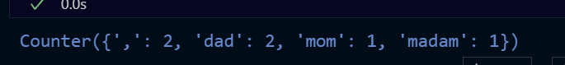

Q.No.3:
def is_disarium(num):
# Converting the number to a string to easily access each digit
num_str = str(num)
length = len(num_str)

# Initializing sum to 0
sum_of_powers = 0

# Creating a copy of the number
temp = num

# Calculating the sum of digits powered with their respective positions
while temp > 0:
single_digit = temp % 10
sum_of_powers += single_digit ** length
temp //= 10
length -= 1

# Checking if the sum of powers is equal to the original number
return sum_of_powers == num

# Checking if the given number is a Disarium number
if is_disarium(num):
print(f"{num} is a Disarium number")
else:
print(f"{num} is not a Disarium number")

Output:




