**GitHub Username**: https://github.com/AbdullahAyman

**KeepFit**

# Description

Workout at home, suited for anybody at any time. The **KeepFit** Challenge Workout, designed by a professional fitness coach, is scientifically proven to help improve fitness and health.

App provide users with best practice of sports and cardio through watching highly rated coach videos step by step doing exercises.

# Intended User

This app for users that doesn’t have time to go to GYM, they will practice in home or their working offices.

Also, for users that need weight loss with easiest way and fastest one.

# Features

* Step by step doing exercises by highly rated and most watched videos and coaches.
* Unlike other apps, our app provide cardio exercises as well as very useful diet programs.
* Will display nearest GYM places, if user decide to go.

# User Interface Mocks

## Screen 1

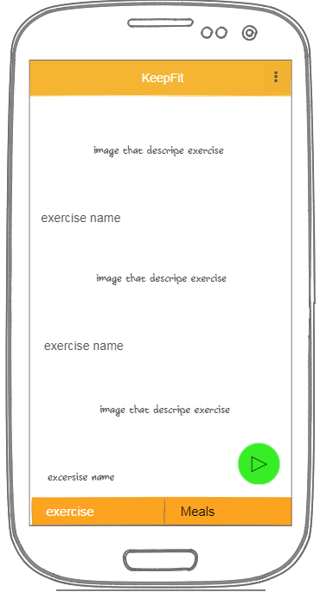

Main screen that user will show at first. It contains cards of exercises with images and text description.

## Screen 2

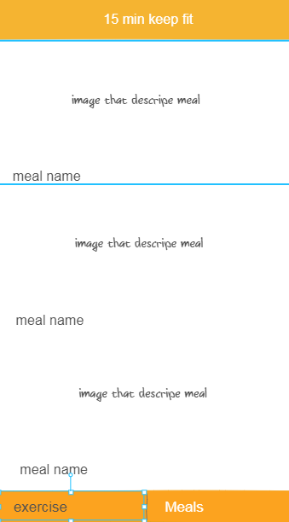

When user navigate to meals screen data will be displayed as cards with image and meal name.

## Screen3

## D:\UdacityProjects\CapStoneApp\DOC\fitness\DOC\excercisedetail.PNG D:\UdacityProjects\CapStoneApp\DOC\fitness\DOC\excercisedetail.PNG

When use select to show details of exercise or meal it will be displayed as upper images.

## Screen4

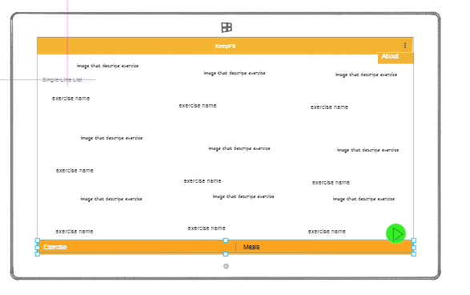

In the tablet view it will be displayed as upper image

## Screen4

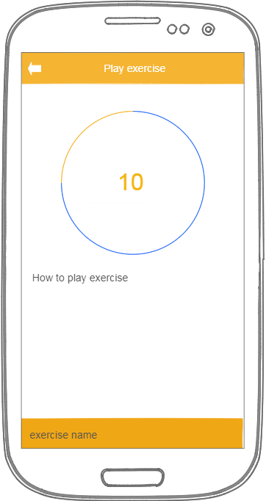

If user select to play exercises app will navigate to that screen and show sequence of exercises.

## Screen5

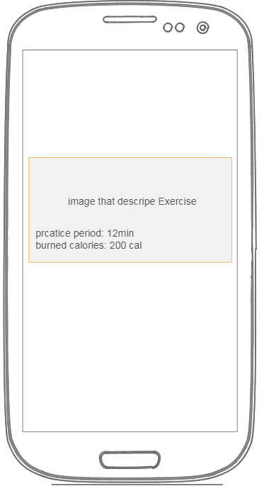

Through app widget we will display list of exercises and each one will provide number of mins and burned calories if done.

# Key Considerations

### How will your app handle data persistence?

KeepFit App will handle data persistence as dealing with local files and content provider and loaders that store links of videos and video description.

The connection to external servers will be done by Retrofit2.0 for displaying videos per request.

**It performs short duration, on-demand requests for viewing videos, app uses an AsyncTask.**

Each time user wants to view specific video we will request that video to server and view video to user when it is ready to play.

User can go back from current screen through default system back or from the back button included in the toolbar.

Through app widget, user can click on specific exercise to show video of how to practice it.

### Describe any libraries you’ll be using and share your reasoning for including them.

* Picasso to handle the loading and caching of images.
* ExoPlayer2.0 to handle loading and viewing of videos.
* Pull to refresh layout to handle refresh recycler view.
* Card View to display items in cards.
* RxJava and Dagger for dependency injection.
* YOYO for adding animation.
* ButterKnife for handling Bind Views.

### Describe how you will implement Google Play Services or other external services.

I will use google play services for displaying nearest available GYMs to user on MAP view.

Also, we will use **AdMob** to monetize the app.

# Next Steps: Required Tasks

This is the section where you can take the main features of your app (declared above) and break them down into tangible technical tasks that you can complete one at a time until you have a finished app.

## Task 1: Project Setup

* Adding dependencies Libs.
* Create google console project for adding Map to our project.
* Setting up Scops, dependencies, Components and Modules for Dagger usage.

## Task 2: Implement UI for Each Activity and Fragment

* Build UI for Main recycler view and it’s cards.
* Build UI for Video Player and description.
* Build UI for Tablet View and Land Scape Views.

## Task 3: Implement Google Play Services

* Build UI for Map View to display nearest entertainment places.

## Task 4: Adding Adapters and Handling Layout Actions.

* Handle actions form user and life cycle for fragment and activity.
* Taking actions and support handling exceptions.