***Web Systems & Technologies***

***ITL-226***

***Lab Journal 5***



**Student Name :** M ABDULLAH BIN ABDUL AZIZ

**Enrolment No.** 01-135231-043

**Class and Section** BS IT 5B

**Department of Computer Science**

**BAHRIA UNIVERSITY, ISLAMABAD**

**Lab # 5: Responsive Web Design**

**Objectives:**

Learning about Responsive Web Design

**Tools Used:**

Visual Studio

**Submission Date:**

**Evaluation: Signatures of Lab Engineer:**

**Media Queries :**

**Code:**

<!DOCTYPE html>

<html lang="en">

<head>

  <meta charset="UTF-8">

  <meta name="viewport" content="width=device-width, initial-scale=1.0">

  <title>Media Queries Practice</title>

  <style>

    /* Default Styles */

    body {

      font-family: Arial, sans-serif;

      margin: 0;

      padding: 0;

      background-color: #f4f4f4;

    }

    .container {

      display: flex;

      flex-direction: row;

      justify-content: space-between;

      padding: 20px;

    }

    .box {

      background-color: #3498db;

      color: white;

      padding: 20px;

      margin: 10px;

      width: 30%;

      text-align: center;

      border-radius: 8px;

    }

    /* Media Queries for Different Screen Sizes */

    /* For 480px and below (small mobile screens) */

    @media (max-width: 480px) {

      .container {

        flex-direction: column;

        align-items: center;

      }

      .box {

        width: 90%; /* Increase width for better visibility on small screens */

        margin: 10px 0;

      }

    }

    /* For 768px and below (tablets and small screens) */

    @media (max-width: 768px) {

      .box {

        width: 45%; /* Adjust width to fit two boxes side by side */

      }

    }

    /* For 980px and below (larger tablets or small laptops) */

    @media (max-width: 980px) {

      .box {

        width: 30%; /* Keep 3 boxes side by side but adjust slightly */

      }

    }

    /* For screens larger than 980px (desktops) */

    @media (min-width: 981px) {

      .box {

        width: 30%; /* Keep the default 3 boxes side by side */

      }

    }

  </style>

</head>

<body>

  <div class="container">

    <div class="box">Box 1</div>

    <div class="box">Box 2</div>

    <div class="box">Box 3</div>

  </div>

</body>

</html>

**Output:**

**1:**

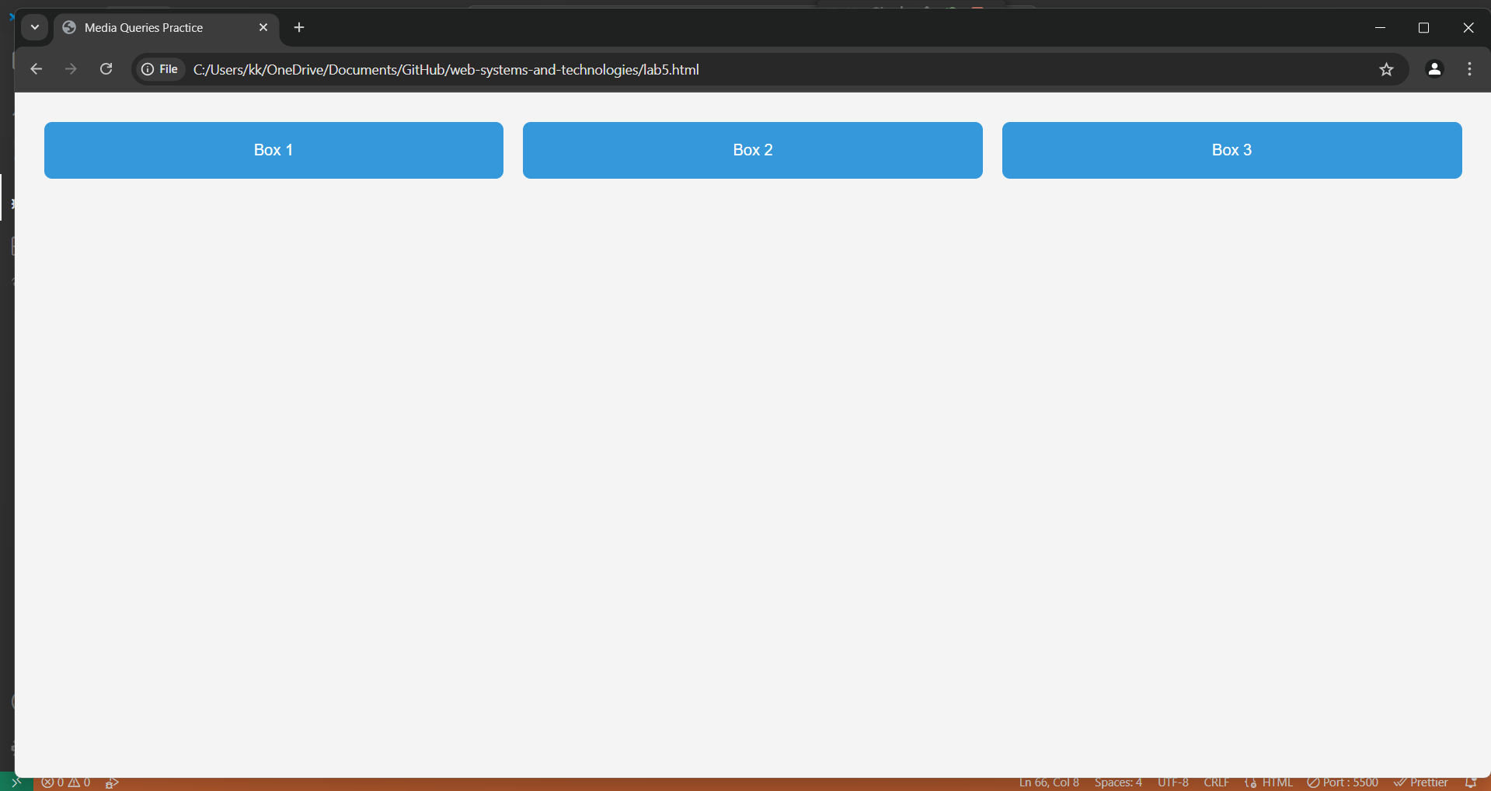

**2:**

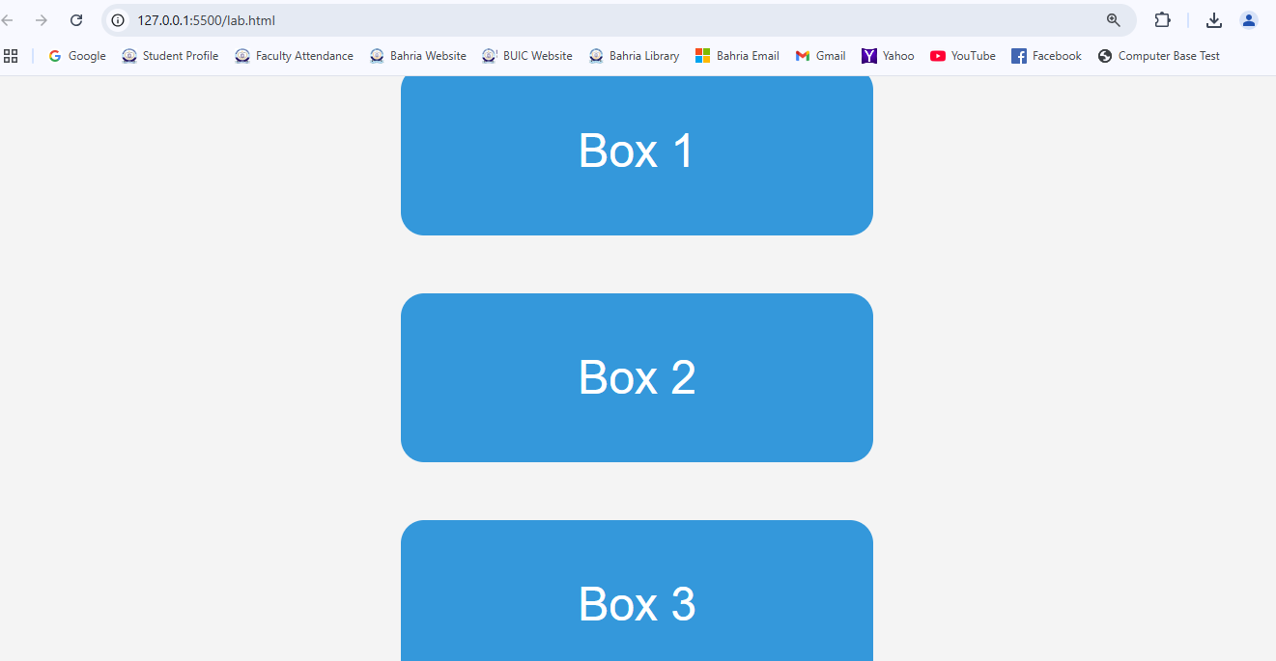

**Task # 1:**

Design the home page of your project using **Bootstrap 5**. Your home page must be responsive.

**Procedure/Program:**

**Result/Output:**

**Analysis/Conclusion:**

**Task # 2:**

Complete the design of your semester project using **Bootstrap 5** (for now, a minimum of 4-5 pages would be enough)

**Procedure/Program:**

**Result/Output:**

**Analysis/Conclusion:**