***Web Systems & Technologies***

***ITL-226***

***Lab Journal 4***



**Student Name:** M ABDULLAH BIN ABDUL AZIZ

**Enrolment No.:** 01-135231-043

**Class and Section:**  BSIT 5-B

**Department of Computer Science**

**BAHRIA UNIVERSITY, ISLAMABAD**

**Lab # 4: HTML5 and CSS**

**Objectives:**

Learn about HTML5 and CSS

**Tools Used:**

Visual Studio

**Submission Date:**

**Evaluation: Signatures of Lab Engineer:**

**Task # 1:**

Create a signup page, get credentials from the user and show them on the other page by using <form> tag.

**Procedure/Program:**

<!DOCTYPE html>

<html lang="en">

<head>

    <meta charset="UTF-8">

    <meta name="viewport" content="width=device-width, initial-scale=1.0">

    <title>Signup Page</title>

</head>

<body>

    <div id="signupPage">

        <h2>Signup Form</h2>

        <form id="signupForm">

            <label for="name">Full Name:</label>

            <input type="text" id="name" name="name" required><br><br>

            <label for="email">Email:</label>

            <input type="email" id="email" name="email" required><br><br>

            <label for="password">Password:</label>

            <input type="password" id="password" name="password" required><br><br>

            <input type="submit" value="Signup">

        </form>

    </div>

    <div id="welcomePage" style="display: none;">

        <h2>Welcome, User!</h2>

        <p><strong>Name:</strong> <span id="displayName"></span></p>

        <p><strong>Email:</strong> <span id="displayEmail"></span></p>

    </div>

    <script>

        document.getElementById("signupForm").addEventListener("submit", function(event) {

            event.preventDefault(); // Prevent form from submitting to a new page

            const name = document.getElementById("name").value;

            const email = document.getElementById("email").value;

            document.getElementById("displayName").textContent = name;

            document.getElementById("displayEmail").textContent = email;

            document.getElementById("signupPage").style.display = "none";

            document.getElementById("welcomePage").style.display = "block";

        });

    </script>

</body>

</html>

**Result/Output:**

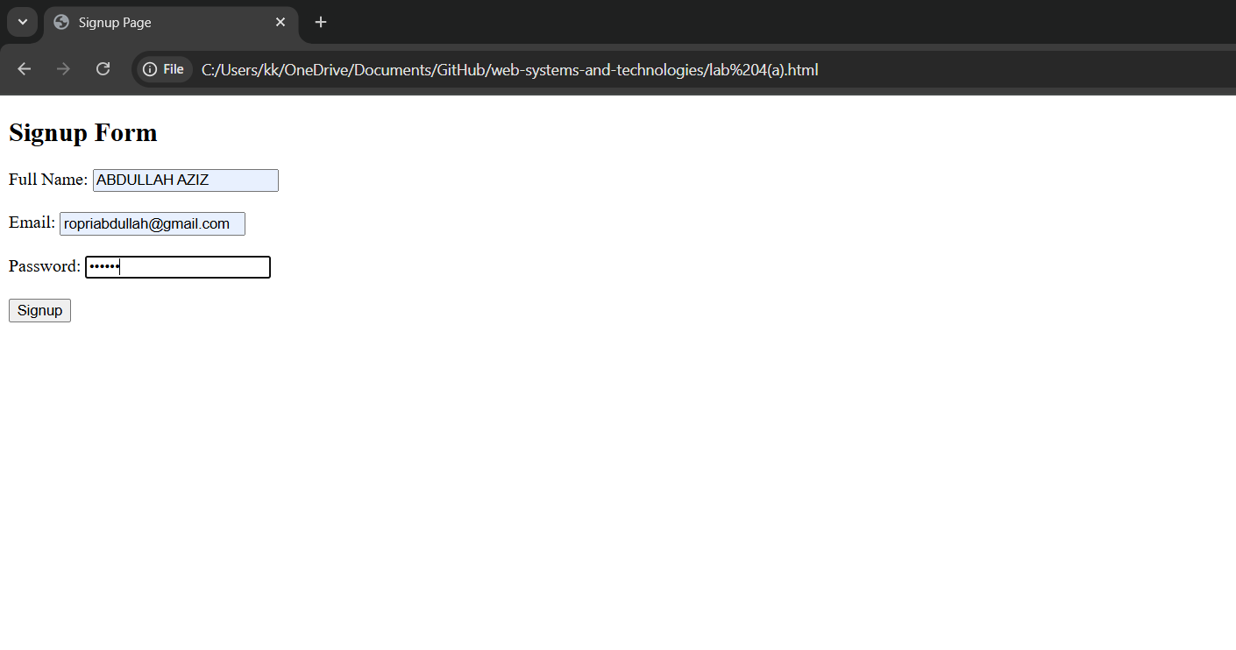

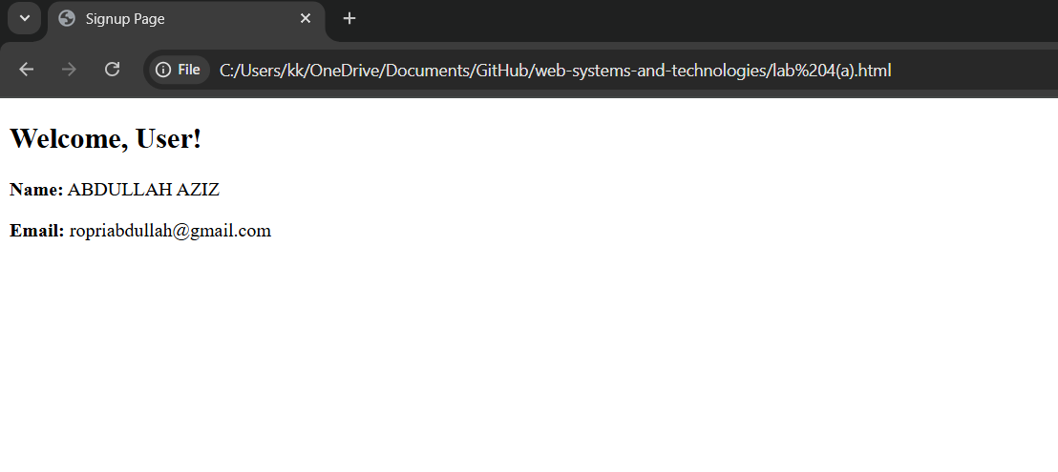

**Analysis/Conclusion:**

**Task # 2:**

Design a static website for an online bookstore, your website must have the following web pages:

* **HOME PAGE:** Shows the list of books.
* **INFORMATION PAGE:** This page displays the information of the selected book. Information includes:
  + Book title
  + Book author
  + Published Year
  + Detail of the book

**Procedure/Program:**

**Result/Output:**

**Analysis/Conclusion:**