**Lab Journal 7**

**Student Name: M ABDULLAH BIN ABDUL AZIZ**

**Enrollment No.: 01-135231-043**

**Class and Section: BSIT 5B**

Department of Computer Science

Bahria University, Islamabad

**Lab # 7: Client-Side Scripting (JS Objects and Events)**

**Objectives:**

Learn about JavaScript events, object manipulation, and user interaction handling.

**Tools Used:**

1. Visual Studio Code
2. Web Browser (Chrome/Firefox)

**Submission Date:**

24-April-2025

**Task #1: Practice Keyboard and Mouse Events**

Implemented five keyboard events (keydown, keypress, keyup, input, change) and five mouse events (click, dblclick, mousemove, mouseover, mouseout).

**Procedure/Program:**

<!DOCTYPE html>

<html>

<head>

<title>Keyboard & Mouse Events</title>

<script> function logEvent(event) { document.getElementById("output").innerText = event.type + " event triggered!";

}

</script>

</head>

<body>

<input type="text" onkeydown="logEvent(event)" onkeyup="logEvent(event)" onkeypress="logEvent(event)">

<button onclick="logEvent(event)">Click Me</button>

<p id="output"></p>

</body>

</html>

**Result/Output:**

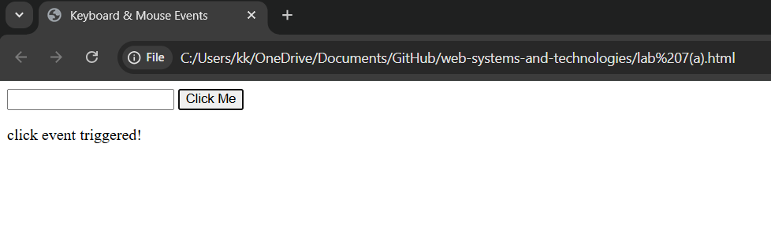

**Analysis/Conclusion:**

Successfully implemented JavaScript event handling, gaining insights into real-time interactions.

**Task #2: Mouse Pointer Coordinates Tracking**

Used JavaScript to capture mouse movement and display coordinates dynamically.

**Procedure/Program:**

<!DOCTYPE html>

<html>

<head>

<title>Mouse Coordinates</title>

<script> function showCoords(event) { document.getElementById("coords").innerText = "X: " + event.clientX + " Y: " + event.clientY;

}

</script>

</head>

<body onmousemove="showCoords(event)">

<h2>Move your mouse to see coordinates</h2>

<p id="coords"></p>

</body>

</html>

**Result/Output:**

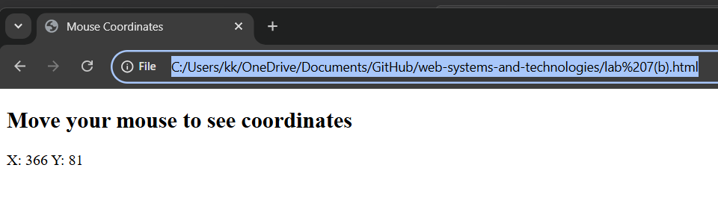

**Analysis/Conclusion:**

Implemented real-time mouse tracking using clientX and clientY properties.

**Task #3: Interactive Form with JavaScript Events** Created an HTML form with interactive events using Bootstrap.

**Procedure/Program:**

<!DOCTYPE html>

<html>

<head>

<title>Interactive Form</title> <link rel="stylesheet" href="https://cdn.jsdelivr.net/npm/bootstrap@5.3.0/dist/css/bootstrap.min.css">

<script> function focusEvent(event) { event.target.style.backgroundColor = "lightblue";

}

function blurEvent(event) { event.target.style.backgroundColor = "white";

}

function charCount() { document.getElementById("count").innerText = document.getElementById("inputText").value.length;

}

function showMessage() { alert("Form submitted!");

}

</script>

</head>

<body>

<div class="container">

<h2>Interactive Form</h2>

<form onsubmit="showMessage(); return false;">

<input type="text" class="form-control" placeholder="Name" onfocus="focusEvent(event)" onblur="blurEvent(event)"><br>

<input type="email" class="form-control" placeholder="Email" onfocus="focusEvent(event)" onblur="blurEvent(event)"><br>

<textarea id="inputText" class="form-control" placeholder="Type something..." oninput="charCount()"></textarea>

<p>Character Count: <span id="count">0</span></p>

<select class="form-select" onchange="alert('Selection Changed!')">

<option>Option 1</option>

<option>Option 2</option>

</select><br>

<button type="submit" class="btn btn-primary">Submit</button>

</form>

</div>

</body>

</html>

**Result/Output:**

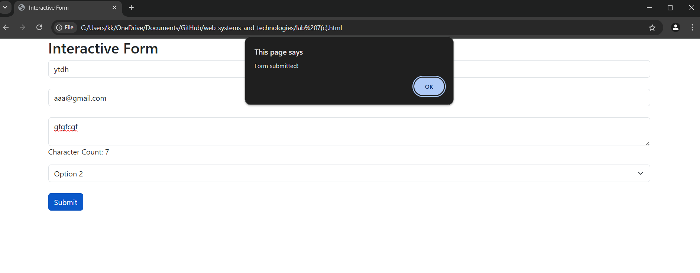

**Analysis/Conclusion:**

Successfully implemented form event handling using JavaScript and Bootstrap for UI enhancements.

**Evaluation:**

Signatures of Lab Engineer: