**Software Requirements and Design Document**

**For**

**TRIP MANAGEMENT SYSTEM**

Prepared by:

Abdullah Chaudhary (i210844)

Zainab Ali (i210492)

Date:  
10-May-2024

**Table of Contents**

1. Introduction 3
   1. Product Scope .................................................................................................................. 3
   2. Title : Uncharted ……………………………................................................................................ 3
   3. Objectives ........................................................................................................................ 3
   4. Problem Statement ......................................................................................................... 3
2. Overall Description 4
   1. Product Perspective ......................................................................................................... 4
   2. Product Functions ............................................................................................................ 4
   3. List of Use Cases ............................................................................................................... 4
   4. Extended Use Cases ......................................................................................................... 4
   5. Use Case Diagram............................................................................................................ 19
3. Other Nonfunctional Requirements 20
   1. Performance Requirements ........................................................................................... 20
   2. Safety Requirements ...................................................................................................... 20
   3. Security Requirements ................................................................................................... 20
   4. Software Quality Attributes .......................................................................................... 20
   5. Business Rules ............................................................................................................... 20
   6. Operating Environment ................................................................................................. 20
   7. User Interfaces ............................................................................................................... 20
4. Domain Model 26
5. System Sequence Diagram 26
6. Sequence Diagram 35
7. Class Diagram 2
8. Package Diagram 3
9. Deployment Diagram 3

# 1. Introduction

## 1.1 Purpose

The purpose of the Trip Management System is to facilitate the seamless organization, coordination, and tracking of travel itineraries and logistics for individuals or groups, ensuring efficient and hassle-free journeys. This system aims to provide users with a user-friendly interface to plan, manage, and monitor their trips, optimizing the travel experience by streamlining processes and enhancing reliability in trip execution and delivery.

## 1.2 Product Scope

Uncharted focuses on domestic tourism within Pakistan, catering to individuals and small groups seeking unique and off-the-beaten-path experiences. While existing travel agencies and booking platforms cater to mainstream destinations, Uncharted specifically targets unexplored regions and caters to adventurous travelers seeking a more authentic experience.

## 1**.**3 Title:

Uncharted. (Trip Management System)

## 

## 1.4 Objectives

* **Empower travelers:** Uncharted empowers individuals to plan and manage their trips independently, offering a comprehensive platform for:
  + **Trip discovery:** Explore curated itineraries, hidden destinations, and unique experiences based on traveler preferences and interests.
  + **Booking management:** Seamlessly book flights, accommodation, activities, and local transportation through integrated partnerships.
  + **Trip budgeting:** Create and manage trip budgets, track expenses, and receive personalized spending recommendations.
* **Promote offbeat destinations:** Uncharted aims to promote lesser-known and unexplored regions within Pakistan through:
  + **Destination information:** Provide comprehensive details about offbeat locations, including cultural attractions, natural wonders, and local activities.
  + **Sustainable tourism practices:** Promote responsible travel practices that benefit local communities and minimize environmental impact.
* **Enhance travel experience:** Uncharted provides tools and resources to enhance the travel experience, fostering a community for sharing experiences and recommendations through:
  + **Travel journal:** Capture memories, share photos, and document experiences during the trip.

## 1.5 Problem Statement

Planning and managing trips to unexplored regions within Pakistan can be challenging due to:

* **Limited information:** Finding reliable and comprehensive information about offbeat destinations, local experiences, and logistics can be difficult.
* **Fragmented booking:** Booking various travel components like accommodation, transportation, and activities often requires navigating multiple platforms.

Uncharted addresses these challenges by providing a centralized platform. Uncharted has the potential to revolutionize the way people explore Pakistan, fostering responsible tourism practices and promoting the country's diverse and hidden treasures.

# 2. Overall Description

## Product Perspective

## Uncharted redefines the concept of trip management, offering a groundbreaking solution that transcends the limitations of existing travel apps. While many platforms provide basic functionalities for trip planning, Uncharted sets itself apart by addressing the shortcomings overlooked by others. Our platform is not just about tracking itineraries; it's a comprehensive tool designed to empower travelers with seamless itinerary planning, booking management, and budget tracking capabilities. By focusing on the unique needs of adventurous travelers and highlighting offbeat destinations, Uncharted offers an unparalleled experience that caters to those seeking authenticity and exploration. It's a one-of-a-kind solution poised to revolutionize the way people discover and experience the world around them.

## 1.2 Product Functions

We offer the following features in our product.

1. Curated Itineraries: Explore handpicked travel plans tailored to your preferences, highlighting hidden gems and unique experiences off the beaten path.
2. Integrated Booking System: Seamlessly book flights, accommodations, activities, and local transportation directly within the platform, streamlining the entire trip planning process.
3. Budget Management Tools: Create, manage, and track trip budgets effortlessly, with personalized spending recommendations to ensure financial peace of mind throughout your journey.
4. Comprehensive Destination Information: Access detailed insights about offbeat locations, including cultural attractions, natural wonders, and local activities, empowering you to make informed decisions while exploring.
5. Community Engagement: Connect with fellow travelers, share experiences, and gain valuable insights through our interactive platform, fostering a vibrant community of adventure enthusiasts.

## 1.3 List of Use Cases

* Create Trip
* View Trip Details
* Trip Promotion by Organizer
* Join Trip
* Cancel Trip Reservation
* Search Trip
* Trip Itinerary
* Customer Management
* Finalize Trip
* Trip Updates
* Feedback
* Chat with admin

## 1.4 Extended Use Cases

**1) Creating a Trip:**

|  |  |
| --- | --- |
| Use case name: | Organize Trip |
| Scope: | This use case covers the process of creating  a new trip within the system by an  organizer who is already logged in. |
| Level: | User level |
| Primary actor: | Organize |
| Stakeholder and their interests: | 1) Organizer: Wants to create a trip with a specific detail to attract customers.  2) System: Storing trip information and making it available for viewing and joining. |
| Preconditions: | The organizer must be logged into the system.  The system must be operational. |
| Post conditions: | The trip details are successfully defined and saved in the system, and the trip is  made available for viewing and joining by  customers. |
| Main success scenario: | Actor action System response  1) Organizer selects "Create Trip."  2) Inputs trip details.  3) System displays entered information.  4) Organizer confirms.  5) System saves trip details.  6) Trip is listed for customers. |

**Extensions:**

If the organizer encounters errors in defining trip details: System prompts the organizer to correct the errors before proceeding with trip creation.

If the organizer cancels the trip creation process: System discards the entered trip info.

Top of Form

**2) View Trip Details:**

**Scope:** This use case covers the process of viewing trip details within the system by users, whether they are organizers or customers.

**Level:** User level

**Primary Actor:** Traveler (Customer)

**Stakeholders and their Interests:**

User: Wants to view detailed information about specific trips.

System: Responsible for retrieving and displaying trip details accurately.

**Pre-condition:** The user must be logged into the system. Trips must be available in the system database.

**Post-condition:** The user successfully views detailed trip information, facilitating informed decisions about trip participation.

**Main Success Scenario:**

|  |  |
| --- | --- |
| Actor Action: |  |
| 1. User searches for a specific trip using filters or browses available trips. | Displays a list of trips matching the search criteria or all available trips if browsing. |
| 2. User selects a trip from the list to view detailed information. | Retrieves and displays detailed trip  information, including:  Destination  Dates  Itinerary  Available slots  Organizer information |
| 3. User reviews the displayed trip details. | Allows the user to scroll through the trip details and organizer information. |
| 4. User may choose to join the trip or go back to browsing. | Provides options for the user to join the trip or return to the list of available trips. |

**Extensions:**

If the user's search yields no results: ∙ System Response: Displays a message indicating no matching trips found and prompts the user to refine their search criteria.

If the user encounters a technical issue while viewing trip details: ∙ System Response: Displays an error message and provides options for the user to retry or contact support.

If the user wants to filter trips further: ∙ System Response: Allows the user to apply additional filters or modify existing ones to narrow down the search results.

If the user decides not to join the selected trip: ∙ System Response: Provides options for the user to continue browsing other trips or return to the main menu.

**3) Join Trip**

**Scope:** This use case covers the process of a customer joining a trip within the system.

**Level**: User Level

**Primary Actor:** Traveler

Stakeholders and their Interests:

∙ Customer: Wants to join a specific trip.

∙ System: Responsible for confirming customer details and updating trip slots accordingly.

**Pre-condition:** The customer must be logged into the system. ∙ Trips with available slots must be listed in the system.

**Post-condition:** The customer successfully joins the selected trip, and the system updates the available slots accordingly.

**Main Success Scenario:**

|  |  |
| --- | --- |
| Actor Action: | System Response: |
| 1. Customer selects a trip they want to join with available slots. | Displays detailed information about the selected trip and prompts the customer to confirm their participation. |
| 2. Customer confirms their intention to join the trip. | Retrieves customer details from the logged-in account and prompts the customer to review and confirm. |
| 3. Customer reviews and confirms their details for trip registration. | Displays customer details for review and prompts the customer to confirm their participation. |
|  | System registers the customer for the trip, reducing the available slots by one.  System Response: Updates the trip's slot availability in the system database and confirms the customer's successful registration. |

**Extensions**:

∙If the selected trip has no available slots:

System Response: Informs the customer that the trip is fully booked and suggests alternative trips with available slots.

∙If the customer's account information is incomplete or outdated:

System Response: Prompts the customer to update their details before proceeding with trip registration.

∙If there is a system error during registration:

System Response: Displays an error message and provides options for the customer to retry or contact support.

∙If the customer decides not to join the trip:

System Response: Cancels the registration process and returns the customer to the trip selection screen.

**4) Cancel Trip**

**Scope:** This use case covers the process of a customer canceling their trip reservation within the system.

**Level:** User Level Primary Actor: Customer

Stakeholders and Interests:

**∙ Customer**: Wants to cancel their reservation for a specific trip.

**∙ System**: Responsible for handling trip cancellations and updating slot availability.

**Preconditions:** The customer must be logged into the system. The customer must have an existing reservation for a trip.

**Post conditions**: The customer successfully cancels their trip reservation, and the system updates the available slots accordingly.

**Main Success Scenario:** Actor Action System Response

1. Customer accesses their profile and selects a trip they are registered for.
2. System displays cancellation options and potential fees (if applicable).
3. Customer confirms cancellation.
4. System removes the customer's registration from the trip and updates the available slots.

System Response: Removes the customer's reservation from the trip list and updates the available slots in the system database.

**Extensions:**

1. If there are penalties or fees associated with cancellation: System Response: Displays information about the applicable fees and prompts the customer to acknowledge before confirming cancellation.
2. If the cancellation period has expired: System Response: Informs the customer that cancellation is no longer possible due to the expiration of the cancellation period.
3. If the customer has already made payments for the trip: System Response: Provides options for refund processing and notifies the customer about the refund timeline.
4. If the cancellation process encounters errors: System Response: Displays an error message and provides options for the customer to retry or contact support.

**5) Search Trip**

**Scope:** This use case covers the process of searching for trips within the system by users, whether they are organizers or customers.

**Level:** User Case Primary Actor: Traveler (Customer)

**Stakeholders and their Interests:**

∙ User: Wants to find trips matching specific criteria.

∙ System: Responsible for retrieving and displaying trip search results accurately.

**Pre-condition:** The user must be logged into the system. Trips must be available in the system database.

**Post-condition:** The user successfully finds trips matching their search criteria, and the system displays a filtered list of available trips accordingly.

**Main Success Scenario:**

Actor Action: System Response:

1. User enters search criteria based on destination, dates, keywords in the trip description, or organizer name. Provides input fields for the user to enter search criteria.
2. User submits the search request. Initiates the search process based on the entered criteria.
3. System searches for trips matching the criteria. Retrieves trips from the system database that match the entered search criteria. System displays a filtered list of available trips.

**Extensions:**

∙If no trips match the entered search criteria:

System Response: Informs the user that no matching trips were found and suggests refining the search criteria.

∙If the user encounters technical issues during the search process:

System Response: Displays an error message and provides options for the user to retry or contact support.

∙If the user wants to modify the search criteria:

System Response: Allows the user to refine or update the entered search criteria and initiates a new search based on the modified criteria.

∙If the user wants to browse all available trips without entering specific search criteria:

System Response: Provides options for the user to view all available trips without entering search criteria.

**6) Trip Itinerary**

**Scope:** This use case covers the process of creating and managing a trip itinerary within the system by organizers.

**Level:** User Level Primary Actor: Organizer

Stakeholders and their Interests:

∙ Organizer: Wants to provide comprehensive trip details to participants.

∙ System: Responsible for facilitating the organization and presentation of trip itineraries.

**Pre-condition:** The organizer must be logged into the system. The organizer must have already created the trip for which they want to add an itinerary.

**Post-condition:** The organizer successfully adds detailed information for each day of the trip itinerary, enhancing the trip experience for participants.

**Main Success Scenario**: Actor Action System response

1. Organizer accesses a specific trip they created. Displays trip details and provides options for itinerary management.
2. Organizer selects the option to add or edit the trip itinerary. Provides an interface for the organizer to add or edit itinerary details for each day of the trip.
3. Organizer adds detailed information for each day of the trip itinerary, including: ∙ Activities ∙ Timings ∙ Locations ∙ Additional notes Allows the organizer to input and save detailed itinerary information for each day of the trip.

**Extensions:**

∙ If the organizer wants to modify existing itinerary details:

System Response: Provides options for the organizer to edit or update previously added itinerary information.

∙ If the organizer encounters conflicts or overlaps in the itinerary:

System Response: Alerts the organizer about conflicting schedule entries and provides options for resolution.

∙ If the organizer wants to add images or multimedia content to the itinerary:

System Response: Provides functionality for the organizer to upload and attach images or multimedia content to itinerary entries.

∙ If the organizer wants to share the itinerary with trip participants:

System Response: Provides options for the organizer to share the finalized itinerary with trip participants via email or within the system.

**7) Managing Customer**

**Scope:** This use case covers the process of customer management within the system by trip organizers.

**Level:** User Level Primary Actor: The primary actor is the hostel management.

**Stakeholders and their Interests:**

∙ Organizer: Wants to efficiently manage customer information and preferences for a trip they created.

∙ System: Responsible for providing tools to organize and display customer information effectively.

**Pre-condition:** The organizer must be logged into the system. The organizer must have already created the trip for which they want to manage customers.

**Post-condition:** The organizer successfully accesses and manages customer information for the trip, facilitating communication and ensuring a personalized trip experience.

**Main Success Scenario**: Actor Action: System Response:

1. Organizer accesses a specific trip they created. Displays trip details and provides options for customer management.
2. Organizer selects the option to view registered customers for the trip. Displays a list of customers registered for the trip, including their contact information and any notes/preferences added during registration.
3. Organizer can view and update customer information as needed. Provides functionality for the organizer to view and edit customer details, including contact information, preferences, and special requests.
4. Organizer can communicate with customers individually or in bulk. System sends invitation to customer and asks to reply within certain time if they are still interested.

**Extensions:**

∙ If the organizer wants to filter or sort the list of registered customers:

System Response: Provides filtering and sorting options based on criteria such as name, registration date, or special requests.

∙ If the organizer wants to add new customers manually:

System Response: Allows the organizer to manually add new customers to the list and enter their information.

∙ If the organizer wants to export customer information for external use:

System Response: Provides functionality to export customer data to a spreadsheet or other external formats for further analysis or communication.

∙ If the organizer encounters errors or discrepancies in customer information:

System Response: Provides options for the organizer to review and reconcile any errors or discrepancies in customer data.

**8) Finalizing Trip**

**Scope:** This use case covers the process of payment processing within the system for customers registered for trips.

**Level:** User Level Primary Actor: Customer

**Stakeholders and Interests:**

Customer: Wants to make a secure payment for a registered trip. System: Responsible for securely processing payments and updating customer registration status.

**Preconditions:** The customer must be logged into the system. The customer must have a trip registration with pending payment.

**Post conditions:** The customer successfully completes the payment process, and the system updates their registration status accordingly.

**Main Success Scenario:**

Actor Action System Response Customer selects a trip they are registered for and chooses the "Make Payment" option. Displays trip details and provides options for payment processing.

System securely redirects the customer to a payment gateway for processing the trip fee. Customer enters payment details and confirms the transaction.

Provides a secure interface for the customer to enter payment information and confirms the transaction.

Upon successful payment, the system confirms the payment and updates the customer's registration status.

**9) TRIP UPDATES/NOTIFICATIONS**

Use Case Name: Trip Updates/Notifications  
Scope: This use case covers the process of sending trip updates or notifications within the system by trip organizers.  
Level: User Level  
Primary Actor: Organizer  
Stakeholders and Interests:

1. Organizer: Wants to communicate important trip-related information to registered customers.
2. System: Responsible for facilitating the composition and delivery of trip updates or notifications.

Preconditions:

1. The organizer must be logged into the system.
2. The organizer must have already created the trip for which they want to send updates/notifications.

Post conditions: The organizer successfully composes and sends trip-related updates or notifications to registered customers, ensuring effective communication and engagement.

Main Success Scenario:

Actor Action System Response

1. Organizer composes a message containing trip-related updates or important information.
2. Organizer selects all or specific customers registered for the trip.
3. System allows the organizer to choose the delivery method (email or SMS). Organizer send messages

Extensions:

1. If the organizer wants to schedule the message for future delivery: System Response: Provides options for the organizer to schedule the message to be sent at a later date and time.
2. If the organizer wants to personalize the message for each recipient: System Response: Allows the organizer to customize the message content for individual recipients before sending.
3. If the organizer wants to track delivery and engagement metrics: System Response: Provides analytics and reporting tools for the organizer to track message delivery, open rates, and engagement metrics.
4. If the organizer wants to send follow-up messages or reminders: System Response: Offers options for the organizer to send additional messages or reminders to recipients who have not engaged with the initial communication

**10) FEEDBACK AND REVIEWS**

Use Case Name: Giving Feedback  
Scope: This use case covers the process of submitting feedback and reviews within the system by customers who have completed a trip.  
Level: User Level  
Primary Actor: Customer  
Stakeholders and Their Interests:  
Customer: Wants to share their experience and provide feedback about a completed trip.  
System: Responsible for collecting and managing customer feedback and reviews.

Pre-conditions:  
The customer must be logged into the system.  
The customer must have completed a trip for which they want to submit feedback and reviews.

Post-conditions:  
The customer successfully submits feedback and reviews about their trip experience, contributing to the improvement of future trips and enhancing the overall customer experience.

Main Success Scenario:

Actor Action System Response

1. Customer accesses their profile.  
   Displays the customer's profile page with options for managing trip-related activities.
2. Customer selects the completed trip for which they want to provide feedback and reviews.  
   Displays trip details and provides options for submitting feedback and reviews
3. Customer composes and submits feedback and reviews about their trip experience.  
   Provides a feedback form or text entry field for the customer to write their comments and ratings.
4. System records the feedback and reviews and updates trip ratings and reviews accordingly.  
   Receives and saves the submitted feedback and reviews in the system database, updating trip ratings and reviews for future reference.

Extensions:

* If the customer encounters technical issues while submitting feedback:  
  System Response: Displays an error message and provides options for the customer to retry or contact support for assistance.
* If the customer wants to provide detailed feedback or suggestions for improvement:  
  System Response: Provides additional text entry fields or prompts for specific feedback categories to gather more detailed information.

**11) CHAT WITH ORGANIZER/ADMIN**

Use Case Name: Chat with Organizer/Admin  
Scope: This use case covers the process of initiating and participating in chat conversations within the system between customers, trip organizers, and system administrators.  
Level: User Level.  
Primary Actor: Customer  
Stakeholders and Their Interests:  
∙ Customer: Wants to communicate with trip organizers and administrators for inquiries, support, and feedback.  
∙ Trip Organizer: Responsible for managing trip-related inquiries and providing support to customers.  
∙ System Administrator: Responsible for handling system-related inquiries and providing assistance to customers and organizers.

Pre-conditions:  
The customer must be logged into the system.  
Trip organizers and system administrators must be available and reachable through the chat interface.

Post-conditions:  
Customers can initiate and participate in chat conversations with trip organizers and administrators, facilitating efficient communication and support.

Main Success Scenario:

Actor Action: System Response:

1. Customer accesses the chat feature within the system.  
   Displays the chat interface with options to start a new conversation or continue existing ones.
2. Customer selects the option to chat with trip organizers or system administrators.  
   Provides a list of available trip organizers and administrators for the customer to choose from.
3. Customer selects the organizer or administrator they want to chat with.  
   Initiates a chat conversation with the selected organizer or administrator.
4. Customer sends a message with their inquiry, request, or feedback.  
   Delivers the message to the selected organizer or administrator in real-time.
5. Organizer or administrator receives the message and responds accordingly.  
   Delivers the response to the customer, facilitating a real-time conversation.

Extensions:

* If the selected organizer or administrator is unavailable:  
  System Response: Notifies the customer and provides options to leave a message for follow-up.
* If the conversation requires escalation to higher-level support:  
  System Response: Provides options for the customer to escalate the conversation to a system administrator for further assistance.

**12) TRIP PROMOTION**

Use Case Name: Trip Promotion  
Scope: This use case covers the process of promoting trips within the system by trip organizers.  
Level: User Level.  
Primary Actor: Customer  
Stakeholders and Their Interests:  
∙ Organizer: Wants to attract potential customers and increase trip bookings through effective promotion.  
∙ System: Responsible for providing tools and features to facilitate trip promotion and tracking.

Pre-conditions:  
The organizer must be logged into the system.  
The organizer must have created one or more trips that they want to promote.

Post-conditions:  
Organizers successfully promote their trips to potential customers, resulting in increased trip bookings and participation.

Main Success Scenario:

Actor Action: System Response:

1. Organizer accesses the trip promotion feature within the system.  
   Displays the trip promotion interface with options to create and manage promotional campaigns.
2. Organizer selects the trip they want to promote.  
   Provides a list of available trips for the organizer to choose from.
3. Organizer creates promotional content for the selected trip.  
   Offers tools for the organizer to create engaging promotional content, including text, images, and videos.
4. Organizer defines the target audience for the promotional campaign.  
   Provides options for the organizer to specify customer segments based on demographics, interests, or previous interactions.
5. Organizer sets the duration and budget for the promotional campaign.  
   Allows the organizer to define the campaign duration and allocate a budget for advertising or promotional activities.

Extensions:

* If the promotional content needs approval from system administrators:  
  System Response: Routes the promotional content for review and approval by system administrators before launching the campaign.
* If the organizer wants to offer discounts or incentives to encourage bookings:  
  System Response: Allows the organizer to include special offers or discounts as part of the promotional campaign to incentivize potential customers.

## 1.5 Use Case Diagram

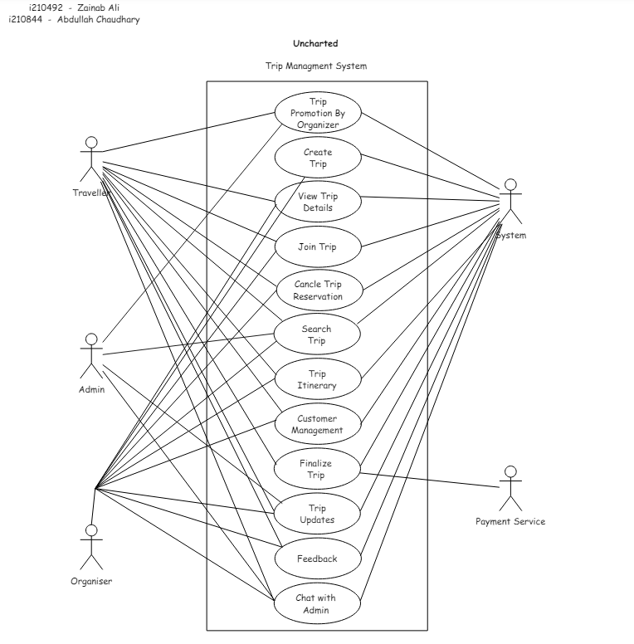

# 3. Other Nonfunctional Requirements

## Performance Requirements

* Ensuring an efficient response time for itinerary retrieval and booking procedures to enhance user experience.
* The system should maintain high performance and responsiveness even during peak usage periods.
* Efficient handling of data processing and traffic to accommodate the influx of users and data volume.
* The system should aim for minimal downtime and ensure round-the-clock availability for users.

## Safety Requirements

* Ensuring the safety and security of travelers' personal information and payment details.
* Implementing measures to mitigate the risk of data loss or unauthorized access to user data.
* Providing secure encryption protocols for safeguarding sensitive information during transactions and interactions within the system.

## Security Requirements

* Implementing robust security measures to protect user data, including personal details and payment information.
* Ensuring compliance with data protection regulations and industry standards to uphold user privacy and security.
* Regular security audits and updates to address potential vulnerabilities and enhance overall system security.

## Software Quality Attributes

* Prioritizing reliability to ensure consistent performance and functionality throughout the user experience.
* Emphasizing accessibility to ensure the system is user-friendly and accessible to users with diverse needs and abilities.
* Striving for a balance between reliability and efficiency, prioritizing consistent performance over speed in critical functionalities.

## 1.5 Business Rules

* The system caters to both travelers and trip organizers, providing functionalities such as itinerary browsing, booking, and trip management.
* Customers can access features like itinerary discovery, booking management, and customer support through the user interface.
* Staff members have additional privileges, such as updating trip information and managing inventory, to facilitate efficient operation of the system.

## 1.6 Operating Environment

The ideal operating environment for this application is Windows running on x86 architecture. The minimum space required is 5 MB.

## **1.7 User Interfaces**

**Main Screen:**



**LOGIN SCREEN:**

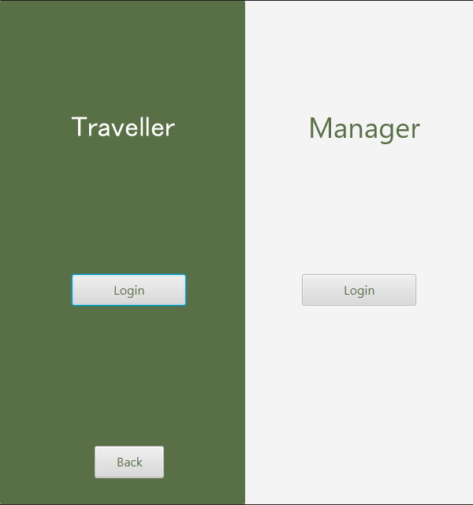

**TRAVELER SCREEN:**

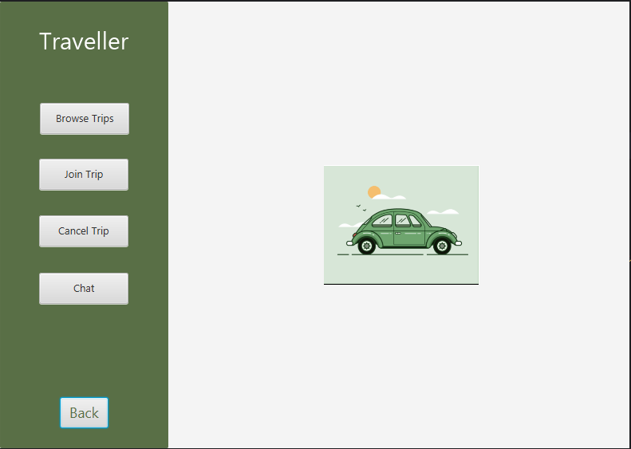

**BROWSER TRIP:**

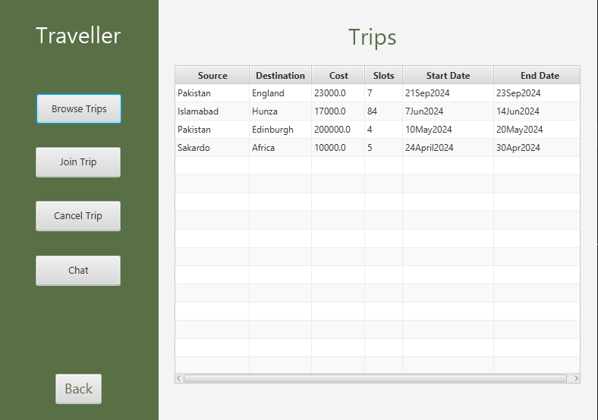

**JOIN TRIP:**

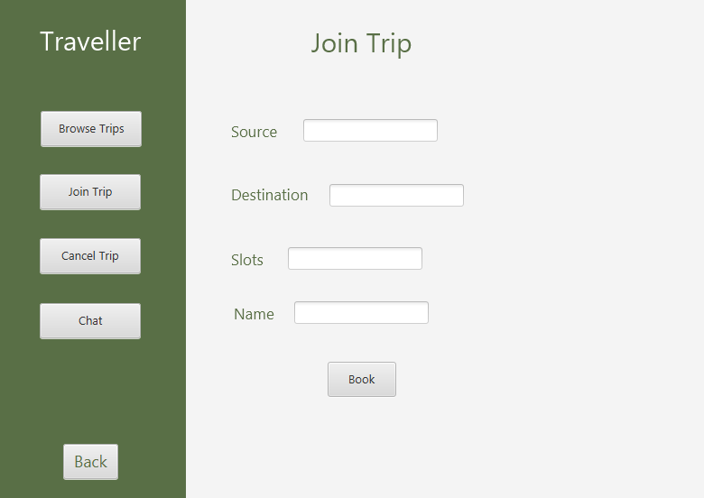

**CANCLE TRIP:  
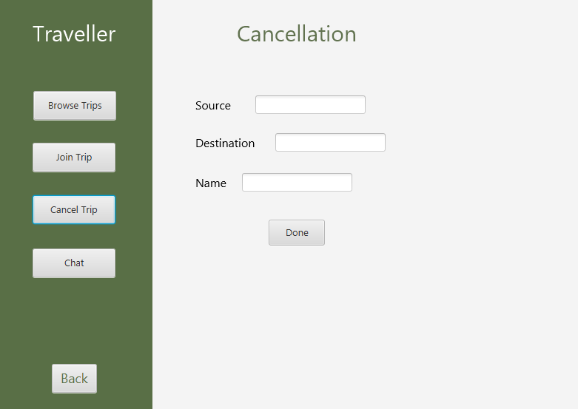**

**GIVE FEEDBACK:  
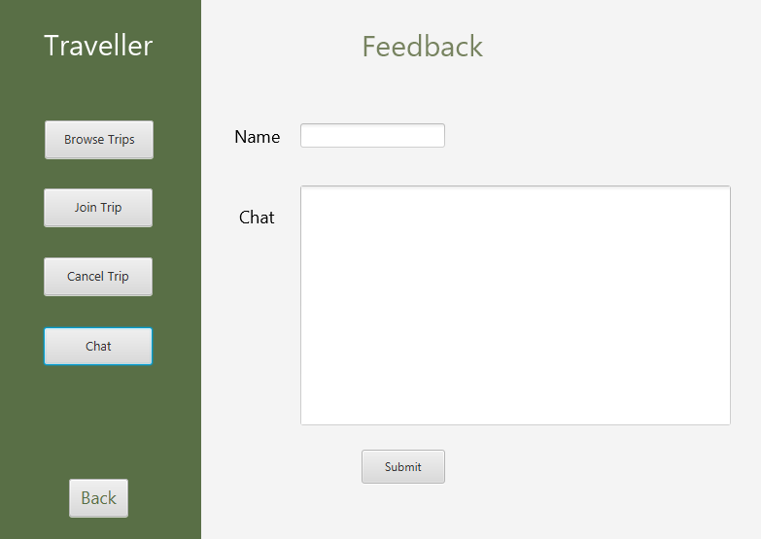**

**MANAGER’S SCREEN:**

**MANAGE SLOTS:**

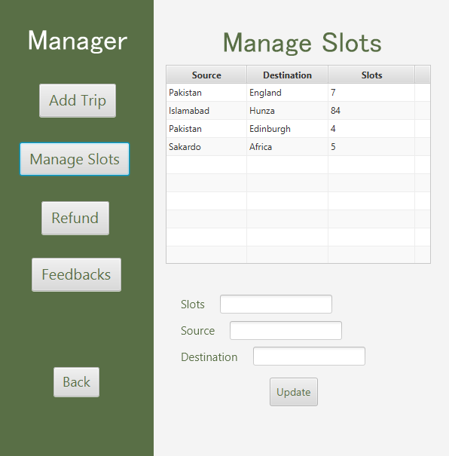

**ADD TRIP:  
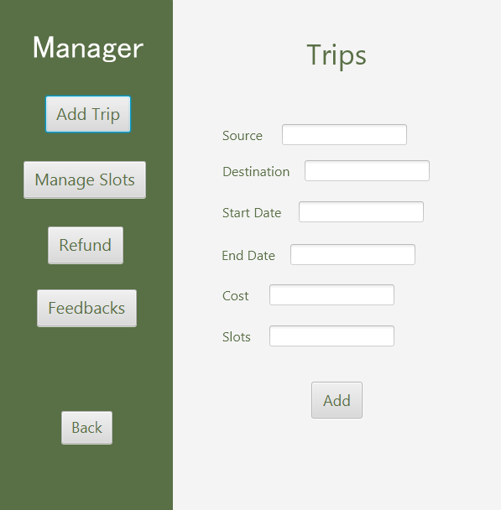**

**REFUND:  
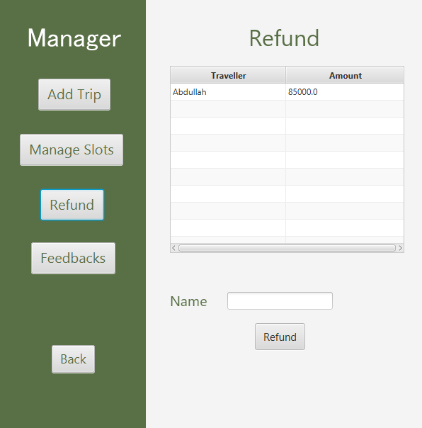**

**SEE FEEDBACK:**

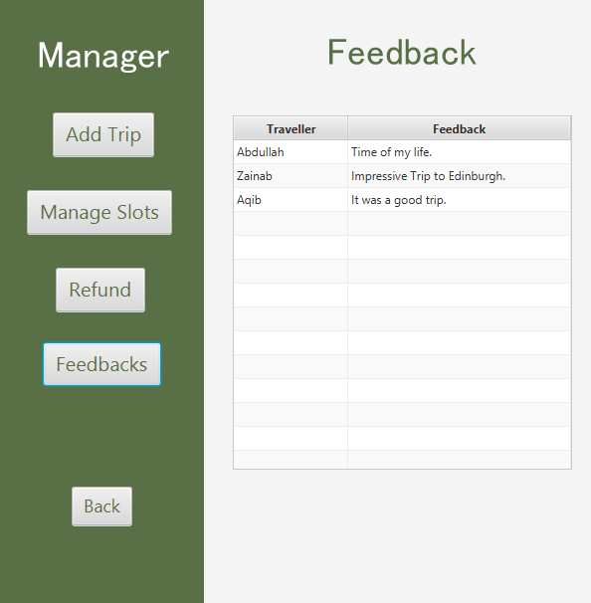

# 4. Domain Model

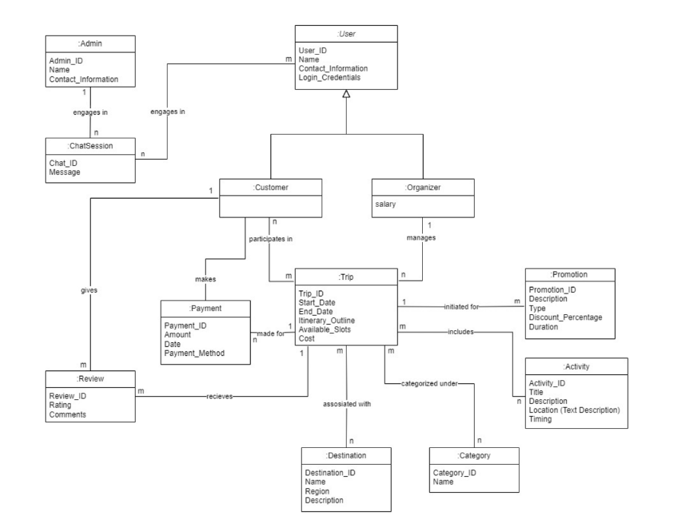

# 5. System Sequence Diagram

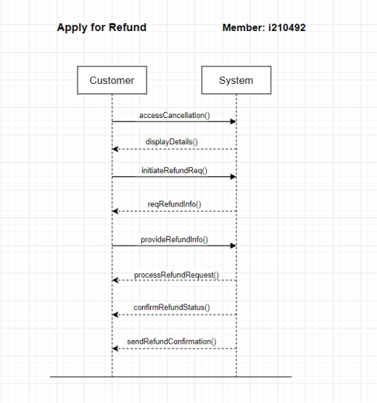

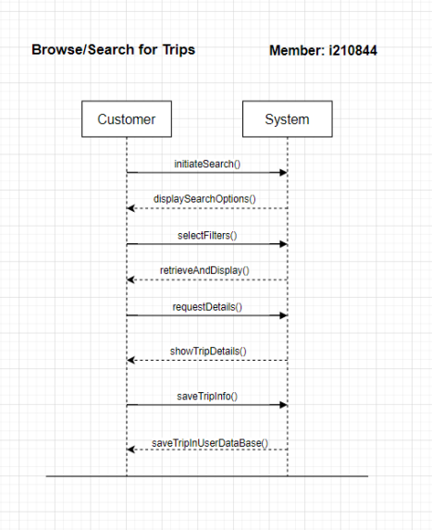

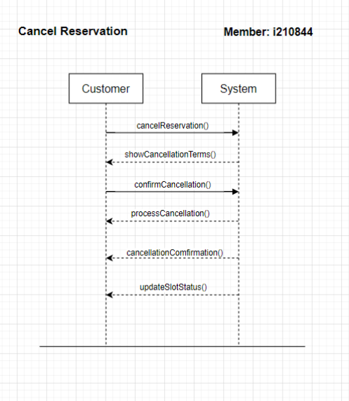

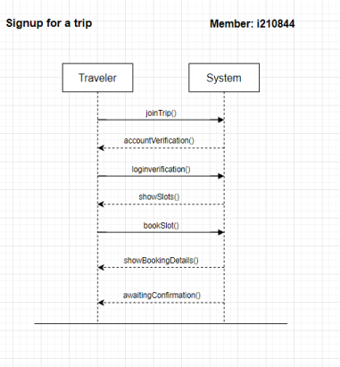

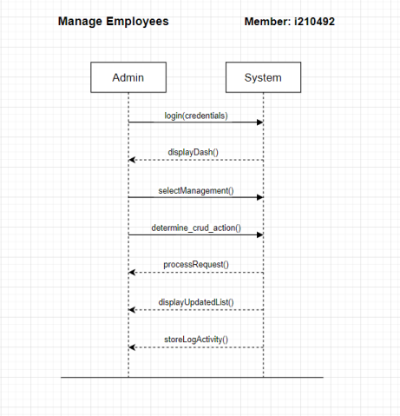

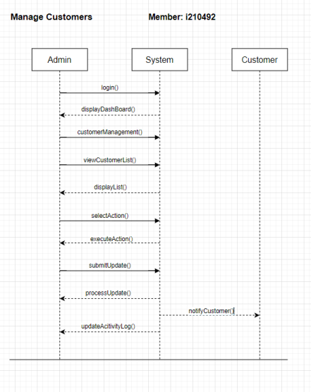

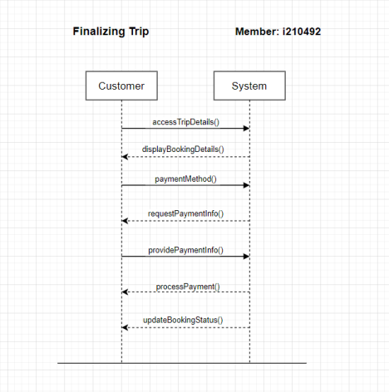

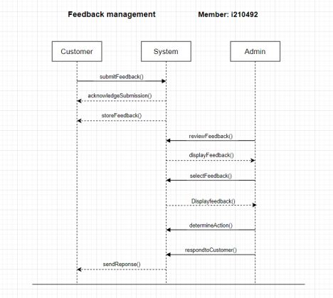

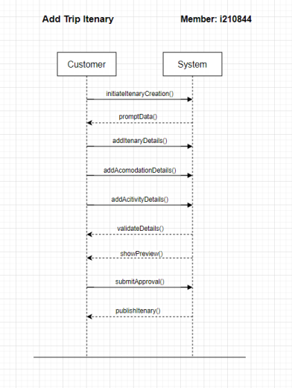

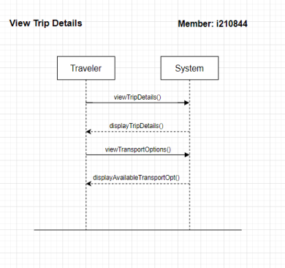

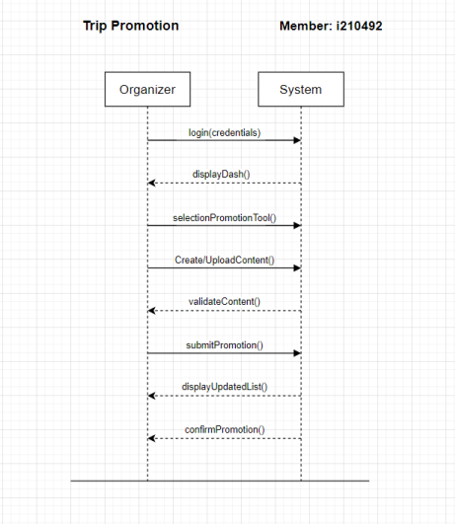

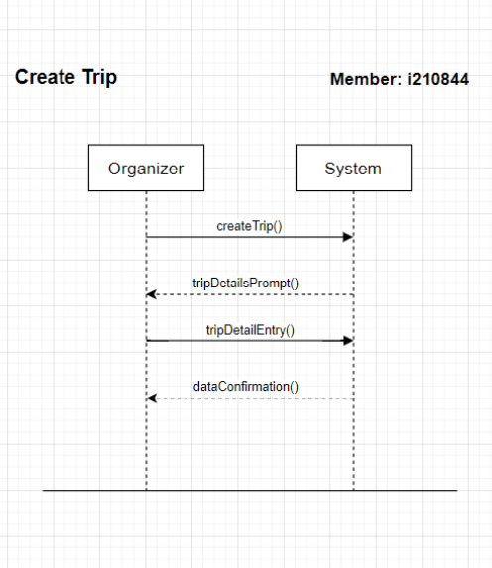

# Sequence Diagram

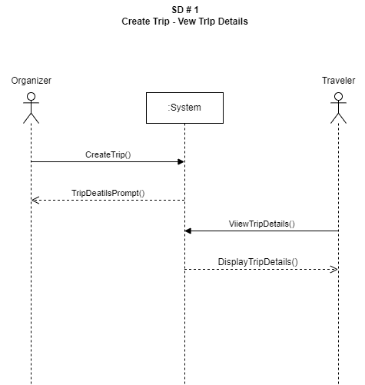

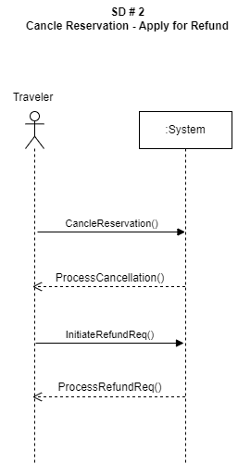

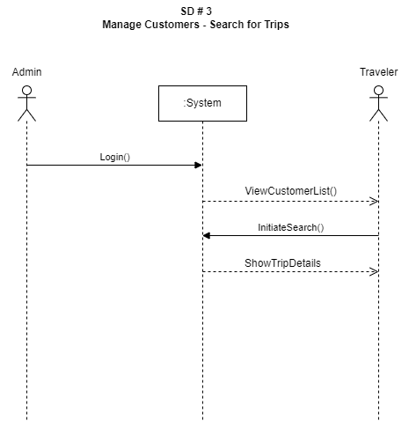

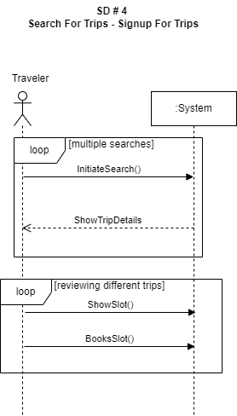

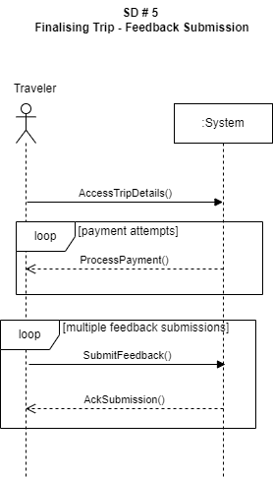

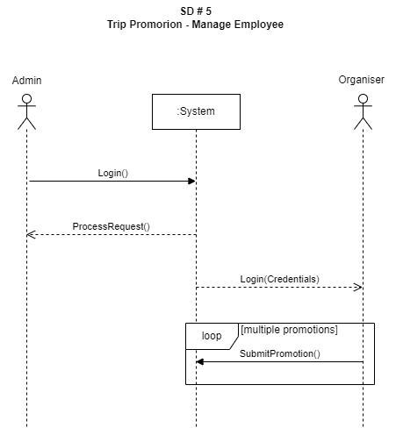

**SSD # 7**

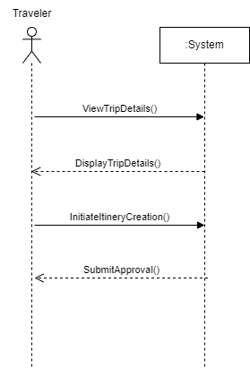

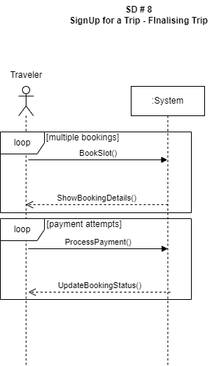

# 7. Class Diagram

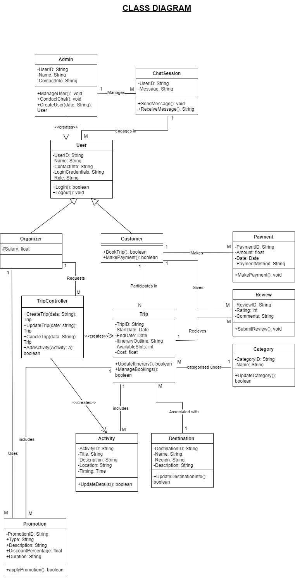

# 8. Package Diagram

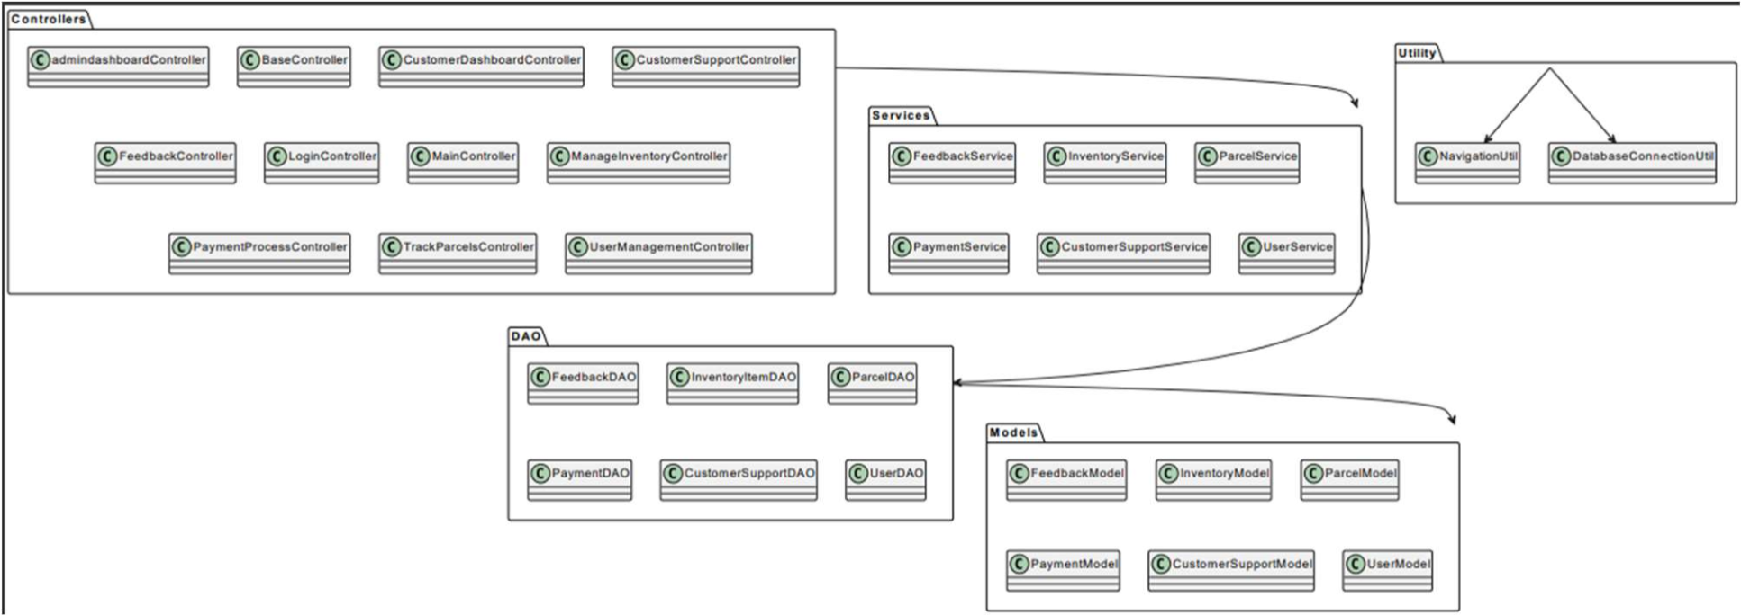

# 9. Deployment Diagram

