A*

Python.file:

Screenshot:
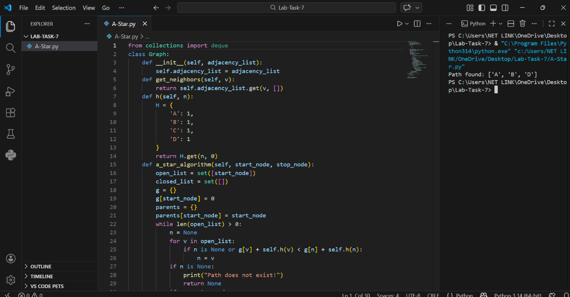

Details:
This Python program implements the A* (A-Star) Search Algorithm on a Graph.
It allows the user to:
• Create a graph using an adjacency list
• Assign weights (costs) to edges
• Define a heuristic function
• Find the shortest path between two nodes
• Display the final path
The program runs in the terminal.

Main Components:
• Class: Graph
• Dictionary used to store graph: self.adjacency_list = {}
• Method to get neighbours: get_neighbors()
• Heuristic function: h()
• Method to perform A* search: a_star_algorithm()
• Data structures used:
- open_list (set)
- closed_list (set)
- g dictionary (stores actual cost)
- parents dictionary (stores path)

How the Program Works:

1️. Start:
• The program creates a graph using a dictionary (adjacency list).
• Each node stores a list of (neighbor, weight).
• An object of the Graph class is created.
Example structure:
A → B (1), C (3), D (7)

2️. Heuristic Function:
• h(n) method returns estimated cost from node to goal.
• In this program, all nodes have equal heuristic value (1).
• A* formula used:
f(n) = g(n) + h(n)
Where:
• g(n) = actual cost from start to current node
• h(n) = estimated cost to goal

3️. A* Search Algorithm:
• a_star_algorithm(start_node, stop_node) is called.
• open_list contains nodes to be explored.
• closed_list contains already explored nodes.
• g dictionary stores shortest known cost from start.
• parents dictionary is used to reconstruct path.

Algorithm Steps:
• Select node from open_list with lowest f(n).
• If selected node is goal →
→ Reconstruct path using parents dictionary
→ Print the shortest path
• Otherwise:
→ Check all neighbours
→ Calculate new cost
→ If better path found → update g and parent
• Move node from open_list to closed_list
• Repeat until open_list becomes empty

4️. Path Reconstruction:
• Once goal is reached,
• Parents dictionary is used to trace path back to start.
• Path is reversed and displayed.

