ToDo List (Python OOP Project)

Python.file:

Screenshot:

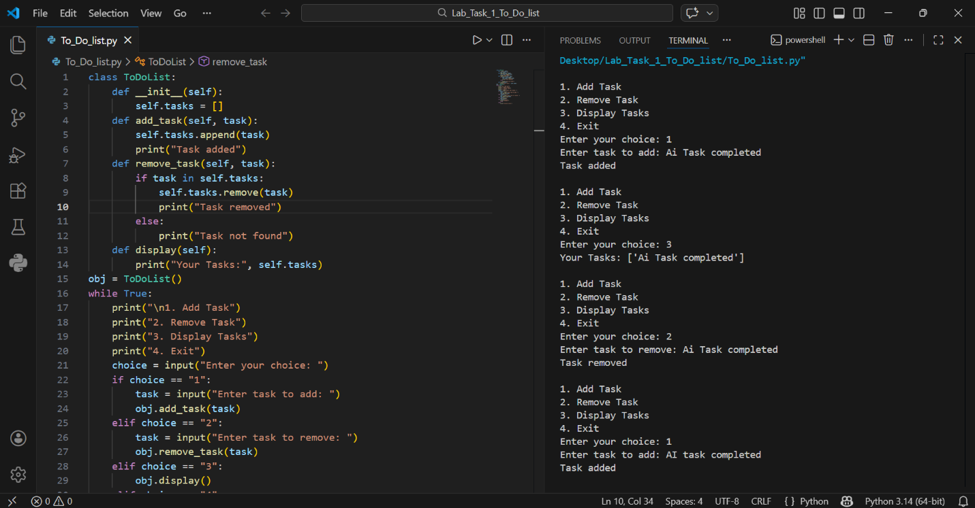

Details:
This Python program is a simple ToDo List system.
It allows the user to:
• Add tasks
• Remove tasks
• View all tasks
• Exit the program
The program runs in the terminal.

Main Components:
• Class: ToDolist
• List used to store tasks: self.task = []
• Menu with 4 options
• Loop runs until user exits

How the Program Works:

1️. Start:
• The program creates an empty task list.
• A menu is shown again and again using while True.

2️. Add Task:
• User enters a task.
• Task is added to the list using append().

3️. Remove Task:
• User enters task name.
• If task exists → it is removed.
• If not → shows "Task not found".

4️. Display Tasks:
• Shows all saved tasks.

5️. Exit:
• When user selects 4 → program stops.

