1. Loading the Datasets
Both the Breast Cancer Wisconsin and Wine Classification datasets were successfully loaded using scikit-learn. The features (X) and targets (y) were separated. In Breast Cancer, original labels (0=malignant, 1=benign) were maintained. In Wine, classes 0, 1, and 2 were retained. Target variables were converted to pandas Series to preserve original row indices.
2. Dataset Quality Checks
No missing values or duplicate rows were found in either dataset, meaning no imputation was necessary.
Regarding potential outliers observed in the boxplots, they reflect natural biological/chemical variations rather than data entry errors. Distance-based algorithms (KNN, K-Means) and variance-based algorithms (Gaussian Naive Bayes) are highly sensitive to these extreme values, as they can disproportionately influence distance calculations and mean/variance estimates. Decision trees, however, split based on rank and are largely immune to outlier magnitudes.
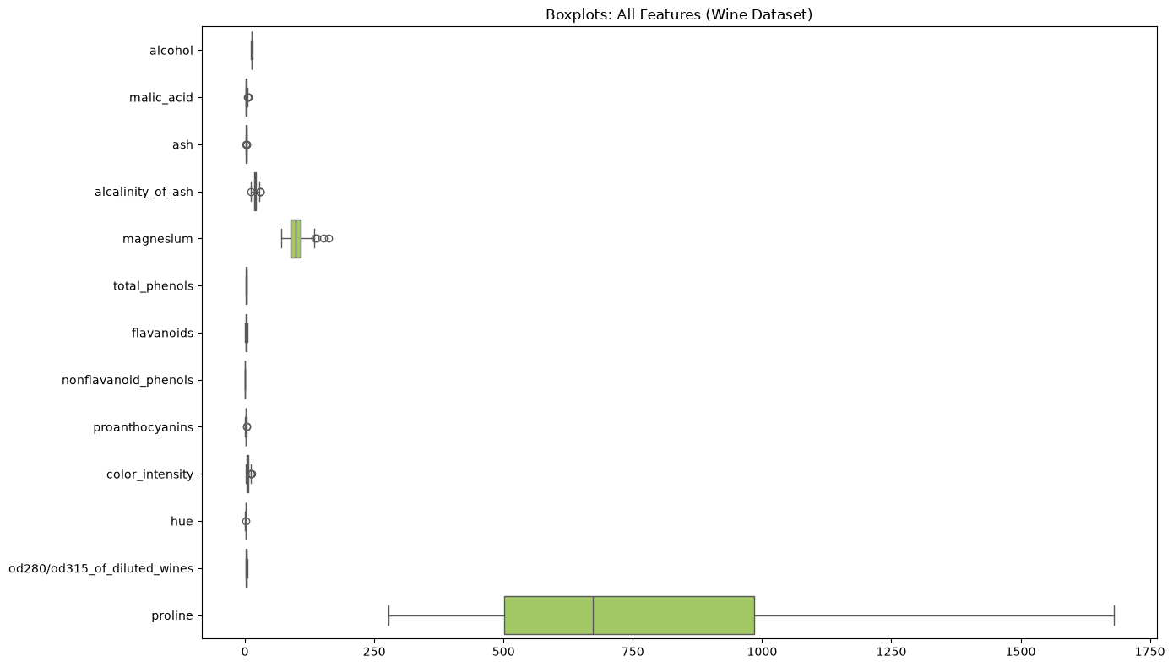
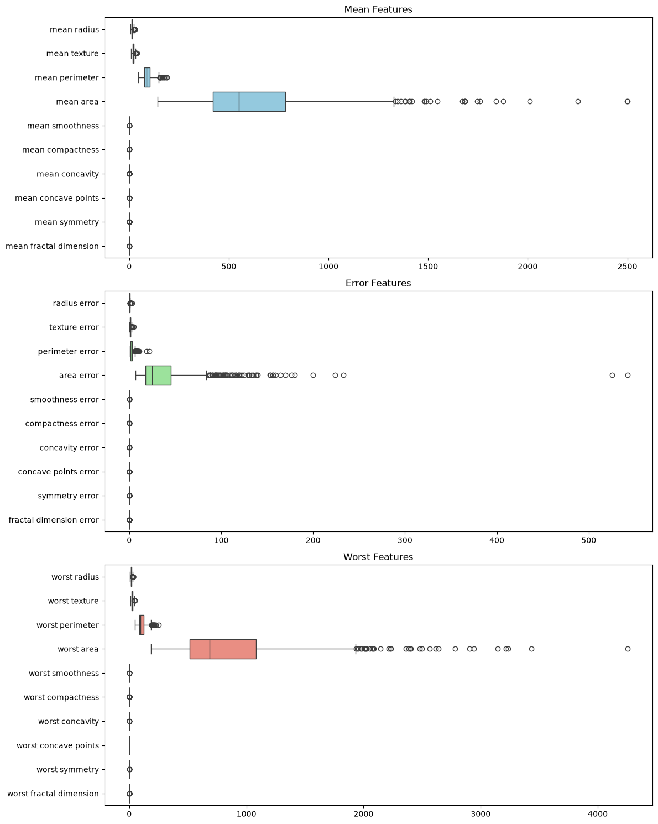
3. Exploratory Data Analysis (EDA)
For Breast Cancer, the descriptive statistics and boxplots reveal vastly different scales across features (e.g., mean area vs. mean smoothness). The correlation heatmap identifies highly correlated blocks, particularly among size metrics (radius, perimeter, area).
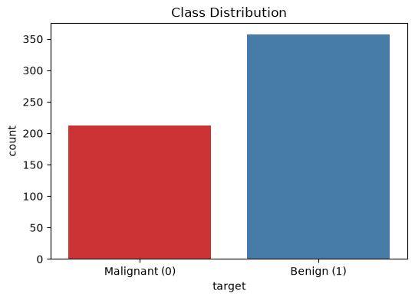
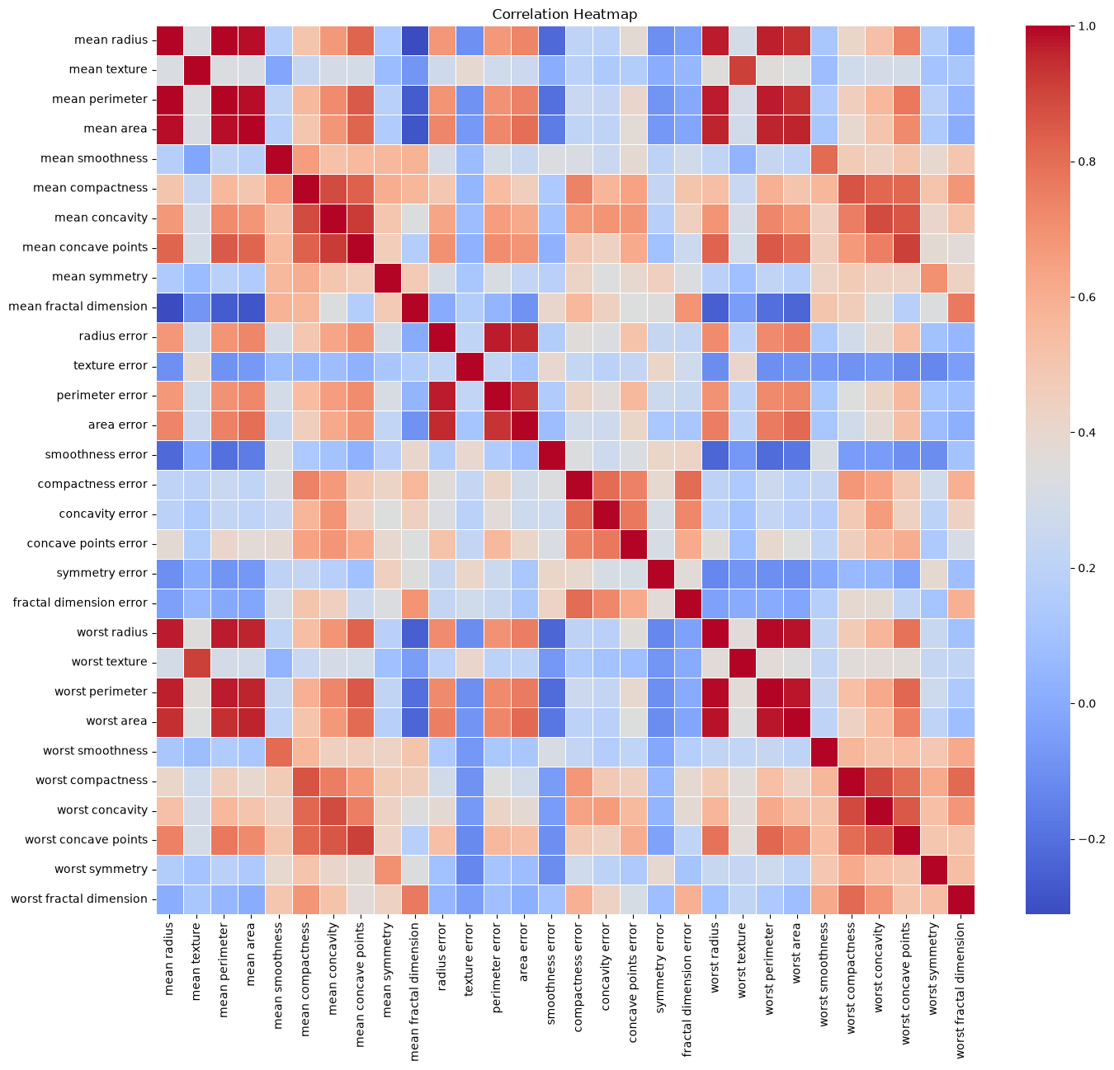
For Wine, the data is similarly unscaled (proline ranges in the thousands while od280/od315 is <4). The target classes are well-balanced. High correlation is observed among specific chemical constituents, indicating multicollinearity.

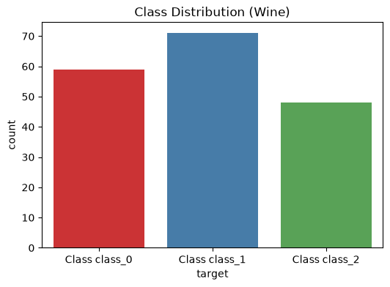

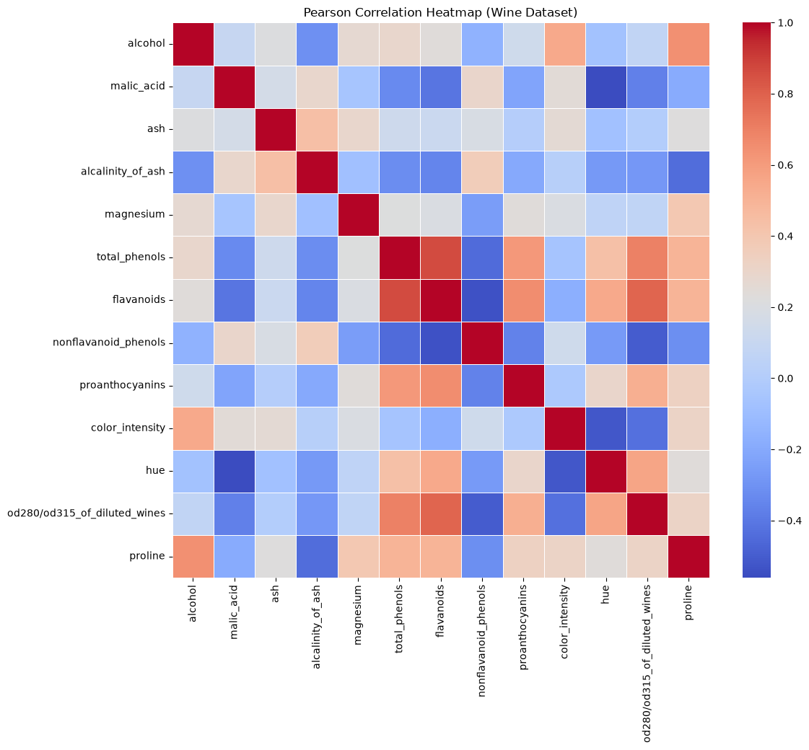

4. Splitting the Datasets
A fixed 20% test set was reserved once (random_state=42). The remaining 80% was split into 70% training and 10% validation using test_size=0.125 across three seeds (42, 52, 62). All splits were stratified by target labels. Original row indices were preserved, and tests confirmed zero overlap between subsets (no data leakage).
5. Data Preprocessing and Scaling
Since there were no missing values, imputation was skipped. StandardScaler was selected. To prevent data leakage, it was fitted exclusively on the training subset for each seed. The validation subsets (and later the test set for seed 42) were transformed using parameters learned solely from the training data. Scaling standardizes features to have a mean of 0 and a standard deviation of 1.
6. Preparing the Two Data Representations
Two representations were prepared: 'unscaled' (raw features) and 'scaled' (StandardScaler output). Both representations use identical sample indices for each seed to ensure fair comparison. No dimensionality reduction was applied.
7. Training the Classification Models
A total of 132 classifier fits were executed (66 per dataset). Decision Trees used max_depth in [2, 3, 5, 10, None] with random_state=seed. KNN used n_neighbors in [1, 3, 5, 7, 11] with uniform weights and Euclidean distance. Gaussian Naive Bayes was trained with default settings. Training accuracy and macro-F1 were recorded for all runs.
8. Measuring Validation Performance
Validation metrics (Accuracy, Macro-Precision, Macro-Recall, Macro-F1, ROC-AUC) were calculated. For Breast Cancer ROC-AUC, a binary target mapping original class 0 to 1 was used. For Wine, multi_class='ovr' and average='macro' were applied. Mean and sample standard deviation (ddof=1) were calculated across seeds.
.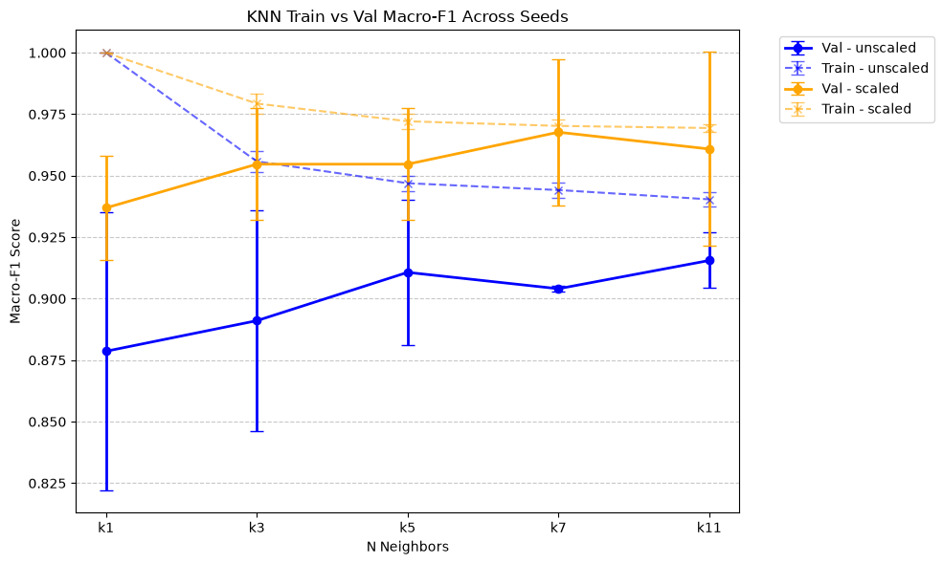
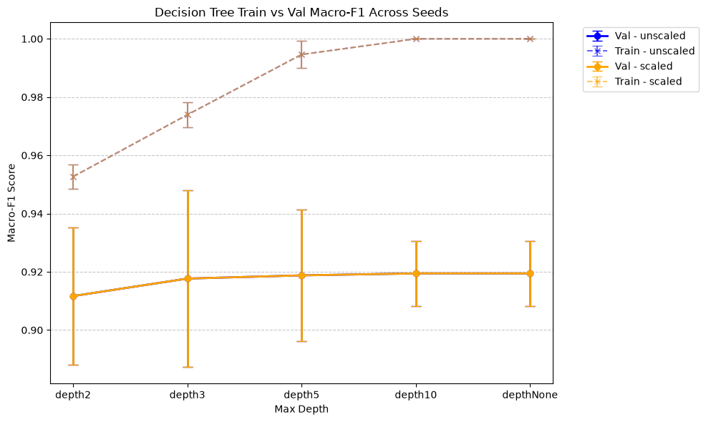
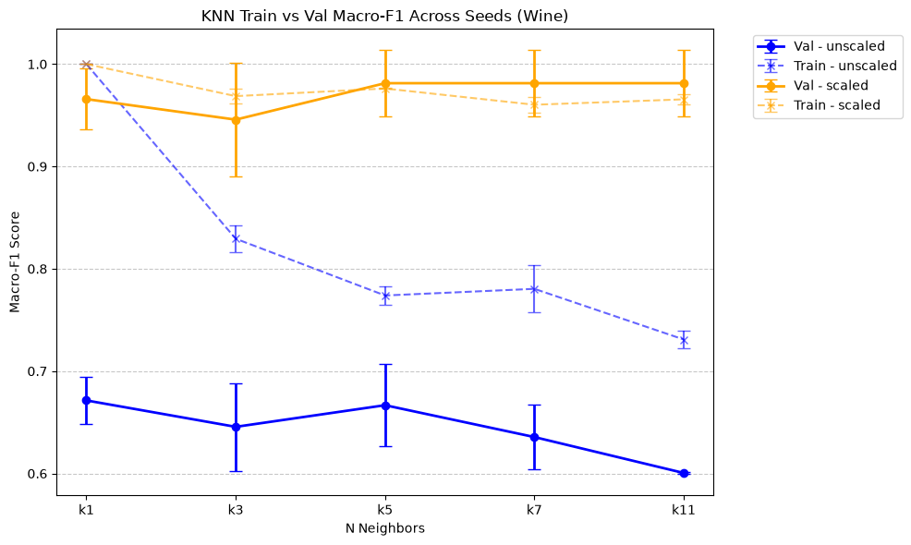
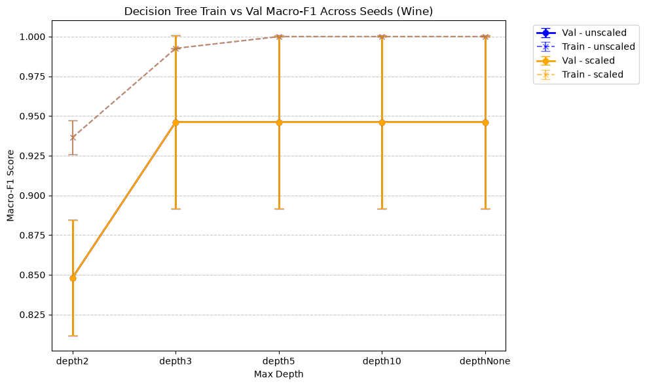
Scaling dramatically improved KNN performance but had no effect on Decision Trees. Deeper trees showed overfitting (perfect training scores but lower validation scores). Seed variability demonstrated that model performance fluctuates based on the train/val split. The selected configurations were KNN_scaled_k7 for Breast Cancer and KNN_scaled_k11 for Wine
9. Evaluating the Selected Models on the Test Sets
The selected models were evaluated on the fixed test set using the seed-42 fitted models and preprocessors. The Breast Cancer model achieved strong results but produced 3 False Negatives. The Wine model achieved perfect classification. A perfect test result on a small holdout set is insufficient to prove generalisation. Threshold changes in ROC curves highlight the trade-off between True Positive Rate and False Positive Rate.

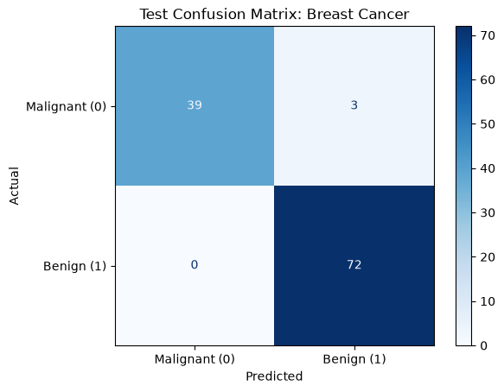
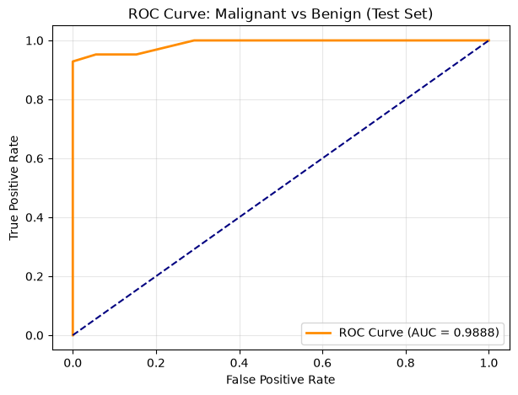

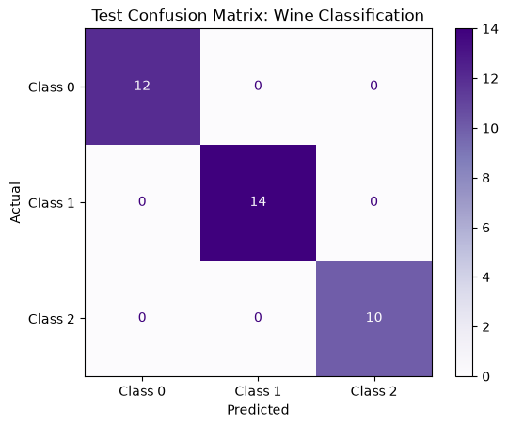
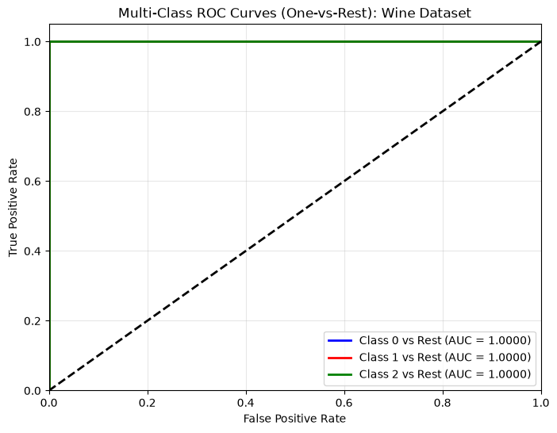

10. K-Means Clustering
K-Means was fitted unsupervised (n_init=10) on training data. Scaling significantly improved Adjusted Rand Index (ARI) on the test sets, indicating clusters aligned much better with true classes in scaled space. Unlike the classifiers, K-Means groups data based purely on geometric distance without access to target labels.
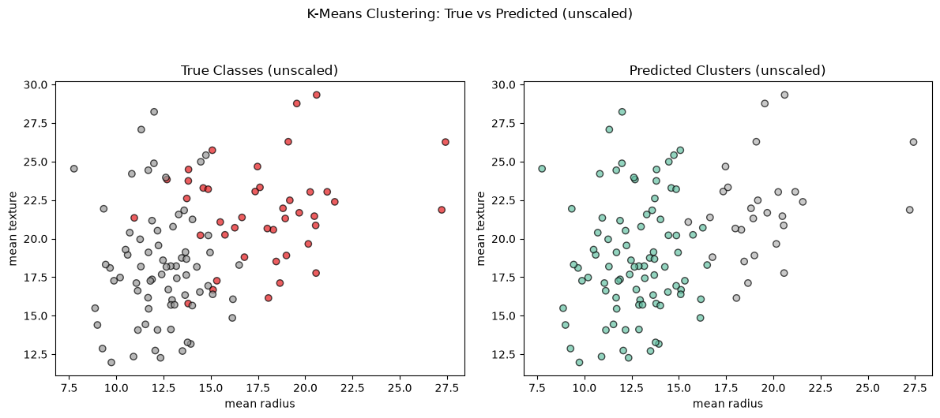
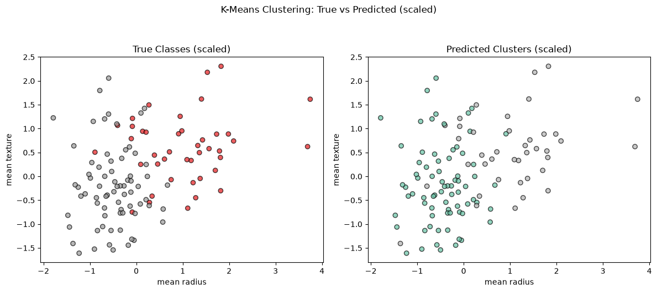
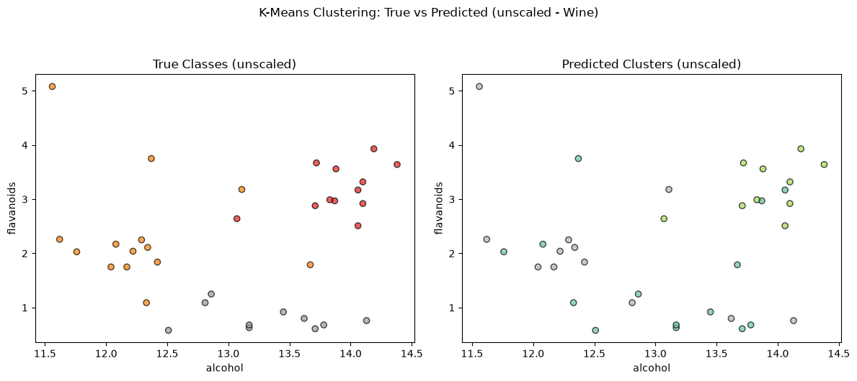
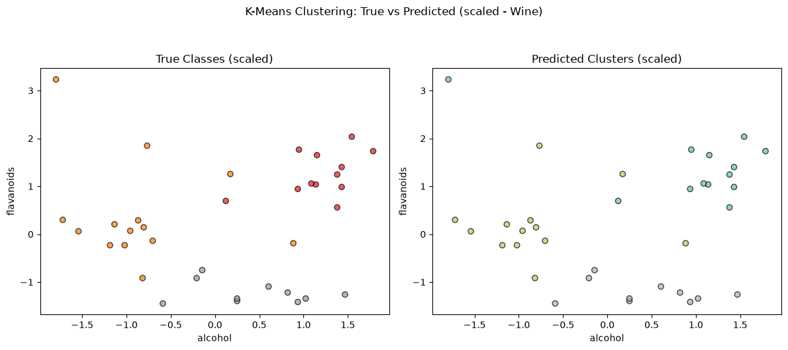
11. Comparing the Two Datasets
-Did the same classifier and representation perform best on both datasets?
Yes, the K-Nearest Neighbors (KNN) algorithm trained on the scaled data representation achieved the best performance for both datasets. However, the optimal hyperparameters were different: Breast Cancer favored k=7, while Wine favored k=11. Looking at the validation phase, the Breast Cancer model reached a mean Macro-F1 of 0.9677 ± 0.0297, and the Wine model scored 0.9814 ± 0.0323. On the final held-out test sets, Breast Cancer got a 0.9713 Macro-F1, and Wine achieved a perfect 1.0000. It is important to note, though, that evaluating on a single fixed test set does not guarantee perfect overall generalization for future data.
-Which algorithm was most affected by scaling in your experiments?
In my experiments, KNN was by far the most affected algorithm. For instance, in the Wine dataset, the unscaled KNN (k=11) struggled heavily with a mean validation Macro-F1 of only 0.6005. When the data was standardized (scaled), the exact same configuration's score soared to 0.9814. The Breast Cancer dataset also improved with scaling, but the leap in Wine was much more dramatic due to its heavily varying feature scales. On the other hand, Decision Trees were essentially unaffected because they rely on threshold-based splits, making them inherently scale-invariant.
-Did deeper trees or larger neighbour counts always improve mean validation performance?
No, increasing tree depth or neighbor counts did not always lead to better validation performance. For Decision Trees, deeper trees (like depth 10 or None) simply memorized the training data (reaching a 1.0 train Macro-F1) without improving validation scores, widening the train-validation gap as a clear sign of overfitting. Similarly, larger neighbor counts in KNN didn't guarantee linear improvements. In Breast Cancer, the scaled KNN's Macro-F1 actually dropped slightly from 0.9677 (k=7) to 0.9608 (k=11). In Wine, it rose from 0.9457 (k=3) to 0.9814 (k=5) and then just plateaued for k=7 and k=11. Additionally, the results varied visibly across different random seeds; standard deviations ranged from approximately 0.0013 to 0.0566 for Breast Cancer, and 0.0010 to 0.0558 for Wine, showing that model performance relies heavily on how the data happens to be split.
-How did the main classification errors differ between the two datasets?
The real-world severity of the test set errors was completely different. Looking at the Breast Cancer confusion matrix, the model made 3 False Negatives (predicting a malignant tumor as benign) and 0 False Positives. In a medical context, a False Negative is a critical failure since a patient with cancer might go untreated. For the Wine dataset, the selected model actually made zero errors on the test set, resulting in a perfect diagonal confusion matrix. While this is an excellent result, getting zero errors on one specific test set is not absolute proof of flawless generalization.

-How did K-Means agreement with the true classes differ between datasets?
K-Means agreement with the true classes—measured by the Adjusted Rand Index (ARI) rather than classification accuracy—improved for both datasets after scaling, but the impact was much stronger for Wine. The Breast Cancer test ARI went from 0.5585 (unscaled) to 0.7354 (scaled), while the Wine test ARI saw a massive jump from 0.3733 (unscaled) to 0.9088 (scaled). This shows that the scaled Wine data formed clusters that aligned with the true classes much better than Breast Cancer. When examining the 2D scatter plots (which only display two features and cannot fully capture the algorithm's multi-dimensional clustering), the unscaled Wine data looked completely mixed, whereas the scaled projection showed distinct groupings. The contingency tables confirmed this observation, displaying much cleaner and more distinct cluster assignments for the scaled Wine dataset compared to the unscaled one.
-What one change would you investigate next, and why?
If I were to continue this work, I would investigate replacing the 3-seed repeated holdout approach with a more robust method like k-fold Cross-Validation (e.g., 5-fold CV) paired with GridSearchCV. Since my current results showed standard deviations up to ~0.056 across just three seeds, adopting cross-validation could help reduce the model's reliance on a specific data split and provide a much more stable, reliable estimate of its true performance.

GitHub Link: https://github.com/AbdullahEsad/Machine_Learning_Midterm
Video Link: https://youtu.be/2DSj2LPIGTg

