**Introduction :**

**Executive Summary:**

Traveling Abroad is an online website offering service to anyone who wants to study abroad, our website shows the users the papers they need before traveling, the best colleges and the scholarships available, the best hostels they can stay at, the best restaurants in the country, the jobs available and the tips they need to know when traveling to any country.

**Document Overview:**

This document introduce country where students can travel to it to study. It introduces study plan, general description, technical description, development plan study, operation plan, cost analysis and marketing.

**Abbreviations and Terminologies:**

**…….**

**References:**

1. <https://www.transitionsabroad.com/publications/studentwritingcontest/student-reference-guide-to-study-abroad.shtml>
2. <https://ieo.ucla.edu/get-started/>

**System Description:**

**Introduction:**

This site offers a lot of services for students studying abroad, starting from the beginning to the end, because of the many advantages and services will be detailed in the following. The first thing that the site offers is the country where the student can travel. Many of the students do not have enough information, they do not have enough information about the country to travel to, or those countries that offer scholarships to study, and they do not know which country suits their desire. Therefore, the site provides all this information as it provides the countries available for travel not only this, but also provide information about each country. This was the first of the site. In the second place after the country universities where in each country is available a lot of universities that offer them and the student does not know all the university and all these universities can shorten his knowledge on some of the few colleges and may be incompatible with his wishes and not agree to the field of study and thus in this The position will be in need of those who give him such information in a detailed and clear and simplified to be able to choose one of those universities that want to join the study and therefore the site to provide all the universities that include all countries and not only this, but also provide information about each university and Basic Information About study Data that the student can have a presentation or study which shows any areas of study within the university, in addition to the conditions for these grants rates for the enrollment of these grants and all related grants. After this comes to his way of travel it is natural that this is the first time the student to travel abroad and there are many that need to know, for example the papers necessary to travel and the important steps of any traveler is not only students, but the student will need it Because he may not have sufficient experience to know all the required papers and therefore this site provides information about the papers required for travel and not only this, but more accurate and more clear, where he explains the papers required for each country to travel to and clarify the papers required to apply to the university chosen to join and Li student will not be in need to compile any information from any other source for papers that must be available to travel to study abroad. This was the first point in the way of travel and then immediately provide the flying thanks available in the country to which he belongs to be able to book his ticket to travel abroad and will not forget that before all this the student will have to communicate with the university that wants to join the impact of this feature is to communicate with The university, which the student wants and then will be able to determine the date of travel and therefore will be based on this basis booking travel ticket through one of the airlines that are available in his country, which the site brings them together in one place. It is certain that the student will need to live somewhere in this country, so we collect all the bytes from all the housing the student can live in and provide him with a way to communicate with the owners of these houses allocated to the student and even more way to book them. In addition to this, the student may need to study some of the courses required to join a specific grant. The site helps the student in identifying these courses and in determining the places where the student can take the courses and will not forget the course of course. So that he wants to study these courses from home. The site has included all that the student should do while he is still in his country. This site provides an integrated, coherent and comprehensive picture of everything in a clear, simple and proper way so that the student is able to take the proper marks and join the university he wants and he will continue He sets the date of travel and book his ticket and also studies the courses necessary for travel.  
  
All this is a description of what the student needs and is still in his country now we will show what the site will provide to the student after reaching the country where he wants to travel to it will not forget the site that will travel what is only a student and will therefore need money to wish to live in that country Which he will travel to and for this reason the site offers some of the partial work that a student may apply to if he wants to collect money in addition to his studies so we collect information about the part work in all the countries that students can travel to. The site will not forget the fact that life is not just a study, but there are other things interested in the non-study, so the site was interested in giving ideas for leisure. For example, the site offers the tourist places that are available in each country and places that people visit frequently and is given a comment on them. We will not forget the time of entertainment and eating so it provides the names and addresses of the clubs that are available in every country and also the restaurants that are available in every country and there is no one who eats always from outside the house. The site provided the places where the student will be able to buy what he needs. Because it is sure to be the first time for the student in this country we will provide some advice to him because he does not need a reliable tip when he does something new does not know so provides useful tips for those who want to travel and of course determine the tips depending on the country to travel and also provides the site The views of other students have traveled to this country before and have left their experience on the site to benefit others and here comes to a significant point, but allows the site for each student to create a room on the site to be a member of the site and be able to share his experiences with everyone can be He left his face About the country to which he traveled, as well as his experience about the university he studied and will not forget the site that it is better to communicate with oneof the people who have made this experience before, so the site provides you with a conversation to be able to communicate with those you want and to take advantage of the greatest possible use of others .

Above all this makes the site to deal with it as easy as possible, so it provides the search feature where the student searches for what he wants directly and the difficulty and fatigue in that and thus this one of the characteristics of the site that makes the site easy and simplified and not only this site provides the possibility of communication with the originators of this site and Thus, this is one of the advantages that the site provides and thus users will be able to provide the site Mullah.

**Users:**

In this section, we will clarify the people who serve the site only those who want to travel abroad and all those who want to give a point of view to travel for study abroad and also who want to offer their experiences to benefit others and people who want to give advice to others and of course will be able to. The site deals with it.

**Modules:**

This site includes a lot of modules for example the countries, universities, grants, Part-time job, papers, airlines, places of residence, tourist places, restaurants and supermarkets.

**System Users:**

The users divide to:

Visitors:

The visitor can browse the site, search in the site, contact with the page owner, get the information from site and make account.

Members:

The members can do every things visitor do and they can chat with other member, search member in a particular country and contact with them, and write feedback in our site.

Responsible:

They can erase any information or user, edit the text (information) and add new text.

**System Modules:**

* Countries Module Description

In this module all the countries where students can travel are shown.

* Universities Module Description

In this module, the universities which the student can travel to can be decorated according to the country chosen by the student. Each university includes the types of study available in each university.

* Grants Module Description

In this module, the scholarships offered in each university are displayed. Also, the conditions for each grant, the prices of each grant, and the required papers for each scholarship are determined.

* Papers Module Description

In this module, the documents required to travel to the country in which the student can travel are clarified and this is to facilitate the collection of these papers so that he can apply for travel easily.

* Airlines Module Description

This module provides information on the airlines available in the country where the student lives and the prices of airline tickets in all his thanks according to the country to which he will travel.

* Places of residence Module Description

This unit provides data on where students can live in any country they can travel to and the prices of accommodation in these places.

**System Functions:**

**System Models:**

**Use Case Diagrams**

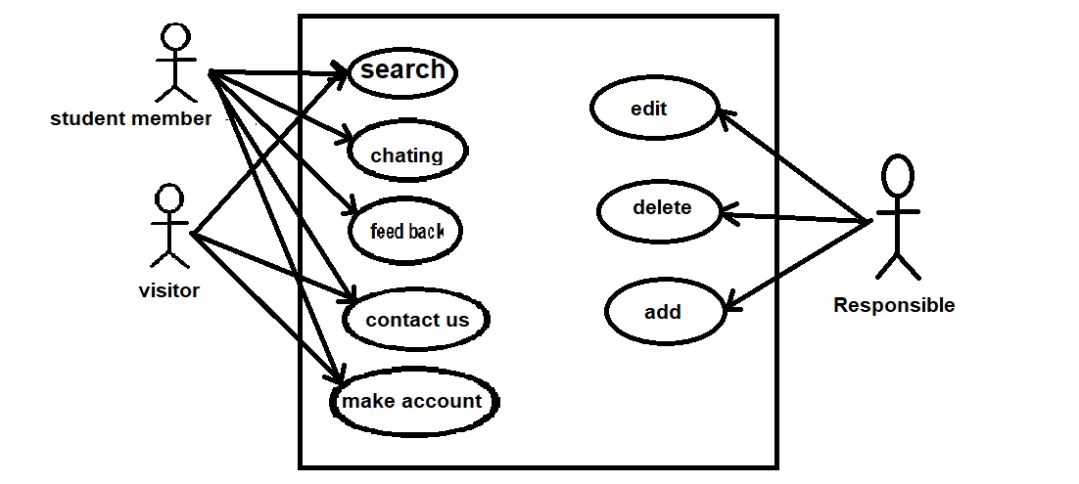

**Sequence Diagrams**

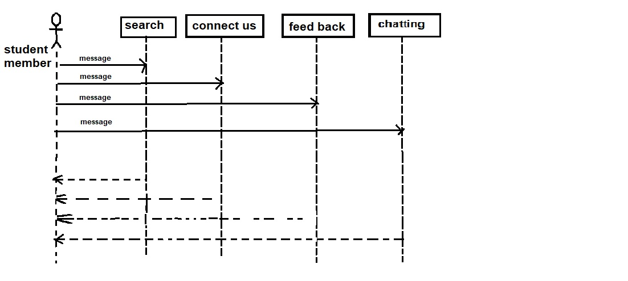

**Non-functional Requirements:**

**Security Requirements:**

The server on which the Online Journal resides will have its own security to prevent unauthorized *write*/*delete* access. There is no restriction on *read* access. The use of email by an Author or Reviewer is on the client systems and thus is external to the system .The PC on which the Article Manager resides will have its own security. Only the Editor will have physical access to the machine and the program on it. There is no special protection built into this system other than to provide the editor with *write* access to the Online Journal to publish an article.

**Performance**

We have used Server machine have a powerful CPU and high speed internet access so that it can

handle multiple users at the same time. May reach 100 users.

and used the Higher storage space .

Higher storage space means more user and bigger workspace per user so higher the storage, better the performance.