K8s resources

K8s architecture

Pod:-

Deification:-

Yaml of pod

apiVersion: v1
kind: Pod
metadata:
name: nginx
spec:
containers:
- name: nginx
image: nginx:1.14.2
ports:
- containerPort: 80

Kind: it will define obje
metadt

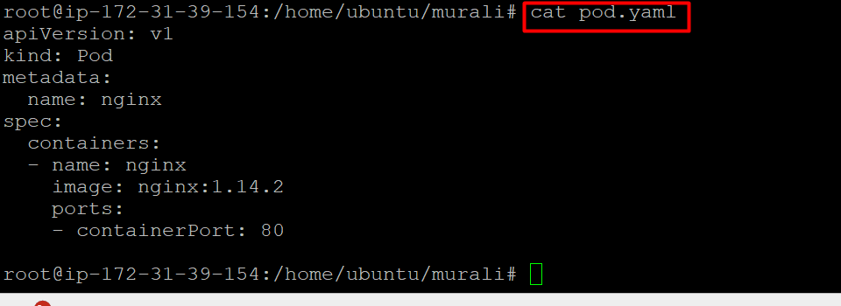

Pod commands

Kubectl get pods:- to list pods
