Personal Information

**ABDULLAH HAIDAR**

**COMPUTER SCIENCE**

**Address**: Beirut, Mrayge. **Phone**: 76 170 995 **Email**: abdullahhaidar92@gmail.com **Birthdate**: 1992/3/14

Skills

Soon to be graduate with a degree in computer science possessing a diverse variety of skills in web development, system and network administration and data science. Proven academic and curricular achievements and possesses the right traits of a fast learner and hardworking developer.

Java

C# / Asp.NET Core

PHP / Laravel

JavaScript

Microsoft SQL

MySQL

C++/C

Linux

Python

Data Science

OpenGL

VHDL

Education

2017 – 2019

2017 – 2019

Lebanese University Faculty of Sciences, bachelor degree in Computer Science with Total average: 85/100

High School Degree, General Sciences

2008 – 2009

**LinkedIn:** www.linkedin.com/in/abdullah-haidar

**Portfolio:** https://abdullahhaidar.github.io

**GitHub Repository:** https://github.com/abdullahhaidar92/Projects/tree/master

Links

Projects

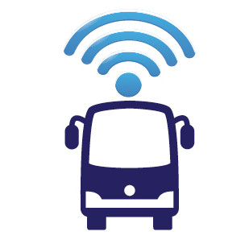

**Fleet Management System:** A complete system for the management of any type of fleets with essential features such as live tracking, route optimization and data analysis.

**Clinic Management System**: An Asp.NET Core web application for the management of a clinic. The application users include: administrator, doctors, patients, assistants and insurance companies.





**Samba Server Configuration:** **Samba Server Configuration:** The goal of this project to install and completely deploy the SAMBA server. It includes users authentication, file sharing , log management, and using SAMBA for backup.

**Supermarket database application:** The database system for the management of a supermarket using advanced features in the Microsoft SQL Server 2014 such as authentication and authorization in the SQL server side, procedures and triggers, transact-sql, etc..

