Audio Power Amplifier with Power Supply PCB Project
Revision 00

Authored By:
Abdullah Hendy

- Introduction

This document discusses the complete design and implementation of an audio power amplifier with a custom power supply PCB, detailing the rationale behind component choices and analyzing the performance of the Class AB amplifier, AC/DC adapter, linear voltage regulator, protection mechanisms, filtering stages, and LED indicators.

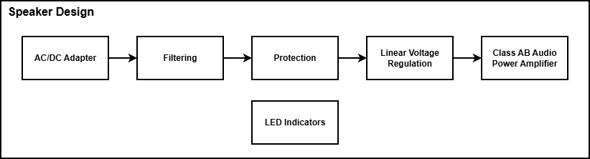
Diagram 1: General Project Diagram

Diagram 1 highlights the main structure of the final amplifier design. The first block converts the mains outlet AC voltage to DC, which is then filtered in the second block. The filtered voltage is then fed to the next block, which is a linear voltage regulator to further reduce the power supply noise and to get the desired supply voltage for the amplifier. Since wires (traces) have inductive characteristics as well as the inductive component used for the filtering block, a protection block is added at the input of the regulator to protect the chip from voltage spikes that might come through the mains outlet or might be generated due to a sudden current change. An example of this would be unplugging the adapter connector. The inductor voltage equation gives an idea on how instantaneous change in current can produce huge voltages: $V_{L}= L\left(\frac{dI}{dt}\right)$ An LED indicator is added to show whether the adapter is functioning.

- Design
- Class AB Audio Power Amplifier

The amplifier used in this project is the LM384 class AB audio power amplifier. Despite being old, this chip was used due to its popularity as well as the availability of useful documentation that shows design examples and explanations.
Also, one of the advantages of using this chip is its simple minimum-component circuit shown in Figure 1. The figure features the audio input, V_{in}, power supply, V_{s}, coupling capacitor, C_{o}, high-frequency oscillation suppressors, R_{c}, and C_{c}. The capacitor C_{o} is used to filter the DC biasing voltage of the output transistor out of the amplified output signal. According to the datasheet of the LM384, R_{c} and C_{c} are used to suppress 5MHz – 10MHz oscillations that might show up with the amplified output signal.
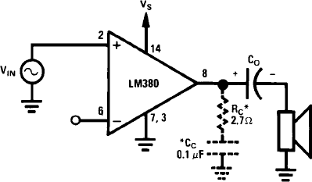
Figure 1: Minimum-component circuit for LM384
Another advantage of using this class AB chip over a more reliable and power-efficient power amplifiers, like class D, is also simplicity. Using a class AB amplifier eliminates the need for more complex stages like modulation and filtering in the case of using switching-based class D chips. It also provides more power efficiency than the case of simpler amplifiers like class A.

A disadvantage of using Class AB amplifiers is that they are still power-inefficient, which imposes the need for a heatsink. The LM384 is a 5W amplifier with a junction-to-ambient thermal resistance, θ_{JA}, of 79°C/W, which can cause the chip to significantly heat up when operating at close to 5W. For example, assuming the ambient temperature to be 25°C, operating at 3W would cause the chip junction temperature to reach about 262°C (T_{J} = 3*79 + 25). The maximum junction temperature of the chip, T_{Jmax}, is 150°C, which means that it could be safe to operate at less than 2W without a heatsink at room temperature.

The LM384 can supposedly provide up to 5W. Consulting the datasheet, the total harmonic distortion (THD) appears to be around 10% at 5W, which is high. However, the maximum THD at 4W is specified to be 1% so operating below 4W would be desired for lower distortion levels.

Figure 2 shows the complete design for the amplifier stage. The design is taken from the “typical design” section in the datasheet with minor modifications to some of the capacitors’ values. This design is very similar to the minimum-component circuit in Figure 1. One of the differences is the potentiometer added for volume control. Other differences are the decoupling capacitor added at the supply voltage, V_{s}. Adding the decoupling capacitor is recommended when the distance between the IC power supply pin and the power supply source is more than two to three inches when the inherit inductance of the wires(traces) becomes significant. In general, adding a decoupling capacitor at the power supply input of ICs is good practice. The bypass capacitor added at pin 1 is related to the internal input stage design of the amplifier and improves the power supply rejection ratio (PSRR). PSRR is specified to be 31 dB with a 5μF bypass capacitor. The supply voltage, V_{s}, is set to be 20V.
Notes that all the pins not shown in Figure 2 are ground and no-connection pins. That is, 4, 5, 10, 11, 12 are ground pins and 9, 13 are no-connection pins. In Figure 2, J2 is the audio input connector while J3 is the 8Ω speaker connector.

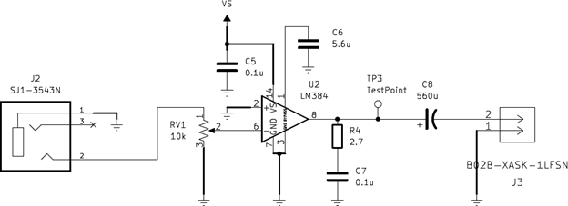
Figure 2: complete design of the amplifier block

The amplifier chip can operate at 5W so assuming that it will be operated at this power, basic analysis can give an idea about how much current might be drawn by the output. Since an 8Ω speaker is used and P = I² R, at 5W, $I= \sqrt{\begin{aligned}5 \\ 8\end{aligned}}$ ≈ 0.8A.

Please note that in a realistic situation, the output power most likely will not continuously stay at 5W, or any other value, since the audio input is not a constant signal. This makes mathematical analysis inaccurate and challenging. However, the simple analysis previously stated gives an upper bound or an idea about the current requirements for such design.

Heatsink Thermal Resistance Requirement Calculations:
- The heatsink calculations will be done assuming the worst-case scenario, which happens when the output power is 3W. The device dissipates about 2.5W at this output power.
- A simplified linear relation will be used as a good approximation to the relation between temperature, power, and thermal resistance: ΔT = P * θ.
- The following parameters and assumptions will be used to approximate the maximum thermal resistance required for the heatsink:
  - ΔT: Difference between junction temperature and ambient temperature (T_{J} – T_{A})
  - θ_{JA}: Junction-Ambient thermal resistance
  - θ_{JC}: Junction-Case thermal resistance
  - θ_{CA}: Case-Ambient thermal resistance
  - θ_{SA}: Heatsink-Ambient thermal resistance
  - θ_{CS}: Heatsink-Case thermal resistance
  - Junction-Ambient thermal resistance for the chip with the heatsink: θ_{JA} = θ_{JC} + θ_{SA} + θ_{CS}
- The heatsink-case thermal resistance is very small and will be neglected: θ_{CS} ≈ 0°C/W.
- The ambient temperature will always be assumed to be 25°C.
- The maximum junction temperature allowed by the design will be chosen to be the same as the maximum junction temperature of the chip (T_{J} = T_{Jmax} = 150°C).

ΔT = P * θ = P * θ_{JA} = P * (θ_{JC} + θ_{SA} + θ_{CS}) = P * (θ_{JC} + θ_{SA}) (θ_{CS} ≈ 0°C/W)
θ_{SA} = $\frac{ΔT}{P}-θ_{JC}$ = $\frac{T_{J}-T_{A}}{P}-θ_{JC}$
θ_{SA} = $\frac{150-25}{2.5}-30$ = 20°C/W (θ_{JC} of the LM384 is 30°C/W)

This shows that the heatsink-ambient thermal resistance, θ_{SA}, for the heatsink used for the chip must be at most 20°C/W to get the junction temperature, T_{J}, to be 150°C at the worst-case condition (2.5W).

- AC/DC Adapter

The recommended supply voltage of the amplifier design in Figure 2 is 22V. The output voltage of the adapter was chosen to be close to this number. A switching adapter with 24V and 1A output capabilities was used for the design. The switching adapter was used for its high efficiency. The 24V output characteristic, despite not matching the recommended value, was chosen for its low cost and wide availability for general-purpose AC/DC adapters. Also, the 1A output characteristic to supply enough current that satisfies the simple power analysis performed in the previous section. The adapter used has a ripple noise percent of about 1%, which might be considered as a small value for some applications. However, for an audio amplifier, producing quality sound is highly desired, which makes reducing the ripple percent important.

An adjustable linear regulator was used, as shown in Diagram 1, to overcome some of the issues listed in the previous paragraph. The regulator was chosen to help bring the supply voltage closer to the recommended value (22V) and to reduce the relatively high noise in the adapter output.

- Linear Voltage Regulator

The regulator used in this project is the LM317 adjustable linear voltage regulator. This chip was used since it’s one of the most popular adjustable regulators as well as being produced by multiple manufacturers. This regulator provides satisfactory specifications at low cost. A disadvantage of using that chip is the limitations imposed by the fact that it is not a low dropout voltage (LDO) chip.

Figure 3 shows this circuit with C_{in} and C_{o} being recommended but not required. The figure features the regulator chip, the resistors used to get the desired output voltage, the decoupling capacitor, C_{in}, and the output capacitor, C_{o}. Similar to the amplifier, the decoupling capacitor becomes highly recommended when the distance between the regulator and the input voltage source is relatively long. C_{o} is solely responsible for enhancing the transient response of the regulator.

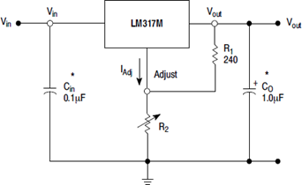
Figure 3: Basic circuit for LM317

The output voltage, V_{out}, which is the supply voltage for the amplifier, is calculated from the following equation:
$$V_{out}= V_{ref}*\left(1+\frac{R_{2}}{R_{1}}\right)+I_{adj}*R_{2}$$
V_{ref} is the voltage across R₁. R₁ recommended by the manufacturer to be 240Ω in this simple application. V_{ref} and I_{Adj} are provided in the datasheet of the chip.

Since the supply voltage to the amplifier is recommended to be 22V, an initial thought would be using this value for V_{out} and solving for R₂. One issue with this thought is that the regulator used requires a minimum dropout voltage to function properly. When the output current is 0.5A, the dropout voltage must be about 2.2V. Recalling that the input to the regulator is 24V (the output of the AC/DC adapter) and the desired output is 22V, it appears to be impossible to get this output voltage considering the dropout voltage of the regulator. Since the difference between the input and the output voltages is very close to the minimum dropout voltage of the chip, additional measures should be taken to ensure that the regulator will give the desired output. These measures include the tolerances of the values that directly affect the input voltage i.e., the accuracy of the AC/DC adapter output and the tolerances of the values that directly affect the output voltage equation i.e., V_{ref}, R₁, R₂, and I_{Adj}.

The output voltage of the adapter (the input of the regulator) has an accuracy of about 5% (24V*0.05 = 1.2V). This means that in the worst case, the output voltage of the adapter could be 22.8V (24V – 1.2V). Considering the minimum dropout voltage and this analysis, it would be reasonable to initially choose V_{out} to be 20.6V (22.8V – 2.2V).

On the other hand, the output voltage, V_{out}, has its own tolerance due to the tolerances of the values that directly affect it. Analyzing the output voltage equation shows that V_{ref} and the resistors’ tolerances directly affect the accuracy of V_{out}. The tolerance of the resistors used is 1%. Consulting the datasheet about the minimum, typical, and maximum value of V_{ref} shows that V_{ref} tolerance is about 2%. I_{Adj} is a very low current in the order of micro amperes and therefore its tolerance can be neglected. Combining the tolerances of the resistance and V_{ref} to be 3% is a good enough approximation for the V_{out} tolerance. This means that if V_{out} is 20.6V, the tolerance is approximately ± 0.6V (20.6*0.03). To avoid violations of the minimum dropout voltage of the regulator, V_{out} was chosen to be 20V (20.6V – 0.6).

To find the value of R₂, the following values were substituted in the output voltage equation: V_{out} = 20V, R₁ = 240Ω, V_{ref} = 1.25V, I_{Adj} = 100μA.
$$20=1.25*\left(1+\frac{R_{2}}{240}\right)+{10}^{-4}*R_{2}$$

$$R_{2}=3.53kΩ$$

Figure 4 shows a more advanced design with a capacitor, C_{Adj}, connected between the adjustment terminal and the ground. Also, the datasheet recommends two protection diodes, D₁ and D₂ to protect the IC. As shown in Figure 4, D₁ protects against C_{o} discharging into the IC in the case of input short circuits (V_{in} to GND).
D₂ protects against C_{Adj} discharging into the IC in the case of output short circuits. Both D₁ and D₂ protect against C_{Adj} in the case of input short circuits (V_{in} to GND).

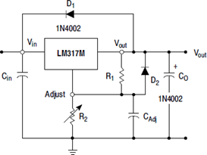
Figure 4: CAdj and protection diodes are added to the regulator circuit

Figure 5 displays the final design of the Linear Voltage Regulator block in Diagram 1. R₂ was chosen to be 3.57kΩ instead of the value calculated above (3.53kΩ) for cost and availability reasons. A 10μF capacitor is used for C_{Adj}, which enhances the PSRR characteristics of the regulator block. The output capacitor, C₄, is added to the design to supply current to the amplifier in the case of sudden high increases in the audio input signal, which will cause the amplifier to suddenly require more current to operate smoothly. A relatively high value capacitor (100μF) is used to perform this task.

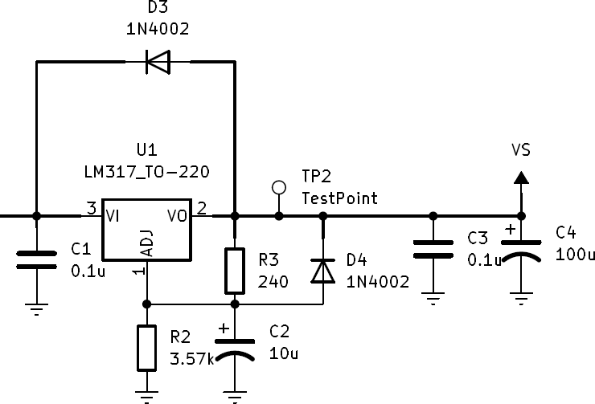
Figure 5: Final design of the Linear Voltage Regulator block

The LM317 also heats up due to the power dissipation of the chip. The worst-case scenario for power dissipation will happen when the voltage drop on the regulator is maximum and the output current is also maximum. The worst-case scenario for the input voltage is when V_{in} = 25.2V (5% tolerance) while for the output voltage is when V_{out} = 19.4V (3% tolerance). The worst-case scenario for the output current is when I_{out} = 0.8A, which happens when the amplifier operates at 5W. Combining these results, the power dissipated by the regulator is P = (V_{in} – V_{out}) * I_{out} = (25.2 – 19.4) * 0.8 = 4.64W. This calculation neglects the current drawn by the regulator itself since it is a very small value compared to 0.8A.
The junction to ambient thermal resistance, θ_{JA}, of the LM317 package used is 70°C/W, which means that if the chip dissipated 4.64W, its junction temperature could reach 349.8°C (T_{J} = 4.64*70 + 25), assuming the ambient temperature to be 25°C. The maximum junction temperature of the chip, T_{Jmax}, is 150°C. This illustrates the need for a heatsink if the chip is to be operated at these conditions.

Please note that one of the limitations of using this LM317 package is the typical versus minimum value for the maximum output current, I_{max}. Recalling earlier analysis of the amplifier shows that the regulator must provide an average of 0.8A for the amplifier to operate at 5W. The minimum value for I_{max} is 0.5A while the typical value is 0.9A. Although considering the typical value makes it seem like there is no issue, a good design shouldn’t take typical values for granted. Typical value works at certain conditions while minimum values are guaranteed at all conditions of temperature and aging. This adds limitations on the operation of the amplifier. A good rule of thumb would be to avoid drawing continuous currents above 0.5A from the regulator. This means that the amplifier should be operated at about 2W continuous output power, which is, in a way, in line with the recommendation to keep the operation region below 4W to avoid high total harmonic distortion levels.

Heatsink Thermal Resistance Requirement Calculations:
- The heatsink calculations will be done assuming the worst-case scenario, which is when the chip dissipates 4.64W.
- A simplified linear relation will be used as a good approximation to the relation between temperature, power, and thermal resistance: ΔT = P * θ.
- The following parameters and assumptions will be used to approximate the maximum thermal resistance required for the heatsink:
  - ΔT: Difference between junction temperature and ambient temperature (T_{J} – T_{A})
  - θ_{JA}: Junction-Ambient thermal resistance
  - θ_{JC}: Junction-Case thermal resistance
  - θ_{CA}: Case-Ambient thermal resistance
  - θ_{SA}: Heatsink-Ambient thermal resistance
  - θ_{CS}: Heatsink-Case thermal resistance
  - Junction-Ambient thermal resistance for the chip with the heatsink: θ_{JA} = θ_{JC} + θ_{SA} + θ_{CS}
- The heatsink-case thermal resistance is very small and will be neglected: θ_{CS} ≈ 0°C/W.
- The ambient temperature will always be assumed to be 25°C.
- The maximum junction temperature allowed by the design will be chosen to be the same as the maximum junction temperature of the chip (T_{J} = T_{Jmax} = 150°C).

ΔT = P * θ = P * θ_{JA} = P * (θ_{JC} + θ_{SA} + θ_{CS}) = P * (θ_{JC} + θ_{SA}) (θ_{CS} ≈ 0°C/W)
θ_{SA} = $\frac{ΔT}{P}-θ_{JC}$ = $\frac{T_{J}-T_{A}}{P}-θ_{JC}$
θ_{SA} = $\frac{150-25}{4.64}-5$ = 22°C/W (θ_{JC} of the LM384 is 5°C/W)

This shows that the heatsink-ambient thermal resistance, θ_{SA}, for the heatsink used for the chip must be at most 22°C/W to get the junction temperature, T_{J}, to be 150°C at the worst-case condition (4.64W).

- Protection

The protection in this project is designed to protect the linear voltage regulator from high voltage spikes that can damage it and other components in the circuit too. The protection is done using a Transient Voltage Suppressor (TVS), which is placed after the filtering block and before the regulator as shown in Figure 6. The TVS is used to clamp the transient overvoltage (spikes) to a safe level that does not damage the circuit. The transient overvoltage could arise from a sudden current interruption in the circuit, which produces very high voltages because of the inductive elements in the circuit. These elements could be the wires, or the ferrite bead used for filtering. The following equation makes this clear: $V_{L}=L\frac{dI}{dt}$. A sudden change in the current can happen for several reasons including, plugging/unplugging the adapter from the main outlet, plugging/unplugging the adapter connector from the circuit, or electrostatic discharge (ESD).

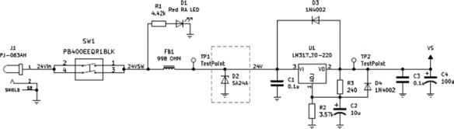
Figure 6: The TVS location in the schematic

The TVS used for this project is a diode TVS, which was chosen for its fast response, high withstand capabilities, long life, low clamping voltage. The TVS required specifications are determined based on the circuit to be protected. The stand-off voltage of the TVS is chosen based on the highest expected operating voltage at the point of intended, which is the adapter output voltage. Therefore, for a good design, the stand-off voltage, and therefore the breakdown voltage, of the TVS should be slightly above 25.2V (24V + 5% tolerance). The clamping voltage of the TVS is chosen based on the maximum input voltage allowed for the regulator. The maximum input-output voltage differential for the regulator is 40V. For normal operation conditions, the output voltage of the regulator is expected to be about 20V, the maximum input voltage allowed is 60V (40+20). However, at the moment of turning on the circuit, the output voltage of the regulator is expected to be 0V, so the maximum input voltage allowed is 40V (40+0). This means that the clamping voltage of the TVS should not exceed 40V to avoid violating the regulator specifications. Also, a reasonable Peak Pulse Power dissipation capability should be chosen for the TVS to allow for safe suppression of different overvoltage conditions.

The TVS chosen for this project is the SA24A. Although the stand-off voltage of this TVS is 24V (less than what is calculated above), its breakdown voltage is 26.7V (min) at 1 mA. The clamping voltage of the SA24A is 38.9V and the Peak Pulse Power dissipation of 500W at 10/1000 μs. These characteristics make the SA24A a reasonable choice for protecting the circuit.

Please note that this design doesn’t provide protection for the AC/DC adapter since it is assumed that such a commercial item is already protected.

- Filtering

The filtering stage in this project is designed to filter the high frequency harmonics in the power supply noise. Although these harmonics are certainly above the audible range for humans, filtering such high frequency noise is a good practice to prevent the noise from propagating through the circuit and becoming a source of electromagnetic interference (EMI). The filtering is done using a low-pass filter formed by the ferrite bead and the decoupling capacitor highlighted in Figure 7.

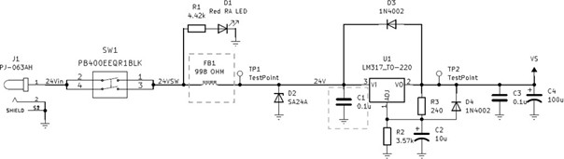
Figure 7: The low-pass network location in the schematic

The ferrite bead acts as a resistive component within its resistive band, which can be found from the impedance curve of the device. Within this resistive band, the ferrite bead will dissipate the noise as heat energy. The low-pass network plays two major roles in the filtering process. First, it will filter the power supply high frequency noise preventing the propagation of noise as previously explained. Second, it will dampen the transient overvoltage (spikes) caused by the reasons explained in the previous section including ESD. Dampening these spikes reduces the stress on the TVS in the protection stage. Figure 8 demonstrates this by showing simulation results of the voltage and current at the TVS with and without the ferrite bead when the system is stimulated by a large-magnitude pulse resembling a spike. Comparing the voltage and current levels in both cases makes it clear that the low-pass network leads to better results.

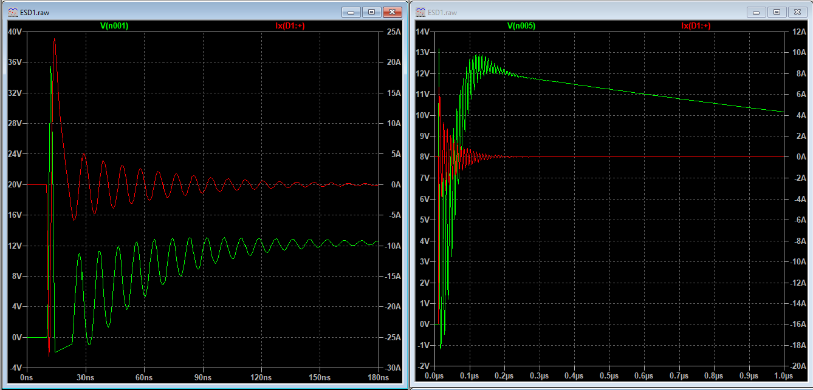
Figure 8: Voltage on the TVS without (left) and (with) the ferrite bead

The famous and most widely used criteria when picking ferrite bead is its DC resistance, impedance at high frequencies, DC bias current characteristics and LC resonant frequency when used in a low-pass network. In this design, a low value of the DC resistance is highly desirable to prevent further voltage drop causing lower voltage at the input of the regulator. Also, higher impedance at high frequencies is desirable to improve the dissipation of the high frequency noise. Additionally, high DC current rating for the bead is desirable since the impedance significantly decreases as the DC bias current gets closer to the rated current. It’s usually advisable to run the ferrite bead at current levels less than 20% of its rated current.

The ferrite bead chosen for this project is the 28C0236-0EW, which was mainly chosen for its small DC resistance and large high frequency impedance among other available options in the stock. This bead has a DC resistance of 0.01Ω, which makes the voltage drop across it negligible. It also impedance values between 0.6Ω and 1kΩ at frequencies ranging from about 25MHz to 125MHz, peaking at the value of 998Ω at 100MHz. Although this ferrite bead has high impedance values in the resistive region, these high values start to appear at frequencies largely higher than the expected noise band for a switching power supply. Switching power supply noise is typically in the hundreds of kilohertz. The ferrite bead is rated at 5A. When the speaker is running at 5W, the current was found before to be averaging 0.8A, which is less than 20% of the rated current.

Please note that this design doesn’t analyze the LC resonant frequency and its possible side effects.

Please note that this ferrite bead selected might need to be revisited due to the significant impedance values being at a range well above the power supply switching noise. A simple inductor could be a valid component to replace the ferrite bead with.

- LED Indicators

There is one LED indicator in this project that is designed to indicate whether the power is connected or not. The LED is located after the power supply and before the filtering block, which can be seen in Figure 6. A low-intensity LED was used to avoid excessive light and therefore prevent inconvenience when dealing with the amplifier board. The LED is connected in parallel with the power supply and a series resistor is used to control the current flowing through the LED to get a reasonable luminous intensity.

According to the datasheet of the LED used, the typical luminous intensity is 160mcd when the forward current, I_{F}, is 20mA. This intensity could still be brought down to achieve the convenience-related design goal. The datasheet states that the relative intensity is about 0.4 when I_{F} is 5 mA. This luminous intensity is reasonable for the project and the resistor value is chosen based on I_{F} = 5mA. The forward voltage of the LED is stated to be about 1.9V. Assuming the typical supply voltage is 24V, the voltage drop across the resistor is 22.1V (24-1.9). The resistor value should then be equal to $(\frac{22.1}{5*{10}^{-3}})$.

Please note that parameters like viewing angle, dominant wavelength, peak wavelength, and spectrum radiation bandwidth were overlooked for simplicity.

It might seem counter intuitive to start by introducing the amplifier instead of, possibly, the AC/DC Adapter. However, knowing the characteristics and requirements for the main component of the circuit provides valuable information on how the rest of the stages should be designed.
Dropout voltage is the magnitude of the difference between V_{out} and V_{in}
The simulation duration is not the same in both situations.

