|  |  |  |
| --- | --- | --- |
| **Digital Logic Design** | | |
| Faisal Iradat, PhD | Quiz – 10 | Marks: 5 |

1. Given the circuit below:

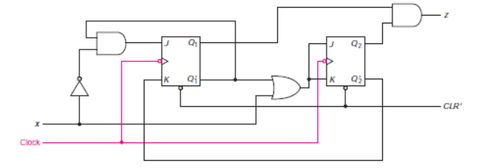

Do the following:

1. Draw the timing diagram.
2. Draw the state diagram.
3. Draw the state table.
4. Derive the state equations.