|  |  |  |
| --- | --- | --- |
| **Digital Logic Design** | | |
| Faisal Iradat, PhD | Quiz – 2 | Marks: 20 (Scaled to 2) |

1. Apply DeMorgan's theorems to the following expressions:
   1. $\overline{XYZ }$ and $\overline{X + Y + Z}$

(X+Y+Z).(X.Y.Z)

$\overline{\overline{A+B\overline{C}}+D \left(\overline{E+\overline{F}}\right)}$

$$\overline{A+B\overline{C}}+D (\overline{E+\overline{F}})$$

[2+2]

1. Using Boolean algebra techniques, simplify the following expressions:
   1. AB + A(B + C) + B(B + C)

AB+AC+BB+BC  
AB+AC+B+BC  
AB+AC+B(1+C)  
AB+B+AC  
B+AC

$\overline{A}BC + A\overline{B}\overline{C} + \overline{A}\overline{B}\overline{C}+ A \overline{B} C + + ABC$

$$A'BC +AB'C'+A'B'C'+ AB'C+ ABC$$

$$A'BC+B'C'(1)+AB'C+ ABC$$

$$A'BC+B'(C'+AC)+ABC$$

$$BC (A'+A)+B'(C'+A)$$

$$BC(1)+B'(C'+A)$$

$$BC+ B'C'+ B'A$$

[3+3]

1. Convert the following expression into standard SOP form:

$$A\overline{B}C + \overline{AB} + AB\overline{C}D$$

AB’C(D+D’)+(C+C’)(D+D’)+ABC’D

[3]

1. Convert the following expression into standard POS form:

$$(\overline{A} + B + C)(\overline{B} + C + \overline{D})(A + \overline{B} + \overline{C} + D)$$

(A’+B+C+DD’)(AA’+B’+C+D’)(A+B’+C’+D)

[3]

1. Convert the following circuit using NAND and NOR implementations

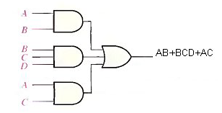

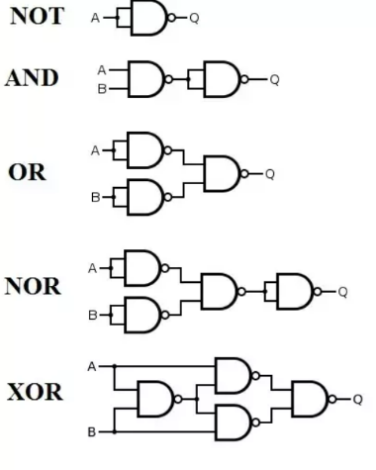

[2+2]