|  |  |  |
| --- | --- | --- |
| **Digital Logic Design** | | |
| Faisal Iradat, PhD | Quiz – 3 | Marks: 20 (Scaled to 2) |

1. Given the circuit below:

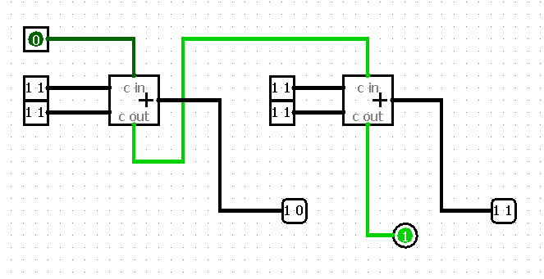

* 1. Label the inputs (A3, A2, A1, A0 – B3, B2, B1, B0 & S3, S2, S1, S0)

[2]

* 1. Determine the function of this circuit

4-bit Adder

[2]

For on Full adder

* 1. Draw the truth table

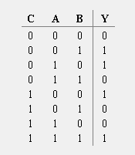

[3]

* 1. Write the SOP

[3]

* 1. Write the POS

[3]

* 1. Simplify SOP using K-Map

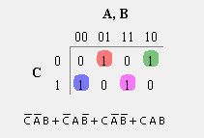

[4]

* 1. Draw the circuit

[3]