|  |  |  |
| --- | --- | --- |
| **Digital Logic Design** | | |
| Faisal Iradat, PhD | Quiz – 3 | Marks: 20 (Scaled to 2) |

1. Given the circuit below:

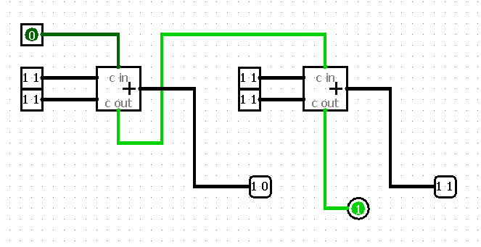

* 1. Label the inputs

[2]

* 1. Determine the function of this circuit

[2]

For on Full adder

* 1. Draw the truth table

[3]

* 1. Write the SOP

[3]

* 1. Write the POS

[3]

* 1. Simplify SOP using K-Map

[4]

* 1. Draw the circuit

[3]