|  |  |  |
| --- | --- | --- |
| **Digital Logic Design** | | |
| Faisal Iradat, PhD | Quiz – 4 | Marks: 20 (Scaled to 2) |

1. Design a MOD-10 synchronous sequential circuit using D-Flipflops only

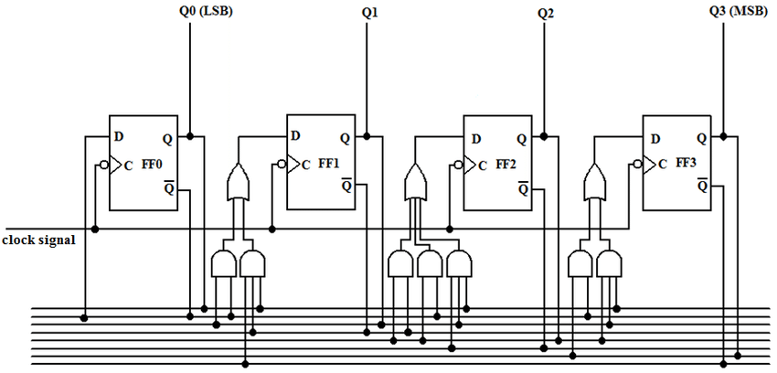

1. Design a MOD-10 asynchronous sequential circuity using JK flipflops only

