|  |  |  |
| --- | --- | --- |
| **Digital Logic Design** | | |
| Faisal Iradat, PhD | Quiz – 5 | Marks: 20 (Scaled to 2) |

1. Given the synchronous sequential circuit below

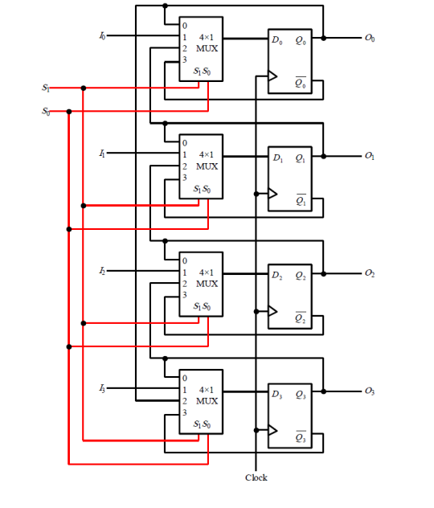

1. What circuit is implemented?
2. The functions of this circuit corresponding to values of S1S0 is incorrectly written below. Reorder the functions for the right values of S1S0

|  |  |  |
| --- | --- | --- |
| S1 | S0 | Functions |
| 0 | 0 | Load with 1’s complement of current value |
| 0 | 1 | Rotate Right |
| 1 | 0 | No change |
| 1 | 1 | Parallel load |

1. Given the circuit below

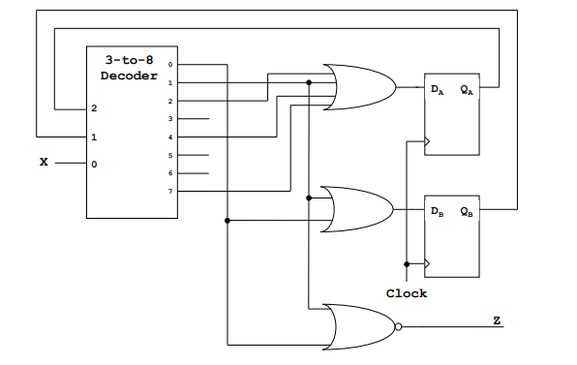

1. Draw the stat transition table
2. Derive the state transition equations
3. Draw the state transition diagram
4. Is this a Mealy machine or a Moore Machine?

3 x 8 decoder circuit with EN is as follows:

