<Give Here Your Own Project Title>
Design Document

Version 1.0



Group Id: AbdullahIrshadShah

Supervisor Name : Zaid Ismail

Revision History
Date (dd/mm/yyyy) | Version | Description | Author
03-03-2025 | 1.0 | Introduction of the project | Abdullah Irshad

Table of Contents

- Introduction of Design Document
- Entity Relationship Diagram (ERD)
- Sequence Diagrams
- Architecture Design Diagram
- Class Diagram
- Database Design
- Interface Design
- Test Cases

- Introduction of Design Document
- Implementing Design Documents
Design documents are an important part of the software development lifecycle. It serves as a detailed planning and technical roadmap for creating and implementing software solutions. Fruit Lips Detection System, this document provides a clear and comprehensive structure for system development, including tools, technology, system components selection, and how to interact. This design document is an integral part of ensuring that the development process remains on the right track and meets the goals and requirements of the project. The design document covers technical approaches, data flow, algorithmic design, and key technologies needed to create successful machine learning models that can predict the ripening of different types of fruit.
This document contains:
1. This section discusses expected features such as image input processing, fruit classification, maturation recognition, and output (which can include warnings, recommendations, or classification beds).
2. Technical Requirements:
This section describes the nuclear technology used in system development. In this project, Tensorflow is used to train and run machine learning models, while Python is used for both backend implementation and data processing tasks. System Architecture:
Describes the systemwide structure, including clientside interfaces (frontend), backend servers, and machine learning models. Dataflow and Processing:
Details on how to process fruit photos. This section includes image preprocessing steps such as size, normalization, and augmentation techniques size. Machine Learning Model Design:
This section describes specific models of machine learning where the maturity of fruits is recorded. It covers deep learning models (such as neural networks and CNNs), training processes, data recording requirements, and evaluation metrics (such as accuracy, accuracy, recall, etc.).
6. User Surface Design:
Overview of a webbased interface, including image uploads, results of maturation predictions, and interaction with the system.
7. Test and Evaluation:
Describes software and machine learning models testing strategies, including unit, integration tests, model validation, and user acceptance tests.
8. Design Strategy:
Provides plans to deliver applications in a production environment. This includes considerations for hosting web applications, integrating models into web frameworks, and assurance of scalability.
9. B. Safe Images Ensures uploading, protecting user data, and other potential weaknesses in the system.
10. Maintenance and Future Improvements:
The plans to maintain the system after deployment are discussed, including error correction, updates, and additions of fruit types, and improving model accuracy, are potential future characteristics. Clear Roadmap:
The design documentation serves as a detailed design for the entire development team, leading every step of the project. We ensure that all involved understand their goals and plans before development begins.
2. Risk Reduction:
Early architectures and technologies allow you to identify and reduce potential technical challenges and risks before development begins. This reduces the chances of significant issues occurring during the development phase.
3. Cost and Time Efficiency:
Proper planning during the design stage will help you optimize your development process. This reduces the need for largescale rework and helps avoid unnecessary costs and delays due to insufficient planning or unknown requirements.
4. Communication Equipment:
Draft documents act as a frequent reference point for all involved in the project (developers, stakeholders, testers, managers) and encourage team members to deepen communication and understanding.
5.
6. Quality Assurance:
Detailed design helps establish clear standards for testing and verification. An explanation of how the system works and what results are expected ensures that the software meets its quality standards.
7. Make it easy to scale or modify your system to meet future requirements.
In summary, the design stage plays an important role in creating a solid foundation for successful development and delivery of fruit injection detection systems. It ensures that all stakeholders are aligned, reduced risk and structured the development process as efficient and effective.

- Entity Relationship Diagram (ERD) (To be developed using Microsoft Visio or any other drawing software of your choice)
Diagram:
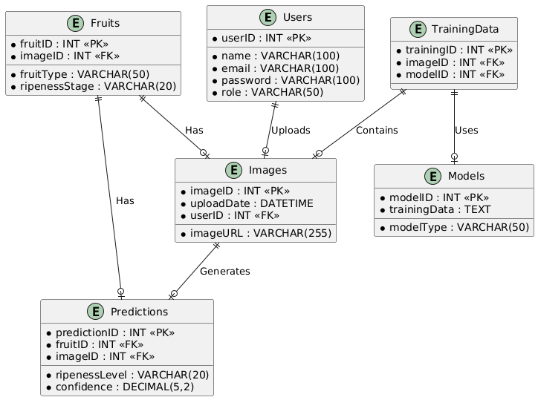
- Sequence Diagrams (To be developed using Rational Rose or any other drawing software of your choice)
- Classes Entities
- Request messages
- Response message
- Self message
- Lifeline
- Alternative method if else method
Admin user Diagram:
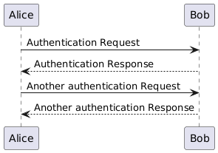

General User:
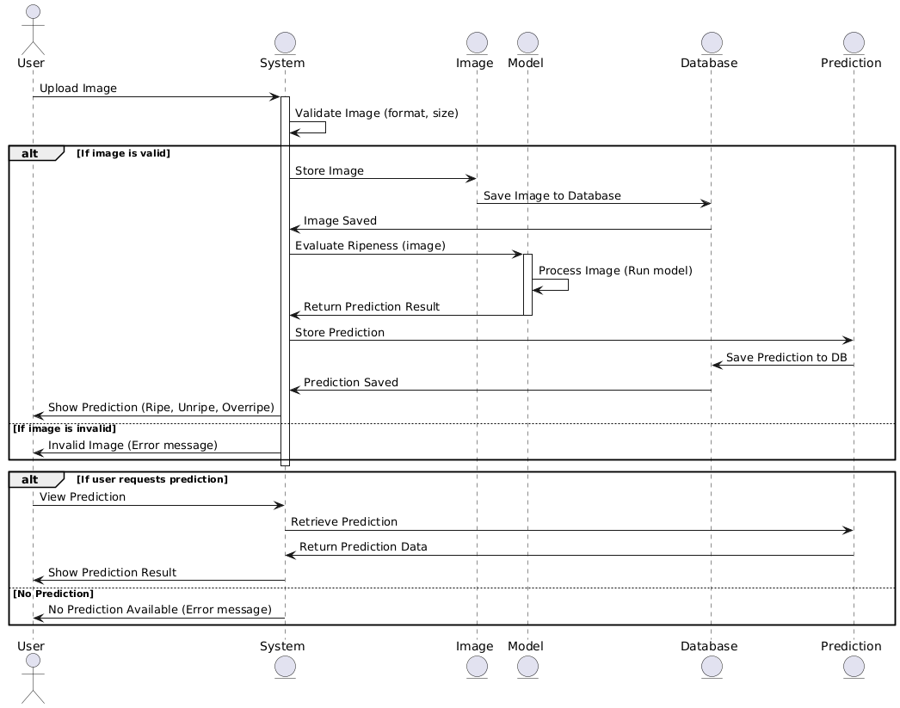
- Architecture Design Diagram
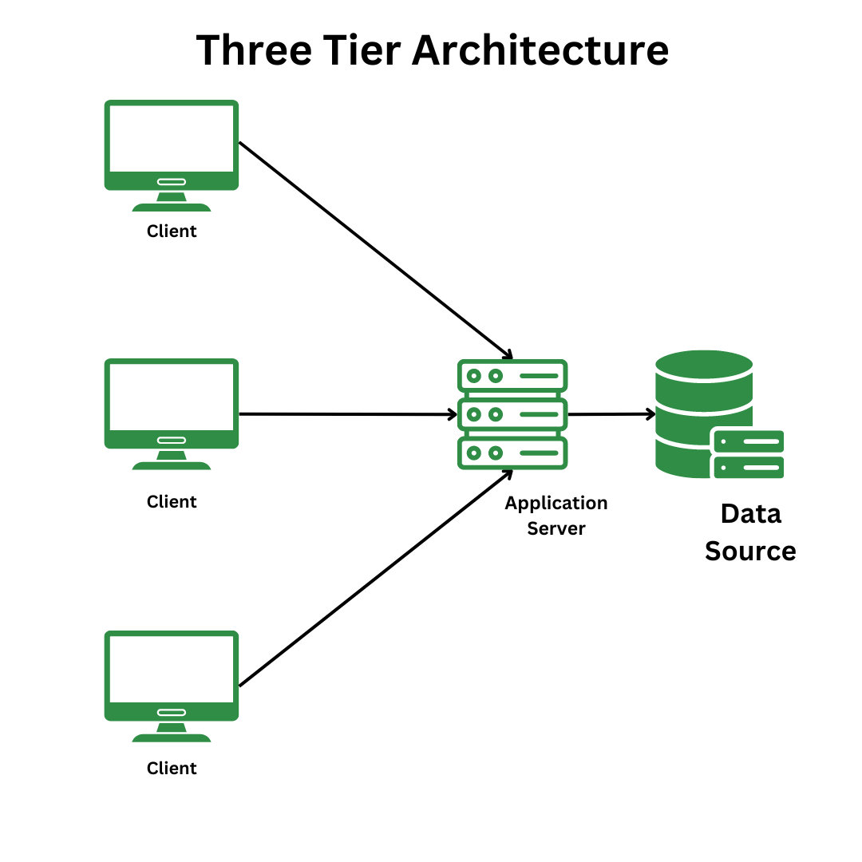

Three-Tier Database Architecture

In the three-tier, the application logic or process lives in the middle tier, it is separated from the data and the user interface. Three-tier systems are more scalable, robust and flexible. In addition, they can integrate data from multiple sources. In the three-tier architecture, a middle tier was added between the user system interface client environment and the database management server environment. There are a variety of ways of implementing this middle tier, such as transaction processing monitors, message servers, or application servers.

- Class Diagram

- Classes
- Attributes
- Methods
- Access Modifier
- Relationship (Inheritence, aggregation, association, composition)
Diagram:
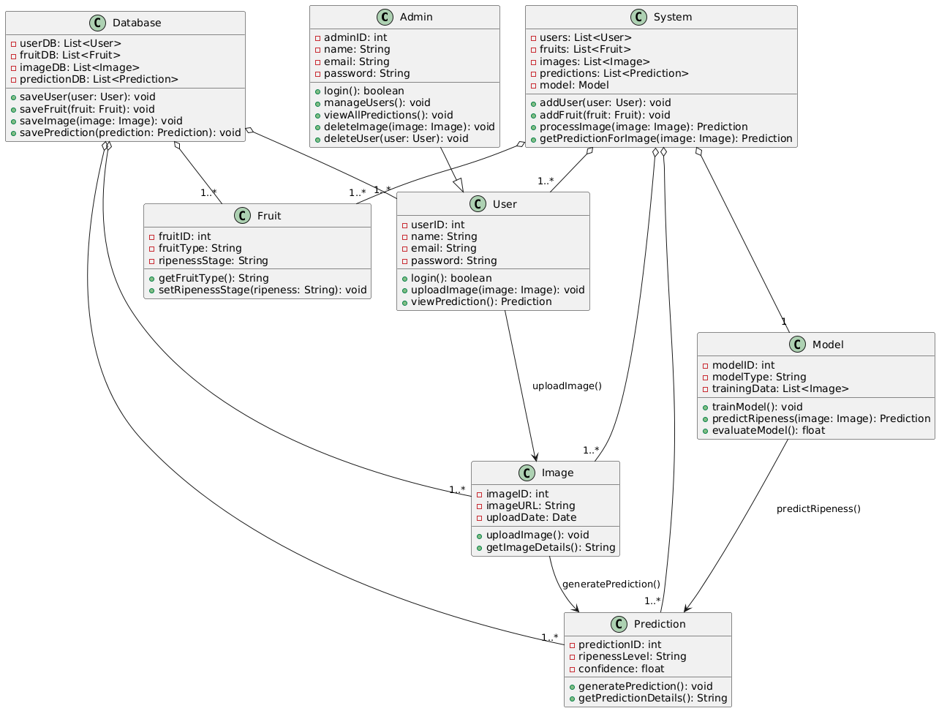

- Database Design

- Database Table
- Primary Key
- Foreign Key
- Relationship between tables in the form of cardinalities
Design:

- Interface Design

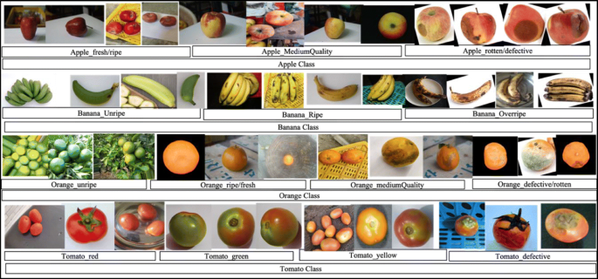

- Test Cases

Test Case ID | Description | Input | Expected Output | Pass/Fail | Tested By | Test Date | Test Environment
TC001 | User Login with valid credentials | Username: "user1", Password: "validPass" | Login successful, redirects to dashboard | Pass | Abdullah Irshad | 03/03/2025 | Test Machine A
TC002 | User Login with invalid credentials | Username: "user1", Password: "invalidPass" | Error message: "Invalid credentials" | Pass | Abdullah Irshad | 03/03/2025 | Test Machine A
TC003 | Admin creates a new user | Name: "John Doe", Email: "johndoe@example.com" | Success message: "User created successfully" | Pass | Abdullah Irshad | 03/03/2025 | Test Machine B
TC004 | Admin deletes an existing user | User ID: 5 | Success message: "User deleted successfully" | Pass | Abdullah Irshad | 03/03/2025 | Test Machine B
TC005 | User uploads a valid fruit image | Image file: "apple.jpg" | Success message: "Image uploaded successfully" | Pass | Abdullah Irshad | 03/03/2025 | Test Machine A
TC006 | User uploads an invalid image (unsupported type) | Image file: "invalid_image.txt" | Error message: "Unsupported file type" | Pass | Abdullah Irshad | 03/03/2025 | Test Machine A
TC007 | Admin views all user predictions | User ID: 3 | List of predictions with user details | Pass | Abdullah Irshad | 03/03/2025 | Test Machine B
TC008 | Prediction of fruit ripeness for an uploaded image | Image: "banana.jpg" | Prediction: "Unripe", Confidence: 85% | Pass | Abdullah Irshad | 03/03/2025 | Test Machine C
TC009 | Model training with a set of fruit images | Training Data: ["apple.jpg", "banana.jpg"] | Model trained successfully with accuracy: 92% | Pass | Abdullah Irshad | 03/03/2025 | Test Machine C
TC010 | User views fruit ripeness prediction details | Image ID: 7 | Ripeness Level: "Ripe", Confidence: 95% | Pass | Abdullah Irshad | 03/03/2025 | Test Machine A
TC011 | Admin deletes a fruit image | Image ID: 10 | Success message: "Image deleted successfully" | Pass | Abdullah Irshad | 03/03/2025 | Test Machine B
TC012 | Model evaluation with a test dataset | Test Data: ["grape.jpg", "apple.jpg"] | Model evaluation result: Accuracy 91%, Precision 90% | Pass | Abdullah Irshad | 03/03/2025 | Test Machine C
TC013 | User logs out | None | User is logged out, redirects to login page | Pass | Abdullah Irshad | 03/03/2025 | Test Machine A
TC014 | Admin views all images uploaded by users | User ID: 6 | List of all images uploaded by User 6 | Pass | Abdullah Irshad | 03/03/2025 | Test Machine B
TC015 | Admin views all model details | Model ID: 3 | Model details: "Model Type: CNN, Training Accuracy: 91%" | Pass | Abdullah Irshad | 03/03/2025 | Test Machine B

