Error Reports
Questions

● Read, Load and View the Dataset

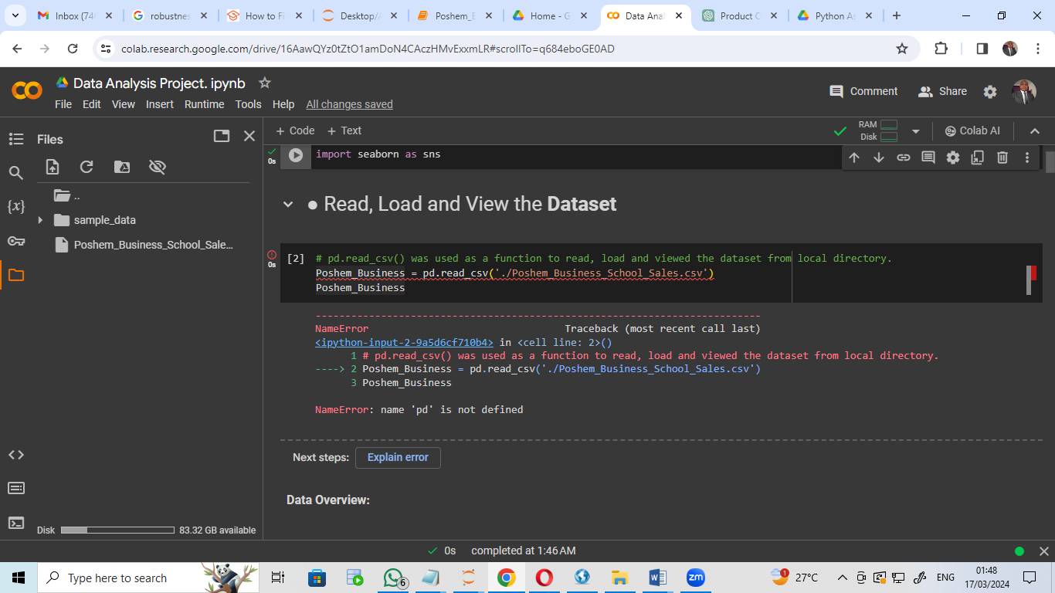
Error Type : NameError: name ‘pd’ is not defined
Causes: absence of the dataset in colab.
Resolution: Dataset was re-imported to colab using: (Poshem_Business = pd.read_csv('./Poshem_Business_School_Sales.csv')

● ● What is the timeframe of the dataset? (Start and end date)

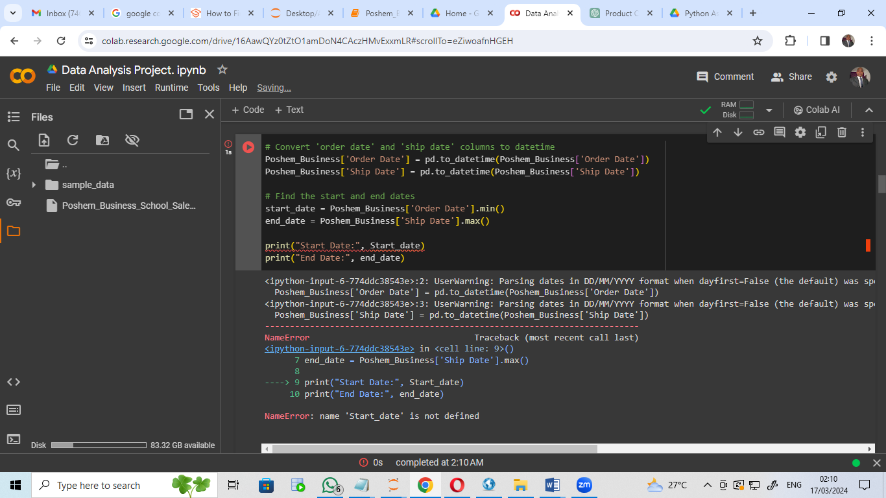
Error Type : NameError: ‘start_date’ is not defined
Causes: variable ‘Start_date’ started with small letter ‘s’.
Resolution: print(“start_date”) instead print( ‘Start_date’)

● Can you identify the top 5 cities with the highest number of orders?

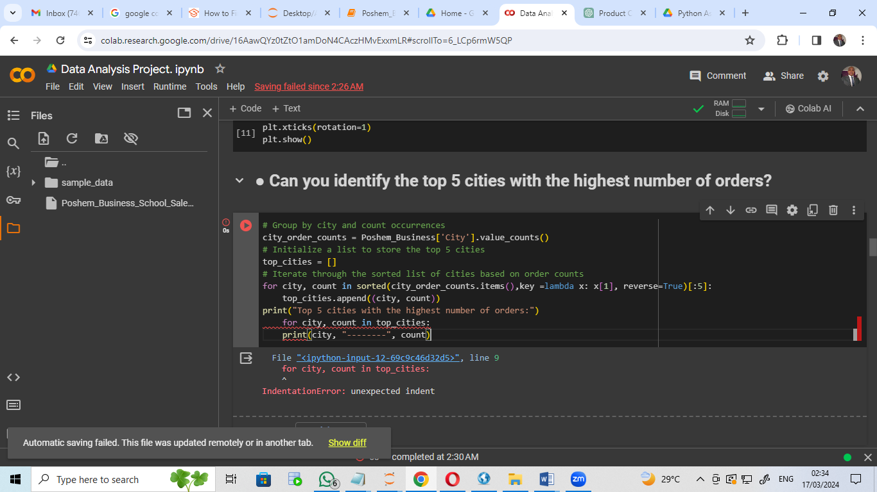
Error Type : IndentationError: unexpected indent
Causes: for loop was not property indented after column
Resolution: proper indentation was carried out

● Can you identify the top 5 selling products?
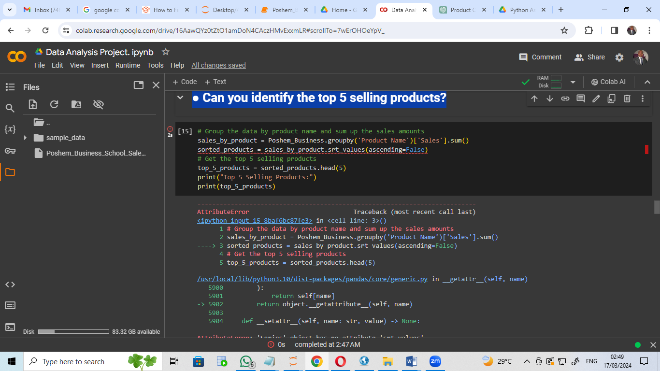

Error Type : AttributeError: ‘Series’ object has no attribute ‘srt_values’
Causes: the function ‘srt_values’ was wrongly spelt.
Resolution: ‘srt_values’ was corrected to be ‘sort_values’

● What is the average profit margin?

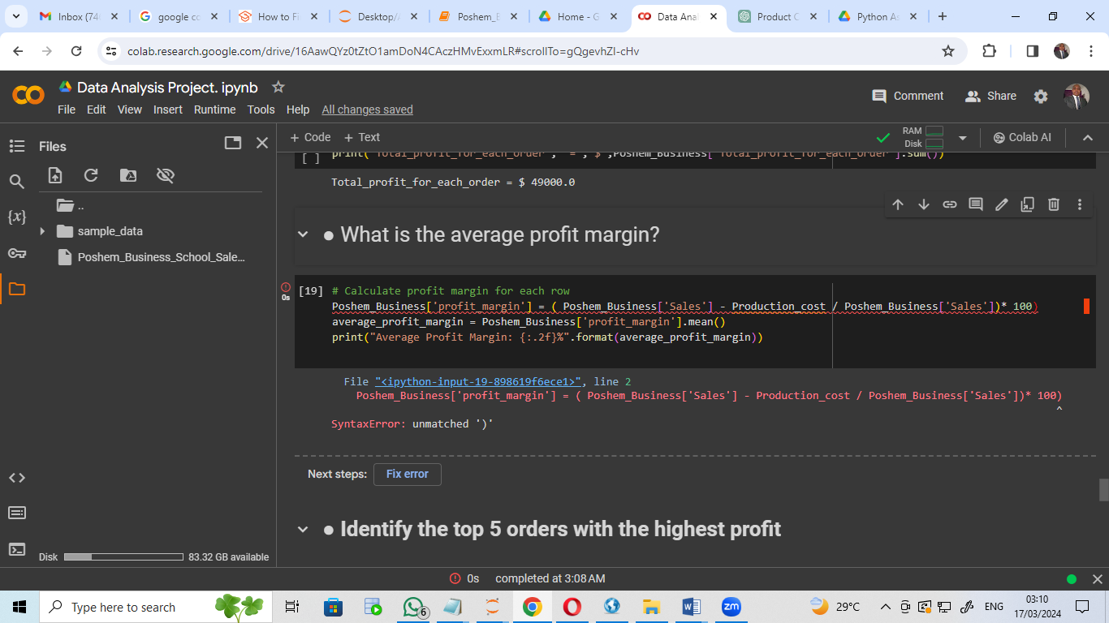
Error Type : SyntaxError: unmatch ‘)’
Causes: the function parenthesis omited
Resolution: Parenthesis introduced ((Poshem_Business[‘Sales’]-Production_cost/Poshem_Business[‘Sales’])*100)

● What are the different shipping modes available?

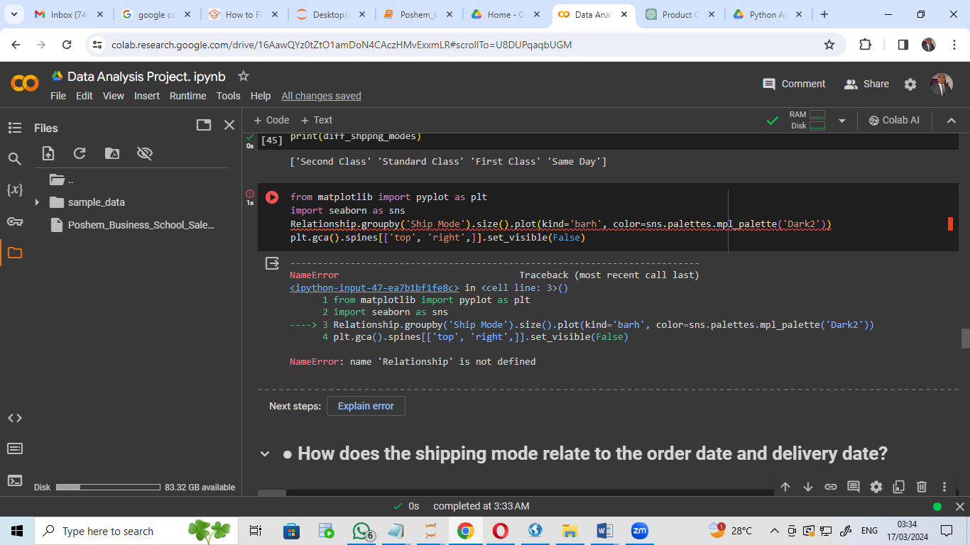
Error Type : NameError: name ‘Relationship’ is not defined
Causes: ‘Relationship’ was not defined
Resolution: The variable ‘Relationship ‘ was defined

