# ModernRestaurantBilling – Documentation

## 1. Background

The food and hospitality industry demands efficient and user-friendly systems to streamline order processing, manage customers, and generate accurate bills. Traditional billing systems often suffer from issues like manual errors, lack of record keeping, and poor customer experience. The ModernRestaurantBilling system aims to address these issues by providing a fully digital, GUI-based solution built using Python.

## 2. Problem Statement

Manual billing processes in restaurants are prone to errors, time-consuming operations, and poor traceability of orders and customer data. There is a need for an automated system that:  
- Allows easy and quick billing  
- Stores customer and order history  
- Generates printable receipts  
- Provides a smooth user interface for both customers and restaurant staff

## 3. Project Scope

The project focuses on creating a desktop-based application to manage restaurant billing, orders, and customer information.

### In Scope

- GUI-based application using Tkinter  
- Customer and Order Management  
- Dynamic menu and quantity-based ordering  
- Auto-calculated taxes and service charges  
- Bill generation and export to PDF  
- Local data storage using SQLite  
- Order and customer history tracking

### Out of Scope

- Web or mobile application versions  
- Integration with payment gateways  
- Cloud-based database or APIs

## 3.1 User Roles

### User (Staff)

- Add/select customers  
- Place and edit orders  
- View bill summaries  
- Export bill to PDF  
- Search previous orders

### Admin (Future Scope)

- User authentication/login  
- Manage menu categories and items  
- Generate sales reports  
- Manage staff access and privileges

## 3.2 User Experience Features

### Usability

- Intuitive tab-based interface  
- Real-time feedback and dynamic updates  
- Organized layout for easy navigation

### Performance and Robustness

- Fast and responsive UI built with Tkinter  
- Optimized database operations using SQLite  
- Error handling for database and file operations

### Reporting

- Detailed PDF bill generation  
- Customer and order history view  
- Future potential for Excel/CSV report export

## 4. User Interface

The application consists of a main window with three primary tabs:  
- Billing Tab: Select food items, manage quantities, view bill summary  
- Customer Tab: Add, find, or search for customers  
- History Tab: View and search order history  
  
Key interface components:  
- Dynamic menu generation  
- Auto-calculated billing  
- Summary section with total, tax, service charge  
- Print/export to PDF button  
- Customer form fields

## 5. Technology Stack

|  |  |
| --- | --- |
| Component | Technology |
| Frontend | Python (Tkinter GUI) |
| Backend | Python |
| Database | SQLite (Local DB) |
| PDF Generation | fpdf (Python Module) |
| Data Formats | JSON (for order storage) |
| Date Handling | datetime (Python stdlib) |
| File Management | os (Python stdlib) |

## 6. Enhanced User Interface (Screenshots)

The ModernRestaurantBilling application offers a clear and well-structured user interface, designed for ease of use and efficiency. Screenshots of the interface are presented below to illustrate the application’s layout and functionality.

• Order History Tab:

Displays a searchable table of all previous orders. Details such as bill number, customer name, phone, subtotal, tax, service charge, total, and date are shown.

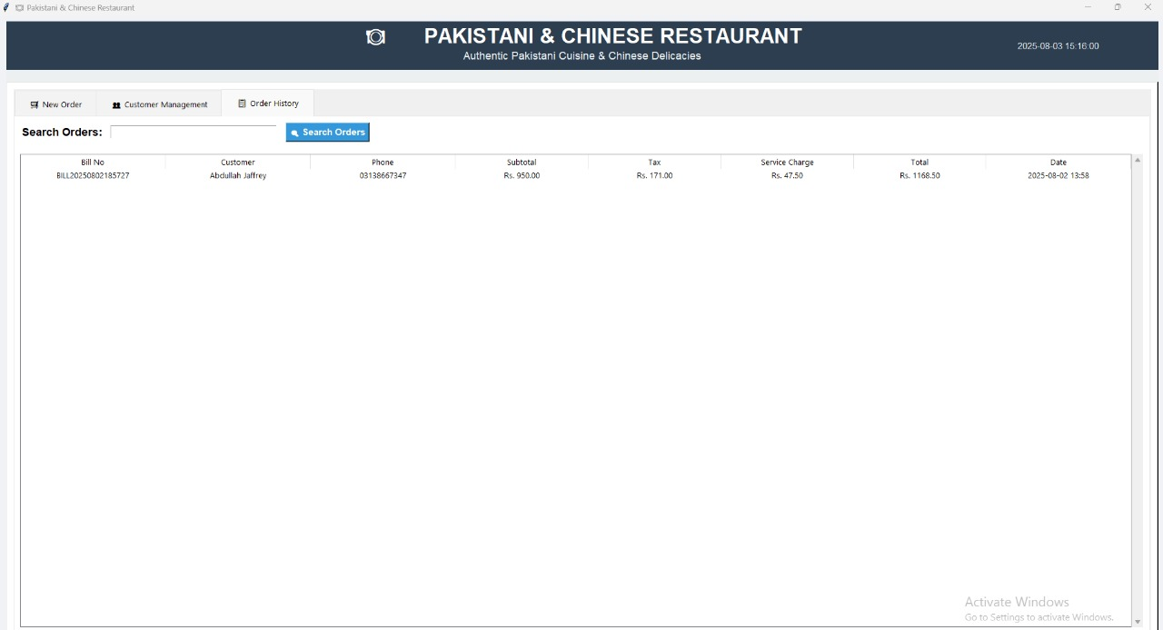

• New Order Tab with Menu Items:

Allows the user to search for customers, manage food orders by adjusting quantities, and view calculated billing amounts in real time. Tabs separate food types (Pakistani Dishes, Chinese Dishes, Beverages & Desserts). The user can also save the order and export the bill as a PDF.

