Lab 12

Task 1:

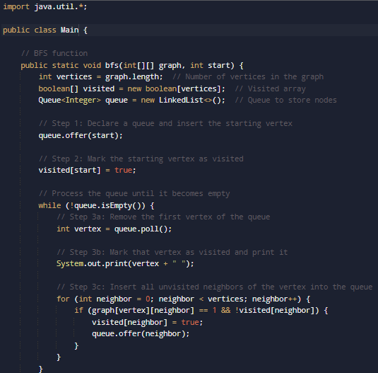

Output:



Task 2:

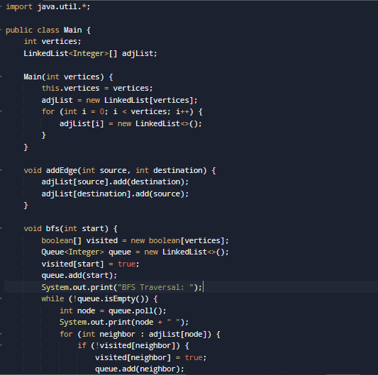

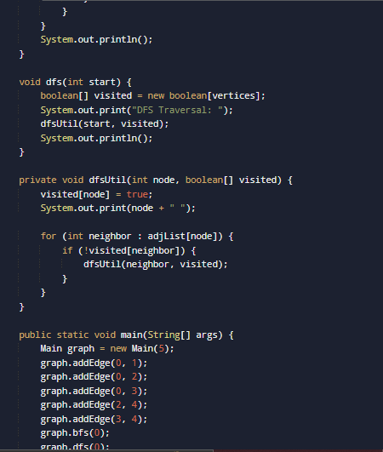

Output:

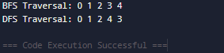

Home Task

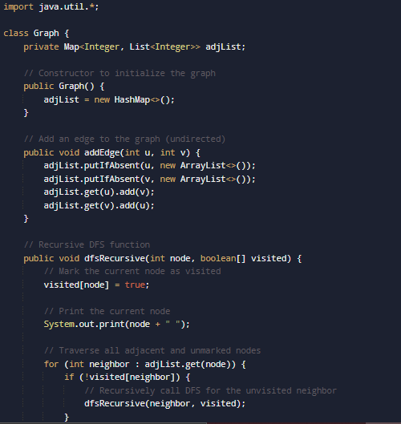

Output:

Home Task

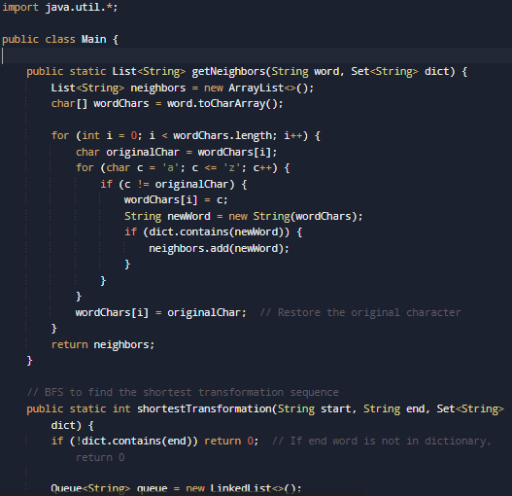

Output:

Home Task

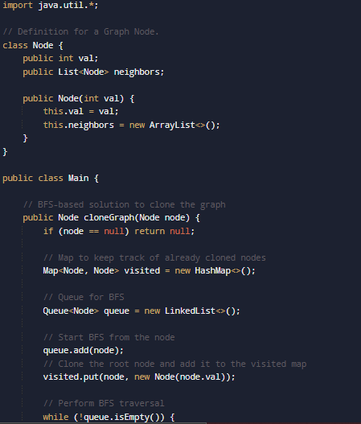

Output:

