**Lab 13**

**Task 1:**

**Output:**

**Task 2:**

**Output:**

**Task 3:**

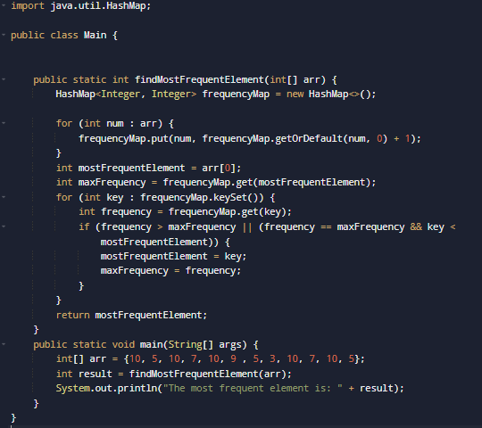

**Output:**

**Task 4:**

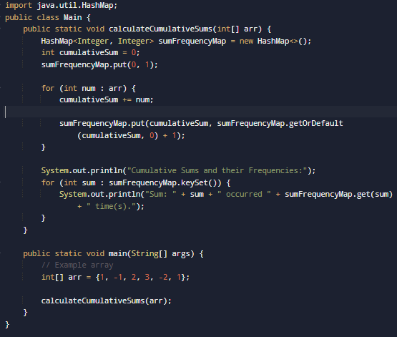

**Output:**

**Task 5:**

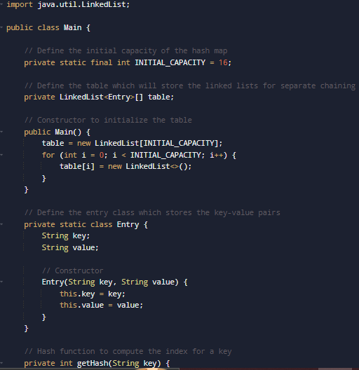

**Output:**

**HomeTask:**

**Output:**

**HomeTask:**

**Output:**

