DieBieMS

-

A manual for the (potential) user of a DieBieMS battery management system to assist with initial connections, configuration and power-up, to explain the theory of operation and to give example implementations.

-

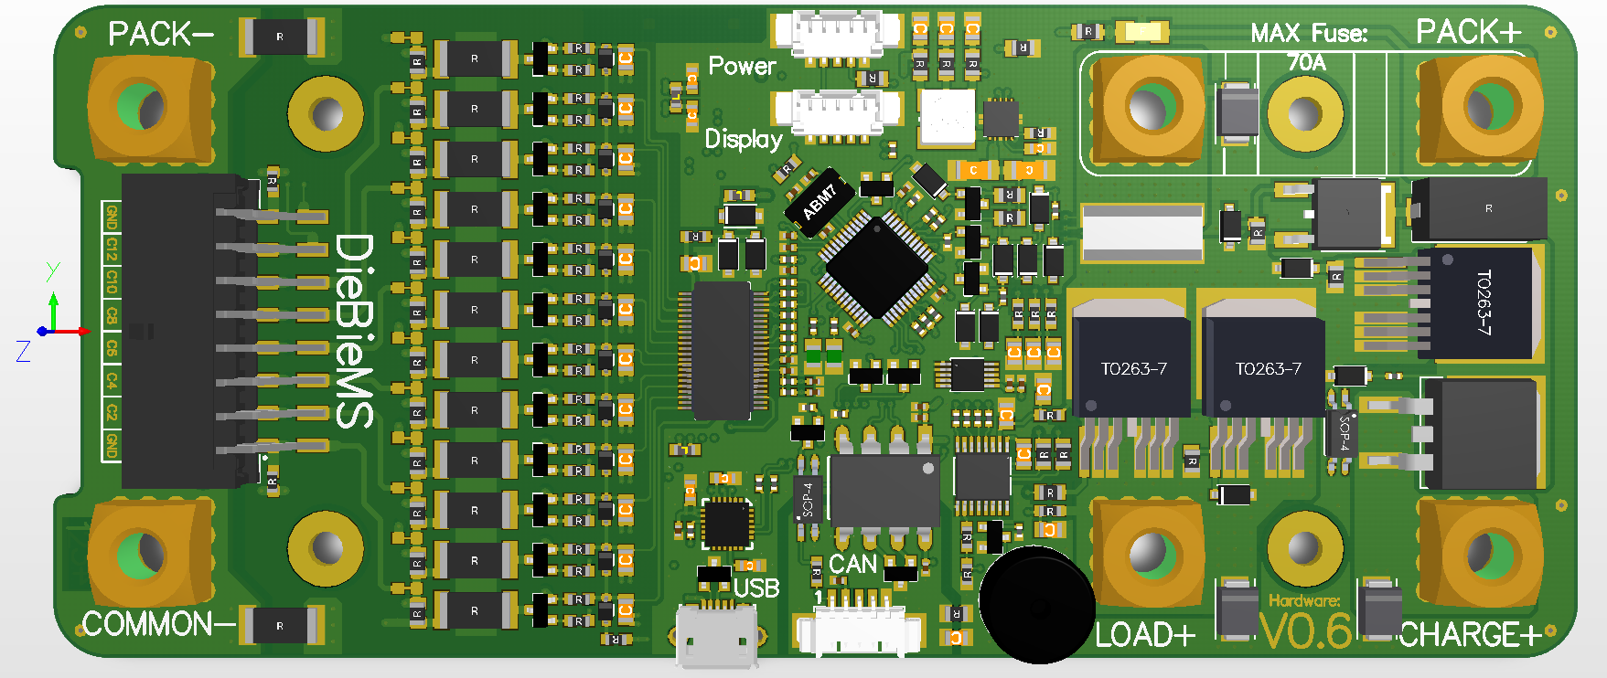- Pin-out, getting started, configuration explanation, flashing and troubleshooting - 

Author : Danny Bokma  
Document version : V0.1  
Date : 24-12-‘17

# Table of contents

Table of contents 2

Introduction 3

Interfacing 3

Pinout 3

Mechanical 3

Quick start 3

Minimal connections 3

Initial power-on 3

What’s next 3

Power states 3

Normal 3

Charging 3

USB / CAN 3

Functionalities 3

Power paths 3

Discharge 3

Charge 4

Accessories 4

Firmware 4

Bootloader 4

Application 4

Troubleshooting 4

# Introduction

-

# Interfacing

-

## Pinout

-

## Mechanical

-

# Quick start

-

## Minimal connections

-

## Initial power-on

-

## What’s next

-

# Power states

-

## Normal

-

## Charging

-

## USB / CAN

-

# Functionalities

-

## Power paths

-

### Discharge

-

### Charge

-

## Accessories

-

# Firmware

-

## Bootloader

-

## Application

-

# Troubleshooting

-