**OVMS**

**Open Vehicle Monitoring System**



[www.openvehicles.com](http://www.openvehicles.com/)

**GeoSIM**

**Guide v1.0 (23rd January 2013)**

**History**

v1.0 23rd January 2013 Initial version written

**Table of Contents**

Welcome 3

The GeoSIM 4

Advantages and Disadvantages 4

Where to Buy 4

Activating the GeoSIM 5

Provisioning your OVMS Module with GeoSIM 6

Conclusions 11

# Welcome

The OVMS (Open Vehicle Monitoring System) team is a group of enthusiasts who are developing a means to remotely communicate with our cars, and are having fun while doing it.

The OVMS module is a low-cost hardware device that you install in your car simply by installing a SIM card, connecting the module to your car’s Diagnostic port connector, and positioning a cellular antenna. Once connected, the OVMS module enables remote control and monitoring of your car.

There are two ways for you to communicate with the OVMS module:

1. Send text messages from a cell phone to the OVMS module’s phone number. The module will respond back via text messaging. If you want, the OVMS module can also send text messages to you when the car reaches certain states, such as if charging is interrupted.
2. Use a smartphone App. Both the OVMS module and the App communicate with an OVMS server via UDP/IP or TCP/IP over the Internet. The smartphone Apps provide a richer experience and more functionality, but they do require a data plan on the SIM car you purchase and install in the OVMS module.

This guide describes a cellular option for OVMS that we call GeoSIM. OVMS supports GeoSIM as a global roaming SIM card option with relatively hassle free subscription and recharge arrangements. It is will work pretty much anywhere in the world, and is a pre-paid device (you put a balance on your account, and as you use the service the balance will be deducted).

GeoSIM is available from:



<http://www.globalsimcard.co.uk/index.php?aID=202>

*Note that the OVMS project receives a small commission from globalsimcard when you purchase using that link, or use coupon code “OVMS” during checkout. We use these commissions, as well as donations, to help subsidise the free-of-charge SMS provisioning system on www.openvehicles.com that we use to configure GeoSIM modules.*

# The GeoSIM

## Advantages and Disadvantages

The advantages of using GeoSIM are that it can be used pretty much anywhere around the world for clear published charge rates, with very low monthly charges for low data usage scenarios such as OVMS. The disadvantages are that there is no local number (unless you are in UK), so SMS messages are prohibitively expensive.

You can expect to pay perhaps US$5/month for a GeoSIM data plan for OVMS.

If you can find a low-cost GSM GPRS SMS+Data plan in your own country, with reasonable data rates, cheaper than that - then that is probably preferable. GeoSIM is for those without such plans.

## Where to Buy

You purchase GeoSIM on-line at [www.globalsimcard.co.uk](http://www.globalsimcard.co.uk). The SIM to choose is the GeoSIM standard – UK number voice, SMS and data. Don’t choose the dual-number or data-only SIMs.

When purchasing, please either use the link given below, or enter “OVMS” as a coupon code during checkout, to support the Open Vehicles project.



<http://www.globalsimcard.co.uk/index.php?aID=202>

**GeoSIM Standard - UK +44 number Roams in 200+ Countries on 550+ networks.**

**Voice, SMS & Data**[**From £8.00**](http://www.globalsimcard.co.uk/catalog/index.php?cPath=16)

[All SIMs also fit iPhone4 and iPad](http://www.globalsimcard.co.uk/catalog/index.php?cPath=16)

* **+44 UK number** - Can be called from anywhere in the world
* **Roams in 200+ Countries on 550+ Networks**
* **Huge savings world wide when roaming**
* **No** roaming charges
* **Real time** billing
* **Will fit all handsets including iPhone4 & iPad**
* Additional savings calling between GeoSIMs
* **Conference calling** from handset or web interface
* **Uses existing** GSM networks
* **High quality** "Tier 1"carriers for **crystal clear** calls
* **24/7 top up** facility online or via SMS
* **No contracts, monthly charges or connection fees**
* Call **recording**
* Download **itemised call log** for expenses
* Online call records and GeoSIM account easily managed by your Admin. Staff
* Data/GPRS enabled.

We recommend that you purchase the GeoSIM, with £10.00 or £20.00 of credit to get you started. The GeoSIM will be posted to you, at typically takes a week or so to arrive.

# Activating the GeoSIM

Once you receive your GeoSIM you should activate it. This step is entirely optional, but helpful to ensure everything works as expected.

To activate GeoSIM, put it in a normal cellular telephone, and switch the phone on. Ensure there is no PIN lock on the SIM card, and choose the “Global Profile” from the list of profiles presented.

If you want, you can place a short telephone call to ensure everything works as expected.

There is a user guide for GeoSIM available here:

<http://www.globalsimcard.co.uk/catalog/docs/GeoSIM_Prepay_Global_SIM_User_Guide.pdf>

Make a note of the cellular telephone number and PIN provided with your SIM.

You can visit the “SIM Control Panel” on globalsimcard.co.uk to maintain your GeoSIM account.

**Note: Please ensure that you always keep at least US$6 balance on your GeoSIM account.**

**Without that minimum balance, your GeoSIM will not be able to establish GPRS**

**data connections.**

# Provisioning your OVMS Module with GeoSIM

Following the instructions in the OVMS installation guides, install the GeoSIM SIM card into the OVMS module, and the OVMS module into your car. Make sure that both the vehicle cable and antenna are correctly and tightly connected.

The next step is to provision your OVMS module using SMS messages. You can do this manually from any cellular phone with SMS capability, but you will incur international SMS charges which can be very expensive (perhaps US$0.50 to US$1.00 per SMS message). A much more cost-effective, and somewhat easier, method is to use the Open Vehicles SMS Provisioning system (which is what we document here).

1. Please make sure the firmware in your OVMS module is reasonably up-to-date. In particular, we highly recommend you use firmware v2.x, or at least v1.3.6. Provisioning modules with firmware v1.3.5 is expensive and should not be done with GeoSIMs. To check the version of your module firmware, the easiest way is to watch the module when you turn it on. It will blink out the firmware version as three sets of flashes with the green LED.
2. Go to [www.openvehicles.com](http://www.openvehicles.com) and login to your account. Go to “My Account”, and choose the Vehicles tab to show your vehicle records. Following the OVMS installation guides, create a vehicle record for your vehicle and enter the GeoSIM telephone number (+44…) as the telephone number of the vehicle module.
3. Click on the little SMS icon () next to your vehicle record.
4. Complete the form presented with all your details.
5. Click “SMS Provision Vehicle”. The OVMS web site will then send an SMS to your vehicle

The SMS provisioning form consists of a sequence of areas. Let’s go through each one in detail.

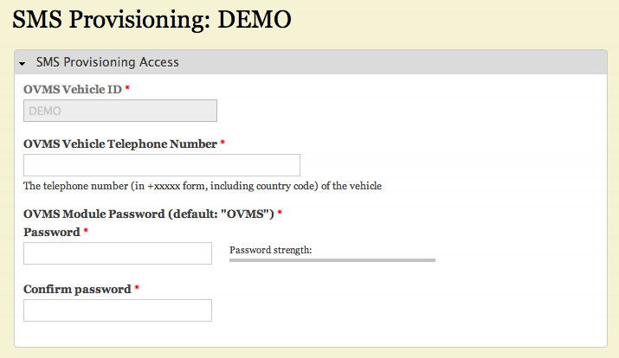

The “SMS Provisioning Access” form let’s you tell the server how to contact the vehicle module. You should enter the OVMS Vehicle Telephone Number (+44…) provided with your GeoSIM. The OVMS Module Password should be “OVMS” (unless you have changed it). Please enter the password twice, to help prevent typos.

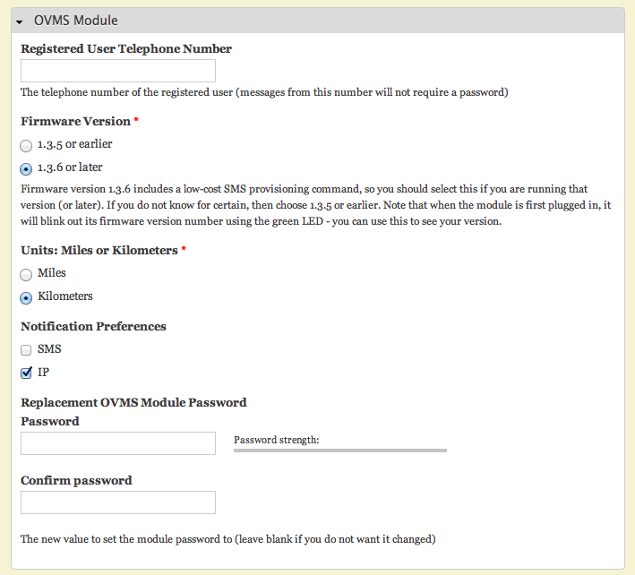

The “OVMS Module” form allows you to enter the details about the OVMS module itself. You should enter the Registered User Telephone Number (the telephone number of your cellular handset), firmware version (v1.3.6 or later), and choose between Miles/Kilometers. You should choose IP as the Notification Preference (do not choose SMS for GeoSIM). Finally, you can at this time change the OVMS module password – but we recommend against that until you have everything working perfectly.

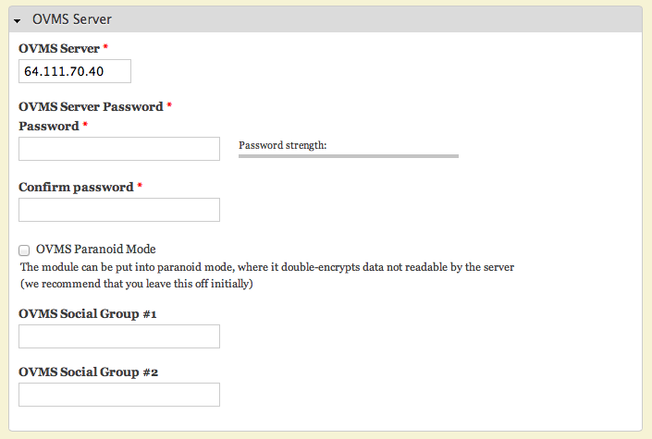

The “OVMS Server” form allows you to enter the details of how the OVMS module will connect to the OVMS server. You should enter the OVMS server IP address (the provided default 64.111.70.40 is the tmc.openvehicles.com server), the OVMS server password (that you chose and entered to be associated with your vehicle record). Please enter the server password twice to help prevent against typos.

The OVMS Paranoid Mode and Social Groups should be left off and blank respectively. You may choose to define these later, but we recommend you leave them until you have everything working perfectly.

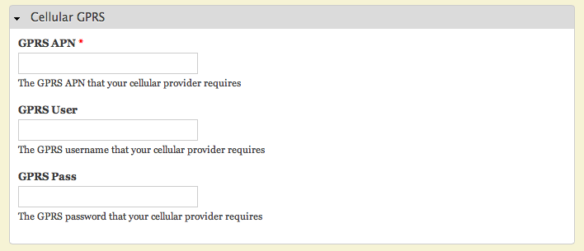

The “Cellular GPRS” form allows you to enter the details of how the module will connect to the Internet. For GeoSIM, enter “MOBILEDATA” as the GPRS APN and leave the GPRS user and password fields blank.

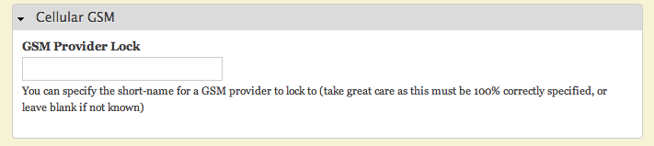

Finally, please refer to the globalsimcard.co.uk website Data Rates and Coverage page (<http://www.globalsimcard.co.uk/Data_rates.php>) to review the providers and data rates for your area. If you find one provider particularly attractive over another, you can force the module to **only** connect to that one provider by entering the provider short-name in the GSM Provider Lock field of the “Cellular GSM” form. Please take great care here, as locking to an incorrect provider can mean you won’t be able to contact the SIM card in the module any more and will have to re-flash erase the module to recover.

For US users we recommend “AT&T” as the GSM Provider Lock.

# Conclusions

Using GeoSIM and the www.openvehicles.com SMS Provision system is pretty-much fire-and-forget. There are very few diagnostic messages possible, and the system relies on the information you enter being 100% correct.

The best way to succeed with this is to triple-check everything you enter into the forms. Passwords, telephone numbers, etc. Make sure everything is 100%. The vast majority of problems reported with provisioning modules are caused by simple typos in these form fields.

You can monitor the LED blink codes on the OVMS module itself to see how the provisioning process is progressing. Please see the installation guides for further information on this.

As always, should you need help, please either ask another experienced OVMS user or eMail [support@openvehicles.com](mailto:support@openvehicles.com).