**Name: Abdullah**

Abdullah (FA22-BSE-022)

[Company name]  [Company address]

sodtware design and architecture

**Reg no: FA22-BSE-022**

**Use Case Diagram:**

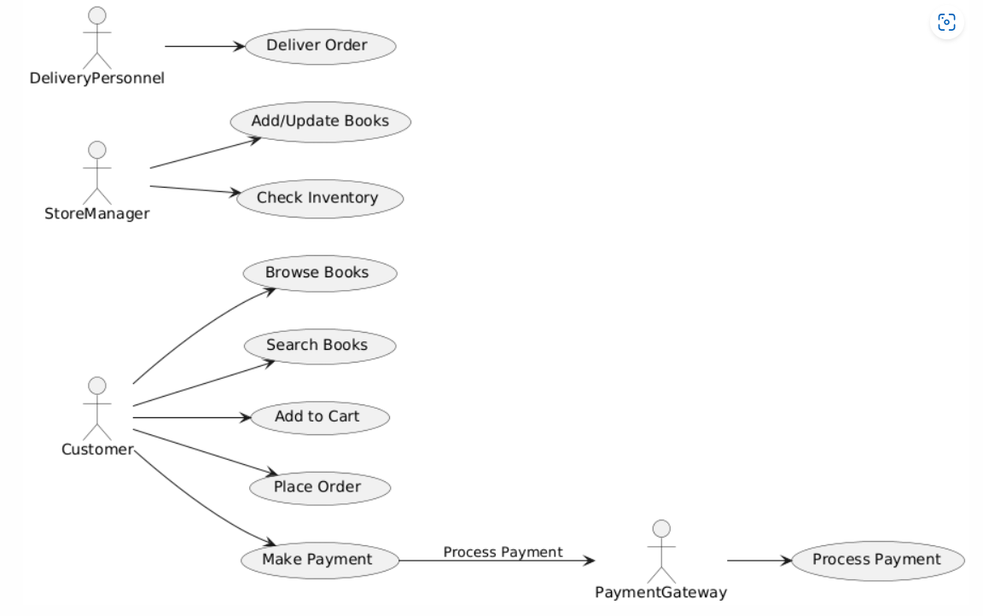**Full Dressed Use case:**

**System Sequenced Diagram:**

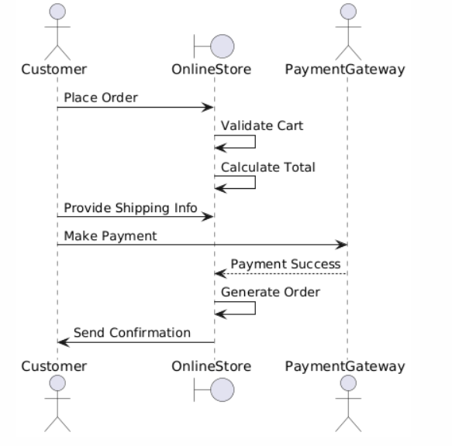

**Class Diagram:**

**Communication Diagram:**

