Name-surname: Abdullah KASRI
Specialization: Data science
E-mail: abdullah00kasri@gmail.com
Country: Turkey
Internship batch: LISUM03
Project: Healthcare - Persistency of a drug

In this project, I’ve tried to seek out the hidden patterns within the dataset provided in order to better understand the persistency of the drugs made by ABC pharmaceuticals.
Let me start by first sharing the plots and results concluded, and then to emphasize about them.
- ROC curve;
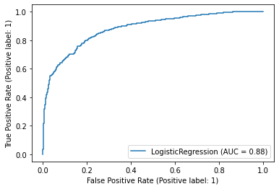

We can see that the drug’s persistency has performed quite well, scoring 88% at the AUC.
- Recall curve;
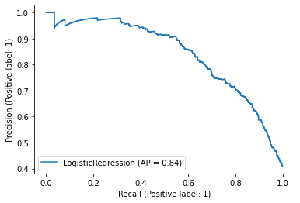
And as for the Precision-Recall curve, we notice that precision falls as the model progresses, raising the recall to a modest 84%

- Confusion matrix;
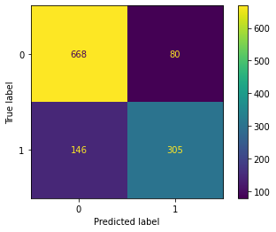

This matrix is demonstrating to us that the vast majority of cases (668), have performed well while the model was trying predict the correlations and also found some cases that didn’t perform as well (305) as expected.
But don’t worry, we’ll be looking at this issue in the next page.

Classification Report;
Log loss = 0.41435
AUC = 0.87972
Average Precision = 0.83605

Using 0.5 as threshold:
Accuracy = 0.81022
Precision = 0.79630
Recall = 0.66667
F1 score = 0.72574

 | Precision | Recall | F1-Score | Support
Non-Persistent | 0.82 | 0.9 | 0.85 | 427
persistent | 0.8 | 0.67 | 0.73 | 258
Accuracy | - | - | 0.81 | 685
Macro mean | 0.81 | 0.78 | 0.79 | 685
Weighted mean | 0.81 | 0.81 | 0.81 | 685

And also, I’ve prepared some visualization for you to check out…

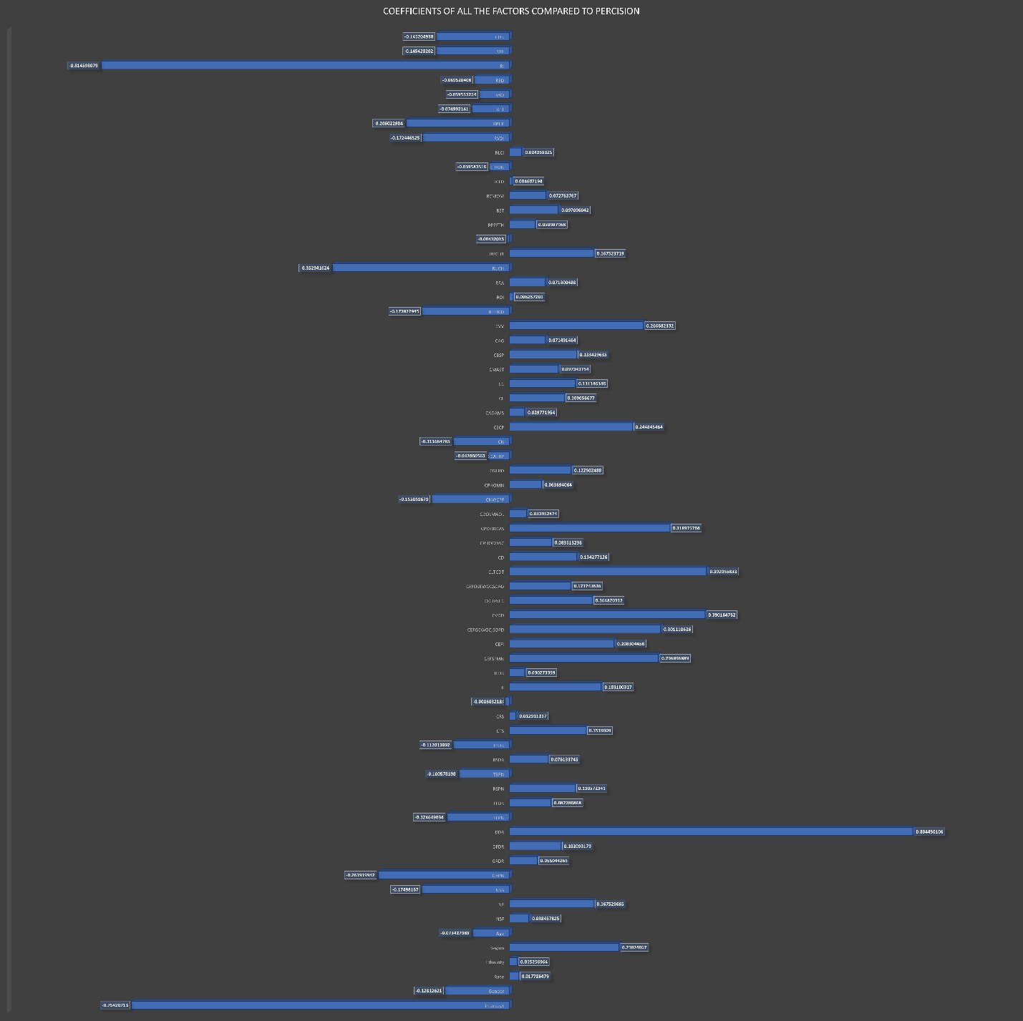
Reflects the correlation coefficients of all the variables versus the persistency
Region has had a somewhat positive impact on the implementation of the drug.
Meanwhile, age affected the drug’s efficiency negatively, meaning that as age increases, the drug’s performance might be impacted.
Also, we see that the Glucose levels have soared after intake of the drug compared to before.
Sadly though, this bar graph is telling us that the risk factor rose unexpectedly, another indicator to confirm this is the falling T-Score
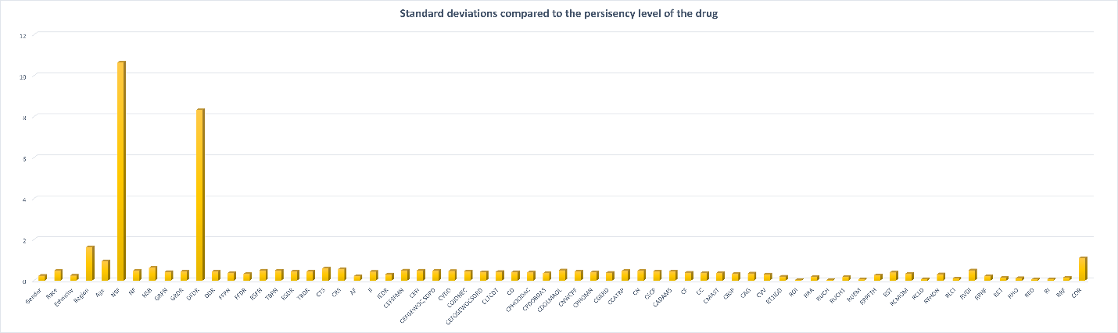
And this graph represents the standard deviation of all the factors versus persistency.
We obviously, see that also, variables like; Age & region have some impact on the efficiency of the drug.
But more importantly, data about the patient’s medical history has played a huge role in determining the success rate of the drug. So, for example, people with problems related to Osteoporosis, joint disorders or even metabolism have performed poorly on this machine learning model.
Similarly, patients who are suffering from deficiencies of essential things like glucose and fructose have also shown less response to the drug implemented.
Note: The data for these two graphs will be provided on my GitHub.

This was a hopefully good explanation of the main key points that I wanted to shed a light on.
More technical stuff is available in my EDA.

Thanks for reading

