
UIT University
Department of Software Engineering
& Technology
FALL-2026

ASSIGNMENT#01

Advanced Web Engineering

(SED312)
AbdullahMohsin
Name of Student : ______________________________________
23FA-048-ST
Roll Number : ___________________________________
A
Section : ______________________________________
^{7th}
Semester : ______________________________________

Instructor : Fizzah Sohail

Question
Develop a small React-based Campus Task Board application to demonstrate your understanding and practical implementation of fundamental React concepts.
Complete all of the following requirements:
1. Create and Display Tasks — 2 Marks
- Create a list of at least 3 tasks.
- Store the tasks using useState.
- Each task should contain:
  - id
  - title
  - category
- Display all tasks using the .map() method.
- Assign a unique key to every task.

- Creating React Project
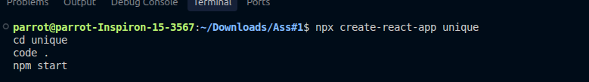
- Create list of tasks
import { useState } from "react";
function App() {
const [tasks, setTasks] = useState([
{
id: 1,
title: "Complete University Assignment",
category: "University",
},
{
id: 2,
title: "Study UV-Vis Spectroscopy",
category: "Study",
},
{
id: 3,
title: "Study for Neurobiology Exam",
category: "Class",
},
]);

console.log("Tasks:", tasks);

return (
<div>
<h1>University Tasks Assigned</h1>

{tasks.map((task) => (
<div key={task.id}>
<h3>{task.title}</h3>
<p>Category: {task.category}</p>
</div>
))}
</div>
);
}
export default App;

OUTPUT
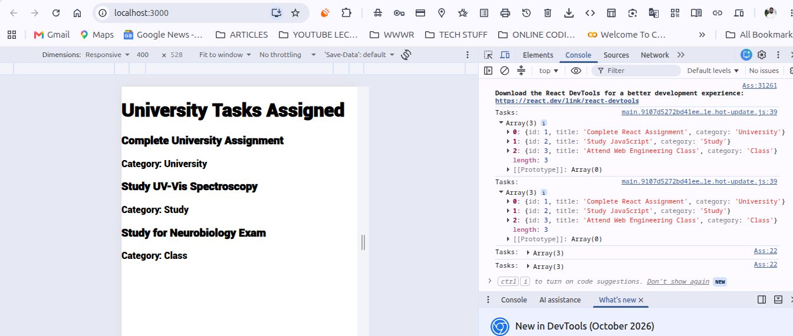

2. Create a Reusable Component — 2 Marks
- Create a separate TaskCard component.
- Display each task inside the TaskCard.
- Pass the task information from the parent component to TaskCard using props.
- Display at least the task title and category.

- Adding Components
1.box.jsx
function TaskCard({ task }) {
console.log("TaskCard:", task);

return (
<div>
<h3>{task.title}</h3>
<p>Category: {task.category}</p>
</div>
);
}

export default TaskCard;

2.App.jsx
import { useState } from "react";
import TaskCard from "./box";
function App() {
const [tasks, setTasks] = useState([
{
id: 1,
title: "Complete University Assignment",
category: "University",
},
{
id: 2,
title: "Study UV-Vis Spectroscopy",
category: "Study",
},
{
id: 3,
title: "Study for Neurobiology Exam",
category: "Class",
},
]);

console.log("Tasks:", tasks);

return (
<div>
<h1>University Tasks Assigned</h1>

{tasks.map((task) => (
<div key={task.id}>
<h3>{task.title}</h3>
<p>Category: {task.category}</p>
</div>
))}
</div>
);
}
export default App;

OUTPUT:
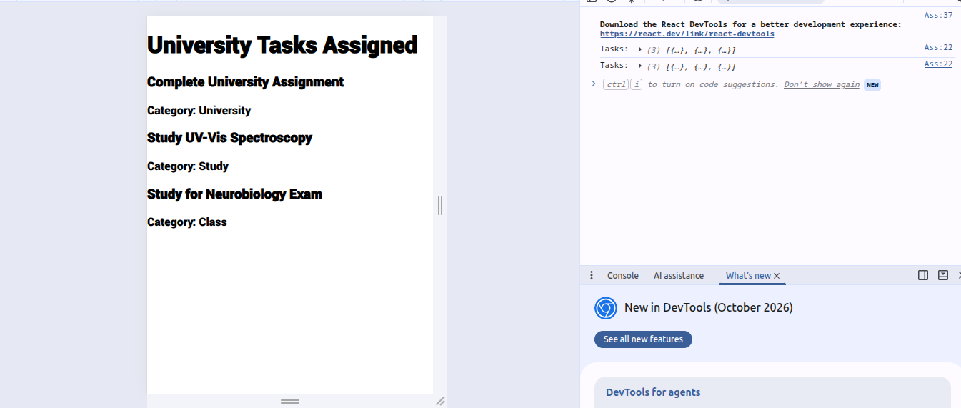

3. Add a New Task — 2 Marks
- Create an input field where the user can enter a task.
- Add an "Add Task" button.
- Use an appropriate event handler such as onClick or onSubmit.
- When the user adds a task, update the task list using useState.
- The newly added task should appear on the screen without refreshing the page.
App.jsx:
import { useState } from "react";
import TaskCard from "./box";
function App() {
const [tasks, setTasks] = useState([
{
id: 1,
title: "Complete University Assignment",
category: "University",
},
{
id: 2,
title: "Study UV-Vis Spectroscopy",
category: "Study",
},
{
id: 3,
title: "Study for Neurobiology Exam",
category: "Class",
},
]);

const [taskName, setTaskName] = useState("");

function addTask() {
console.log("Button clicked");
console.log("Task entered:", taskName);

const newTask = {
id: tasks.length + 1,
title: taskName,
category: "General",
};

setTasks([...tasks, newTask]);
setTaskName("");

console.log("New task added");
}

return (
<div>
<h1>University Task Board</h1>

<input
type="text"
placeholder="Write your task"
value={taskName}
onChange={(e) => setTaskName(e.target.value)}
/>

<button onClick={addTask}>
Add Task
</button>

{tasks.map((task) => (
<TaskCard key={task.id} task={task} />
))}
</div>
);
}

export default App;

Output:
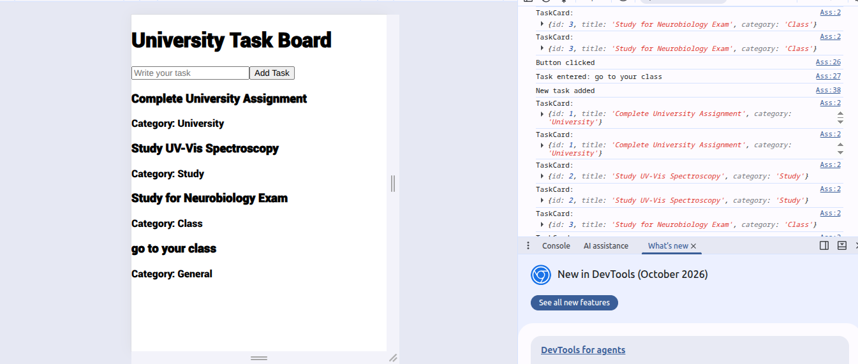
4. Use useEffect — 2 Marks
- Use useEffect in the application.
- The effect should run whenever the task list changes.
- Display the following information in the browser console:
  - "Task list updated!"
  - Total number of tasks.

App.jsx:
import { useState, useEffect } from "react";

function App() {
const [tasks, setTasks] = useState([
{
id: 1,
title: "Complete Assignment",
category: "University",
},
{
id: 2,
title: "Study React",
category: "Study",
},
{
id: 3,
title: "Attend Class",
category: "Class",
},
]);

// Task #4: useEffect
useEffect(() => {
console.log("Task list updated!");
console.log("Total number of tasks:", tasks.length);
}, [tasks]);

// Add a new task
function addTask() {
console.log("Add Task button clicked");

const newTask = {
id: tasks.length + 1,
title: "New University Task",
category: "General",
};

setTasks([...tasks, newTask]);

console.log("New task added");
}

return (
<div>
<h1>University Task Board</h1>

<h2>Total Tasks: {tasks.length}</h2>

<button onClick={addTask}>
Add Task
</button>

{tasks.map((task) => (
<div key={task.id}>
<h3>{task.title}</h3>
<p>Category: {task.category}</p>
</div>
))}
</div>
);
}
export default App;

OUTPUT:
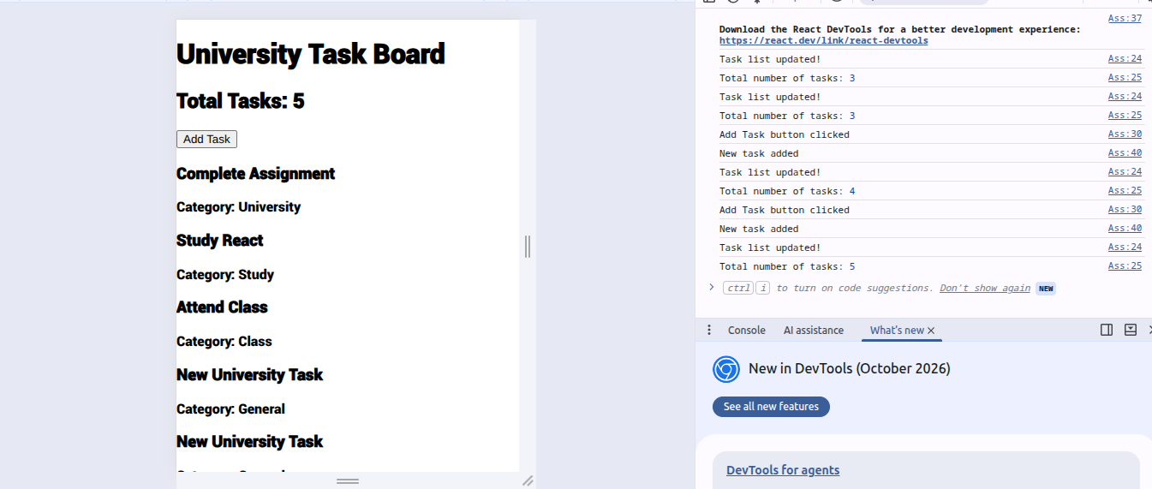

5. Git & GitHub Submission — 2 Marks
- Initialize a Git repository for your project.
- Add and commit your project files.
- Create a GitHub repository and push your project.
- Use appropriate Git commands such as:
git init
git add .
git commit -m "Create Campus Task Board"
git branch -M main
git remote add origin YOUR_GITHUB_REPOSITORY_URL
git push -u origin main



