**"PROJECT-TITLE: FARMING-MANAGEMENT SYSTEM"“**

**“ER-DIAGRAM UML WITH BUSINESS RULES”**

* **REPORT:**
* **INTRODUCTION:**

We are creating this database in order to manage data of farmer. It is a mini project with some tables. Here in this figure of ER-diagram, we just use 9 tables which includes for relationship you can see in this figure.

* **BUSINESS-RULE:**

1. **Farmers and Farms:**

* Each farmer can manage one or more farms.
* Each farm is managed by exactly one farmer.

1. **Farmer and Fields:**

* Each farmer having one or more fields.
* Each field belongs to exactly one farmer.

1. **Fields and Crops:**

* Each field is associated with one crop at a time.
* Each crop grows in one field.

1. **Fields and Fertilizers:**

* Each field uses multiple fertilizer.
* Each fertilizer analysis is associated with exactly one field.

1. **Fields and Irrigation Schedules:**

* Each field having one or more irrigation schedules.
* Each irrigation schedule is associated with exactly one field.

1. **Crops and Harvest Records:**

* Each crop having one or more harvest records.
* Each harvest record belongs to exactly one crop.

1. **Farmers and Financial Transactions:**

* Each financial transaction is linked to one and only one farmer.
* Each farmer can have multiple financial transactions.

1. **Farmers and Input Inventory:**

* One farmer manages one input inventory items.
* One inventory item belongs one and only one farmer.

1. **Farm and Fields:**

* One farm has many fields
* One fields belong to one and only one farm

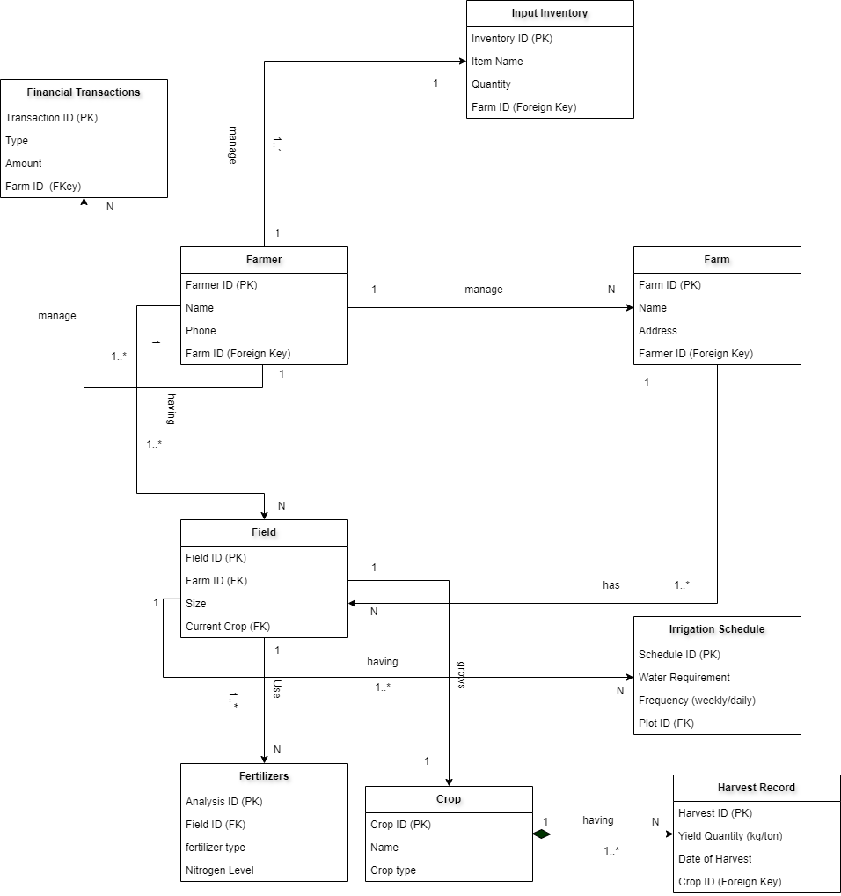

Fig: ER-Diagram

FF

**RELATIONAL DATABASE TABLES**

**1.FARMER TABLE:**

|  |  |  |
| --- | --- | --- |
| **FARMER_ID(PK)** | **NAME** | **PHONE** |
| 1 | Ahmed Ali | 1234567890 |
| 2 | Abdullah Mohsin | 1234567890 |
| 3 | Arish Khan | 1234567890 |
| 4 | Faheem Abbas | 1234567890 |
| 5 | Raman Soquel | 1234567890 |

**2.FARM TABLE:**

|  |  |  |  |
| --- | --- | --- | --- |
| **FARM_ID(PK)** | **NAME** | **ADDRESS** | **FARMER_ID(FK)** |
| 1 | Sunny Farm | 123 Green Road | 3 |
| 2 | Green Valley Farm | 45 Canal View | 4 |
| 3 | Pakistani Orchard | 78 Mango Street | 3 |
| 4 | Golden Wheat Fields | 12 Lahore Avenue | 4 |
| 5 | Golden Wheat Fields | 90 Karachi Road | 2 |

**3.INPUT INVENTORY TABLE:**

|  |  |  |  |
| --- | --- | --- | --- |
| **INVENTORY_ID(PK)** | **ITEM_NAME** | **QUANTITY** | **FARMER_ID(FK)** |
| 1 | Wheat Seeds | 500 | 3 |
| 2 | Fertilizer | 300 | 2 |
| 3 | Pesticides | 150 | 2 |
| 4 | Tractor Fuel | 200 | 3 |
| 5 | Irrigation Pipes | 50 | 4 |

**4.FIELD TABLE:**

|  |  |  |  |  |
| --- | --- | --- | --- | --- |
| **FIELD_ID(PK)** | **FARMER_ID(FK)** | **SIZE** | **FARM_ID(FK)** | **CROP_ID(FK)** |
| 1 | 2 | 10.50 | 3 | 3 |
| 2 | 4 | 15.00 | 4 | 4 |
| 3 | 3 | 8.25 | 2 | 2 |
| 4 | 5 | 12.00 | 4 | 4 |
| 5 | 5 | 20.00 | 3 | 3 |

**5.FINANCIAL TRANSACTIONS TABLE:**

|  |  |  |  |
| --- | --- | --- | --- |
| **TRANSACTION_ID(PK)** | **TYPE** | **AMOUNT** | **FARM_ID(FK)** |
| 1 | Crop Sale | 1500.00 | 5 |
| 2 | Fertilizer Purchase | 2500 | 2 |
| 3 | Seed Purchase | 4300 | 5 |
| 4 | Equipment Maintenance | 1200 | 2 |
| 5 | Milk Sale | 1000 | 4 |

**6.IRRIGATION SCHEDULE TABLE:**

|  |  |  |  |
| --- | --- | --- | --- |
| **SCHEDULE_ID** | **WATER_REQUIREMENT** | **FREQUENCY(WEEKLY/DAILY)** | **FIELD__ID(FK)** |
| 1 | 500.00 | Weekly | 2 |
| 2 | 300.00 | Bi-Weekly | 2 |
| 3 | 600.00 | Monthly | 4 |
| 4 | 700.00 | Weekly | 5 |
| 5 | 250.00 | Weekly | 4 |

**7.FERTILIZERS TABLE:**

|  |  |  |  |
| --- | --- | --- | --- |
| **ANALYSIS_ID(PK)** | **FIELD_ID(FK)** | **FERTILIZER_TYPE** | **FERTILIZER _LEVEL** |
| 1 | 2 | Nitrogen | 12.50 |
| 2 | 2 | Phosphorus | 15.00 |
| 3 | 3 | Potassium | 10.00 |
| 4 | 4 | Organic Compost | 8.00 |
| 5 | 5 | Micronutrients Mix | 20.00 |
| 6 | 3 | Organic Compost | 13.98 |
| 7 | 5 | Micronutrients Mix | 15.67 |
| 8 | 1 | Organic Compost | 13.91 |
| 9 | 4 | Nitrogen | 17.89 |
| 10 | 1 | Micronutrients Mix | 14.56 |

**8.CROP TABLE:**

|  |  |  |
| --- | --- | --- |
| **CROP_ID(PK)** | **NAME** | **CROP_TYPE** |
| 1 | Wheat | Grain |
| 2 | Rice | Grain |
| 3 | Cotton | Fiber |
| 4 | Sugarcane | Cash Crop |
| 5 | Mango | Fruit |

**9.HARVEST RECORD TABLE:**

|  |  |  |  |
| --- | --- | --- | --- |
| **HARVEST_ID(PK)** | **YIELD QUANTITY(Kg/Ton)** | **DATE OF HARVEST** | **CROP_ID(FK)** |
| 1 | 2000.00 | 2024-12-15 | 4 |
| 2 | 3500.00 | 2024-11-30 | 4 |
| 3 | 2500.00 | 2024-10-20 | 5 |
| 4 | 4000.00 | 2024-12-01 | 3 |
| 5 | 1500.00 | 2024-07-15 | 3 |

**PROJECT-TITLE:” FARMING MANAGEMENT SYSTEM”**

**SQL QUERIES IN FARMING MANAGEMENT SYSTEM**

1. **CREATE TABLES:**

**a) FARMER TABLE:**

CREATE TABLE FARMER (

FARMER_ID INT PRIMARY KEY,

FARMER_NAME VARCHAR (100),

FARMER_PHONE_NUMBER VARCHAR (15));

**b) FARM TABLE:**

CREATE TABLE FARM (

FARM_ID INT PRIMARY KEY,

FARM_NAME VARCHAR (100),

FARM_ADDRESS VARCHAR (100),

FARMER_ID INT,

FOREIGN KEY (FARMER_ID) REFERENCES FARMER(FARMER_ID));

**c) INPUT INVENTORY TABLE:**

CREATE TABLE INPUT_INVENTORY (

INVENTORY_ID INT PRIMARY KEY,

ITEM_NAME VARCHAR (255),

QUANTITY INT,

FARMER_ID INT,

FOREIGN KEY (FARMER_ID) REFERENCES FARMER(FARMER_ID));

**d) FINANCIAL TRANSACTIONS TABLE:**

CREATE TABLE FINANCIAL_TRANSACTIONS (

TRANSACTION_ID INT PRIMARY KEY,

TYPE_OF_AMOUNT VARCHAR (255),

AMOUNT DECIMAL (15, 2),

FARMER_ID INT,

FOREIGN KEY (FARMER_ID) REFERENCES FARMER(FARMER_ID));

**e) CROP TABLE:**

CREATE TABLE CROP (

CROP_ID INT PRIMARY KEY,

NAME VARCHAR (255),

CROP_TYPE VARCHAR (255));

**f) FARMING FIELD TABLE:**

CREATE TABLE FARMING_FIELD (

FIELD_ID INT PRIMARY KEY,

FARMER_ID INT,

FIELD_SIZE DECIMAL (10, 2),

CROP INT,

FARM_ID INT,

FOREIGN KEY (FIELD_ID) REFERENCES FARMING_FIELD(FIELD_ID));

FOREIGN KEY (FARMER_ID) REFERENCES FARMER(FARMER_ID),

FOREIGN KEY (CROP_ID) REFERENCES CROP(CROP_ID)),

FOREIGN KEY (FARM_ID) REFERENCES FARM(FARM_ID));

**g) FERTILIZERS TABLE:**

CREATE TABLE FERTILIZERS (

ANALYSIS_ID INT PRIMARY KEY,

FIELD_ID INT,

FERTILIZER_TYPE VARCHAR (255),

FERTILIZER_LEVEL DECIMAL (5, 2),

FOREIGN KEY (FIELD_ID) REFERENCES FARMING_FIELD(FIELD_ID));

**h) IRRIGATION SCHEDULE TABLE:**

CREATE TABLE IRRIGATION_SCHEDULE (

SCHEDULE_ID INT PRIMARY KEY,

WATER_REQUIREMENT DECIMAL (10, 2),

FREQUENCY VARCHAR (50),

FOREIGN KEY (FIELD_ID) REFERENCES FARMING_FIELD(FIELD_ID)

);

**i)HARVEST RECORD TABLE:**

CREATE TABLE HARVEST_RECORD (

HARVEST_ID INT PRIMARY KEY,

YIELD_QUANTITY DECIMAL (10, 2),

DATE_OF_HARVEST DATE,

CROP_ID INT,

FOREIGN KEY (CROP_ID) REFERENCES CROP(CROP_ID)

);

1. **INSERT DATA IN TABLES:**

**a) FARMER TABLE:**

INSERT INTO FARMER VALUES (1, 'Ahmed Ali', '1234567890');

INSERT INTO FARMER VALUES (2, 'Abdullah Mohsin', '1234567890');

INSERT INTO FARMER VALUES (3, 'Arish Khan', '1234567890');

INSERT INTO FARMER VALUES (4, 'Faheem Abbas', '1234567890');

INSERT INTO FARMER VALUES (5, 'Raman Soquel', '1234567890');

**b) FARM TABLE:**

INSERT INTO FARM VALUES (1, 'Sunny Farm', '123 Green Road',3);

INSERT INTO FARM VALUES (2, 'Green Valley Farm', '45 Canal View', 4);

INSERT INTO FARM VALUES (3, 'Pakistani Orchard', '78 Mango Street', 3);

INSERT INTO FARM VALUES (4, 'Golden Wheat Fields', '12 Lahore Avenue', 4);

INSERT INTO FARM VALUES (5, 'Sindh Dairy Farm', '90 Karachi Road', 2);

**c) INPUT INVENTORY TABLE:**

INSERT INTO INPUT_INVENTORY VALUES (1, 'Wheat Seeds', 500, 3);

INSERT INTO INPUT_INVENTORY VALUES (2, 'Fertilizer (Urea)', 300, 2);

INSERT INTO INPUT_INVENTORY VALUES (3, 'Pesticides', 150, 2);

INSERT INTO INPUT_INVENTORY VALUES (4, 'Tractor Fuel', 200, 3);

INSERT INTO INPUT_INVENTORY VALUES (5, 'Irrigation Pipes', 50, 4);

**d) FINANCIAL TRANSACTIONS TABLE:**

INSERT INTO FINANCIAL_TRANSACTIONS VALUES (1, 'Crop Sale', 1500.00, 5);

INSERT INTO FINANCIAL_TRANSACTIONS VALUES (2, 'Fertilizer Purchase', 2500, 2);

INSERT INTO FINANCIAL_TRANSACTIONS VALUES (3, 'Seed Purchase', 4300, 5);

INSERT INTO FINANCIAL_TRANSACTIONS VALUES (4, 'Equipment Maintenance', 1200, 2);

INSERT INTO FINANCIAL_TRANSACTIONS VALUES (5, 'Milk Sale', 1000, 4);

**e) CROP TABLE:**

INSERT INTO CROP VALUES (1, 'Wheat', 'Grain');

INSERT INTO CROP VALUES (2, 'Rice', 'Grain');

INSERT INTO CROP VALUES (3, 'Cotton', 'Fiber');

INSERT INTO CROP VALUES (4, 'Sugarcane', 'Cash Crop');

INSERT INTO CROP VALUES (5, 'Mango', 'Fruit');

**f) FARMING FIELD:**

INSERT INTO FARMING_FIELD VALUES (1, 1, 10.50, 3,3);

INSERT INTO FARMING_FIELD VALUES (2, 2, 15.00, 4,4);

INSERT INTO FARMING_FIELD VALUES (3, 3, 8.25, 2,2);

INSERT INTO FARMING_FIELD VALUES (4, 4, 12.00, 4,4);

INSERT INTO FARMING_FIELD VALUES (5, 5, 20.00, 3,3);

**g) FERTILIZERS:**

INSERT INTO FERTILIZERS VALUES (1, 2, 'Nitrogen', 12.50);

INSERT INTO FERTILIZERS VALUES (2, 2, 'Phosphorus', 15.00);

INSERT INTO FERTILIZERS VALUES (3, 3, 'Potassium', 10.00);

INSERT INTO FERTILIZERS VALUES (4, 4, 'Organic Compost', 8.00);

INSERT INTO FERTILIZERS VALUES (5, 5, 'Micronutrients Mix', 20.00);

INSERT INTO FERTILIZERS VALUES (6, 3, 'Organic Compost’, 20.00);

INSERT INTO FERTILIZERS VALUES (7, 5, 'Micronutrients Mix', 20.00);

INSERT INTO FERTILIZERS VALUES (8, 1, 'Organic Compost’, 20.00);

INSERT INTO FERTILIZERS VALUES (9, 4, 'Nitrogen', 20.00);

INSERT INTO FERTILIZERS VALUES (10, 1, 'Micronutrients Mix', 20.00);

**h) IRRIGATION SCHEDULE**

INSERT INTO IRRIGATION_SCHEDULE VALUES (1, 500.00, 'Weekly', 2);

INSERT INTO IRRIGATION_SCHEDULE VALUES (2, 300.00, 'Bi-Weekly', 2);

INSERT INTO IRRIGATION_SCHEDULE VALUES (3, 600.00, 'Monthly', 4);

INSERT INTO IRRIGATION_SCHEDULE VALUES (4, 700.00, 'Weekly', 5);

INSERT INTO IRRIGATION_SCHEDULE VALUES (5, 250.00, 'Bi-Weekly', 4);

**i) HARVEST RECORD**

INSERT INTO HARVEST_RECORD VALUES (1, 2000.00, '2024-12-15', 4);

INSERT INTO HARVEST_RECORD VALUES (2, 3500.00, '2024-11-30', 4);

INSERT INTO HARVEST_RECORD VALUES (3, 2500.00, '2024-10-20', 5);

INSERT INTO HARVEST_RECORD VALUES (4, 4000.00, '2024-12-01', 3);

INSERT INTO HARVEST_RECORD VALUES (5, 1500.00, '2024-07-15', 3);

1. **DISPLAY TABLES:**

**1. Display FARMER Table**

SELECT * FROM FARMER;

**2. Display FARM Table**

SELECT * FROM FARM;

**3. Display INPUT_INVENTORY Table**

SELECT * FROM INPUT_INVENTORY;

**4. Display FINANCIAL_TRANSACTIONS Table**

SELECT * FROM FINANCIAL_TRANSACTIONS;

**5. Display CROP Table**

SELECT * FROM CROP;

**6. Display FARMING_FIELD Table**

SELECT * FROM FARMING_FIELD;

**7. Display FERTILIZERS Table**

SELECT * FROM FERTILIZERS;

**8. Display IRRIGATION_SCHEDULE Table**

SELECT * FROM IRRIGATION_SCHEDULE;

**9. Display HARVEST_RECORD Table**

SELECT * FROM HARVEST_RECORD;