**Assessment**

**Task 1: Splash Screen with Welcome Message**

**Objective:**

Design and implement a Splash Screen in Flutter.

Display a welcome message dynamically.

Task: Develop an Animated Splash Screen

Create a Splash Screen that:

✅ Displays an app logo.

✅ Shows a welcome message.

✅ Automatically navigates to the Main Screen after 4 seconds.

✅ Provides a personal introduction on the second screen.

**MAIN.DART:**

|  |
| --- |
| **import 'package:flutter/material.dart';**  **import 'dart:async';**  **void main() {**  **runApp(MyApp());}**  **class MyApp extends StatelessWidget {**  **@override**  **Widget build(BuildContext context) {**  **return MaterialApp(**  **title: 'Splash Screen Demo',**  **debugShowCheckedModeBanner: false,**  **home: SplashScreen(), );}}**  **class SplashScreen extends StatefulWidget {**  **@override**  **_SplashScreenState createState() => _SplashScreenState();}**  **class _SplashScreenState extends State<SplashScreen>**  **with SingleTickerProviderStateMixin {**  **late AnimationController _controller;**  **late Animation<double> _fadeAnimation;**  **@override**  **void initState() {**  **super.initState();**  **_controller =**  **AnimationController(vsync: this, duration: Duration(seconds: 2));**  **_fadeAnimation = Tween<double>(begin: 0, end: 1).animate(_controller);**  **_controller.forward();**  **Timer(Duration(seconds: 4), () {**  **Navigator.of(context).pushReplacement(**  **MaterialPageRoute(builder: (_) => MainScreen()), );});}**  **@override**  **void dispose() {**  **_controller.dispose();**  **super.dispose();}**  **@override**  **Widget build(BuildContext context) {**  **return Scaffold(**  **backgroundColor: Colors.blueAccent,**  **body: Center(**  **child: FadeTransition(**  **opacity: _fadeAnimation,**  **child: Column(**  **mainAxisSize: MainAxisSize.min,**  **children: [**  **Icon(Icons.flutter_dash, size: 100, color: Colors.white),**  **SizedBox(height: 20),**  **Text(**  **'Welcome to My Awesome App!',**  **style: TextStyle(fontSize: 22, color: Colors.white), ),],),),),); }}**  **// Main screen with personal introduction**  **class MainScreen extends StatelessWidget {**  **@override**  **Widget build(BuildContext context) {**  **return Scaffold(**  **appBar: AppBar(title: Text('Main Screen')),**  **body: Center(**  **child: Text(**  **'Hi, I’m AbdullahMohsin.\nI’m a Flutter Developer!',**  **textAlign: TextAlign.center,**  **style: TextStyle(fontSize: 24), ),),); }}** |

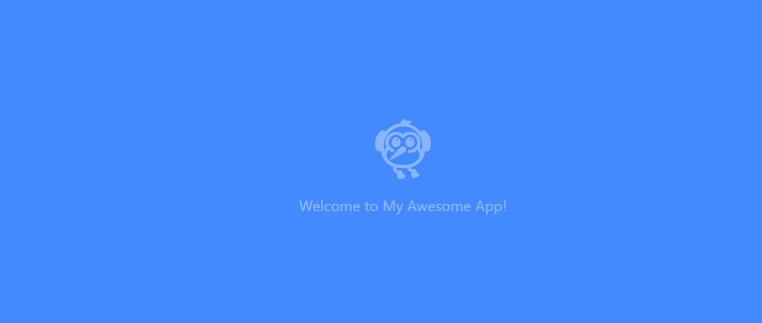**OUTPUT:**

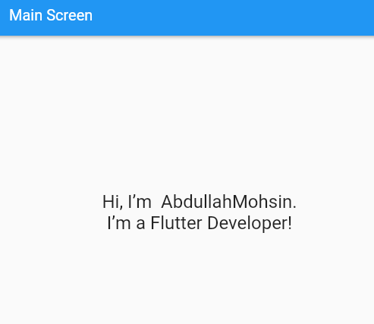 

**Task 2:**

Create a simple Flutter app that demonstrates passing data between two screens. The app should have a form on the first screen where users can enter their name and age. Upon submitting, it should navigate to the second screen and display a personalized message with the entered details.

**Requirements**

1. Screen 1 - InputScreen

* A TextField for the user’s name.
* A TextField for the user’s age.
* A RaisedButton or ElevatedButton to submit and navigate to the next screen.

2. Screen 2 - DisplayScreen

* Displays a greeting message like "Hello [Name], you are [Age] years old!"

Main.dart:

|  |
| --- |
| import 'package:flutter/material.dart';  void main() {  runApp(MyApp());  }  class MyApp extends StatelessWidget {  @override  Widget build(BuildContext context) {  return MaterialApp(  title: 'Data Passing Demo',  home: InputScreen(),);}}  class InputScreen extends StatefulWidget {  @override  _InputScreenState createState() => _InputScreenState();  }  class _InputScreenState extends State<InputScreen> {  final TextEditingController _nameController = TextEditingController();  final TextEditingController _ageController = TextEditingController();  void _submitData() {  String name = _nameController.text.trim();  String age = _ageController.text.trim();  if (name.isNotEmpty && age.isNotEmpty) {  Navigator.push(  context,  MaterialPageRoute(  builder: (context) => DisplayScreen(name: name, age: age),),);}  else {  ScaffoldMessenger.of(context).showSnackBar(  SnackBar(content: Text('Please enter both name and age')),); }}  @override  Widget build(BuildContext context) {  return Scaffold(  appBar: AppBar(title: Text('Input Screen')),  body: Padding(  padding: const EdgeInsets.all(16.0),  child: Column(  children: [  TextField(  controller: _nameController,  decoration: InputDecoration(labelText: 'Enter your name'),),  TextField(  controller: _ageController,  decoration: InputDecoration(labelText: 'Enter your age'),  keyboardType: TextInputType.number,),  SizedBox(height: 20),  ElevatedButton(  onPressed: _submitData,  child: Text('Submit'),),], ),),);}}  class DisplayScreen extends StatelessWidget {  final String name;  final String age;  DisplayScreen({required this.name, required this.age});  @override  Widget build(BuildContext context) {  return Scaffold(  appBar: AppBar(title: Text('Display Screen')),  body: Center(  child: Text(  'Hello $name, you are $age years old!',  style: TextStyle(fontSize: 20),  textAlign: TextAlign.center,), ),); }} |

OUTPUT: 